Array
Q1
//sum of all subarrays
#include <iostream>
using namespace std;
int main()
{
int n;
cin >> n;

int a[n];
for (int i = 0; i < n; i++)
{
cin >> a[i];
}

int curr = 0;

for (int i = 0; i < n; i++)
{
curr = 0;
for (int j = i; j < n; j++)
{
curr += a[j];
cout<< curr<<endl;
}
}
return 0;
}

Q2. An arithmetic array is an array that contains at least two integers and the differences between consecutive integers are equal. For example, [9, 10], [3, 3, 3], and [9, 7, 5, 3] are arithmetic arrays, while [1, 3, 3, 7], [2, 1, 2], and [1, 2, 4] are not arithmetic arrays.
Sarasvati has an array of N non-negative integers. The i-th integer of the array is Ai. She wants to choose a contiguous arithmetic subarray from her array that has the maximum length. Please help her to determine the length of the longest contiguous arithmetic subarray.
Ans:
#include<iostream>
using namespace std;
int main()
{ int n,j;
j=2;
cin>>n;
int arr[n];

for (int i = 0; i < n; i++)
{
cin>>arr[i];
}

int pd=arr[1]-arr[0];
int ans=2;
int curr=2;
while(j<n){
if (pd==arr[j]-arr[j-1])
{
curr++;
}
else{
pd=arr[j]-arr[j-1];
curr=2;
}

ans=max(ans,curr);
j++;
}

cout<<ans<<endl;

return 0;
}

Q3.
Isyana is given the number of visitors at her local theme park on N consecutive days. The number of visitors on the i-th day is Vi. A day is record breaking if it satisfies both of the following conditions: The number of visitors on the day is strictly larger than the number of visitors on each of the previous days. Either it is the last day, or the number of visitors on the day is strictly larger than the number of visitors on the following day. Note that the very first day could be a record breaking day!
Please help Isyana find out the number of record breaking days.
Ans:#include<iostream>
using namespace std;
int main()
{
int n;
cin>>n;

int a[n+1];
a[n]=-1;
for (int i = 0; i < n; i++)
{
cin>>a[i];
}

if(n==1){
cout<<"1"<<endl;
return 0;
}

int ans=0;
int mx=-1;

for (int i = 0; i < n; i++)
{
if (a[i]>mx && a[i]>a[i+1])
{
ans++;
}
mx=max(mx,a[i]);

}

cout<<ans<<endl;

return 0;
}

Q4. Given an array arr[] of size n.The task is to find the first repeating element in the array of integers I.e an element that occurs more than once and whose index of first order is smallest.
Ans:#include "bits/stdc++.h"
using namespace std;
int main()
{
int n;
cin >> n;
int a[n];
for (int i = 0; i < n; i++)
{
cin >> a[i];
}

const int N = 10000;
int idx[N];
for (int i = 0; i < N; i++)
{
idx[i] = -1;
}

int minidx = INT_MAX;

for (int i = 0; i < n; i++)
{
if (idx[a[i]] != -1)
{
minidx = min(minidx, idx[a[i]]);
}
else
{
idx[a[i]] = i;
}
}

if (minidx == INT_MAX)
{
cout << "-1" << endl;
}
else
{
cout << minidx + 1 << endl;
}

return 0;
}

Q5.given an unsorted array a of size n of non negative integers find a continous subarray which adds to a given number s.

#include<iostream>
using namespace std;
int main()
{ int n,s;
cin>>n>>s;

int a[n];
for (int i = 0; i < n; i++)
{
cin>>a[i];
}

int i=0,j=0,st=-1,en=-1,sum=0;
while (j<0&&sum+a[j]==s)
{
sum+=a[j];
j++;
}

if (sum==s)
{
cout<<i+1<<" "<<j<<endl;
return 0;
}

while (j<n)
{
sum+=a[j];
while (sum>s)
{
sum-=a[i];
i++;
}

if (sum == s)
{
st=i+1;
en=j+1;
break;
}

j++;
}

cout<<st<<" "<<en<<endl;

return 0;
}

Q6. You are given an array arr[] of N integers including 0.The task is to find the smallest positive number from the array.
Ans:
#include<bits/stdc++.h>
using namespace std;
int main()
{ int n;
cin>>n;

int a[n];
for (int i = 0; i < n; i++)
{
cin>>a[i];
}

const int N=99999;
bool check[N];
for (int i = 0; i < n; i++)
{
check[i]=false;
}

for (int i = 0; i < n; i++)
{
if (a[i]>=0)
{
check[a[i]] = 1;
}

}

int ans=-1;

for (int i = 0; i < N; i++)
{
if (check[i]==false)
{
ans=i;
break;
}

}

cout<<ans<<endl;

return 0;
}

Q7 . print all 1.subarrays and find 2.maximum subarray sum
1)
#include <stdio.h>

int main(){
int A[] = {1,2,3,4,5};
int len=sizeof(A)/sizeof(int);
for( int i=0; i<len; i++ ){
for( int j=i; j<len; j++ ){ // Now A[i..j] is the subarray
for( int k=i; k<=j; k++ )
printf("%d ", A[k]);
printf("\n");
}
}
return 0;
}

2)
- O(n^3) approach

- Cumulative sum approach:
#include<iostream>
#include<climits>
using namespace std;
int main()
{ int n;
cin>>n;
int arr[n];
for (int i = 0; i < n; i++)
{
cin>>arr[i];
}

int currsum[n+1];
currsum[0]=0;

for (int i = 1; i <=n; i++)
{
currsum[i]=currsum[i-1]+arr[i-1];

}

int maxsum=INT_MIN;

for (int i = 1; i <=n; i++)
{
int sum=0;
for (int j = 0; j < i; j++)
{
sum=currsum[i]-currsum[j];
maxsum=max(sum,maxsum);
}

}

cout<<maxsum;

return 0;
}

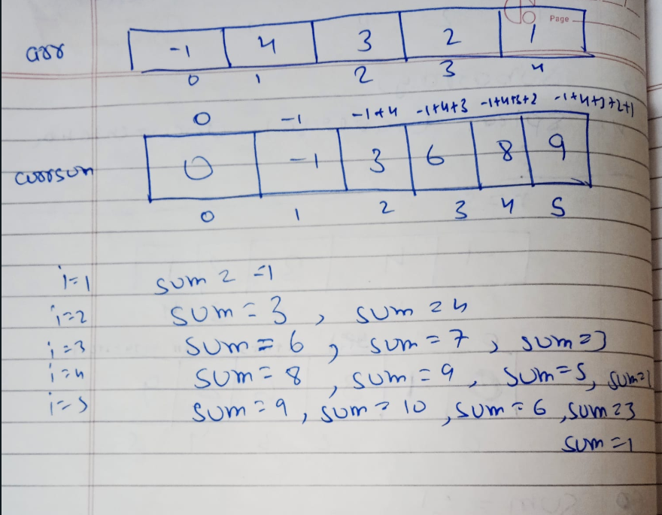

Iii) kadane’s algorithm
//kadan's algorithm
#include <iostream>
#include <climits>
using namespace std;
int main()
{
int n;
cin >> n;
int arr[n];
for (int i = 0; i < n; i++)
{
cin >>arr[i];
}

int currSum = 0;
int maxSum = INT_MIN;
for (int i = 0; i < n; i++)
{
currSum += arr[i];
if (currSum < 0)
{
currSum = 0;
}
maxSum = max(currSum, maxSum);
}

cout << maxSum << endl;
return 0;
}

Q8. Spiral traversal of 2D array
#include<iostream>
using namespace std;
int main()
{
int n,m;
cin>>n>>m;
int a[n][m];
for(int i=0;i<n;i++)
{
for(int j=0;j<m;j++)
{
cin>>a[i][j];
}
}
int row_start=0,col_start=0,row_end=n-1,col_end=m-1;
while(row_start<=row_end && col_start<=col_end)
{
for(int col=col_start;col<=col_end;col++)
{
cout<<a[row_start][col]<<" ";
}
row_start++;

for(int row=row_start;row<=row_end;row++)
{
cout<<a[row][col_end]<<" ";
}
col_end--;
if(row_start<=row_end)
{

for(int col=col_end;col>=col_start;col--)
{
cout<<a[row_end][col]<<" ";
}
}
row_end--;

if(col_start<=col_end)
{

for(int row=row_end;row>=row_start;row--)
{
cout<<a[row][col_start]<<" ";
}
}
col_start++;
}
return 0;
}

