The Fall of Silicon Valley Bank:  
A Detailed Analysis

Achyut Ramakrishna Kowshik, Karan Mudaliar, Pratyush Rokade, Sashank Reddy Vasepalli

Khoury College of Computer Sciences, Northeastern University

*Abstract*— Silicon Valley Bank's downfall has become a multifaceted concern that has piqued the interest of numerous analysts and researchers. This study aims to pinpoint the essential factors that contributed to the downfall of Silicon Valley Bank including, but not limited to a bank's portfolio distribution, risk management and hedging strategies, as well as their capacity to manage short-term capital requirements. Furthermore, this study underscores the importance of continuously monitoring these factors to prevent future incidents in the banking sector.

1. Introduction

On March 10th, 2023, Silicon Valley Bank failed, causing a ripple effect of other bank failures, including prominent names like Signature Bank, Credit Suisse, and First Republic Bank. The prevailing belief is that a combination of economic, managerial, and regulatory factors contributed to the bank's collapse. The most recent failure of a bank of this size happened back in 2008, when Lehman Brothers, a leading investment bank in the United States, went bankrupt. This triggered a similar chain reaction of events that spread across the world, resulting in a widespread recession and is considered one of the worst financial crises in modern history.

The banking sector's vulnerability was likely the result of regulatory modifications made by the Trump administration that eliminated the requirement for banks with $100 to $250 billion in assets to hold enough high-quality liquid assets to cover anticipated net outflows during a stressful period[1]. Consequently, such banks were authorized to invest more in riskier assets that were previously prohibited under older regulations.

To identify potential predictors that may have contributed to Silicon Valley Bank's collapse, we will scrutinize its Uniform Bank Performance Report [1] and that of its peers to assess their investment portfolio distribution.

1. methods

The details of the methods used in this project, i.e., the elaborate description of the procedures, techniques, and tools used to carry out the project can be found in the Methods section outside of this report.

1. results

This section presents the findings of our in-depth investigation of the circumstances surrounding the collapse of Silicon Valley Bank. Our analysis delves into the various factors that contributed to the bank's failure, such as inadequate capital and liquidity buffers, poor risk management, and a challenging economic and regulatory environment. The results are based on a comprehensive examination of Silicon Valley Bank's income statements, balance sheets, summary ratios, and regulatory filings, compared against some of the banks in its peer group (Fig. 1).

Fig. 1: Labels assigned to Silicon Valley Bank and its peers.

1. Rapid Increase in Assets and Capital

We commence by displaying a comparison chart (Fig. 2) that showcases the swift surge in assets and capital for Silicon Valley Bank when compared to its peers in the period leading up to its collapse.

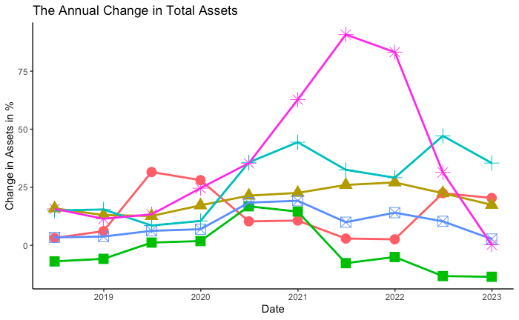

Fig. 2: Rapid changes in Assets and Capital.

1. Steep Climb in Customer Deposits

Figure 3 illustrates the rapid expansion of Silicon Valley Bank, as evidenced by the steep increase in customer deposits starting from 2020 and persisting throughout 2021. The next step is to investigate how the bank utilized the surplus capital resulting from this growth.

Fig. 3: Rapid influx of customer deposits.

1. Breakdown of Assets

Upon scrutinizing the portfolio of Silicon Valley Bank, one asset class stood out as significant: Securities. As depicted in Fig. 4, Silicon Valley Bank held more than double the amount of securities than its peers. Under the prior regulatory guidelines, this would typically have been deemed an overexposure to securities.

Fig. 4: Largest asset class held by Silicon Valley Bank.

1. Breakdown of Securities

Figures 5a and 5b reveal that Silicon Valley Bank had a significant number of Held-to-Maturity and Available for Sale securities. Notably, there was a discernible shift of Available for Sale securities to Held-to-Maturity securities during the 2021 fiscal year, indicating the conversion of short-term investments into long-term investments. Further exploration of these Held-to-Maturity securities is warranted.

Fig. 5a: Changes in Held-to-Maturity portfolios over time.

Fig. 5b: Changes in Held-to-Maturity portfolios over time.

1. Breakdown of Held-to-Maturity Securities

Held-to-Maturity Securities come in various types, but Silicon Valley Bank's holdings were primarily concentrated in Municipal Securities and Treasury & Govt. Agency Securities. While some online news articles[3] attribute Silicon Valley Bank's problems to US Treasury Securities, Figures 7 and 8 indicate that the bank was not overexposed to such securities but instead to Municipal Securities. These securities are generally considered riskier due to the variability of creditworthiness among state and local governments based on economic conditions. Additionally, Municipal Securities are less liquid than US Treasury Securities, and they can be challenging to sell during times of economic uncertainty. Finally, they are more susceptible to Interest Rate Risk, which can increase due to rapidly changing federal reserve interest rates.

Fig. 6: Municipal Securities as a percent of the Bank’s portfolio

Fig. 7: UA Treasury Securities as a percent of the Bank’s portfolio.

1. Unforeseen Rise in Interest Rates

The Federal Reserve's latest announcement highlighted its intention to continue raising interest rates, marking the seventh consecutive increase in the federal funds rate, as depicted in Figure 9. The Fed's motive for raising rates [4] has been to tackle the current high inflation levels, which have surged to levels not seen in the past 40 years[5].

During rapid rises in interest rates, such as the present economic climate, the impact of interest rate risk on securities can be even more pronounced. As interest rates increase, the value of fixed-income securities tends to decline more sharply, as investors move their funds towards securities with higher yields. Consequently, interest rate risk has contributed significantly to the devaluation of Securities to which Silicon Valley Bank has a substantial overexposure.

Fig. 8: Federal Interest Rates over time.

1. Losses Incurred due to Interest Rate Risk

Figure 10 provides a visual representation of the unrealized losses, which are yet to be realized until the securities reach maturity. Therefore, these losses would only be actualized if the bank sells the securities before maturity and reports the loss.

However, the Risk-Weighted Assets of a bank factor in the risk associated with the investments held by the bank, and if the risk is deemed high, the total Risk-Weighted Assets of the bank will be significantly reduced. As depicted in Figure 9, the earlier steep ascent in assets observed is not as prominent anymore, illustrating the effect of the bank's high-risk investments on its Risk-Weighted Assets.

Fig. 9: Risk-Weighted Assets of Silicon Valley Bank and peers.

Fig. 10: Unrealized Depreciation of Securities due to Interest Rate Risk.

1. Need for Short-term Capital

Thus far, it has been established that Silicon Valley Bank has a predominant portion of its portfolio invested in long-term products, and selling these products in the current market before maturity could lead to substantial losses. Hence, Silicon Valley Bank utilized a significant portion of its assets and securities as collateral for loans to address its short-term capital requirements, as demonstrated in Figures 11a and 11b. However, if the bank has depleted all its assets and securities as collateral and still lacks sufficient capital for short-term purposes, what are the potential implications? This will be deliberated in the subsequent section.

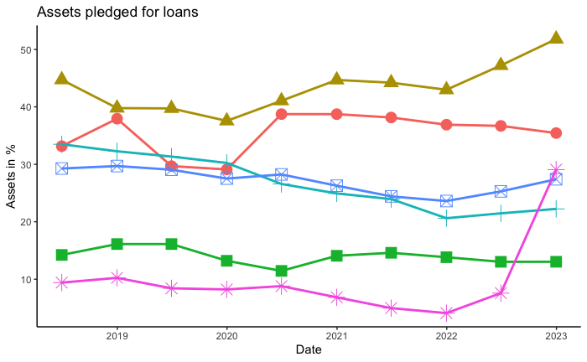

Fig. 11a: Assets pledged by banks for loans.

Fig. 11a: Securities pledged by banks for loans.

1. discussion

As seen in the previous section, Silicon Valley Bank had exhausted all its capital and depleted all its assets and securities as collateral. Despite this, it lacked sufficient capital for short-term purposes as more and more depositors withdrew their money from the bank. This led to the bank becoming insolvent and unable to meet the withdrawal demands of its customers and filed for bankruptcy.

It is noteworthy that Silicon Valley Bank does not have Q1 2023 data available due to its collapse before the reporting deadline. Therefore, all the factors analysed in this discussion will pertain only to the period up to Q4 2022, and the identical analysis could have been conducted three months before the bank's collapse.

Regulators, Analysts and individuals outside the banking industry could readily conduct comparable portfolio and risk assessments for all banks below the regulatory threshold of $250 billion to ascertain their soundness and stability. When instability or uncertainty arises, analysts can voice their concerns to bank management, and regulators can impose penalties on the bank until it establishes its financial stability.

Nevertheless, the parameters in the Uniform Banking Performance Report may not be the sole contributing factors to Silicon Valley Bank's downfall. Other elements such as news & media influence and human errors in bank management could also play a role. Therefore, examining these additional factors would enable us to conduct more precise evaluations of banks.

To illustrate the predictive power of the identified metrics in assessing bank stability, we will employ them as a case study to examine the downfall of another peer from the same list. As depicted in Figure 12, First Republic Bank had a considerable overexposure to Municipal Securities, surpassing even that of Silicon Valley Bank. Furthermore, Figure 10 reveals a substantial decline in securities, while Figure 11a indicates a significant amount of assets pledged. These factors combined led to First Republic Bank's collapse, as shown by their stock value plummeting by almost 90% (Fig. 13)[6] in just ten days following the collapse of Silicon Valley Bank.

Fig. 12: Assets pledged by Banks for loans.

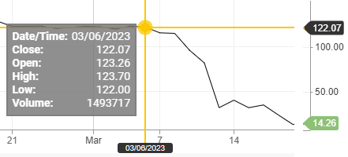

Fig. 13: Steep decline in First Republic Bank’s stock price.

1. statement of contributions

**Achyut Ramakrishna Kowshik** – Data extraction, data transformation and cleaning.

**Praytush Rokade** – Methods, R script for transforming data, converted data from semi-structured text to xlsx.

**Karan Mudaliar** – Identified factors in clean data, EDA assisted with R scripts, data visualization.

**Sashank Reddy Vasepalli** – Data Cleaning, converted semi structured data to xlsx, Identified factors in clean data, EDA, data visualization.

1. appendix

The cleaned datasets and R markdown for this project is available on Github:

<https://github.com/sashank3/SVB_Analysis>

References

1. Trump administration changes to bank regulations - [Link](https://www.whitehouse.gov/briefing-room/statements-releases/2023/03/30/fact-sheet-president-biden-urges-regulators-to-reverse-trump-administration-weakening-of-common-sense-safeguards-and-supervision-for-large-regional-banks/)
2. Federal Financial Institutions Examination Council’s (FFIEC) Data - <https://cdr.ffiec.gov/public/ManageFacsimiles.aspx>
3. Collapse of SVB Article - [Link](https://www.science.org/content/blog-post/collapse-svb)
4. Federal Reserve Interest Rates - <https://fred.stlouisfed.org/>
5. Federal Interest Rate Hike Article by CNBC - [Link](https://www.cnbc.com/select/interest-rates-rising-saving-more-appealing-debt-more-harmful/)
6. First Republic Bank stock price - <https://www.cnbc.com/quotes/FRC>
7. Video on Silicon Valley Bank’s Failure - [Link](https://www.youtube.com/watch?v=QACGoKb48_0&ab_channel=WallStreetJournal)