**Rest parameter** is an improved way to handle function parameter, allowing us to more easily handle various input as parameters in a function. The rest parameter syntax allows us to represent an indefinite number of arguments as an array. With the help of a rest parameter a function can be called with any number of arguments, no matter how it was defined. Rest parameter is added in ES2015 or ES6 which improved the ability to handle parameter.

|  |
| --- |
| // Without rest parameter  function fun(a, b){      return a + b;  }  console.log(fun(1, 2)); // 3  console.log(fun(1, 2, 3, 4, 5)); // 3 |

**Output:**  
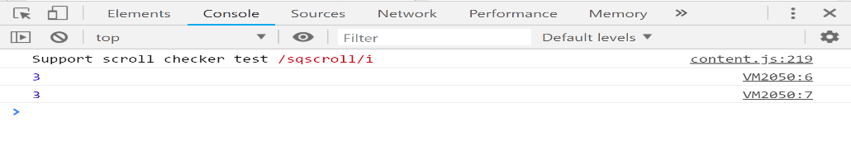  
In the above code, no error will be thrown even when we are passing arguments more than the parameters, but only the first two arguments will be evaluated. It’s different in the case with rest parameter. With the use of the rest parameter, we can gather any number of arguments into an array and do what we want with them.  
Javascript code demonstrating addition of numbers using rest parameter.

|  |
| --- |
| // es6 rest parameter  function fun(...input){      let sum = 0;      for(let i of input){          sum+=i;      }      return sum;  }  console.log(fun(1,2)); //3  console.log(fun(1,2,3)); //6  console.log(fun(1,2,3,4,5)); //15 |

**Output:**  
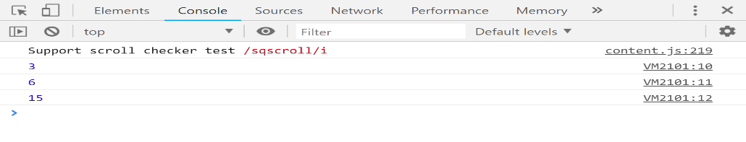  
We were able to get the sum of all the elements that we enter in the argument when we call the fun() function. We get the sum of all the elements in the array by making use of the for..of loop which is used to traverse the iterable elements inside an array.

**Note:** The rest parameter have to be the last argument, as its job is to collect all the remaining arguments into an array. So having a function definition like the code below doesn’t make any sense and will throw an error.