**Hall effect**

In 1879, E.H. Hall devised an experiment that can be used to identify the sign of the predominant charge carriers in a conducting material. From a historical perspective, this experiment was the first to demonstrate that the charge carriers in most metals are negative.

The electrons are moving from left to right, so the magnetic force they experience pushes them to the bottom edge of the strip. This leaves an excess of positive charge at the top edge of the strip, resulting in an electric field *E* directed from top to bottom. The charge concentration at both edges builds up until the electric force on the electrons in one direction is balanced by the magnetic force on them in the opposite direction. Equilibrium is reached when:

eE=evdB

where *e* is the magnitude of the electron charge, vd is the drift speed of the electrons, and *E* is the magnitude of the electric field created by the separated charge. Solving this for the drift speed results in

vd=E/B

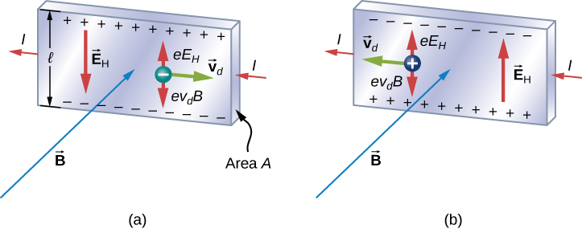

**Figure:** In the Hall effect, a potential difference between the top and bottom edges of the metal strip is produced when moving charge carriers are deflected by the magnetic field. (a) Hall effect for negative charge carriers; (b) Hall effect for positive charge carriers.

A scenario where the electric and magnetic fields are perpendicular to one another is called a crossed-field situation. If these fields produce equal and opposite forces on a charged particle with the velocity that equates the forces, these particles are able to pass through an apparatus, called a **velocity selector**, undeflected. Any other velocity of a charged particle sent into the same fields would be deflected by the magnetic force or electric force.

The field *E* is related to the potential difference *V* between the edges of the strip by

E=V/l

The quantity *V* is called the Hall potential and can be measured with a voltmeter. The Hall effect can be used to measure magnetic fields.

Applications

One can detect and measure all kinds of things with the Hall-effect using what's known as a Hall-effect sensor or probe.

* **Hall-effect sensors** are simple, inexpensive, electronic chips that are used in all sorts of widely available gadgets and products.
* **Hall-effect probes** are more expensive and sophisticated instruments used in scientific laboratories for things like measuring magnetic field strength with very high precision

Question:

A current I flows to the right through a rectangular bar of conducting material, in the presence of a uniform magnetic field B pointing out of the page (Fig.).

(a) If the moving charges are positive, in which direction are they deflected by the magnetic field?

(b) Find the resulting potential difference (the Hall voltage) between the top and bottom of the bar, in terms of B, v (the speed of the charges).

(c) How would your analysis change if the moving charges were negative?

(d) To construct a non-mechanical water meter, a 0.500-T magnetic field is placed across the supply water pipe to a home and the Hall voltage is recorded.

(i) Find the flow rate through a 3.00-cm-diameter pipe if the Hall voltage is 60.0 mV.

(ii) What would the Hall voltage be for the same flow rate through a 10.0-cm-diameter pipe with the same field applied?

Answer:

1. If positive charges flow to the right, they are deflected down, and the bottom plate acquires a positive charge.

1. If negative charges flow to the left they are also deflected down, and the bottom plate acquires a negative charge. The potential difference is still the same, but this time the top plate is at higher potential.
2. Pipe diameter = 3.00 cm

It has some water flowing through it and this water has some dissolved ions in it, as most water does, and those charged ions can form a charged distribution when a magnetic field is put across this pipe. So if a magnetic field is directed into the page here say then putting your fingers in the direction of that magnetic field and your thumb in the direction of motion of the water—let's say the water's to the right— then you would have the positive ions pushed to the top and the negative ions pushed to the bottom of the pipe and so this causes a voltage and this is the Hall voltage that will be measured.

It's 60 millivolts and the magnetic field strength here = 0.500 tesla

We are going to figure out what is the speed of the water in the pipe? This is a non-mechanical water flow rate measuring device. So the Hall voltage is magnetic field times the diameter of the pipe times the speed of the water in it. To solve for v: divide both sides by Bd so the speed of the water then is the Hall voltage divided by the magnetic field strength times the diameter of the pipe. Now the volume flow rate through a pipe is its cross-sectional area multiplied by the speed of a fluid and since this is a pipe with a circular cross-section, its area= πd2 /4times its radius squared. So we can substitute that in for A here and then we substitute this in for v and now we have a formula for the volume flow rate. So this d squared divided by d is d to the power of 1 so we have π times the Hall voltage times the diameter of the pipe divided by 4 times the magnetic field strength. So that's π times 60 millivolts written as times 10 to the minus 3 volts times 3.00 times 10 to the minus 2 meters— diameter of the pipe— divided by 4 times 0.500 tesla and its 2.8274 times 10 to the minus 3 cubic meters per second.

For the volume flow rate in litres per second we get 2.83 liters per second is the volume flow rate

(b) The Hall voltage is expected to reduce because increasing the diameter will reduce the speed given the same volume flow rate. So if we put the same number of liters through the pipe per second as before now that we have a larger diameter to push that water through, we need it to go more slowly to have the same volume going through per time. To solve for the Hall voltage multiply both sides by 4B/πd(new diameter). Hall voltage in the second case = 4 times the magnetic field strength times the volume flow rate divided by π times the new diameter of the pipe.

So that's 4 times 0.500 tesla times 2.8274 times 10 to the minus 3 cubic meters per second divided by π times 10.0 times 10 to the minus 2 meters.

This is equal to 18.0 millivolts, which indeed is less than the 60 millivolts that we had with the small diameter tube.

References:

1. Introduction to electrodynamics / David J. Griffiths
2. https://openstax.org/details/books/university-physics-volume-2