**Capacitor Plate Attached to a Spring**

**Question** : A parallel plate capacitor has its lower plate fixed and the upper plate is hanging on a spring with spring constant = k Nm-1. The plate can move in the vertical direction. A voltage source is connected to the plates. With zero voltage, the distance between the 2 plates is d m. The area of the plates is A m2.

1. Derive the relation between the voltage V and the displacement x of the upper plate in which the attractive force and spring force are in equilibrium
2. What is the maximum voltage for which the plates are in stable equilibrium
3. Draw the graph showing the relation between the voltage (y axis) and the displacement (x axis)

**Solution:**

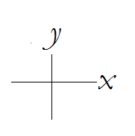*Figure : Choice of axis*

Let the original distance between the capacitor plates be *d*

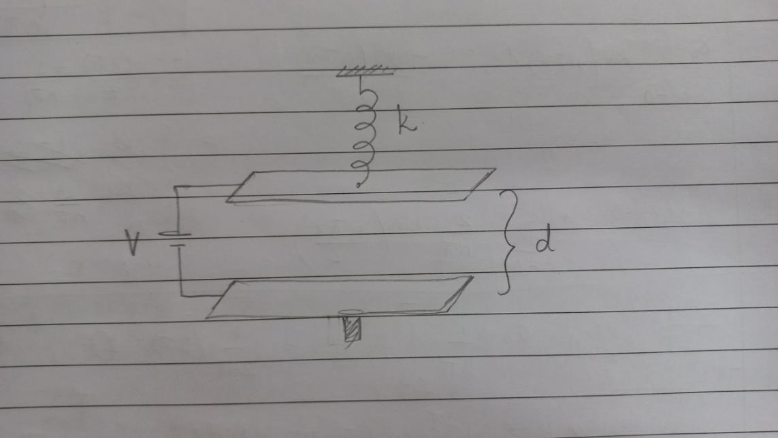

The forces acting on the capacitor before connecting to voltage source are:

- Spring force *Fsp* (towards the *+y* direction)

- Gravitational force *Fg* (towards the *-y* direction)

Due to the force due to gravity, the upper plate will get move in the *-y* direction which will produce a extension *xo* in the spring.

At equilibrium, the force due to the spring will balance the gravitational force.

*Fg = Fsp = kxo*

When the voltage source is activated, an addition electric force *FE* in the *-y* direction will act on the upper capacitor plate. This will increase the extension of the spring from *xo* to *x0 + x.* The distance between the capacitor plates reduces from d to *d-x*

So,

*FE + Fg = F ’sp*

*FE + Fg = k(x0 + x)*

*FE = kx*

But *FE* is the electric force exerted on the upper plate by the lower plate and is given by QE/2 where E is the electric field associated with the capacitor and Q is the charge on the plate of the capacitor.

 ----(1)

We know that  since V is the electric potential which is applied on the capacitor and *d-x* is the distance between capacitor plates after the voltage is applied. ---(2)

The capacitance of the capacitor is given by where A is the area of the plates.

Using Q = CV, we get  ---(3)

Using the 2 equations (2) and (3) and substituting them in (1), we get



1. The electric force can be given by the relation,



Plotting FE, Fsp vs displacement,

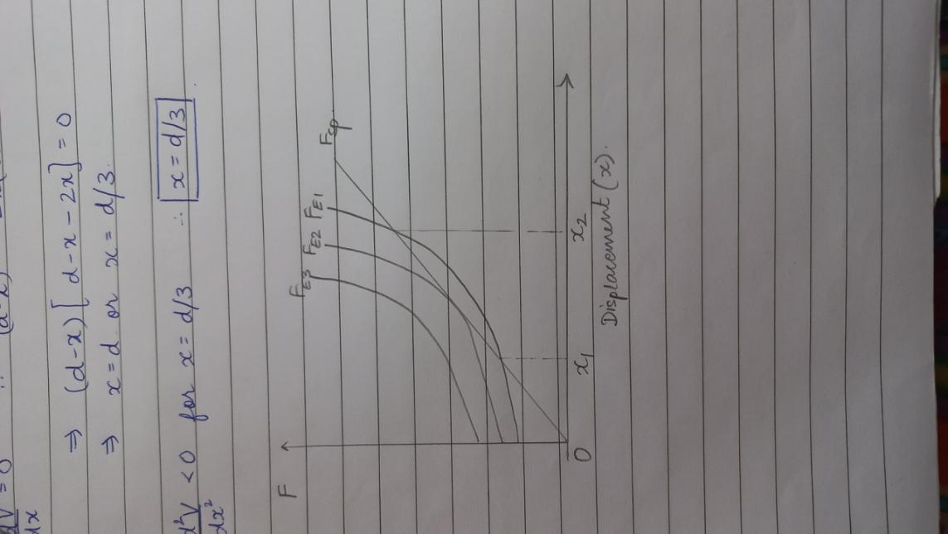

We see that FE and Fsp can intersect at either 2 points when the voltage applied is less than the maximum voltage, 1 point when voltage applied is equal to maximum voltage and 0 points when voltage applied is higher (from the FE, Fsp vs displacement and V vs displacement graph)

In the case when the voltage applied is less than maximum voltage, the lower displacement value (x1) corresponds to stable equilibrium because if we shift the plate away from the bottom plate, FE > Fsp and the plate will return to the equilibrium state. And if we shift the plate closer to the bottom plate, FE < Fsp and the spring will pull the plate back to the equilibrium state.

The higher displacement value (x2) corresponds to unstable equilibrium because if we shift the upper plate farther away from the bottom plate, the spring force will become greater than the electric force and the plate will move upwards away from the equilibrium. If we shift the upper plate closer to the bottom plate, the electric force will become greater than the spring force and the upper plate will be pulled towards the bottom one.

Thus, we can say that the maximum voltage at which stable equilibrium can occur would be at the stationary points in the graph of *V* vs *x*.

This implies that, 

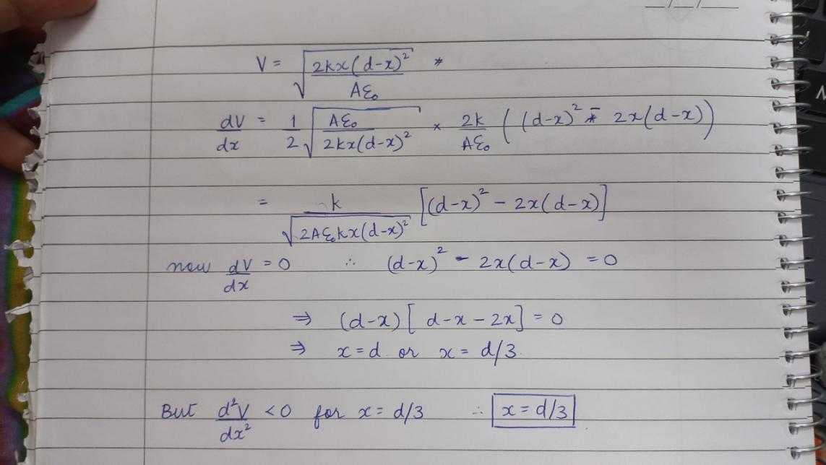

Substituting x = d/3 in the equation for V, we get,

1. Appropriately drawing this graph turns out to be, 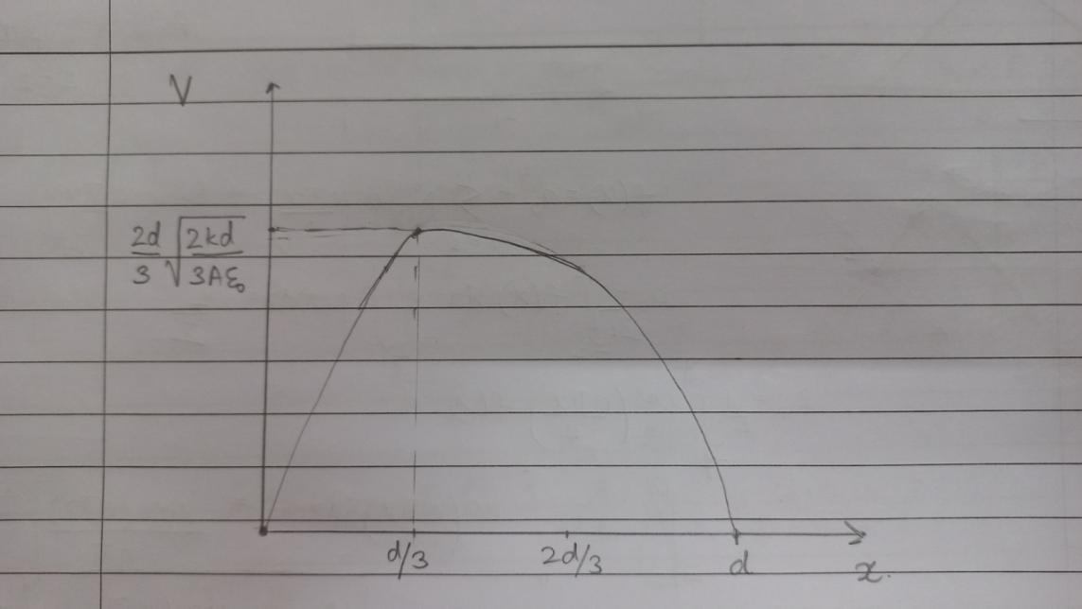

**References: [https://physicstasks.eu/3250/capacitor-with-plate-on-a-spring#eqref-**](https://physicstasks.eu/3250/capacitor-with-plate-on-a-spring#eqref-**)**