**DATA ENGINEERING ASSESMENT**

DATA INGESTION –

Libraries

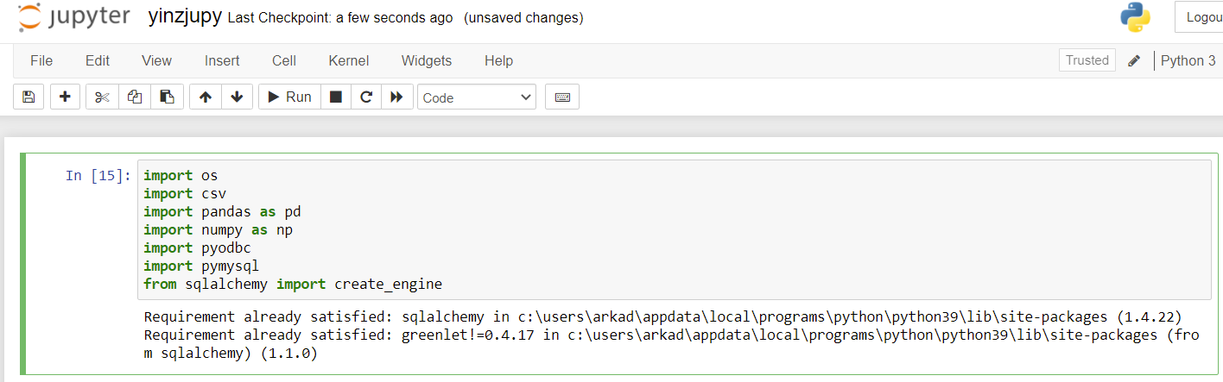

Reading TSV File

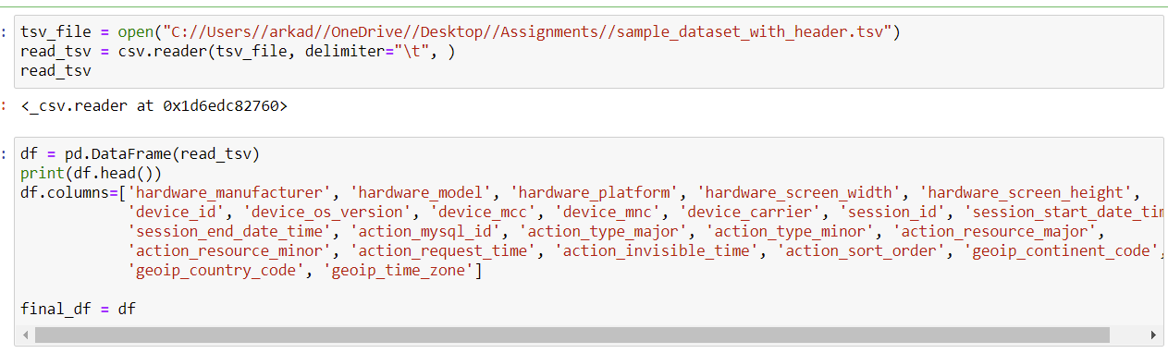

Cleaning

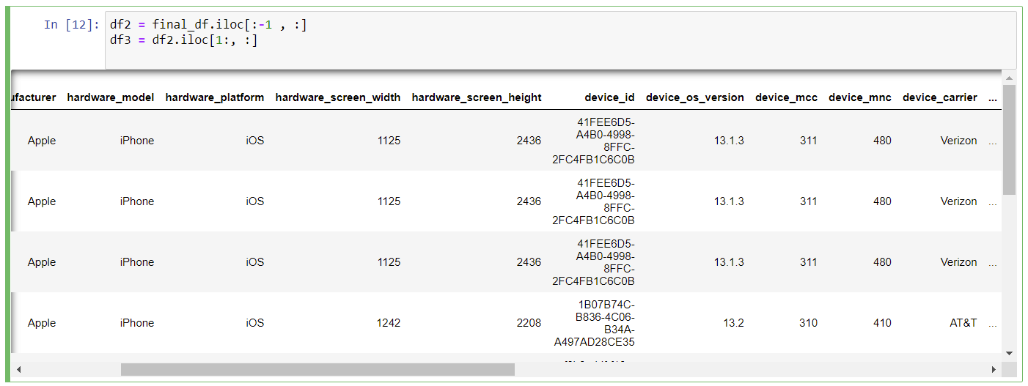

Inserting into MySQL Database

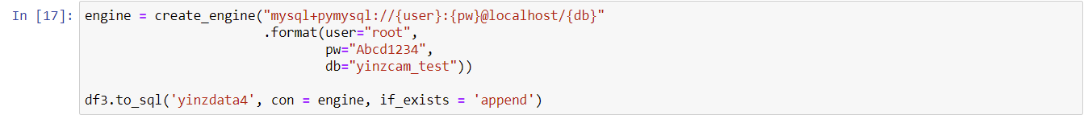

MySQL Database

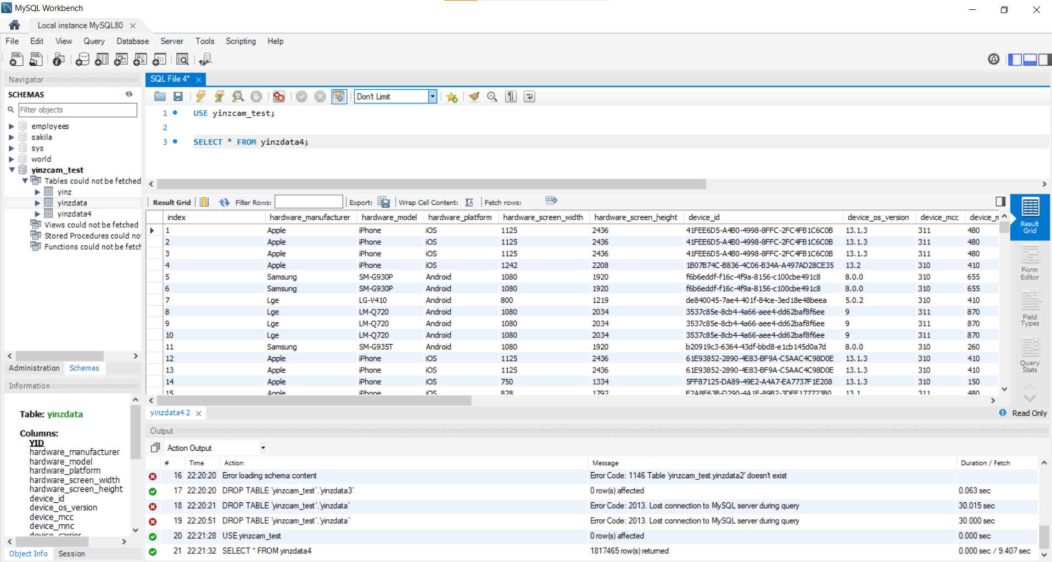

SQL Queries –

1.

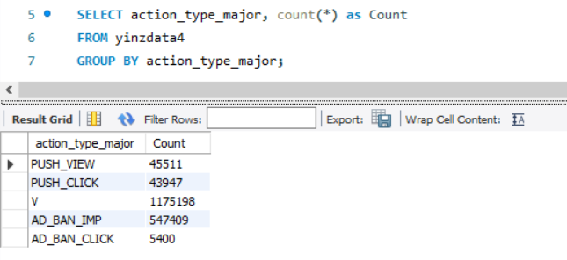

2.

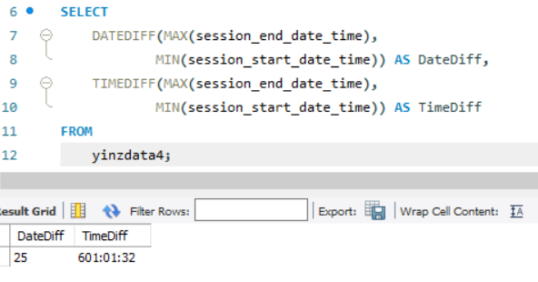

3.

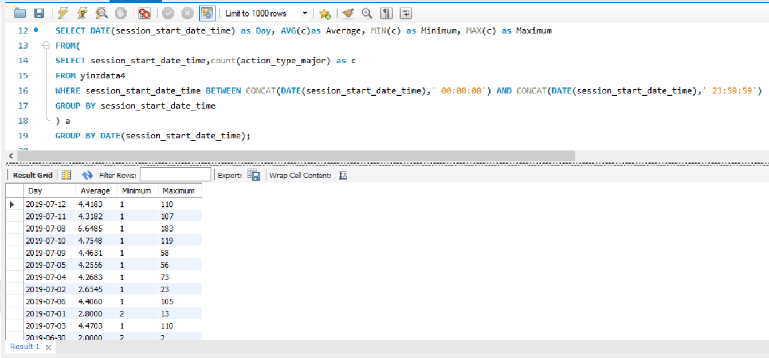

4.

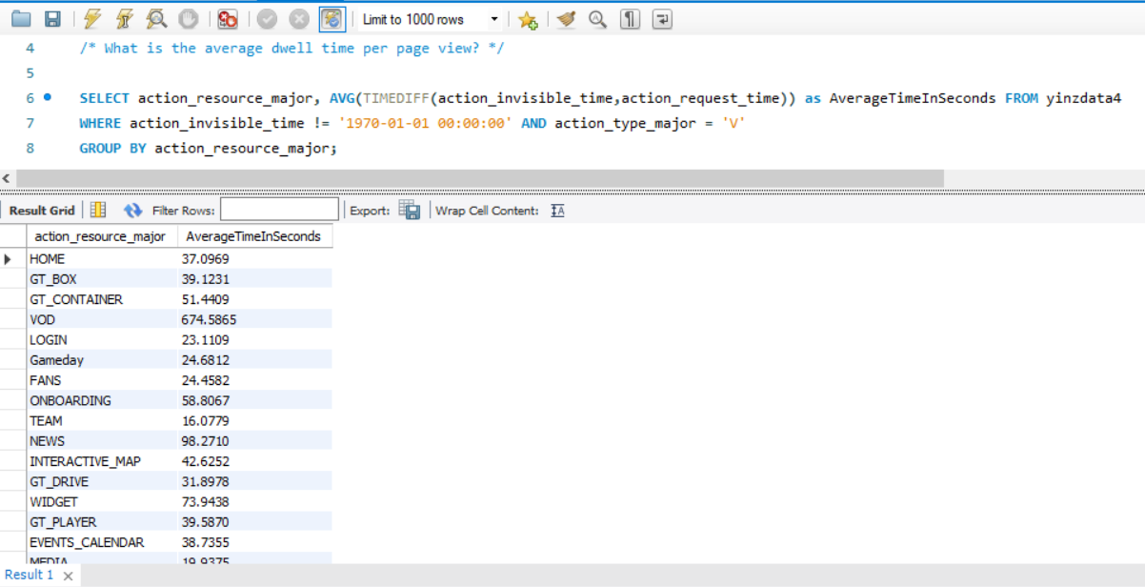

5.

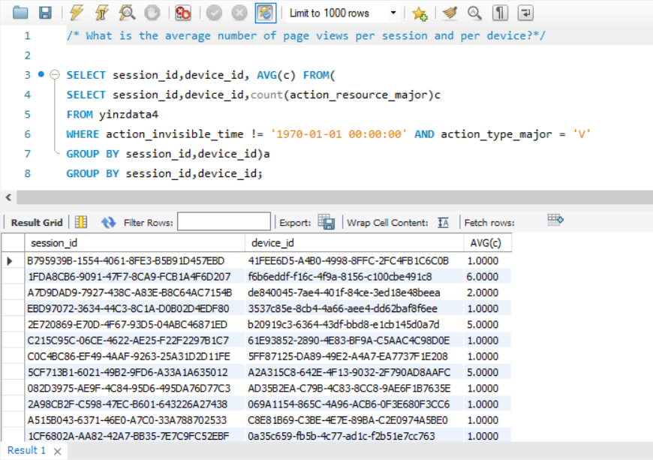

DATA ANALYSIS AND VIZUALISATION –

Most used smartphone brand

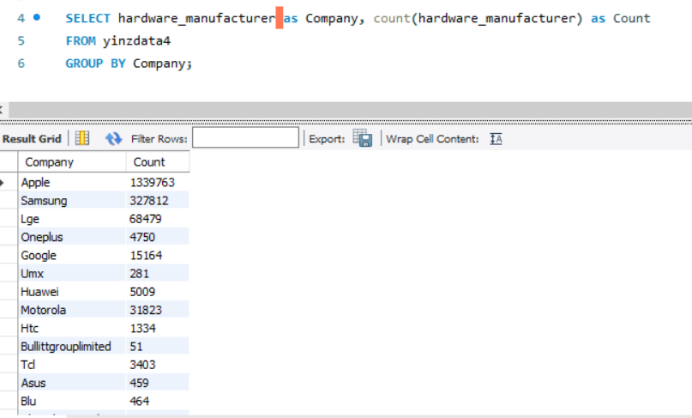

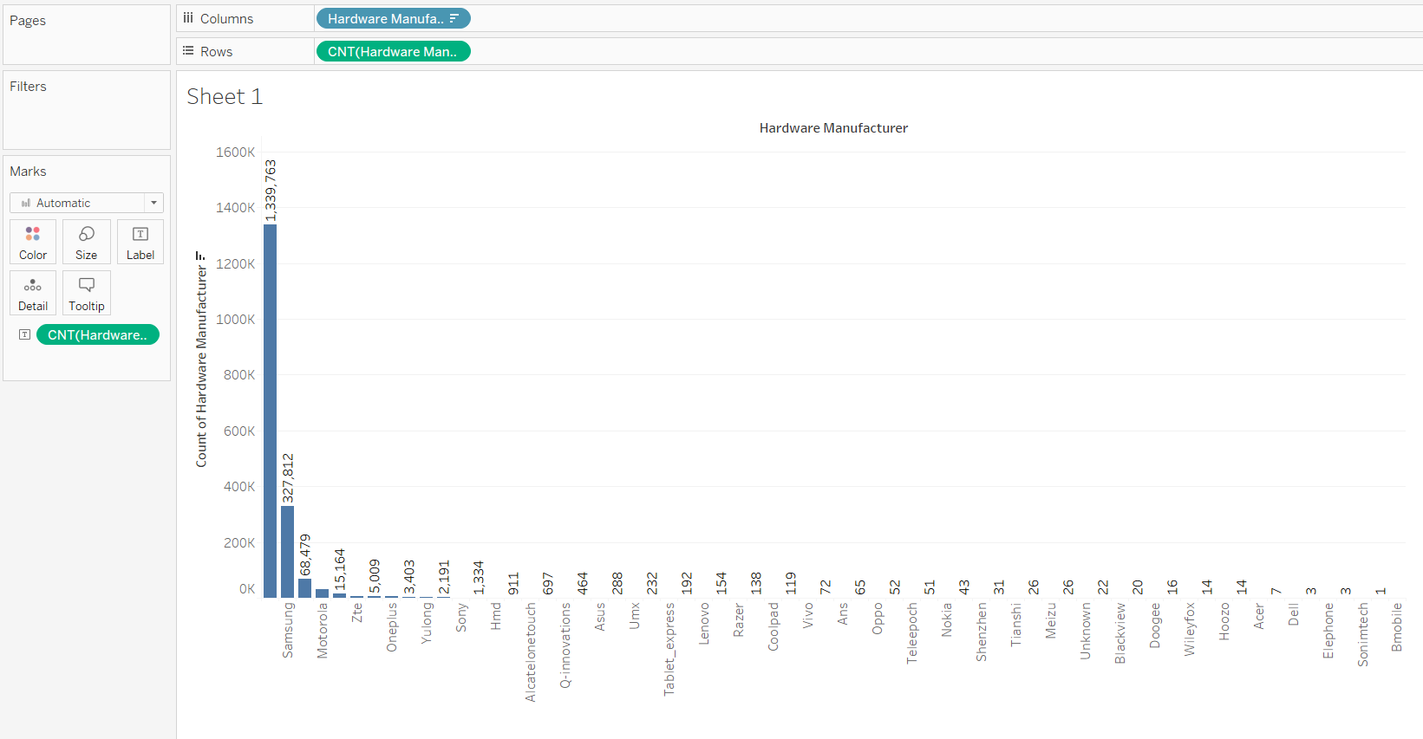

Views

We can see that Sundays have more views

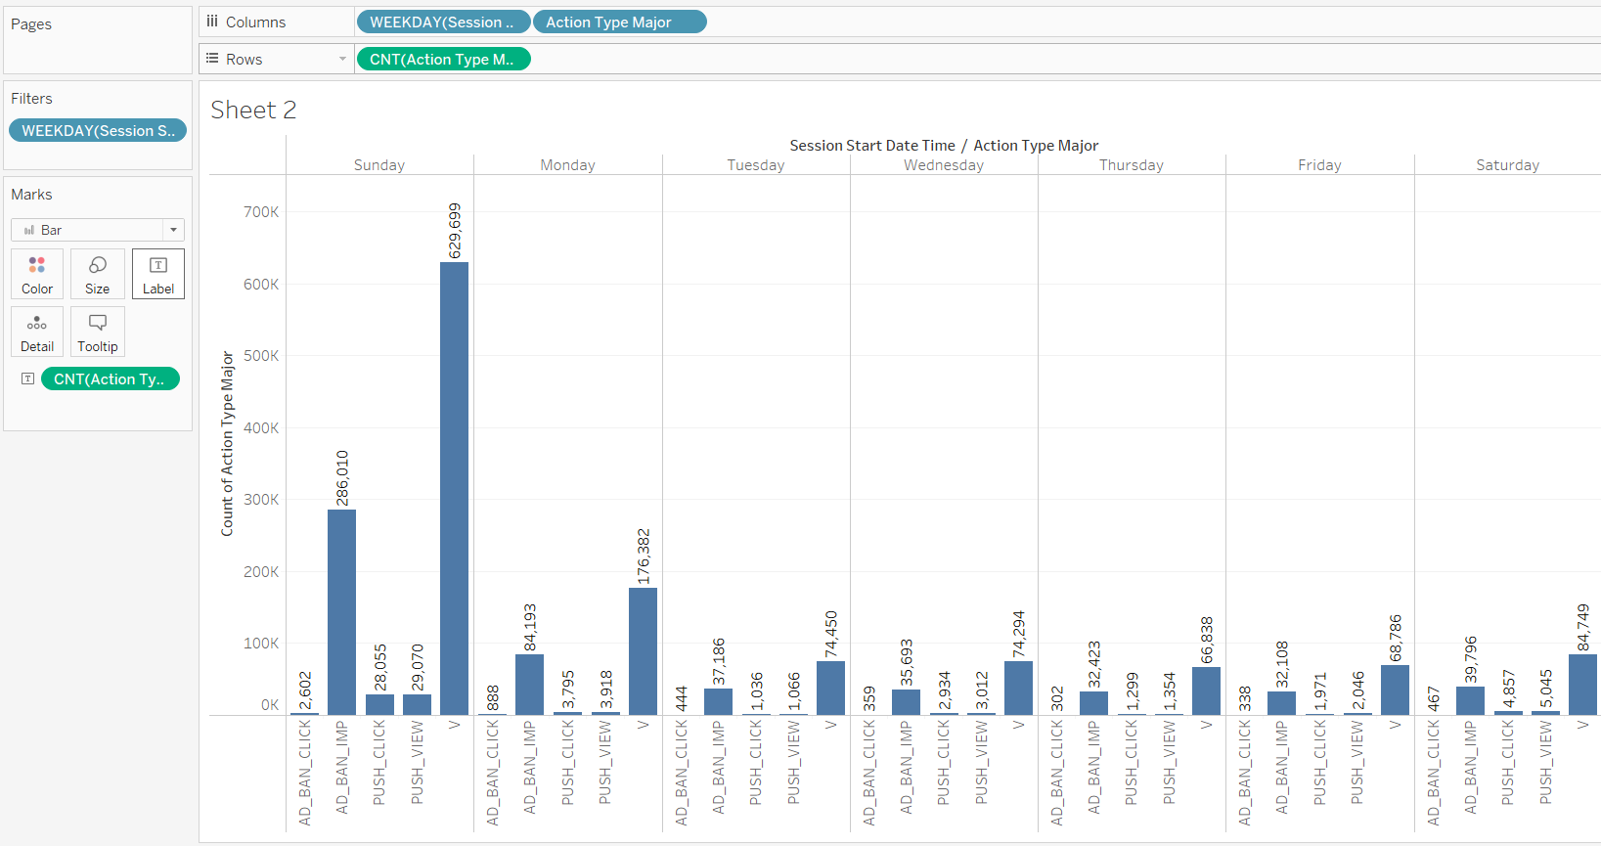

What is the bounce rate or retention rate of features (pages)? Which features perform the best, and which perform the worst?

Are advertisements more effective on certain pages of the app than others? At certain times? Where/when should advertisements be placed to get maximum yield?

When does engagement with push notifications peak, and when is it at its lowest point? When does push-notification engagement fall off after a game?

