Smart Juggling Balls: <https://youtu.be/MuF92wXwjuk>

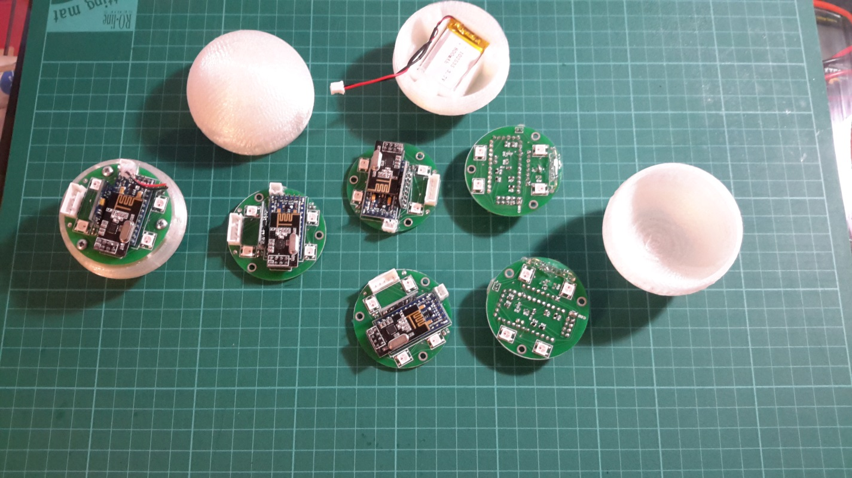

This is my version for smart juggling balls, the files I share include PCB Circuit manufacture files (Gerber)

STL models for the casing, and codes (currently Test code).

It is possible to assemble the juggling balls using a prototype PCB such as: <https://www.sparkfun.com/products/8810> my first iterations were based on the same prototype board and later the PCB was design based on the physical dimensions of the board.

The circuit itself can be ordered from SeeeStudio <http://www.seeedstudio.com/service/index.php?r=pcb>

Just upload the Attached zip in Circuit🡪JB_Gerber.zip and order a standard 2 layer pcb. (Schematics are available in Circuit🡪Juggling_Balls.PDF

STL files for the casing are available in STL🡪Juggling_Maker_Faire

There are 2 versions one is a bit thicker.

All parts and links are available in Juggling_Balls_Bom.xlsx

Some notes on assembling:

Currently the power circuit (Transistor and mosfet) weren`t tested out,I use a wire to short the mosfet and use the connected pin (D8) as a magnet detector through the reed switch.

In one of the batches the holes for the arduino board came a bit tight so I was required to drill wider and then solder the pins for the arduino model from both sides of the pcb.

The Nrf model pins are needed to be cut a bit and the plastics removed so the NRF model will sit flat on the 2x4 header.

The circuit is design for the arduino compatible models available on ebay, such that the pinout for the FTDI is as in the image: (alternatively it is possible to use a different arduino version without soldering the FTDI headers to the pcb board, in that case the 5 pin connector will not be connected to the board DTR).

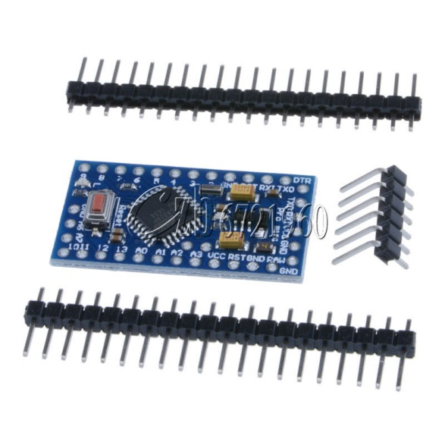

The direction of the SMD RGB LEDS such that the ‘cut’ corner of the LED first in the small Square drawn on the PCB.

All Resistors and capacitors aren`t Solid science, feel free to make variations, I myself solder a 1 uF capacitor instead the 47 uF and use 10kOhm resistors instead the 47kOhm

Note the correct direction for the Pin headers

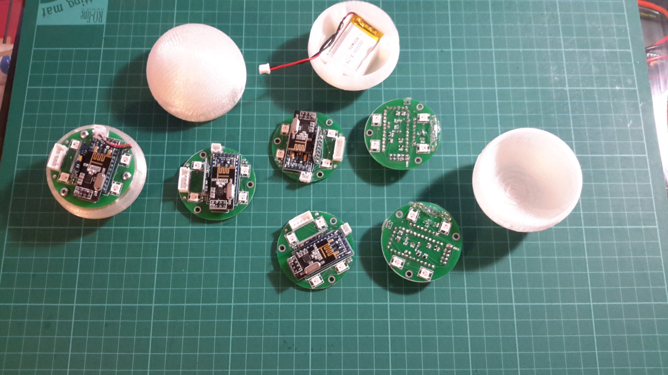

Enjoy.

Thanks to Eugene: <http://techno-mind.ru/> for the initial PCB design for manufacturing.