

Smart ticketing system

**Functional Specifications Document**

Arkadiusz Krzysztof

2014

|  |  |
| --- | --- |
| ticket_1000_color.png | **Table of Content** |

|  |  |
| --- | --- |
| The Use of Ticketer | 3 |
|  |  |
| Timescales and Requirements | 5 |
|  |  |
| Client Specification | 7 |
|  |  |
| Server Specification | 9 |
|  |  |
| User Interface | 11 |

|  |  |
| --- | --- |
| ticket_1000_color.png | **About:** TICKETER |

TICKETER is a new smart ticketing system that allows you to manage, in real time, rules, patterns and schedules of cases related to tickets validation and access control.

With Ticketer Server you are able to set upcoming events, link guests and host employees, select devices on which you run Ticketer Client and many more. In your mobile device, with NFC adapter or camera, apply requested event and enjoy the simplest way to transform your smartphone into professional ticketing machine!

Some things you can do with TICKETER:

* Check presence of attendees on conference or lecture.
* Protect special areas from unauthorized access.
* Verify tickets validity in concert halls or amusement parks.
* Build clever work time recorder.

|  |  |
| --- | --- |
| ticket_1000_color.png | **The Use of Ticketer** |

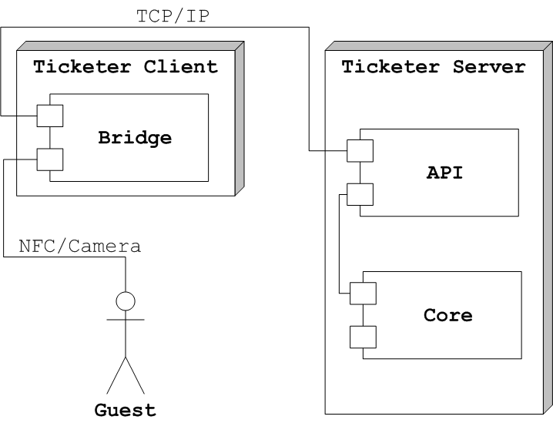

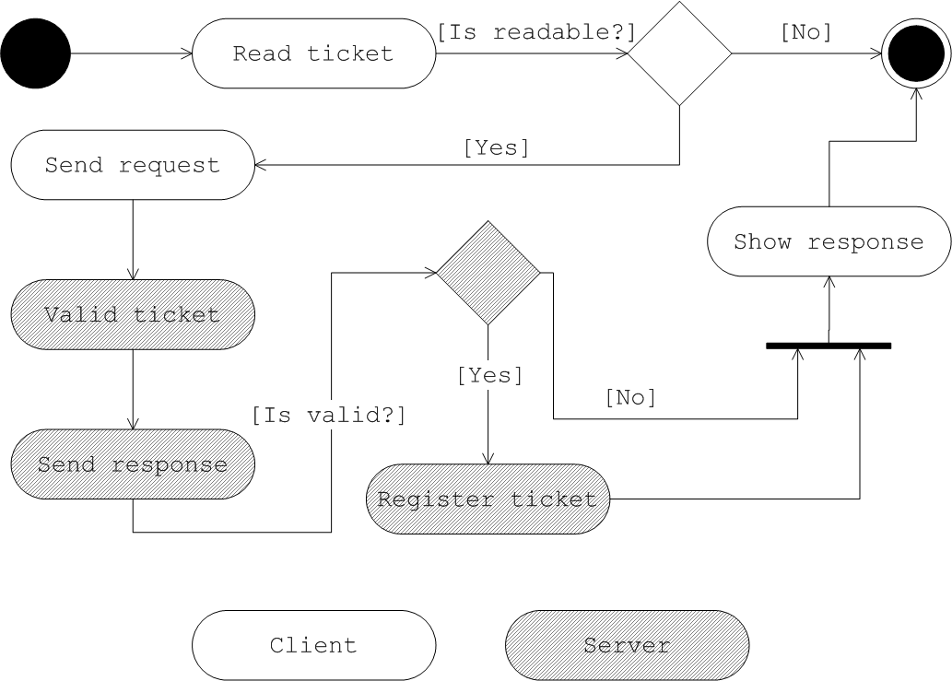

|  |  |
| --- | --- |
| ticket_1000_color.png | **Timescales and Requirements** |

Great thing about Ticketer solution is extensibility. That allows to add new platforms and features to existing version of the product. Base configuration contains Server support, on all main desktop browsers, and Client support on Android platform. Tickets validation provides NFC technology. In near feature, iOS devices support will be introduced and also Camera authorization method (QR, barcode).

|  |  |  |
| --- | --- | --- |
|  | Ticketer v1.0 | Ticketer v2.0 |
| Environment | WEB ANDROID | WEB ANDROID IOS |
| Validation | NFC | NFC QR BARCODE |

|  |  |
| --- | --- |
| ticket_1000_color.png | **Client Specification** |

|  |  |
| --- | --- |
| ticket_1000_color.png | **Server Specification** |

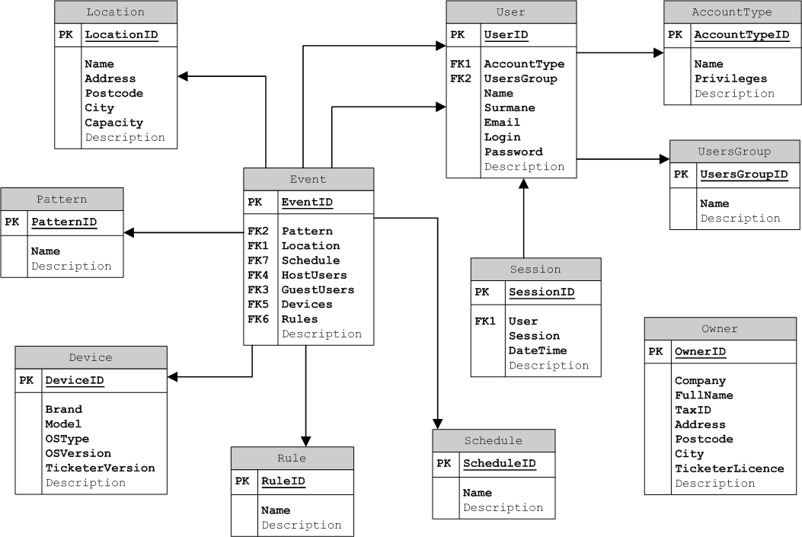

|  |  |
| --- | --- |
| ticket_1000_color.png | **User Interface** |