An application that is in front of you is an easy, intuitive part of you daily work routine. It is intended to be used for any floor ordering needs.

1. Introduction

When application is open it has three tabs which are used register customer in a system, and process customer’s orders.

TAB ONE (Customer Information and Floor Size)

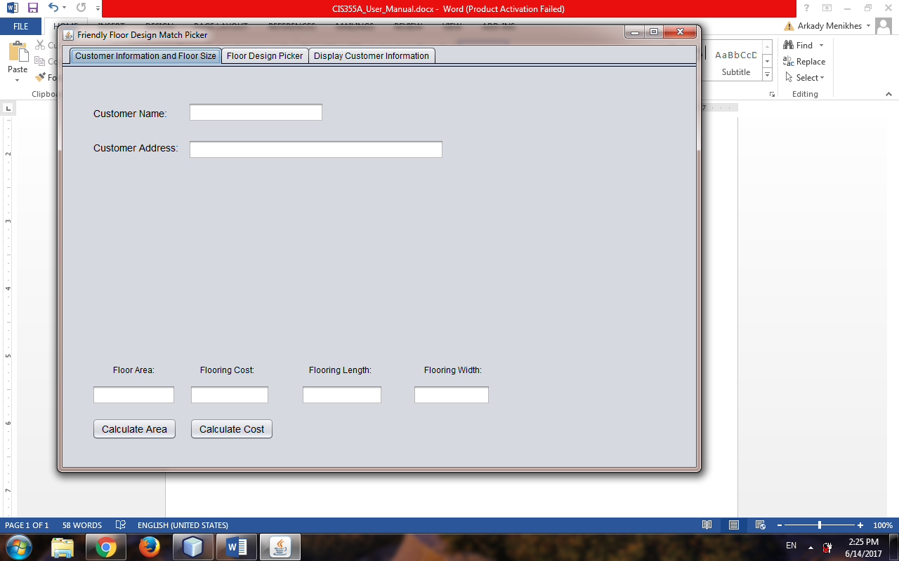

Before we proceed any farther with an order we need to enter customer information, such as First, Last name and address which will be saved in a database upon submitting an order. When customer making an order he/she needs to choose an area of a floor, floor type along with color or pattern but that is on a second TAB page and then he/she will a price at which an order will be entered into processing. If for example we press calculate an area button without entering information first such as Floor Length and Width we will get a warning message like that:

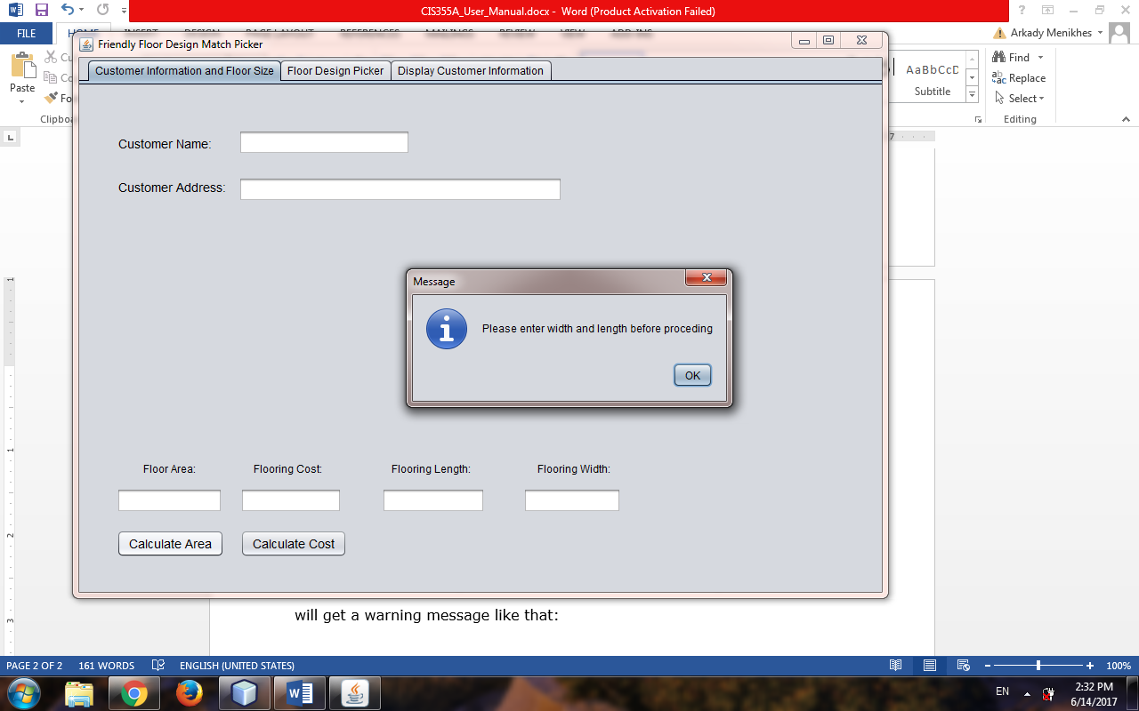

The same will happen if we press Calculate Cost button, we need to know area of a floor before we can calculate a cost(Price) at which floor will be sold. So we will get a warning message just like that:

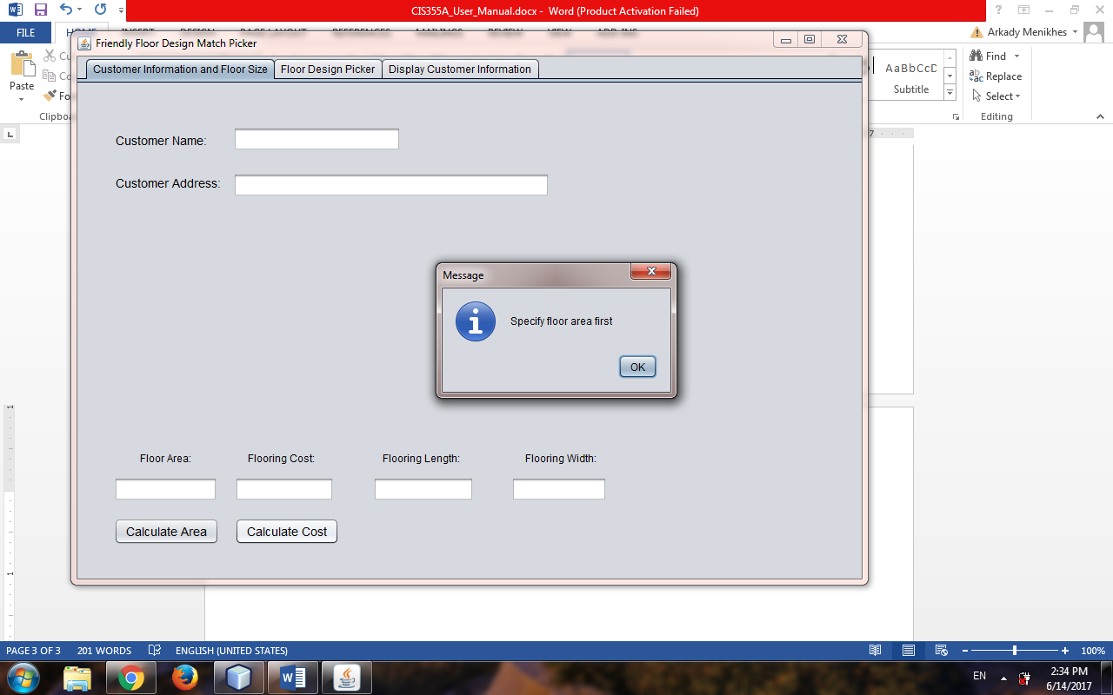

These are the features of this application which tells you what must be done before proceeding. So let’s enter our first customer into the system just to check out how our application functions. To test out let’s enter Customer Name: John Seaman, Customer Address: 3456 Foster Avenue, Brooklyn, NY 11230, Flooring Length and Width: 60/80. Now let’s see what it will display:

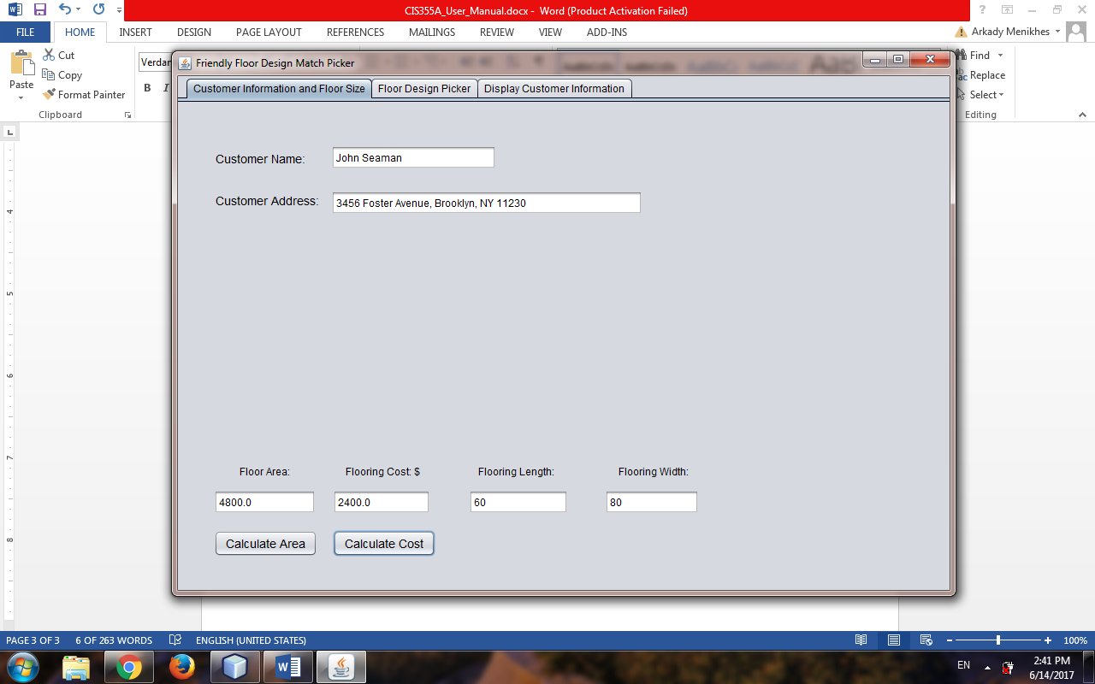

We calculated Floor Area as: 4800 and Floor Cost as: 2400. Now before we can enter this information into a system let’s switch to a second TAB that we talked about previously and pick floor type and color.

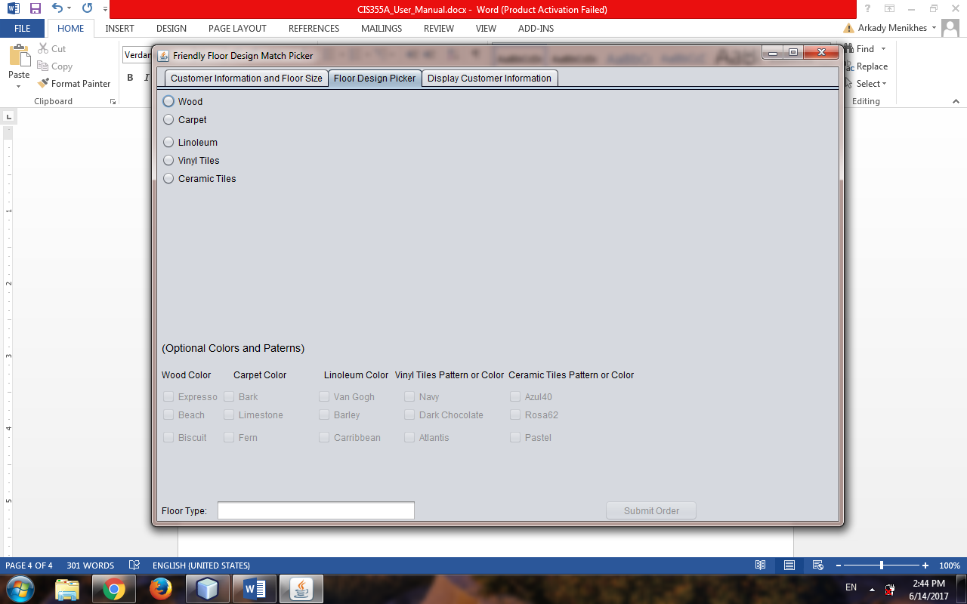

On this page before we proceed and press Submit Order button we need to choose floor type. There are five of them available with default color and then there are optional colors that a customer can choose from. So let’s pick floor type, and see what happens. Let’s choose Wood:

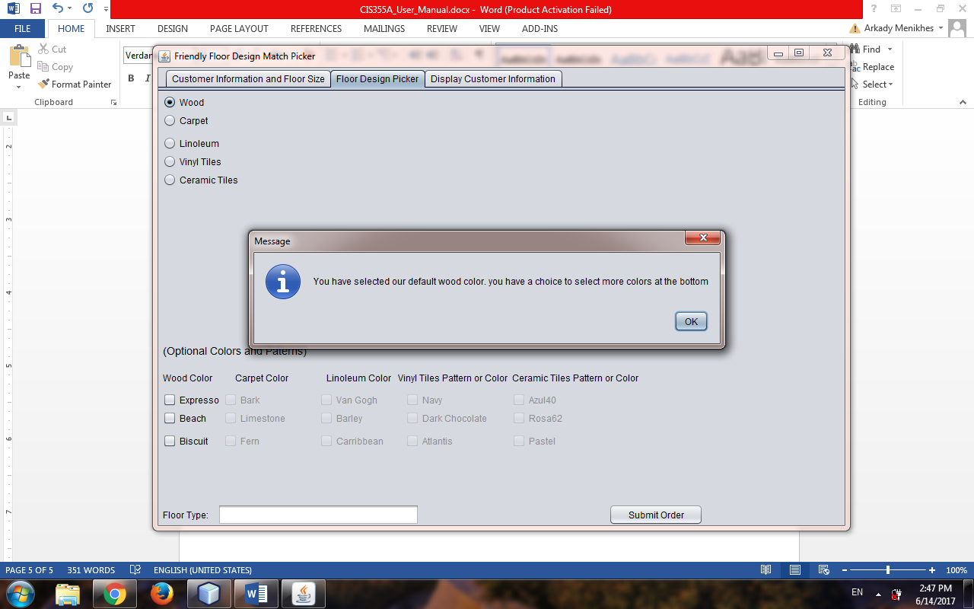

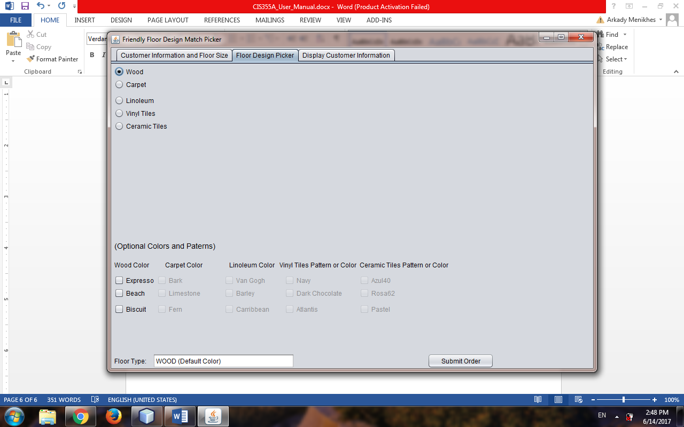

When we choose Wood we get a message that we have selected a default wood color which is chosen by the company, each company has their own set of default colors, when we pressed “OK” button message closed and on the bottom left side we get a text which says Floor Type “Wood(Default Color”) now we are ready to proceed and enter information into the system, but we can also choose a different color. So let’s choose Biscuit under (Optional Colors and Patterns), what happens “Default Color” is replaced by “Biscuit Color”:

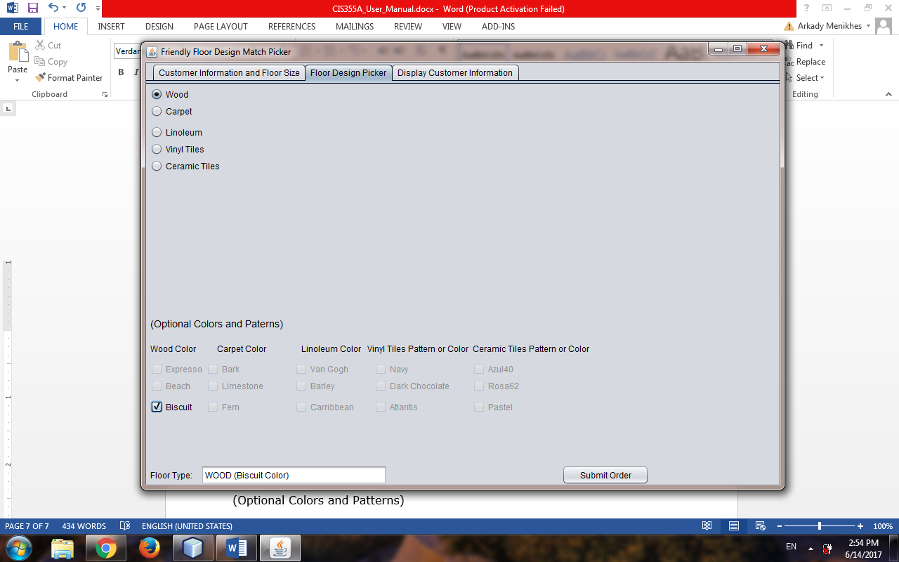

Note what else happened when we checked (Selected) Biscuit, other check boxed become disabled, it means a customer can only choose one color at the time and if he/she wants more colors a process will have to start from the beginning. New information needs to be entered into the system so before a customer can choose a different floor type or another color we have to press Submit Order button and then pick another color or go back to TAB 1 and change area which will change the cost as well. When we uncheck that button other wood colors become available for picking and color goes back to Default Color until different color is picked. Now let’s finally press Submit Order to enter order into a system.

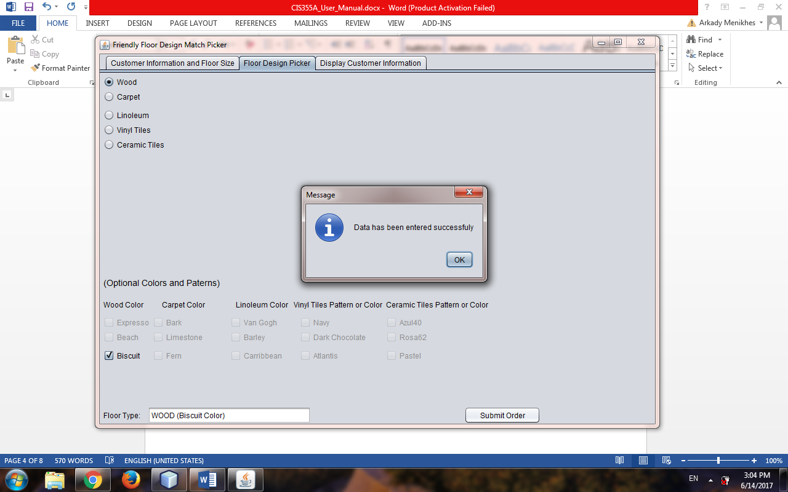

Now we get a message that Data has been entered successfully, it means that an order now is in a system. Now we can use a TAB 3 to retrieve an order, preview an order summary or print an order summary so let’s explore TAB 3. On TAB 3 as we can see we get four buttons one button “Retrieve By Name” when typed in a field to the right a name of a customer we get any orders that was processed for that customer.

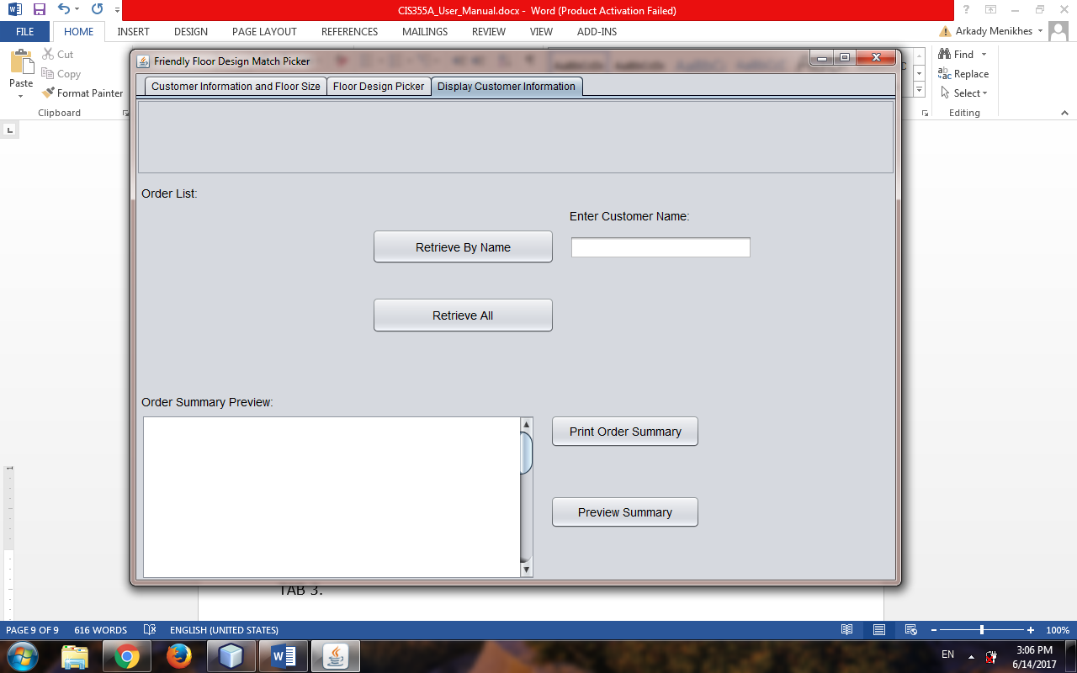

For example let’s type a name of an order that we made for John Seaman. Oh if we press a “Retrieve By Name” button prematurely we get a warning message just like that:

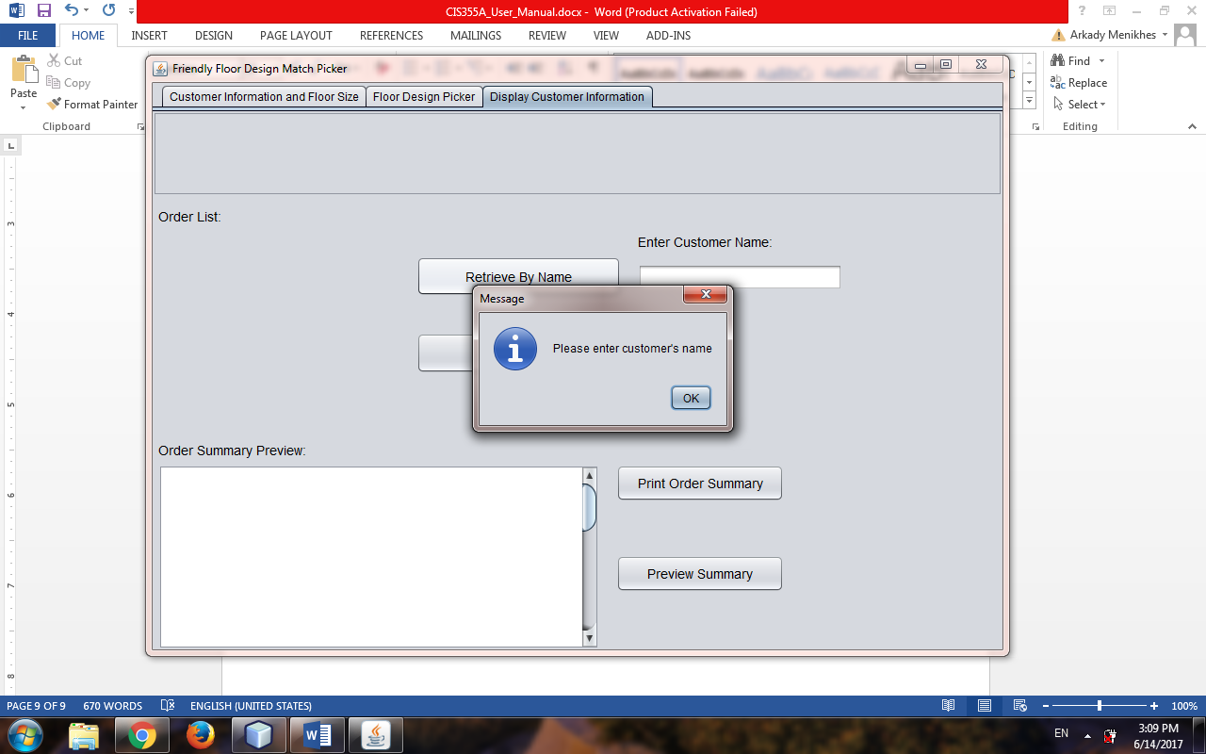

Now let’s enter that name already, so as you can see at the very top we get all of the information about John Seaman

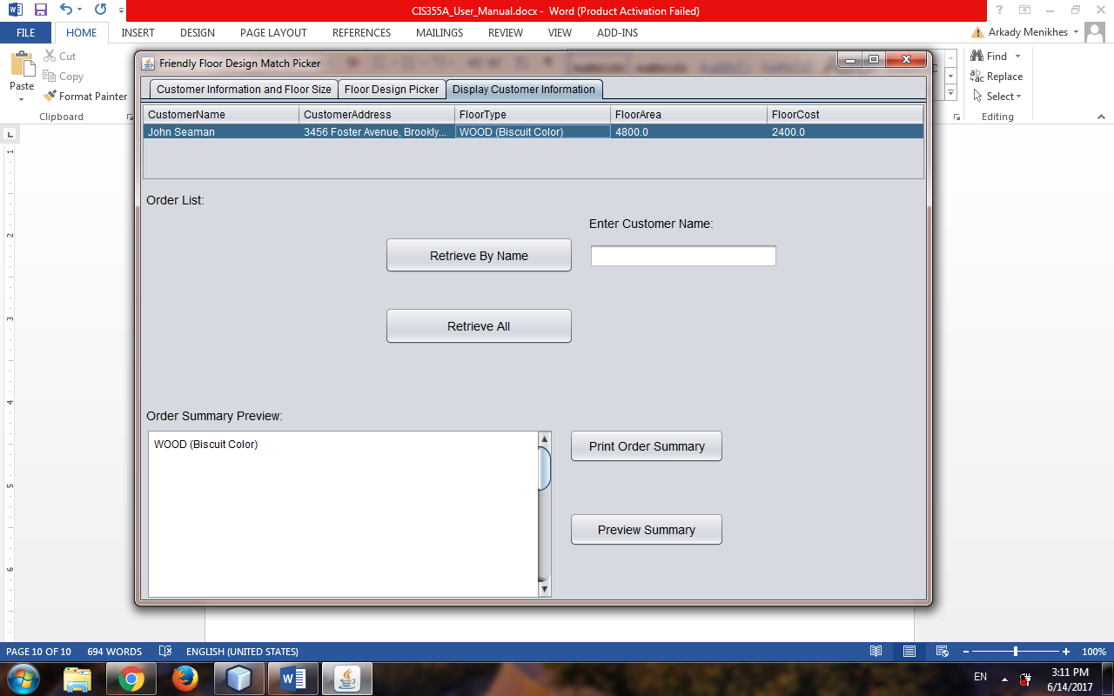

We can also retrieve all of the information from the system, it is good to do that to keep a printout of a record of all the customers that we have in a system. To retrieve all customers we press button “Retrieve All”.

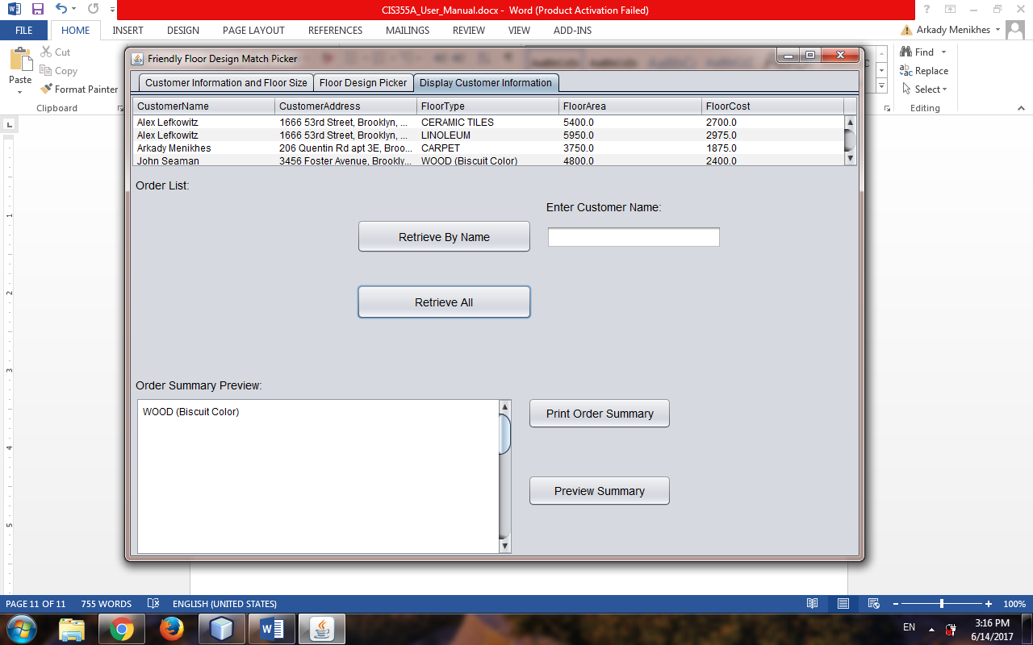

After we are done retrieving either all customers or individual customer we can either preview summary if we have saved such information into a specific file which is done by pressing button “Print Order Summary’ which saves a file and lets us to print an information contained in it.

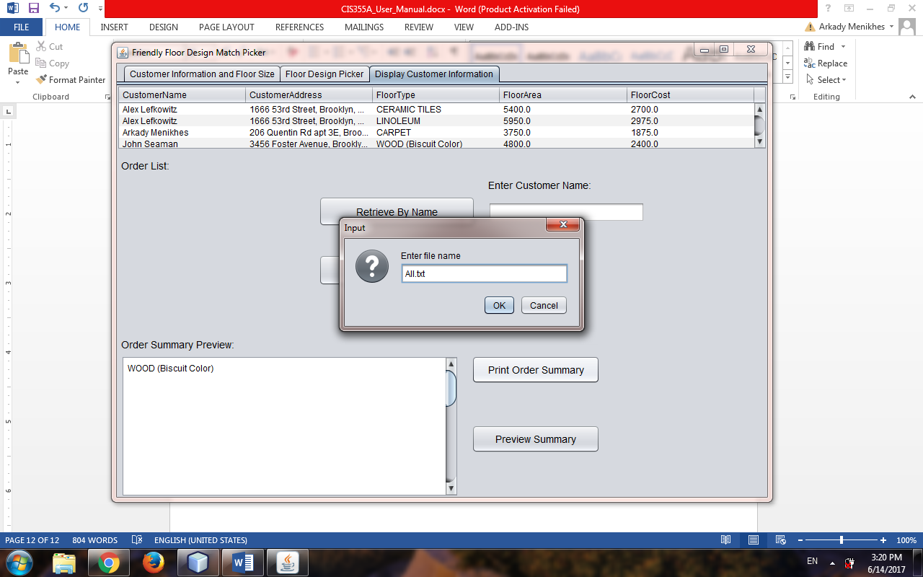

We have to specify the name of a file that we are saving and printing, that way if gives us an opportunity to save it in a file name of our choice. When we press “OK”, a file is already saved under that name and we get a prompt with all the data saved for printing.

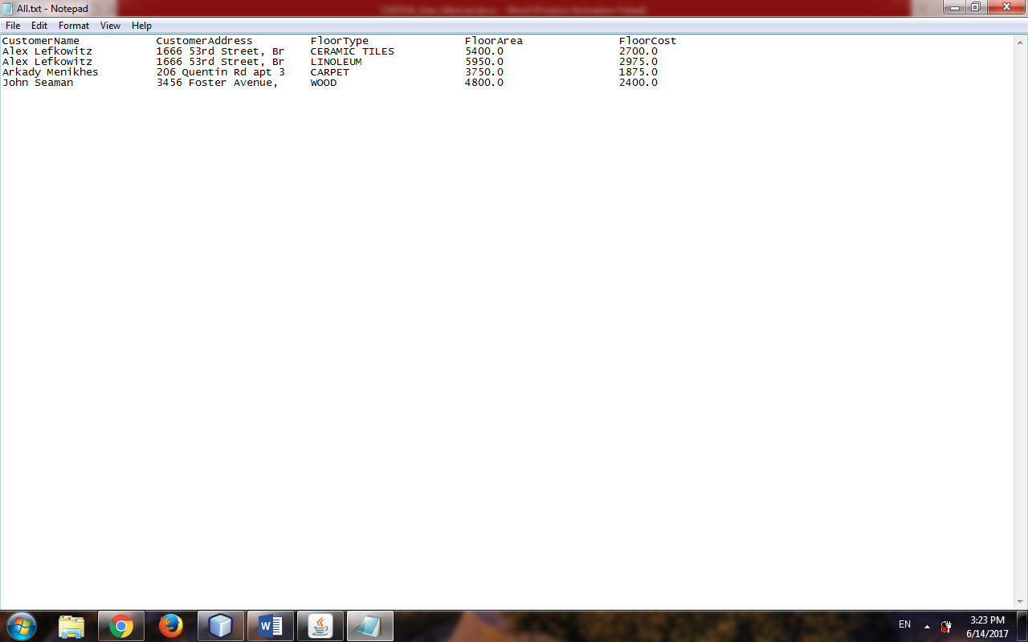

The last feature we have is to preview the same file if it is already exists on our system that is done by pressing “Preview Summary” when we get a prompt to access a file that we already created, we will see a content of that file in a window to the left of the button “Preview Summary”. Important thing is, since we are saving file in a text based editors we have to specify that a file that we are saving has \*.txt extension for example All.txt. So now let’s preview our summary.

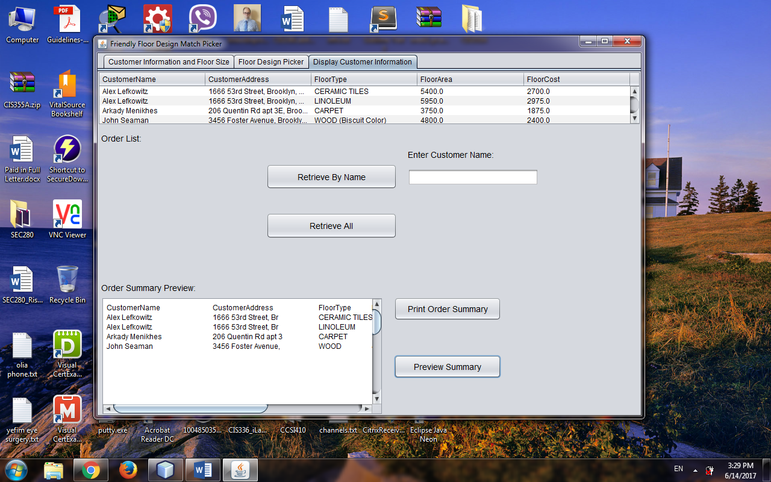

This was a presentation of a “FRIENDLY FLOOR DESIGN MATCH PICKER APPLICATION” intended to keep orders organized for any flooring company needs.

Thank you for reading.