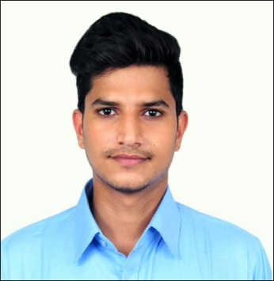 CURRICULUM VITAE

Keshav Deo Sharma

**Mobile :**9681178550

**Email** **:** deosharmakeshav@gmail.com

**Career Objective:** To become associated with a company where I can utilize my skills and gain further experience while enhancing the company’s productivity and reputation.

**Academic Qualification:**

**Graduation: Pursuing B-Tech in CSE from Future Institute of Engineering and Management:**

|  |  |  |  |  |  |  |
| --- | --- | --- | --- | --- | --- | --- |
| **SEM** | **1** | **2** | **3** | **4** | **5** | **6** |
| **SGPA** | 7.37 | 8.17 | 8.24 | 8.92 | 8.69 | 8.73 |
| **Average** | 8.35 | | | | | | |

**Secondary & Higher Secondary**

|  |  |  |  |  |  |
| --- | --- | --- | --- | --- | --- |
| **Examination** | Board | **Year of Passing** | **Marks** | | |
| **Obtained** | **Out of (Total)** | **%** |
| **10th Std** | ICSE | 2013 | 449 | 600 | 74.83 |
| **12th Std** | CBSE | 2015 | 389 | 600 | 64.83 |

**Projects & Internships:**

|  |  |  |  |
| --- | --- | --- | --- |
| **SL. NO.** | **Company** | **Project Title** | **Duration** |
|
| **1** | Ardent Computech Pvt.Ltd | Weather Forecasting using Machine Learning. | 1 month. |

**Technical Proficiency:**

* Core Java.
* C.

**Subjects of interest:**

* Data Base Management System.

**Achievements (Academic & Social)**

* Feliciated two times for Top10 CGPA holders from CSE department.
* Active participant in college fests i.e.,Phoenix.Flamz.
* Organized many events at school level like Farewell, Teacher’s Day.
* School Prefect in class 9and 10.

**Interests & Extra Curricular :**.

* Riding motorcycle.
* Teaching children.
* Meditation.

**Language Known :-**

* English.
* Hindi.
* Bengali.
* Marwari.
* Haryanvi.

**Personal Details:**

Father’s name Mr.Trilok Chand Sharma

Mothers’s name Mrs.Pintu Devi Sharma

|  |  |
| --- | --- |
| Permanent Address | S-3/25,NISCO housing quarter Bally,Howrah 711227. |
| Date of Birth | 28-03-1996 |
| Passport No | S5331604 |
| ADHAR Card | 408242108638 |
| PAN Number | JUVPS1586K |

**Declaration:**

I hereby declare that the information given above is true and correct.

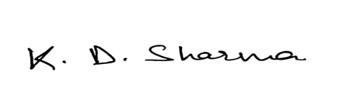

**DATE: _____________________ SIGNATURE:**