**Hive Assignment1**

**1. Download vechile sales data -> https://github.com/shashank-mishra219/Hive-Class/blob/main/sales_order_data.csv**

**2. Store raw data into hdfs location**

**Step1: Moving data to namenode: docker cp sales_order_data.csv namenode:sales_order_data.csv**

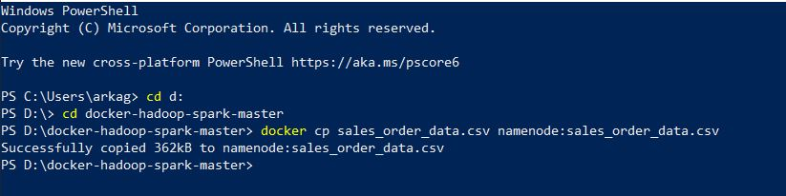

**Step2: Go to the bash shell on the namenode: docker exec -it namenode bash**

**Step3: Creating HDFS directory /data/HiveAssignment1: hdfs dfs -mkdir -p /data/HiveAssignment1**

**Step4: Copy sales_order_data.csv from namenode to HDFS: hdfs dfs -put sales_order_data.csv /data/HiveAssignment1/sales_order_data.csv**

**3. Create a internal hive table "sales_order_csv" which will store csv data sales_order_csv .. make sure to skip header row while creating table**

**Step1: Create database: create database HiveAssignment1;**

**Step2: Create table sales_order_data:**

**Use HiveAssignment1;**

**CREATE TABLE sales_order_data (**

**ORDERNUMBER int,**

**QUANTITYORDERED int,**

**PRICEEACH decimal,**

**ORDERLINENUMBER int,**

**SALES decimal,**

**STATUS string,**

**QTR_ID int,**

**MONTH_ID int,**

**YEAR_ID int,**

**PRODUCTLINE string,**

**MSRP decimal,**

**PRODUCTCODE string,**

**PHONE string,**

**CITY string,**

**STATE string,**

**POSTALCODE string,**

**COUNTRY string,**

**TERRITORY string,**

**CONTACTLASTNAME string,**

**CONTACTFIRSTNAME string,**

**DEALSIZE string**

**) ROW FORMAT SERDE 'org.apache.hadoop.hive.serde2.OpenCSVSerde'**

**WITH SERDEPROPERTIES (**

**'separatorChar' = ',',**

**'quoteChar' = '\"',**

**'skip.header.line.count'='1')**

**STORED AS TEXTFILE;**

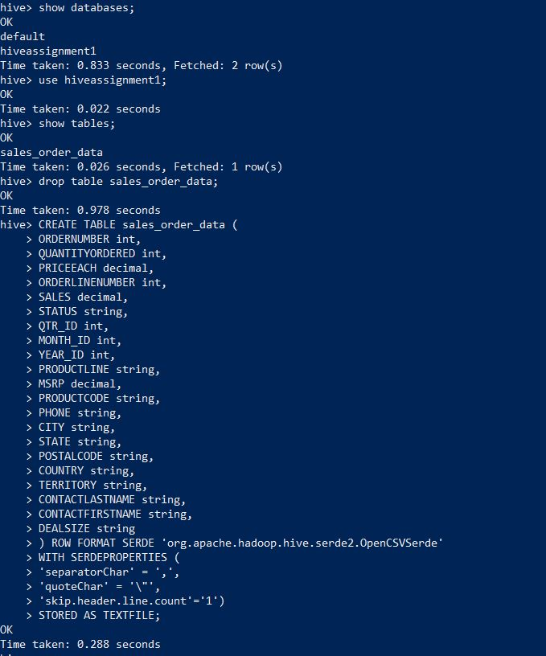

**4. Load data from hdfs path into "sales_order_csv"**

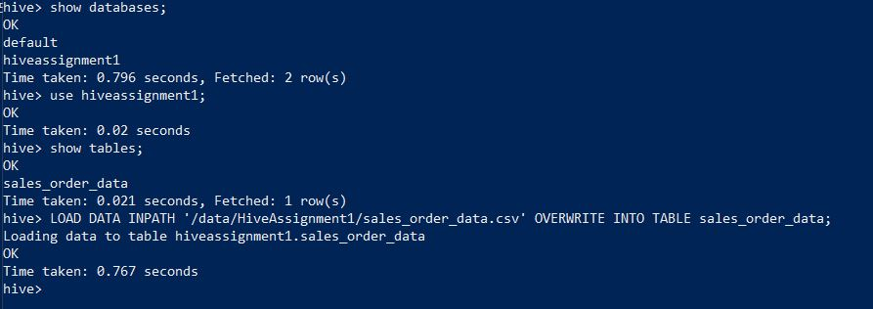

**5. Create an internal hive table which will store data in ORC format "sales_order_orc"**

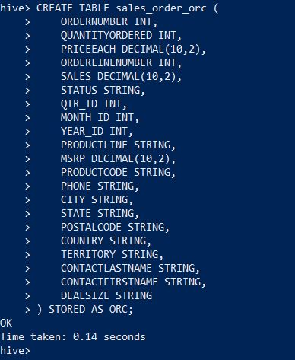

**6. Load data from "sales_order_csv" into "sales_order_orc”: LOAD DATA INPATH '/data/HiveAssignment1/sales_order_data.csv' OVERWRITE INTO TABLE sales_order_data;**

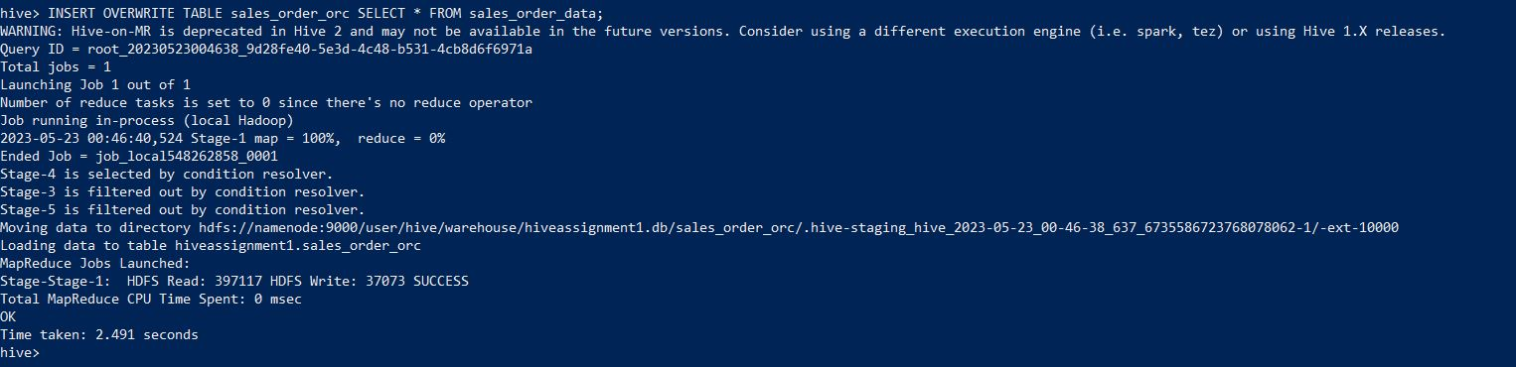

**Perform below menioned queries on "sales_order_orc" table:**

1. **Calculatye total sales per year**

**SELECT YEAR_ID, SUM(SALES) as Total_Sales**

**FROM sales_order_orc**

**GROUP BY YEAR_ID;**

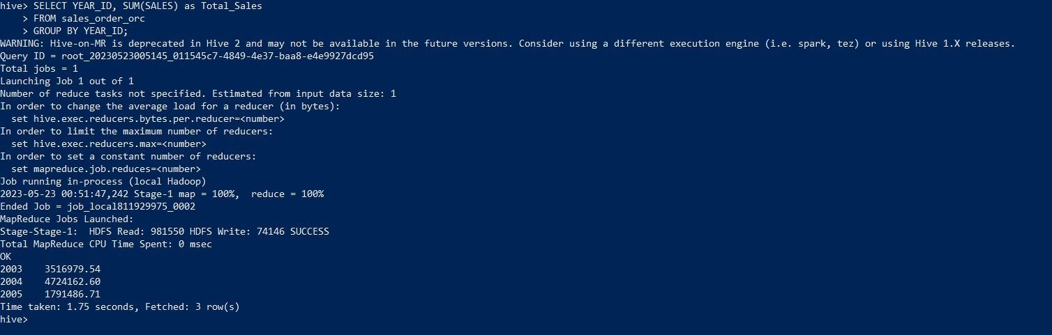

1. **Find a product for which maximum orders were placed**

**SELECT PRODUCTCODE, SUM(QUANTITYORDERED) as Total_Quantity**

**FROM sales_order_orc**

**GROUP BY PRODUCTCODE**

**ORDER BY Total_Quantity DESC**

**LIMIT 1;**

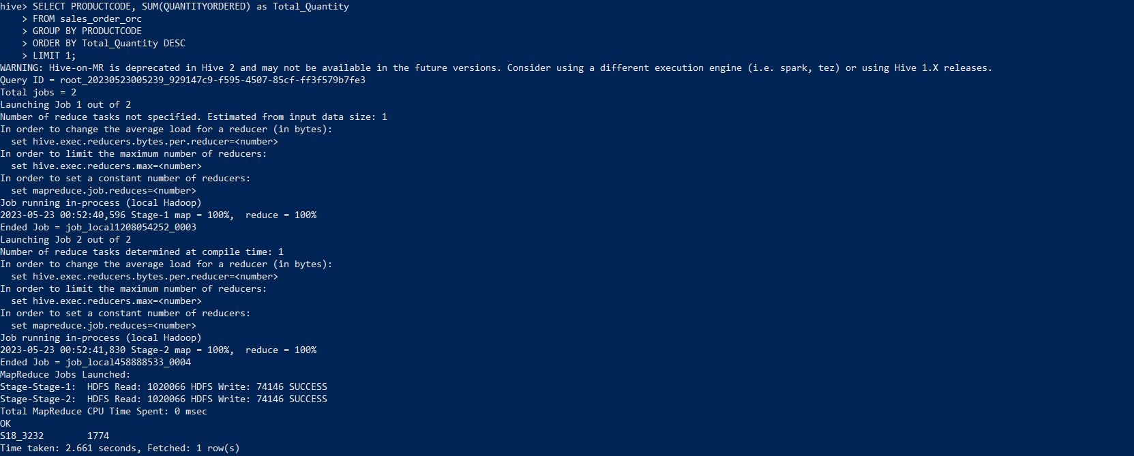

1. **Calculate the total sales for each quarter**

**SELECT QTR_ID, SUM(SALES) as Total_Sales**

**FROM sales_order_orc**

**GROUP BY QTR_ID;**

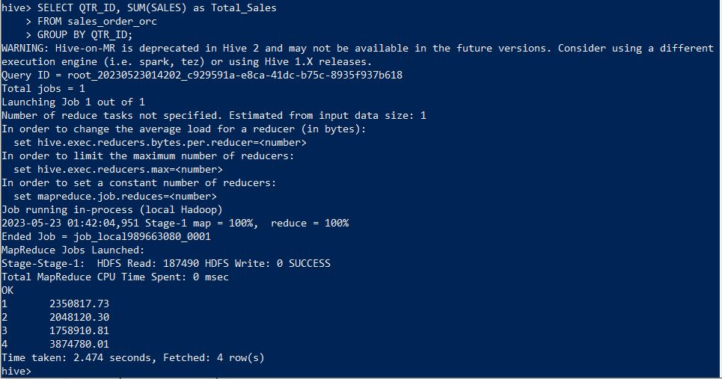

1. **In which quarter sales was minimum**

**SELECT QTR_ID, SUM(SALES) as Total_Sales**

**FROM sales_order_orc**

**GROUP BY QTR_ID**

**ORDER BY Total_Sales ASC**

**LIMIT 1;**

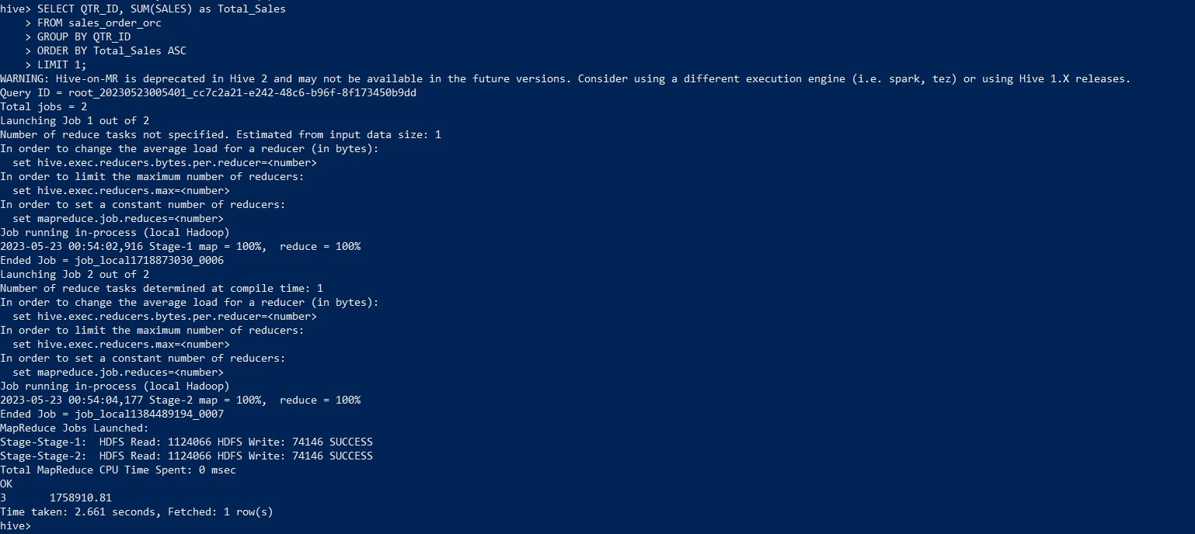

1. **In which country sales was maximum and in which country sales was minimum**

**-- Maximum sales**

**SELECT COUNTRY, SUM(SALES) as Total_Sales**

**FROM sales_order_orc**

**GROUP BY COUNTRY**

**ORDER BY Total_Sales DESC**

**LIMIT 1;**

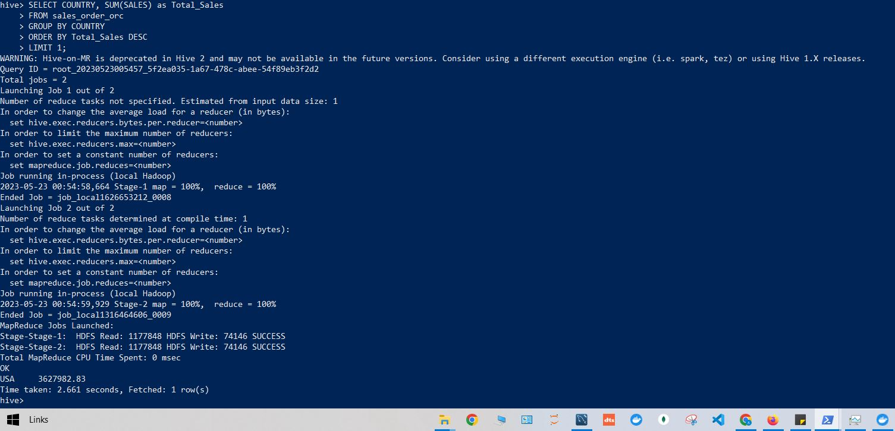

**-- Minimum sales**

**SELECT COUNTRY, SUM(SALES) as Total_Sales**

**FROM sales_order_orc**

**GROUP BY COUNTRY**

**ORDER BY Total_Sales ASC**

**LIMIT 1;**

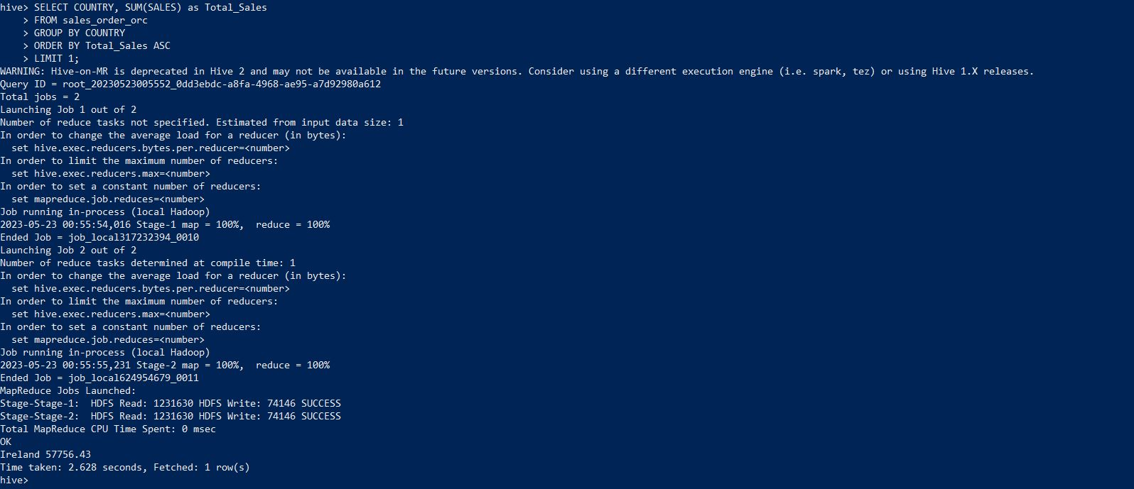

1. **Calculate quartelry sales for each city**

**SELECT CITY, QTR_ID, SUM(SALES) as Total_Sales**

**FROM sales_order_orc**

**GROUP BY CITY, QTR_ID;**

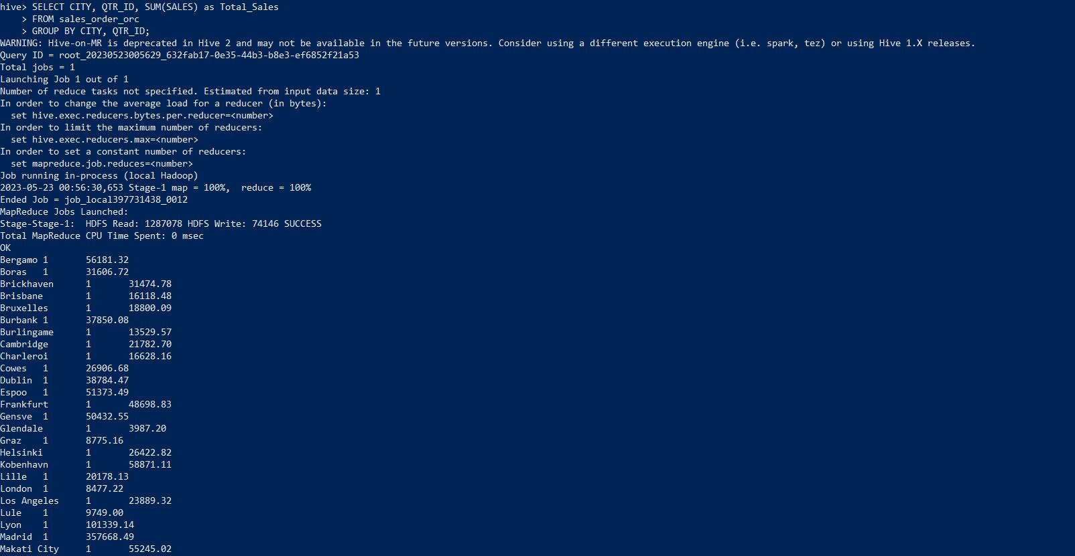

1. **Find a month for each year in which maximum number of quantities were sold**

**SELECT YEAR_ID, MONTH_ID, SUM(QUANTITYORDERED) as Total_Quantity**

**FROM sales_order_orc**

**GROUP BY YEAR_ID, MONTH_ID**

**ORDER BY Total_Quantity DESC;**

