**Kafka Assignment**

**1.) MySQL Table (Table should have some column like created_at or updated_at so that can be used for incremental read)**

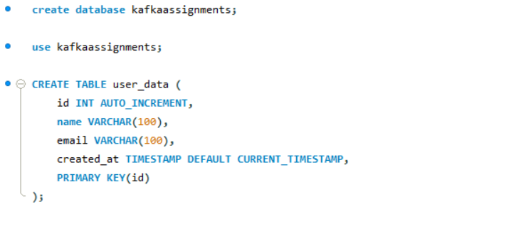

**2.) Write a python script which is running in infinite loop and inserting 4-5 dummy/dynamically prepared records**

**in MySQL Table**

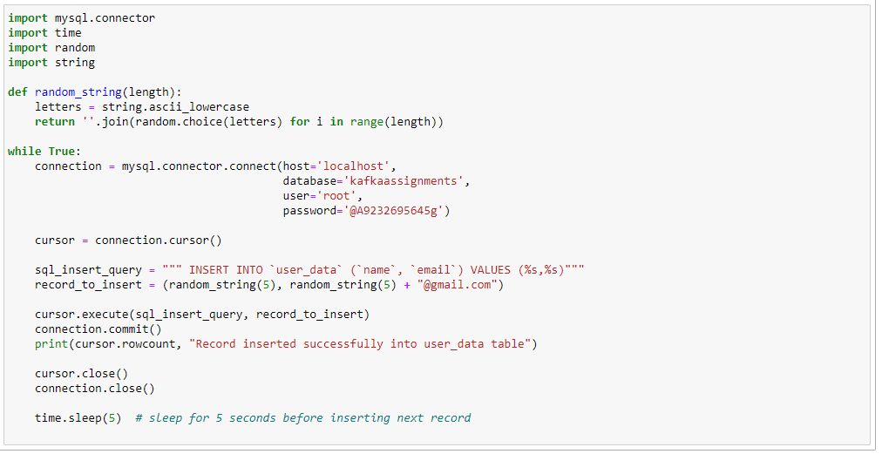

**3.) Setup Confluent Kafka**

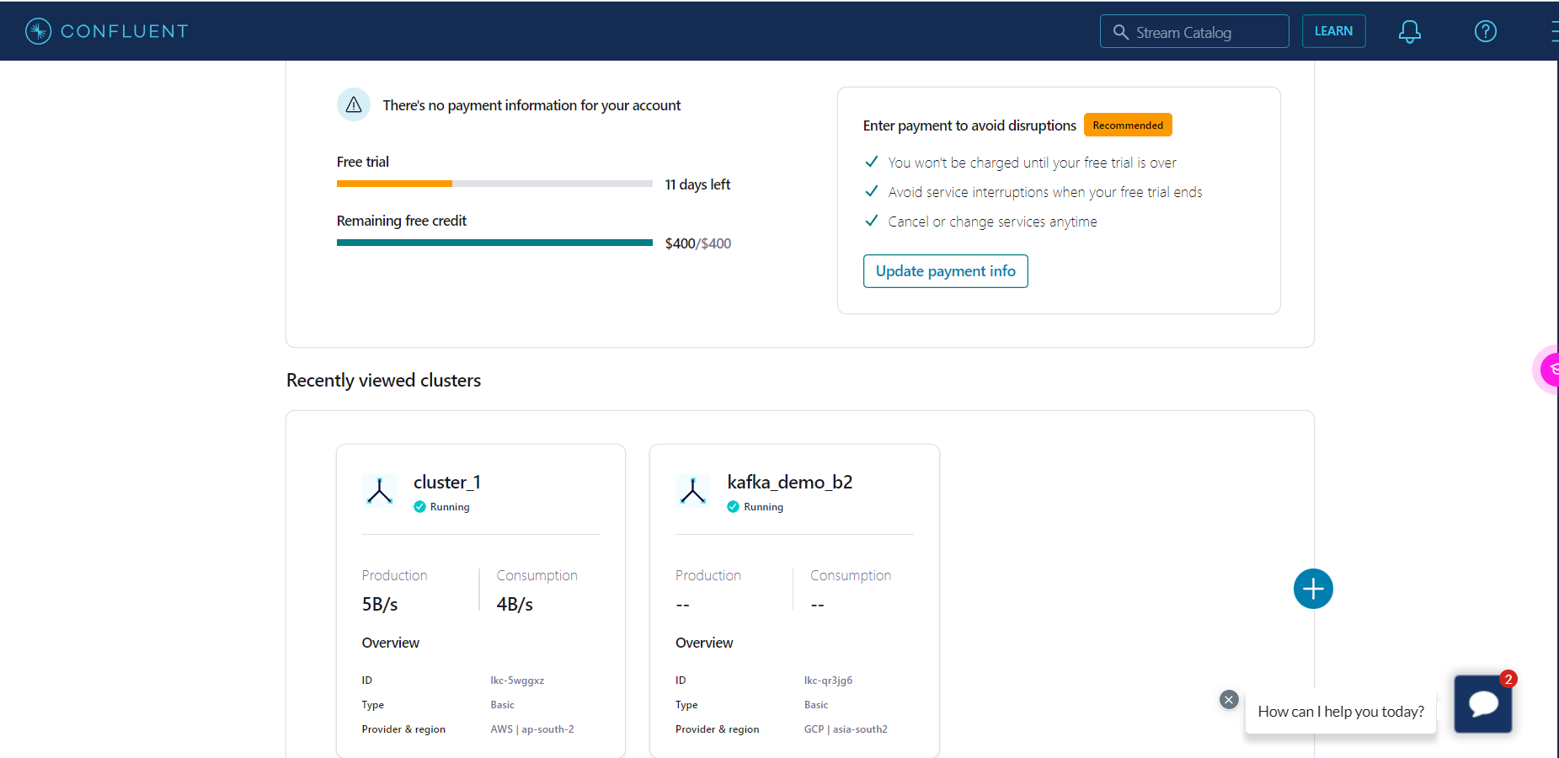

**4.) Create Topic**

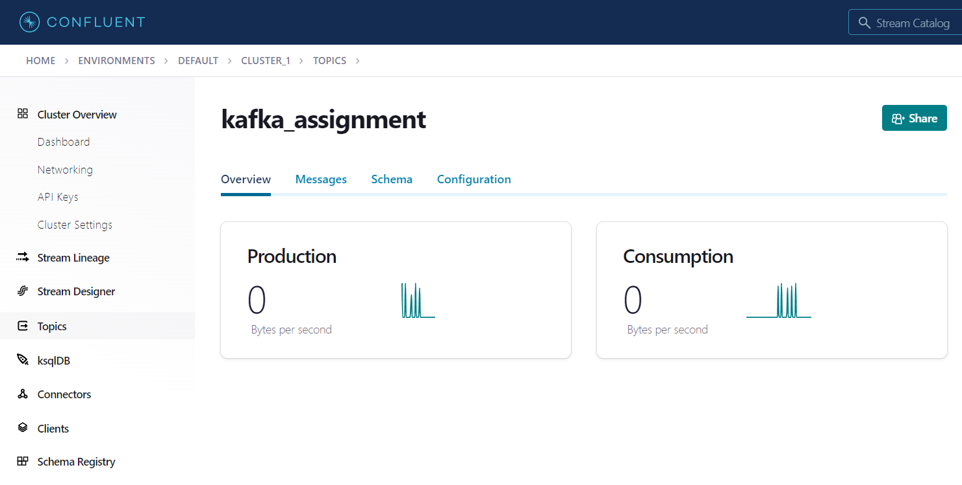

**5.) Create json schema on schema registry (depends on what kind of data you are publishing in mysql table)**

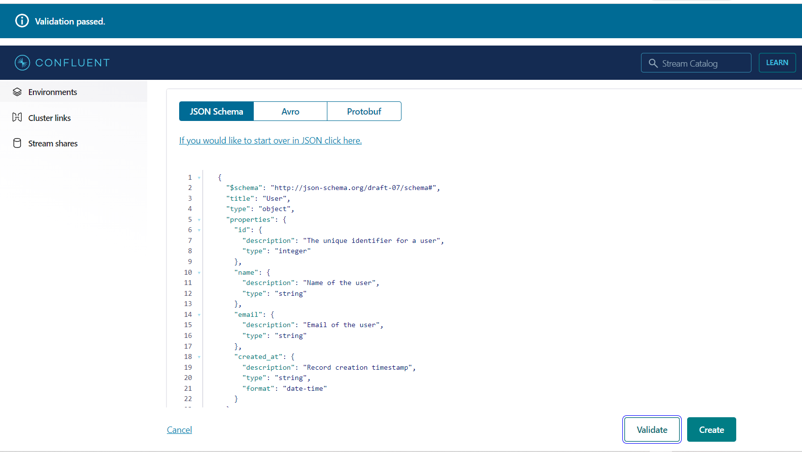

**6.) Write a producer code which will read the data from MySQL table incrementally (hint : use and maintain create_at column)**

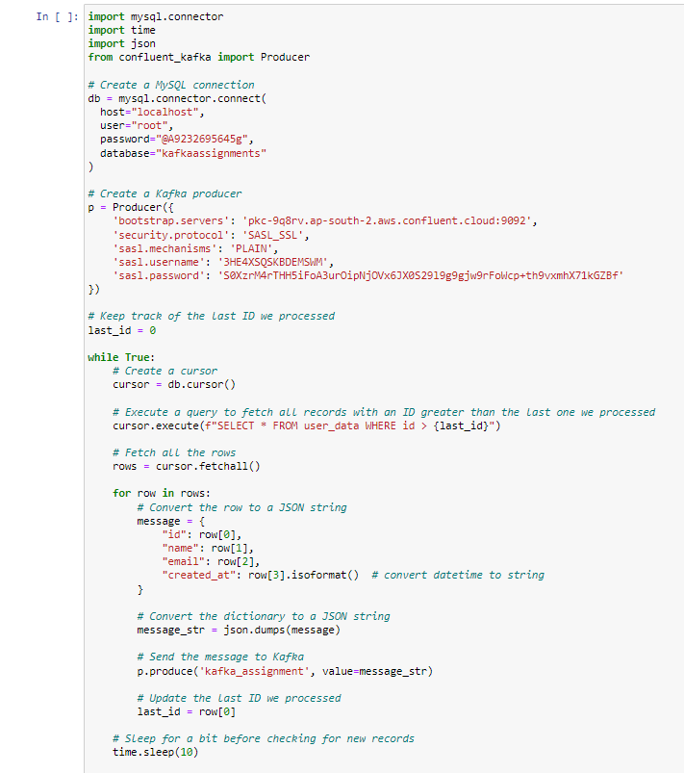

**7.) Producer will publish data in Kafka Topic**

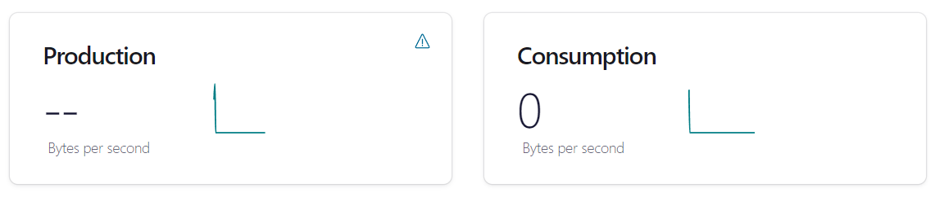

**8.) Write consumer script to consume data from Kafka topic for specifically MySQL**

**a. Consumer script**

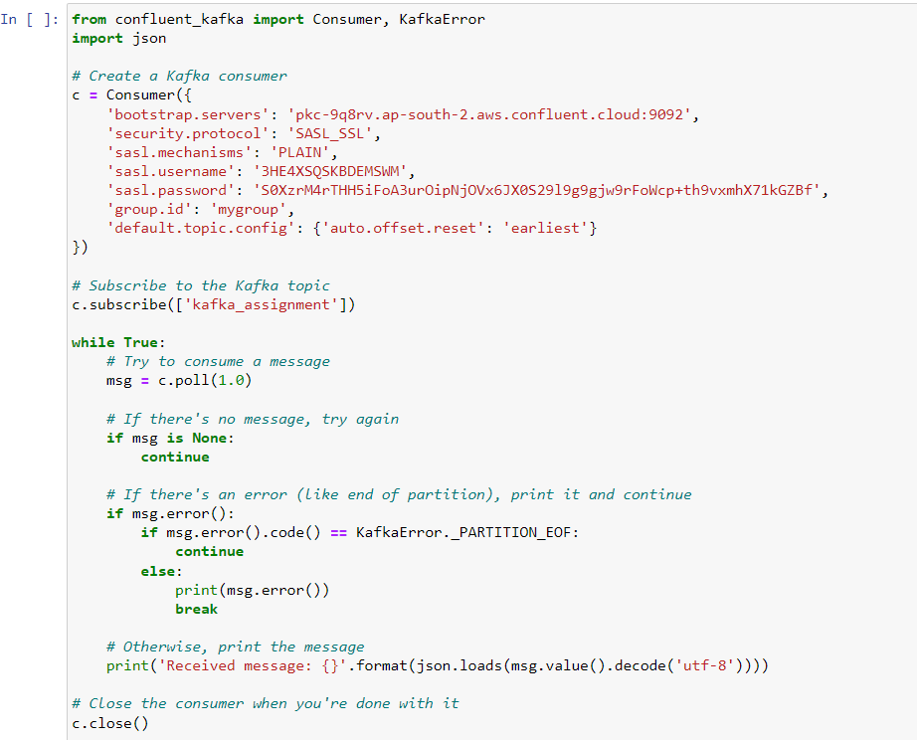

**b. Consumer Script Running**

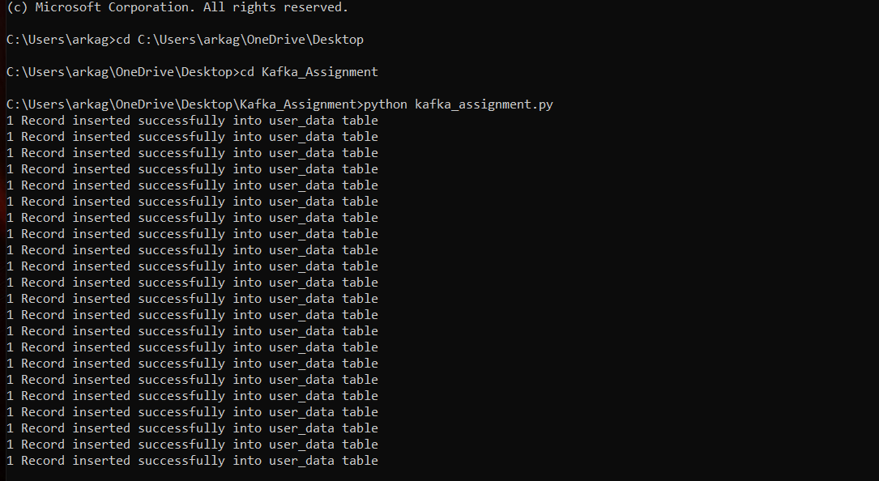

**c. Data in MySQL table after Consumption**

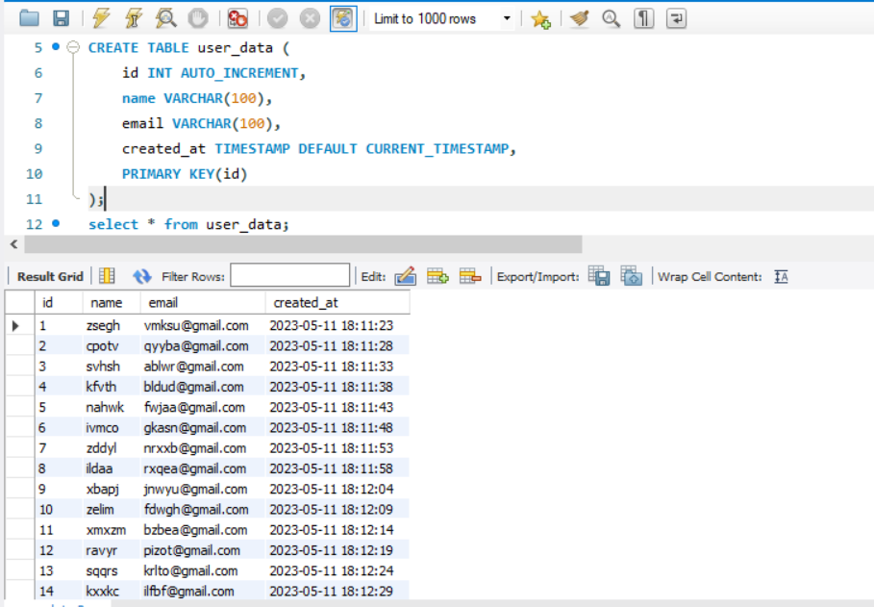

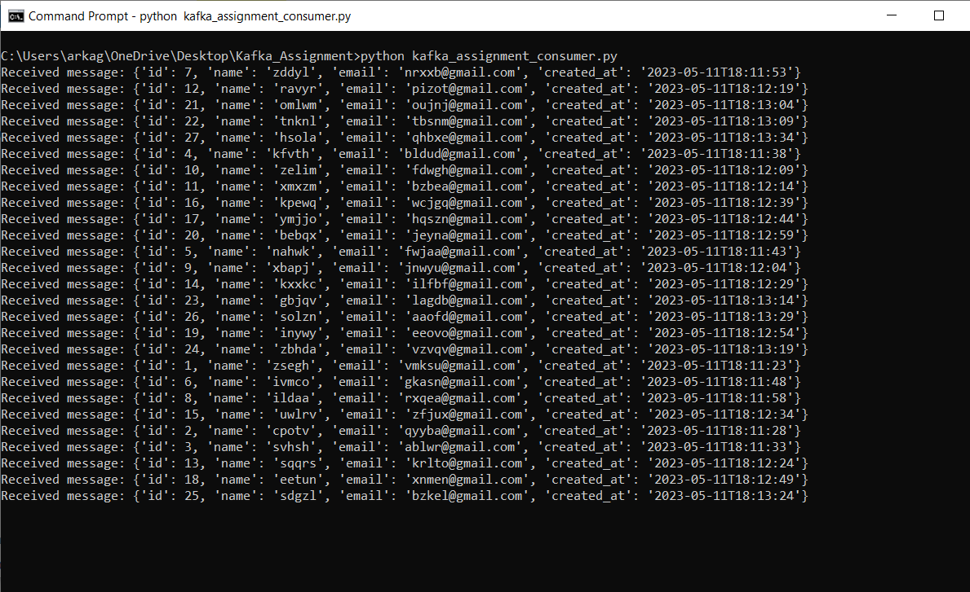

**9.) In Kafka consumer code do some changes or transformation for each record and write it in Cassandra table**

**a. Cassandra Keyspace and Table creation using Python Driver:**

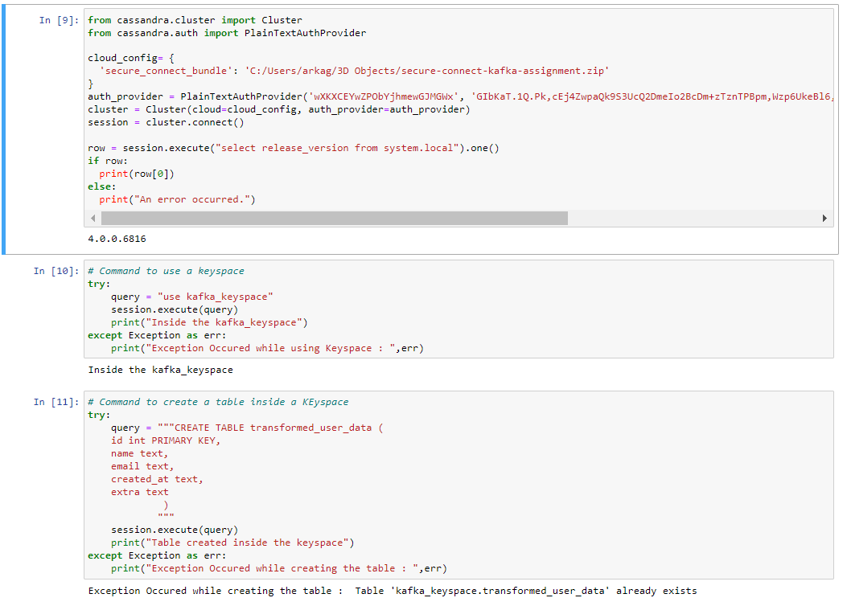

**b. Consumer script for Cassandra**

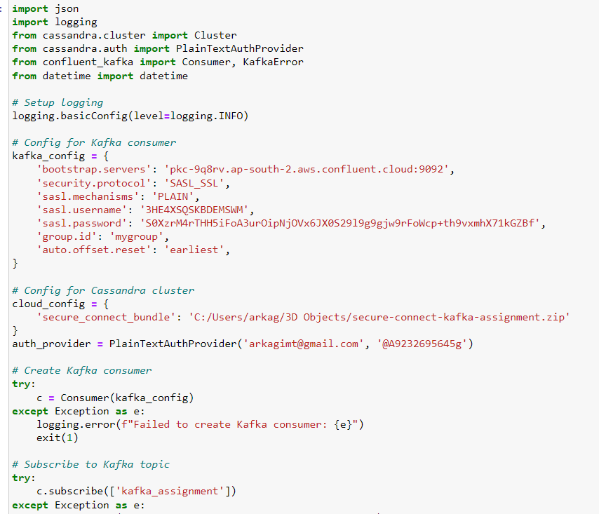

**c. Consumer script run and data insertion**

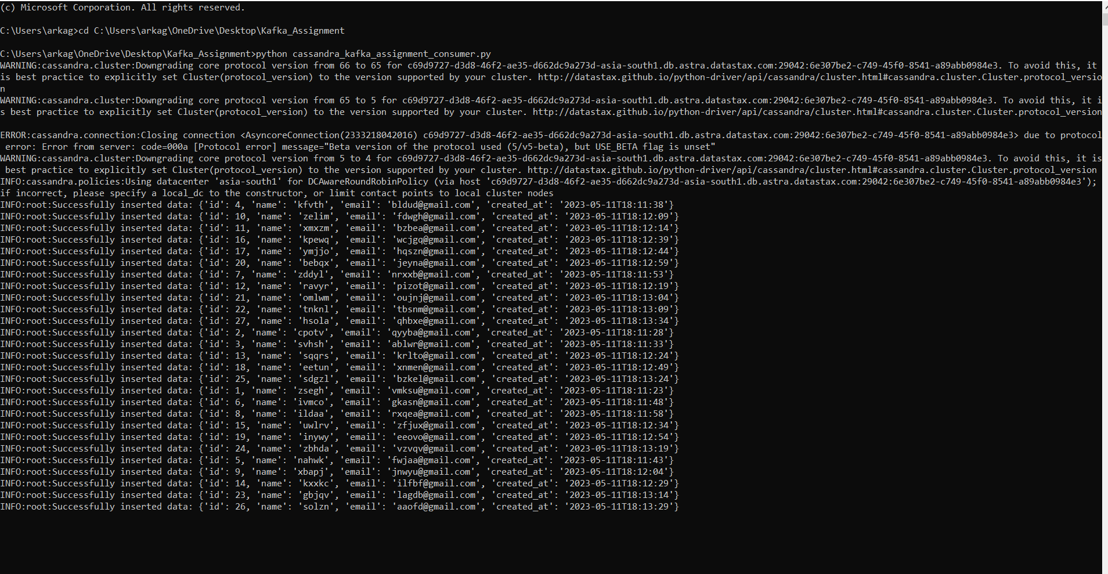

**d. Data in Cassandra table**

