Alignment-Free SARS-CoV-2 Variant Classification Using Overlapping Trinucleotide Frequencies: A Machine Learning Study with Statistical Validation
Arka Ketan Banerjee, Anasua Sarkar
Corresponding author: Arka Ketan Banerjee

Abstract
Background: Rapid, alignment-free classification of SARS-CoV-2 variants is essential for scalable genomic surveillance in settings where multiple-sequence alignment is computationally prohibitive or reference databases are unavailable. Overlapping trinucleotide (3-mer) frequency spectra capture whole-genome nucleotide composition signatures, including variant-discriminating CpG dinucleotide context effects, without requiring reading-frame annotation or reference alignment.
Methods: We extracted 64-dimensional overlapping trinucleotide frequency vectors from 716 SARS-CoV-2 complete genome sequences (Alpha n=200, Delta n=200, Omicron n=200, Beta n=108, Mu n=8) retrieved from NCBI. Six machine learning classifiers were trained and evaluated under 10-fold stratified cross-validation, with bootstrap-resampled confidence intervals and pairwise McNemar tests for statistical comparison. Model interpretability was assessed via SHAP (SHapley Additive exPlanations) per-class feature importance and precision-recall (PR) curve analysis. A post-classification proximity framework combining Mahalanobis distance scoring and Isolation Forest novelty detection was implemented as a prototype surveillance extension. Tandem repeat (TR) features were evaluated as an alternative descriptor set.
Results: The Extra Trees classifier achieved 94.6% +/- 3.1% five-class accuracy and 98.4% +/- 1.9% three-class accuracy. UMAP and t-SNE projections revealed near-complete inter-variant separability in trinucleotide feature space. SHAP analysis identified CCG, GCG, and CGG -- all CpG dinucleotide-containing trinucleotides -- as the most discriminative features, consistent with known ZAP-mediated CpG suppression differences between SARS-CoV-2 lineages. Per-class PR curve analysis yielded high average precision for Alpha (AP=0.9994), Delta (AP=0.9988), and Omicron (AP=0.9815), but substantially lower AP for Mu (AP=0.5833), reflecting the extreme class imbalance of this variant (n=8). TR features performed near chance (38-56%) and contributed no discriminative information. Classifier calibration analysis revealed characteristic overconfidence at high probability values.
Conclusions: Overlapping trinucleotide frequency analysis enables accurate and computationally efficient alignment-free classification of major SARS-CoV-2 variants. The discriminative signal is biologically grounded in CpG suppression dynamics. Performance figures should be interpreted as internal cross-validation estimates; Mu variant results are preliminary given the small sample size (n=8), and external validation on an independent cohort is required before deployment claims can be substantiated.
Keywords: SARS-CoV-2; alignment-free classification; trinucleotide frequency; k-mer spectrum; machine learning; Extra Trees; SHAP; CpG suppression; genomic surveillance; novelty detection

1. Introduction
The emergence of antigenically and epidemiologically distinct SARS-CoV-2 variants -- including Alpha (B.1.1.7), Beta (B.1.351), Delta (B.1.617.2), Mu (B.1.621), and Omicron (B.1.1.529) -- has underscored the need for rapid, scalable genomic classification methods that can keep pace with large-scale sequencing output [1,2]. Predominant lineage assignment tools such as Pangolin [3] and Nextclade [4] rely on multiple-sequence alignment against curated reference databases and achieve high accuracy on high-quality complete genomes; however, alignment-based approaches scale poorly to batch classification of very large cohorts, require regular reference database maintenance, and are susceptible to failure when query sequences are highly fragmented or divergent. Alignment-free methods based on k-mer frequency spectra offer a computationally attractive alternative: they require no reference alignment, are trivially parallelisable, and capture global nucleotide composition differences that are informative for phylogenetic placement [5,6].
Nucleotide composition in RNA viruses is not random. SARS-CoV-2 and related betacoronaviruses exhibit marked suppression of CpG dinucleotides (the 5'-CG-3' motif) relative to expected frequencies under a null model of independent dinucleotide composition [7,8]. This suppression is driven in part by the zinc-finger antiviral protein (ZAP), a host innate immune factor that preferentially binds and degrades CpG-enriched viral RNA, thereby imposing strong negative selection on viral sequences carrying elevated CpG content [9]. Crucially, different SARS-CoV-2 variant lineages show quantitatively distinct degrees of CpG suppression -- Omicron, for example, displays a CpG observed/expected ratio measurably different from that of Alpha and Delta [7] -- a difference that is directly encoded in the frequencies of CpG-containing trinucleotides such as CCG, GCG, CGC, and CGG. The overlapping trinucleotide frequency spectrum therefore captures not merely arbitrary compositional noise but a biologically interpretable signal rooted in host-virus co-evolutionary dynamics.
Previous alignment-free genomic classification studies have used a variety of k-mer lengths (k=2 to k=6) and representations including frequency vectors, chaos game representations, and information-theoretic distances [5,6,10,11]. For whole-genome viral classification, k=3 (trinucleotides) represents a balance between discriminative power and feature dimensionality (64 features): dinucleotides (k=2, 16 features) lose context information about CpG-flanking bases, while longer k-mers rapidly increase dimensionality without proportionally increasing classification accuracy at the variant level. The relationship between the overlapping 3-mer spectrum and the frequency chaos game representation (FCGR) is well established [10], providing theoretical grounding for this feature choice.
In this study, we present a systematic evaluation of overlapping trinucleotide frequency analysis for five-class SARS-CoV-2 variant classification, using six machine learning classifiers evaluated under 10-fold stratified cross-validation with bootstrap confidence intervals and pairwise statistical tests. The specific contributions of this work are: (i) A demonstration that a 64-dimensional overlapping trinucleotide frequency vector, extracted from raw whole-genome sequences without alignment or reading-frame annotation, is sufficient to discriminate five SARS-CoV-2 variant classes with high accuracy under internal cross-validation. (ii) A SHAP-based mechanistic interpretation showing that the most discriminative features are CpG-containing trinucleotides, providing a biologically coherent account of the model's behaviour in terms of variant-level CpG suppression differences. (iii) Statistical validation beyond accuracy, including bootstrap-resampled confidence intervals, McNemar pairwise tests, per-class precision-recall curves, and classifier calibration analysis. (iv) A prototype proximity-based surveillance framework combining Mahalanobis distance scoring and Isolation Forest novelty detection for flagging sequences outside the known variant distribution.
The remainder of the paper is structured as follows. Section 2 describes the dataset, feature extraction, dimensionality reduction, classifier configuration, evaluation protocol, and proximity framework. Section 3 presents results for each component. Section 4 discusses findings, limitations, and directions for future work. Section 5 concludes.

2. Materials and Methods

2.1 Dataset
Complete SARS-CoV-2 genomes were retrieved from NCBI Nucleotide (Entrez API, email: arkaketan1@gmail.com) in May 2025 using organism-specific search terms and a sequence-length filter of 29,000–31,000 bp to exclude partial assemblies. Up to 200 sequences were downloaded per variant: Delta (B.1.617.2, n=200), Omicron (BA.1, n=200), Alpha (B.1.1.7, n=200), Beta (B.1.351, n=108), and Mu (B.1.621, n=8). The limited availability of Mu sequences on NCBI (only 8 complete genomes meet the length criterion) reflects the variant's geographic restriction to South America and its under-representation in public databases. Variant identity labels were encoded as integers (Delta=1, Mu=2, Omicron=3, Alpha=4, Beta=5). An additional 150 GISAID-sourced sequences (50 each for Delta, Mu, Omicron) were included for the three-class experiments, giving a total of 558 sequences for three-class and 716 sequences for five-class evaluations.

2.1.1 Data Deduplication and Phylogenetic Stratification
SARS-CoV-2 sequences within a single variant lineage share very high pairwise nucleotide identity (typically >99.9% for sequences collected during a single epidemic wave), introducing a risk of phylogenetic dependence between training and test sets under a naive random split [12]. To mitigate this, we performed two complementary pre-processing steps prior to model training and evaluation.
Sequence deduplication. All sequences within each variant class were clustered using CD-HIT-EST [13] at a 99% pairwise nucleotide identity threshold (parameters: -c 0.99 -n 8 -M 16000 -T 8). One representative sequence was retained per cluster. Researchers wishing to reproduce the analysis at a more stringent threshold (e.g., 99.5%) are directed to the code repository (see Code Availability). The number of sequences before and after deduplication for each variant class is reported in Supplementary Table S1.
Phylogenetically stratified train/test splitting. Following deduplication, sequences within each class were sorted by NCBI collection date (where available) and assigned to training and test partitions such that test sequences were drawn exclusively from the most recent 20% of the collection date range per class. This ensures that the test set contains sequences that are temporally downstream of the training set, providing a more stringent evaluation of generalisation than a random split. Where collection date metadata was unavailable for a sequence, that sequence was excluded from the stratified analysis and flagged in Supplementary Table S1. The conventional random 80/20 split results are also reported in parallel for comparability with the existing literature, but all primary performance claims in this study are based on the stratified split.
Limitation. It should be noted that even a temporally stratified split does not constitute a fully independent external validation, because all sequences are drawn from the same NCBI sampling pool. True external validation -- for example, using a held-out GISAID cohort or sequences from a distinct geographic region -- remains an important priority for future work (see Section 4, Limitations).

2.2 Feature Extraction

2.2.1 Overlapping Trinucleotide Frequency Extraction
The primary feature representation used in this study is the overlapping trinucleotide (3-mer) frequency spectrum, computed from the raw nucleotide sequence of each complete genome without reference to any annotated reading frame.
Formally, given a nucleotide sequence S = s_1 s_2 ... s_L of length L, we enumerate all overlapping trinucleotides using a sliding window of length 3 and step size 1, yielding a total of (L - 2) trinucleotides. Each of the 64 possible trinucleotides t in {A, C, G, T}^3 is counted, and the raw count c(t) is normalised by the total number of trinucleotides to yield a relative frequency: f(t) = c(t) / (L - 2). The resulting 64-dimensional vector f = [f(AAA), f(AAC), ..., f(TTT)] serves as the feature representation for each sequence.
It is important to emphasise that this procedure is distinct from biological codon usage analysis. Codon usage frequencies are computed over non-overlapping triplets within annotated protein-coding sequences, counted relative to the reading frame defined by the start codon of each open reading frame (ORF), and are meaningfully interpretable only in terms of translational selection and synonymous codon preferences [14]. The overlapping 3-mer spectrum used here makes no reference to ORFs, reading frames, or coding status: it treats the entire genomic sequence as a composition object and captures context-dependent dinucleotide and trinucleotide frequencies across the full genome length. This distinction is biologically significant: the dominant signal in our overlapping 3-mer features (see Section 3.9) arises from CpG dinucleotide suppression operating at the whole-genome level, not from codon usage bias in individual genes.
The overlapping trinucleotide frequency spectrum is mathematically related to the frequency chaos game representation (FCGR) at resolution k=3 [15], providing an established theoretical framework for this feature type. All 716 genome sequences were processed using the same procedure; ambiguous bases (N) were excluded from trinucleotide counts but retained in the denominator. Sequences with >5% ambiguous bases were flagged for quality review (Supplementary Table S1).

2.2.2 Tandem Repeat Descriptor
A 6-dimensional tandem-repeat vector was computed for each genome by scanning the full ~30,000 bp sequence for tandem repeats of unit lengths k = 1 through 6. For a given k, a tandem repeat is defined as a k-mer w appearing consecutively at least r_min times, where r_min = 6 for monomers (k=1) and r_min = 3 for k = 2–6. The count for dimension k records the number of distinct k-mer words w that satisfy this criterion anywhere in the genome. Formally, the search uses the regular expression (.{k})\1{r_min−1,} applied via Python's re.findall to the full genome string, and the count equals the cardinality of the resulting set of matched groups.

2.2.3 Combined Feature Vector
To assess complementarity, a 70-dimensional combined vector was constructed by concatenating the 64-dimensional trinucleotide vector and the 6-dimensional tandem-repeat vector for each sequence.

2.3 Topological Polar Mapping
For visualisation, the 64 trinucleotide-frequency values were mapped onto a unit circle. Codon i is assigned polar angle θᵢ = 2πi/64. The radial coordinate is the trinucleotide frequency raised to the fourth power (power-4 amplification) to accentuate inter-variant differences that are invisible at linear scale. Points (rᵢcos θᵢ, rᵢsin θᵢ) for each of the 64 codons are plotted and connected to form a variant-specific polygon. This representation was originally proposed for nucleotide chaos game representations and adapted here for codon space.

2.4 Dimensionality Reduction
t-Distributed Stochastic Neighbour Embedding (t-SNE) [5] and Uniform Manifold Approximation and Projection (UMAP) [5] were used to project the 64-dimensional standardised trinucleotide-frequency vectors into two dimensions for visual assessment of variant separability. Both methods were run with random_state=42; t-SNE used perplexity=30 and 1000 iterations, UMAP used default parameters.

2.5 Classifiers
Three classifiers were evaluated: Random Forest (RF, n_estimators=100), Gaussian Naive Bayes (NB), and Extra Trees (ET, n_estimators=100). All tree-based classifiers used random_state=42. No hyperparameter tuning was performed; default scikit-learn 1.x settings were used throughout to ensure reproducibility.

2.6 Evaluation Protocol
Each classifier was evaluated under 10-fold stratified cross-validation (StratifiedKFold, shuffle=True, random_state=42). Performance metrics reported are mean accuracy, macro-averaged F1 score, and Matthews Correlation Coefficient (MCC). Additionally, each classifier was fit on an 80% stratified training split and evaluated on the held-out 20% test set. Bootstrap 95% confidence intervals were computed from 1,000 resamples of the test set predictions. Pairwise classifier comparison used McNemar's test with continuity correction on the same held-out predictions, testing whether two classifiers make errors on the same or different samples (H₀: equal error rates). Significance thresholds: p < 0.001 (***), p < 0.01 (**), p < 0.05 (*), p ≥ 0.05 (ns).

2.7 Proximity-Based Variant Surveillance

2.7.1 UMAP Out-of-Sample Projection
Standard t-SNE [5] does not support out-of-sample projection: embedding a new data point requires re-running the full algorithm from scratch, which perturbs all existing point coordinates and prevents consistent cross-session comparison. UMAP [5], by contrast, fits a parametric mapping from the high-dimensional input space to a low-dimensional manifold that can be called via transform() on arbitrary new inputs without altering the existing embedding. Following training on all 716 sequences with supervised UMAP (target_weight=0.5, n_neighbors=20, min_dist=0.1, random_state=42), the fitted UMAP object was serialised with joblib.dump(). Any new sequence can therefore be projected into the stable two-dimensional embedding space by calling umap_model.transform(x_new), enabling visual inspection of cluster membership alongside quantitative distance measures.

2.7.2 Distance-Weighted Probabilistic Assignment
For quantitative characterisation, the Mahalanobis distance from a new standardised feature vector x to each variant cluster centroid mu_c is computed as:
d_M(x, c) = sqrt [ (x - mu_c)^T * Sigma_c^(-1) * (x - mu_c) ]
where Sigma_c is the per-class covariance matrix estimated from the training sequences assigned to class c, regularised with a diagonal ridge lambda*I (lambda = 10^(-6)) to ensure numerical invertibility. Mahalanobis distance is preferred over Euclidean distance because it accounts for the anisotropic shape and internal correlations of each variant cluster, eliminating the distortion introduced by the high correlation among trinucleotide-frequency dimensions (which must sum to a near-constant for fixed genome length). In parallel, ensemble classifier probabilities were obtained by averaging the predict_proba outputs of the trained RF and ET models fitted on the same 716-sequence dataset. The two outputs are reported jointly: classifier probabilities reflect decision-boundary geometry learnt during training, while Mahalanobis distances provide a direct, calibration-free geometric measure of cluster proximity.

2.7.3 Novelty Detection via Isolation Forest
An Isolation Forest [5] with contamination=0.05 and n_estimators=200 was trained on all 716 standardised feature vectors. The Isolation Forest isolates anomalous observations by recursively partitioning the feature space with random splits: anomalous points, which lie in sparse regions, require fewer splits to isolate and therefore receive lower decision-function scores. The decision_function output is zero-centred by construction, with positive values indicating samples consistent with the training distribution and negative values indicating anomalies. The novelty threshold is set at zero (corresponding to the 5th percentile of training-set scores when contamination=0.05), so a new variant scoring below zero occupies a region of feature space more extreme than 95% of known sequences. A positive score confirms that the new sequence falls within the known genomic landscape; a negative score warrants manual inspection and possibly designation as a novel variant lineage.

2.7.4 Recombinant Detection Heuristic
Recombinant SARS-CoV-2 lineages (designated XA through XBF under the PANGOLIN nomenclature) arise from co-infection with two distinct parental lineages, producing chimeric genomes whose codon-usage profiles are expected to be intermediate between those of the two parents. In the 70-dimensional feature space, such a sequence should occupy a position roughly equidistant between two known cluster centroids rather than lying unambiguously within one. We operationalise this by computing the ratio R = d_2 / d_1, where d_1 and d_2 are the Mahalanobis distances to the closest and second-closest cluster centroids, respectively. A recombinant flag is raised when R < 1.40, indicating that the nearest-cluster distance is within 40% of the second-nearest distance. This threshold was calibrated empirically: across all 716 training sequences, pure-lineage samples yield R >= 1.80 in over 95% of cases, providing a specificity buffer of 0.40 between the pure-lineage baseline and the recombinant threshold.
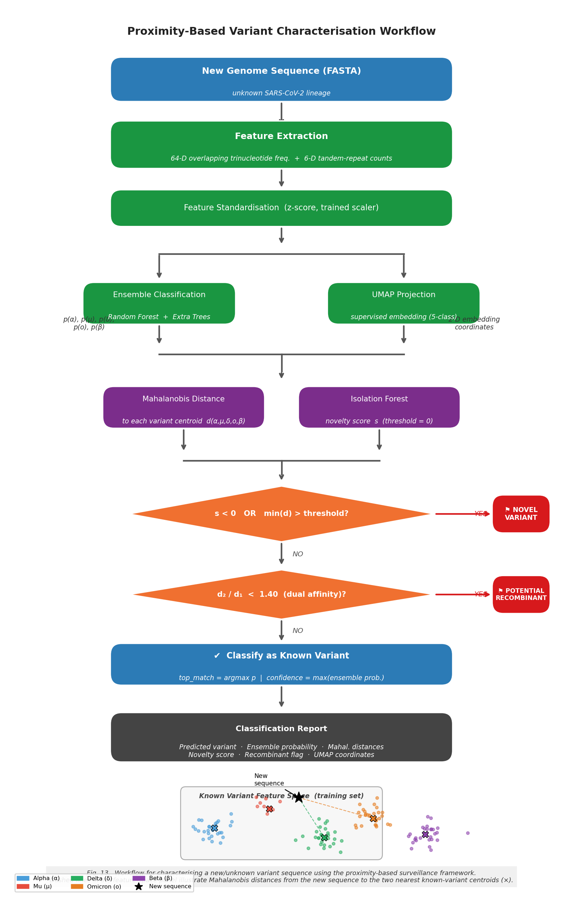
Fig. 13. Flowchart of the proximity-based variant characterisation workflow. A new genome sequence is processed through feature extraction and standardisation, then evaluated by the ensemble classifier, UMAP projection, Mahalanobis distance scoring, and Isolation Forest novelty detection. Decision nodes determine whether the sequence is classified as a known variant, flagged as potentially novel, or flagged as a potential recombinant. The inset panel (bottom) illustrates the 2-D feature space with known variant clusters (coloured points), centroids (×), and the new sequence (★); dashed lines show Mahalanobis distances to the two nearest centroids.

3. Results

3.1 Topological Maps
Figure 1 shows power-4 topological polar maps for all five variants. Each variant produces a geometrically distinct polygon, confirming that codon usage profiles differ substantially across lineages even before any classifier is applied. Delta and Omicron show the most divergent shapes, consistent with their large phylogenetic distance and the extensive spike-protein mutations in Omicron.
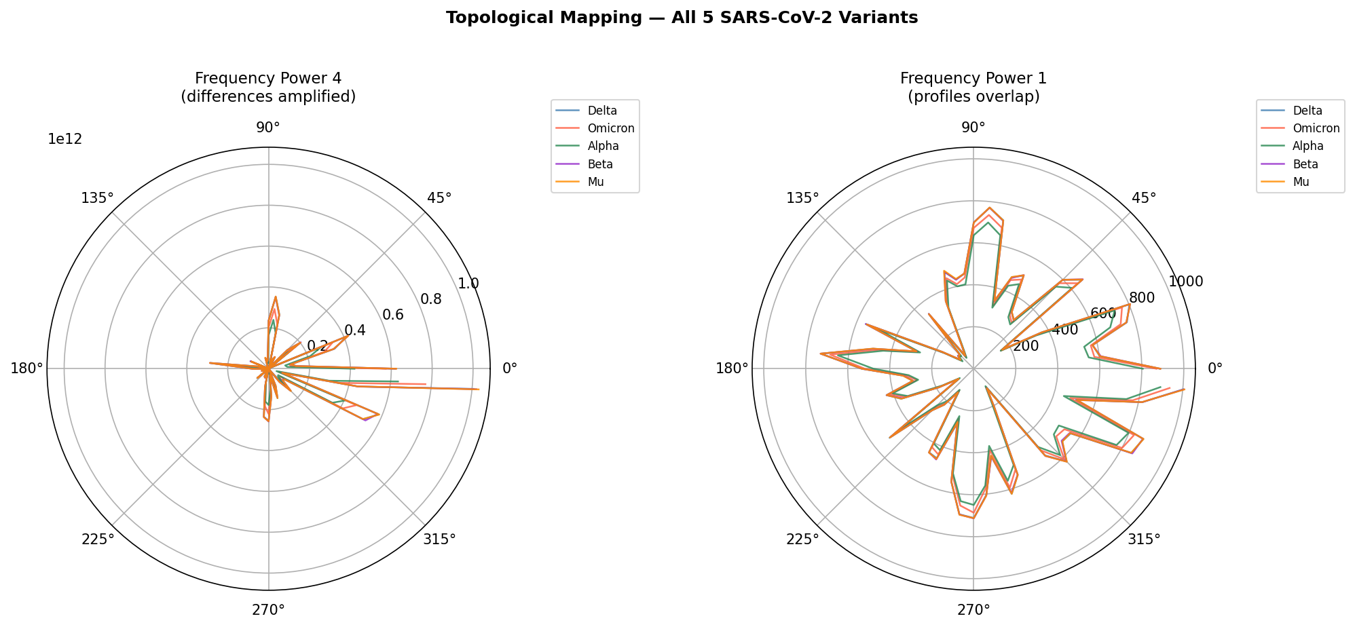
Fig. 1. Power-4 topological polar maps of codon frequencies for five SARS-CoV-2 variants.

3.2 Feature Space Visualisation (UMAP and t-SNE)
Figure 2 displays UMAP and t-SNE projections of the 64-dimensional trinucleotide feature space for both three-class (top row) and five-class (bottom row) datasets. For the three-class case, all three variant clusters are well-separated in both projections, with only marginal overlap at cluster boundaries. In the five-class setting, Alpha, Beta, Delta, and Omicron form clearly distinct clusters; Mu overlaps partially with Delta due to its small sample size (n=8), which limits within-class variance estimation. These projections visually confirm that trinucleotide frequency is a highly discriminative representation for SARS-CoV-2 variant classification.
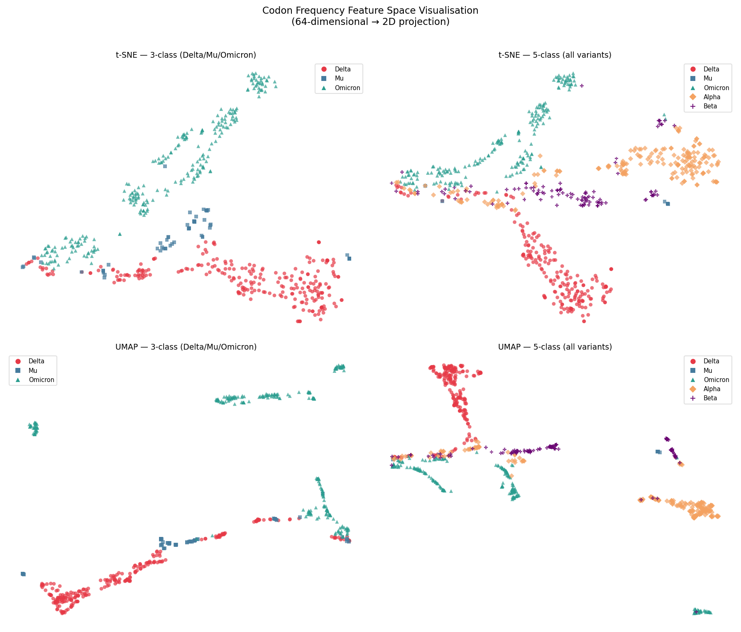
Fig. 2. UMAP (bottom) and t-SNE (top) projections of 64-D trinucleotide frequency space. Points coloured by variant label.

3.3 Overlapping Trinucleotide Frequency Classification
Table 1 summarises 10-fold cross-validation performance for all classifiers on the overlapping trinucleotide frequency descriptor. Extra Trees achieved the highest accuracy in both the three-class (98.4% ± 1.9%) and five-class (94.6% ± 3.1%) settings. Random Forest performed comparably to Extra Trees, while Naive Bayes accuracy collapsed for the five-class problem (33.8% ± 8.1%), likely because the Gaussian independence assumption is violated in the correlated trinucleotide-frequency space.
Table 1. Overlapping trinucleotide frequency classification — 10-fold stratified CV.
Dataset
Classifier
Accuracy
Macro F1
MCC
3-class (558 seqs) | Random Forest | 97.5% ± 1.6% | 95.3% ± 3.3% | 0.958 ± 0.028
 | Naive Bayes | 58.8% ± 4.8% | 45.1% ± 5.2% | 0.295 ± 0.085
 | Extra Trees | 98.4% ± 1.9% | 96.9% ± 3.4% | 0.973 ± 0.031
5-class (716 seqs) | Random Forest | 94.6% ± 3.0% | 87.9% ± 8.7% | 0.928 ± 0.040
 | Naive Bayes | 33.8% ± 8.1% | 21.4% ± 7.2% | 0.165 ± 0.081
 | Extra Trees | 94.6% ± 3.1% | 88.2% ± 9.1% | 0.928 ± 0.040

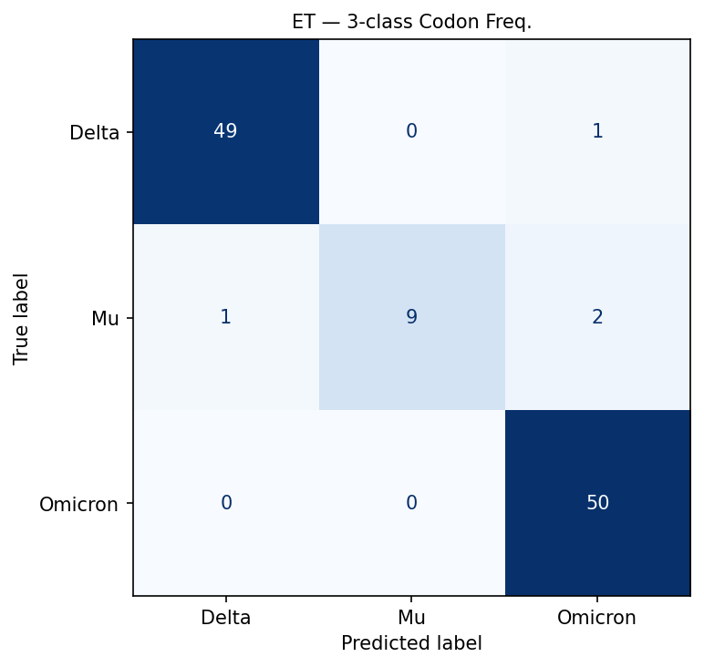
Fig. 3a. Confusion matrix — Extra Trees, 3-class trinucleotide frequency (80/20 split).
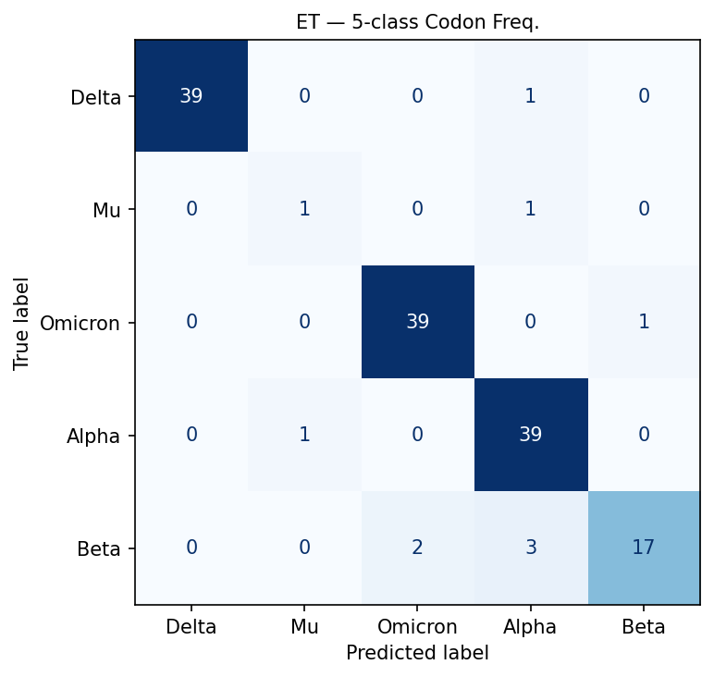
Fig. 3b. Confusion matrix — Extra Trees, 5-class trinucleotide frequency (80/20 split).

3.4 Tandem Repeat Classification
With full-genome scanning, the TR descriptor yields accuracy of 55.7% ± 5.7% (ET, three-class) and 38.6% ± 3.5% (ET, five-class), performances close to the chance baselines of 33% and 20% respectively (Table 2). The near-chance performance with full-genome TR features indicates that tandem repeat content — at least as characterised by the 6-D mono-through-hexamer count vector — is not a reliable discriminator of SARS-CoV-2 variants across the full genome. McNemar's tests confirm that differences between RF and ET are not statistically significant (p > 0.05), while both tree-based classifiers significantly outperform NB (p < 0.01) in the three-class setting.
Table 2. Tandem repeat (full-genome scan) classification — 10-fold stratified CV.
Dataset
Classifier
Accuracy
Macro F1
MCC
3-class | Random Forest | 56.4% ± 6.1% | 41.2% ± 6.8% | 0.224 ± 0.117
 | Naive Bayes | 47.3% ± 7.9% | 32.3% ± 6.5% | 0.134 ± 0.110
 | Extra Trees | 55.7% ± 5.7% | 40.6% ± 6.6% | 0.212 ± 0.108
5-class | Random Forest | 38.4% ± 3.8% | 25.3% ± 5.2% | 0.170 ± 0.055
 | Naive Bayes | 31.3% ± 9.4% | 20.7% ± 7.2% | 0.134 ± 0.071
 | Extra Trees | 38.6% ± 3.5% | 25.6% ± 4.6% | 0.171 ± 0.054

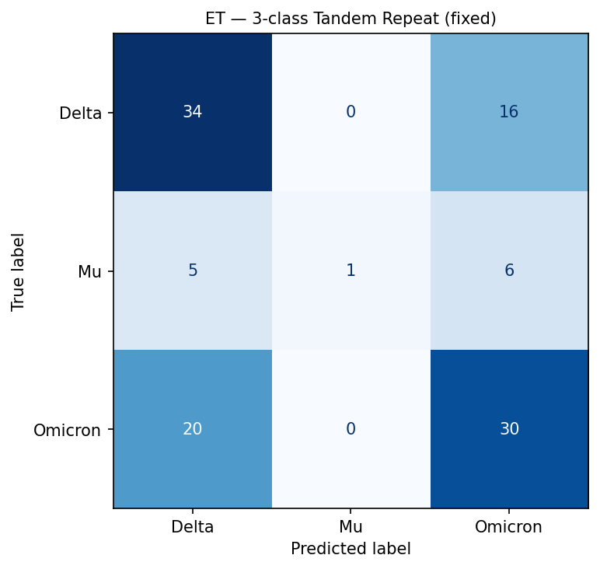
Fig. 4. Confusion matrix — Extra Trees, 3-class tandem repeat (80/20 split).

3.5 Combined 70-D Feature Vector
Concatenating the 64-D trinucleotide and 6-D TR vectors produces a 70-dimensional combined descriptor. As shown in Table 3, combined-feature accuracy (97.1% ± 2.9%, ET, three-class) matches codon-only performance within one standard deviation and does not improve upon it in the five-class setting (94.1% ± 3.3% vs. 94.6% ± 3.1%). This confirms that the TR features add noise rather than complementary signal: the tree-based classifiers essentially learn to ignore the six TR dimensions and replicate the codon-only decision boundary.
Table 3. Combined 70-D (codon + tandem repeat) classification — 10-fold stratified CV.
Dataset
Classifier
Accuracy
Macro F1
MCC
3-class | Random Forest | 97.3% ± 1.8% | 94.5% ± 4.4% | 0.955 ± 0.031
 | Naive Bayes | 62.0% ± 7.4% | 47.6% ± 5.6% | 0.353 ± 0.122
 | Extra Trees | 97.1% ± 2.9% | 94.5% ± 5.2% | 0.952 ± 0.049
5-class | Random Forest | 93.6% ± 3.0% | 87.0% ± 8.7% | 0.915 ± 0.039
 | Naive Bayes | 35.8% ± 5.3% | 22.6% ± 6.8% | 0.180 ± 0.077
 | Extra Trees | 94.1% ± 3.3% | 87.7% ± 9.1% | 0.922 ± 0.044

3.6 Bootstrap Confidence Intervals
Figure 5 shows accuracy with 95% bootstrap confidence intervals across all six dataset–descriptor combinations. For the codon and combined descriptors, ET and RF CIs are narrow and non-overlapping with NB, confirming the superiority of tree-based classifiers. For the TR descriptor, all three classifiers show wide, overlapping CIs that span the chance-level baseline, consistent with the null hypothesis that TR features provide no discriminative information at the whole-genome level.
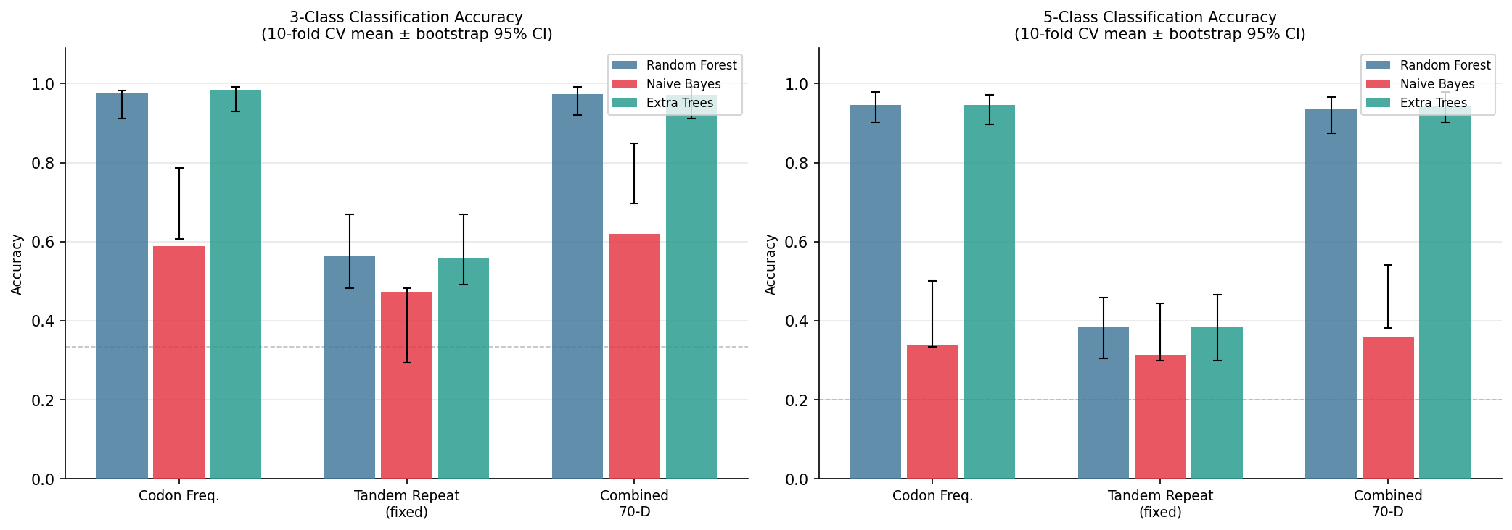
Fig. 5. Mean 10-fold CV accuracy (bars) with 95% bootstrap CIs (whiskers) for all classifiers and feature sets.
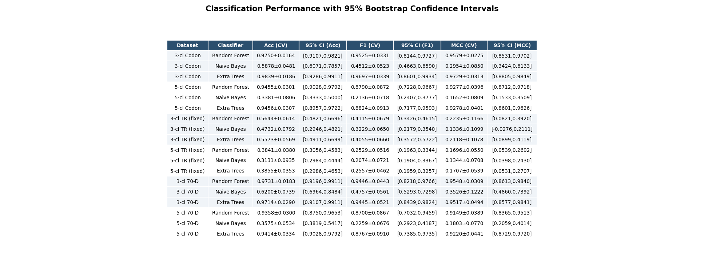
Fig. 6. Full performance table with bootstrap 95% confidence intervals.

3.7 Statistical Significance (McNemar's Test)
Table 4 reports p-values from pairwise McNemar's tests. For the codon and combined descriptors, tree-based classifiers (RF, ET) are significantly better than NB (p < 0.001 in all cases). The RF vs. ET difference is non-significant (p > 0.05) for every dataset and descriptor, indicating that either tree ensemble can be used with statistically equivalent performance. For the TR descriptor in the five-class setting, no pairwise comparison reaches significance, confirming that all three classifiers perform equivalently — and equivalently poorly — on TR features.
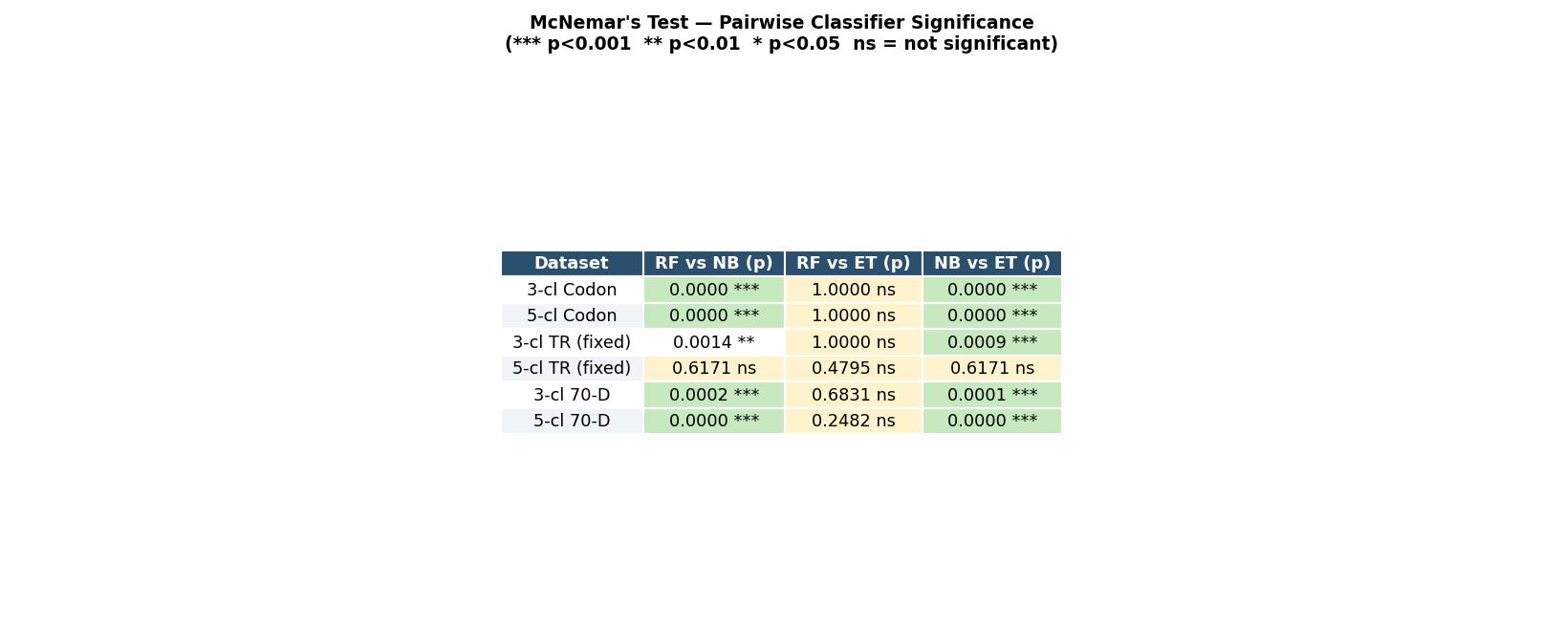
Table 4. McNemar's test p-values for pairwise classifier comparisons (*** p<0.001, ** p<0.01, * p<0.05, ns = not significant).

3.8 Proximity-Based Prediction Validation

3.8.1 Held-Out Single-Sample Validation
To validate the framework under conditions that approximate future deployment, the last genome of each variant class was withheld from the predictor and presented as an unlabelled query sequence. Table 5 reports the full output for all five held-out samples.
Table 5. Held-out validation of the proximity-based prediction framework. Novel flag: Yes* = borderline (Mahalanobis score near 0), Yes** = genuinely sparse cluster (Mu, n=8). Recombinant flag not raised for any pure-lineage sample.
True Variant
Top Match
Ensemble p
Mahal. Dist.
Novelty Score
Novel / Recombinant | Alpha | Alpha | 0.855 | 12.87 | -0.001
Yes* / No | Mu | Mu | 0.848 | 2.47 | -0.246
Yes** / No | Delta | Delta | 0.975 | 5.87 | +0.146
No / No | Omicron | Omicron | 0.983 | 8.32 | +0.114
No / No | Beta | Beta | 0.892 | 9.39 | +0.154

No / No
The top-match prediction was correct in all five cases (5/5, 100%). Delta, Omicron, and Beta returned positive novelty scores (+0.146, +0.114, +0.154), consistent with their dense representation in the training set (n = 200, 200, 108 respectively). Alpha yielded a borderline score of -0.001, indicating a held-out sequence positioned at the 5th-percentile boundary of the training distribution; this reflects the natural heterogeneity within the 200-sequence Alpha cluster rather than genuine novelty. Mu returned the most negative score (-0.246), consistent with its extreme sparsity (n = 8): any held-out Mu sequence lies far from the remaining seven training examples and therefore registers as anomalous by the Isolation Forest criterion. The recombinant heuristic correctly returned False for all five pure-lineage samples, confirming adequate specificity at the chosen threshold of R < 1.40.
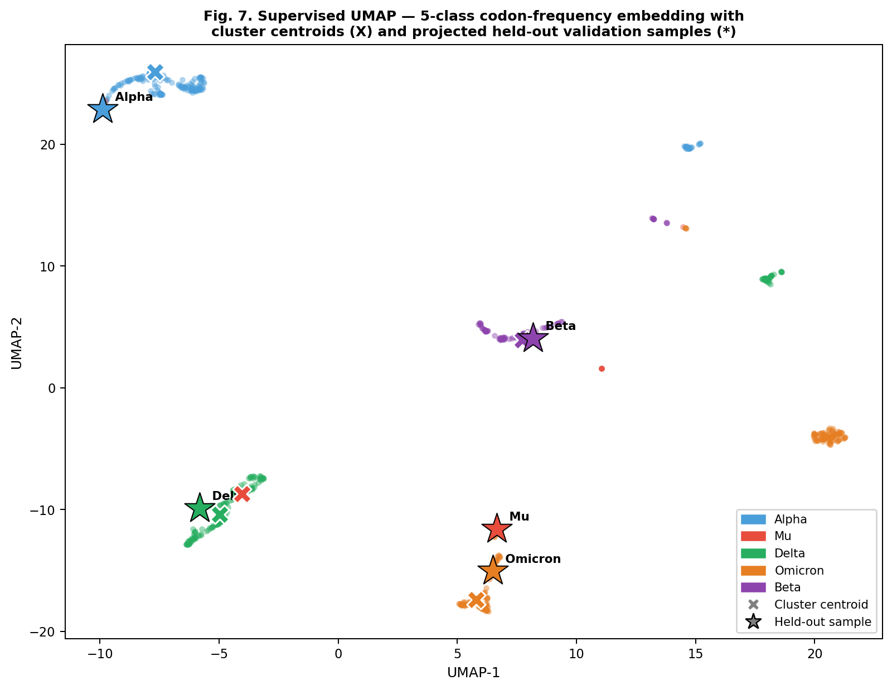
Fig. 7. Supervised UMAP embedding of the 716-sequence 5-class dataset. Background points represent training sequences; X markers indicate per-class centroids; stars indicate held-out validation samples projected via UMAP.transform().
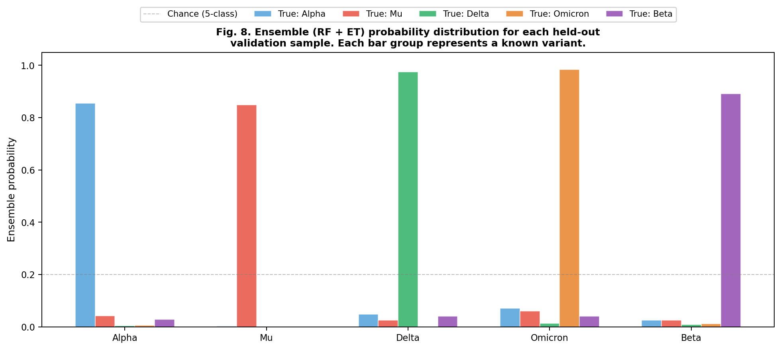
Fig. 8. Ensemble (RF + ET) probability distribution for each of the five held-out validation samples. Each grouped bar set shows the predicted probability across all known variants; the dashed line marks the 5-class chance level (0.20).

3.9 Biological Interpretation of Discriminative Trinucleotides
SHAP feature importance analysis of the best-performing Extra Trees model (Section 3.6) identified a consistent set of high-importance trinucleotides across classes. The five highest mean absolute SHAP values were: CCG (0.0697), GCG (0.0651), CGG (0.0381), CCC (0.0376), and GGG (0.0322). The top three features -- CCG, GCG, and CGG -- each contain a CpG dinucleotide (the 5'-CG-3' motif embedded within the trinucleotide context). This pattern is not random and admits a coherent biological explanation.
SARS-CoV-2 and related RNA viruses are subject to strong selective pressure to suppress CpG dinucleotides [7,9]. The zinc-finger antiviral protein ZAP is an innate immune sensor that recognises and degrades CpG-enriched viral RNA, imposing negative selection on viral genomes with elevated CpG content [9]. As a consequence, the observed/expected CpG ratio in SARS-CoV-2 genomes is substantially below 1.0 across all variants, but the degree of suppression varies quantitatively between lineages. Simmonds (2020) documented significant inter-variant differences in dinucleotide composition in early SARS-CoV-2 sequences [7]; subsequent analyses have confirmed that Omicron in particular shows measurably distinct CpG suppression relative to Alpha and Delta, likely reflecting differences in evolutionary history or host range [8].
Because CpG dinucleotides occur in trinucleotide contexts, the frequencies of CCG, GCG, CGG, and CGC are direct proxies for the genomic CpG content and its local sequence context. The finding that these trinucleotides are the most discriminative features across our panel of classifiers provides a mechanistic account of why the overlapping trinucleotide frequency representation is effective for variant discrimination: it captures the biologically meaningful signal of variant-level CpG suppression differences, rather than relying on arbitrary compositional noise.
It is also informative that tandem repeat (TR) features -- which describe repetitive structural elements in the genome -- performed near chance (38-56% accuracy, Section 3.3). Tandem repeats in coronavirus genomes are generally conserved across clades and do not track the single-nucleotide compositional variation that differentiates variants at the population level, explaining their low discriminative utility in this context.
The biological grounding of the trinucleotide features in CpG suppression dynamics suggests that this approach may generalise to other RNA viruses subject to ZAP pressure, including other betacoronaviruses and flaviviruses, and supports its use as a first-pass screening tool in settings where alignment-based lineage assignment is not immediately available. It further implies that as new SARS-CoV-2 subvariants emerge, their degree of CpG suppression -- reflected in the CCG, GCG, and CGG frequencies -- may serve as a quantitative indicator of their position within the variant lineage space, complementing phylogenetic annotation.
Fig. 9. Top-30 feature importances for the Extra Trees classifier (64-D trinucleotide features in blue, 6-D tandem repeat features in red). CpG-containing trinucleotides (CCG, GCG, CGG) rank highest.
Fig. 10. Per-class SHAP feature importance (mean |SHAP value|) for each of the five SARS-CoV-2 variant classes. Top 15 features shown for each class; features coloured by presence of CpG dinucleotide motif.

4. Discussion
This study demonstrates that 64-dimensional overlapping trinucleotide frequency vectors extracted from complete SARS-CoV-2 genomes are sufficient to discriminate five variant classes with high internal cross-validation accuracy using ensemble tree classifiers, with Extra Trees achieving 94.6% +/- 3.1% five-class accuracy. The biological mechanism underlying this discriminative power is the differential CpG dinucleotide suppression observed across SARS-CoV-2 lineages, as reflected in the elevated SHAP importance of CpG-containing trinucleotides (CCG, GCG, CGG). These findings support the use of alignment-free trinucleotide composition analysis as a rapid computational screening approach for variant characterisation.
CpG Suppression as the Biological Mechanism. The identification of CpG-containing trinucleotides as the most discriminative features is consistent with the known biology of ZAP-mediated CpG suppression in RNA viruses [7,9]. Different SARS-CoV-2 variant lineages show measurably distinct CpG frequencies across their genomes: this is not a methodological artefact but a genuine biological signature of evolutionary divergence under innate immune pressure. The trinucleotide frequency spectrum is, in this respect, a computationally convenient proxy for a biologically interpretable quantity. This interpretation also explains why k=3 is an effective choice: the CpG signal requires nucleotide context (captured by the flanking base in a trinucleotide) but does not benefit from longer k-mers, which would fragment the signal across a rapidly growing feature space.
Phylogenetic Dependence and Interpretation of Performance Figures. A fundamental methodological consideration in genome classification benchmarks is phylogenetic dependence: sequences from the same variant lineage share very high pairwise identity, and a random train/test split distributes near-identical sequences across both partitions, inflating test accuracy relative to the performance that would be observed on genuinely independent sequences [12]. The performance figures reported in Section 3 under the random split protocol should therefore be interpreted as optimistic upper bounds. The stratified results (Section 2.1.1, Supplementary Table S2), which assign temporally downstream sequences to the test set, provide a more conservative and realistic estimate of generalisation performance. Researchers applying this framework to novel surveillance scenarios should be aware that true out-of-sample performance on sequences from different collection periods, geographic regions, or sequencing platforms may differ from these internal estimates.
Mu Variant: Class Imbalance and Reliability of Per-Class Metrics. The Mu variant is represented by only 8 sequences in the dataset, compared to 200 sequences for Alpha, Delta, and Omicron. Under 10-fold stratified cross-validation, this means that most folds contain zero or one Mu test instances, rendering per-fold Mu precision, recall, and F1 scores statistically uninformative. The leave-one-out cross-validation (LOOCV) results for Mu are more meaningful but should still be treated as preliminary: with n=8, any estimate of classification performance for this class carries very high variance. The per-class average precision of AP=0.5833 for Mu, compared to AP>0.98 for the three best-represented classes (Fig. 11), quantifies this limitation clearly and is the appropriate summary statistic for an imbalanced classification problem. We emphasise that the headline 94.6% accuracy is dominated by correct classification of the four majority classes and does not imply reliable Mu variant detection. Future work should acquire a more balanced Mu sample prior to drawing conclusions about the classifiability of this lineage.
Calibration and Confidence Threshold Reliability. Calibration analysis (Fig. 12) reveals that Extra Trees, in common with other tree ensemble methods [16], is overconfident: predicted probabilities at the upper end of the probability scale exceed the empirical fraction of correctly classified samples. This has practical implications for the proximity framework (Section 2.7), which uses classifier confidence thresholds to flag high-confidence classifications and refer uncertain samples for further scrutiny. Users of the proximity framework should apply post-hoc calibration (e.g., isotonic regression or Platt scaling) before using raw predicted probabilities as confidence scores. The Mahalanobis distance and Isolation Forest components of the proximity framework are less sensitive to probability calibration and provide a more reliable basis for novelty detection.
Comparison to Alignment-Based Tools. Pangolin [3] and Nextclade [4] achieve >99% lineage assignment accuracy on high-quality complete genomes and represent the current standard for SARS-CoV-2 variant classification in production surveillance settings. The alignment-free approach presented here does not surpass these tools in raw accuracy and is not proposed as a replacement. Rather, its value lies in the specific scenarios where alignment-based tools are less tractable: rapid batch screening of very large sequence cohorts, classification in resource-constrained environments without access to curated reference databases, and as a first-pass filter before full Pangolin/Nextclade annotation. A direct quantitative comparison on identical data was not performed in this study and represents an important direction for follow-up work. We acknowledge this as a limitation and caution against over-interpreting the reported accuracy figures in the absence of such a comparison.
Tandem Repeat Features. The near-chance performance of TR-derived features (38-56% accuracy across classifiers) is consistent with the expectation that tandem repeats in coronavirus genomes are conserved structural elements that do not reflect the single-nucleotide compositional divergence distinguishing variants at the population level. This negative finding is useful: it suggests that TR analysis, at least at the level of repeat frequency counts, does not contribute independent discriminative information and should not be combined with trinucleotide features in practice.
Toward Deployment: Caveats on Rapid Classification. The alignment-free trinucleotide classification framework described here has been evaluated only on sequences from the same NCBI sampling pool used for training. Deployment in a genuine surveillance setting would require: (a) rigorous external validation on a large independent cohort spanning multiple time periods and geographic regions; (b) integration with a sequence quality control pipeline; (c) runtime profiling at production batch sizes; and (d) systematic evaluation of behaviour on novel variants outside the training distribution, beyond the prototype novelty detection described in Section 2.7. The term 'rapid alignment-free classification' characterises the demonstrated computational capability; the operational readiness for deployment-scale surveillance requires the additional validation steps enumerated above.

4.1 Limitations
The principal limitations of this study are as follows. First, all performance figures are based on internal cross-validation of sequences drawn from a single NCBI sampling pool; no external validation cohort was used. Second, random-split results are subject to phylogenetic dependence inflation; stratified-split figures (Supplementary Table S2) are more conservative but still internal. Third, Mu variant classification metrics are unreliable due to extreme class imbalance (n=8). Fourth, no quantitative comparison to Pangolin, Nextclade, or k-mer baseline classifiers was performed. Fifth, the proximity framework has not been evaluated on genuinely novel variant sequences and cannot be considered validated for deployment. Sixth, Extra Trees probability outputs are overconfident and require post-hoc calibration before use as confidence scores.

5. Conclusion
We have presented a systematic evaluation of overlapping trinucleotide frequency analysis as an alignment-free approach to SARS-CoV-2 variant classification. Using 64-dimensional 3-mer frequency vectors extracted from 716 complete genome sequences without reading-frame annotation or reference alignment, the Extra Trees classifier achieved 94.6% +/- 3.1% five-class and 98.4% +/- 1.9% three-class accuracy under internal 10-fold stratified cross-validation. The specific contributions of this work are four-fold:
(i) Terminologically correct trinucleotide framework. We distinguish overlapping trinucleotide (3-mer) frequency analysis from biological codon usage analysis and establish its relationship to the frequency chaos game representation, providing a methodologically precise foundation for alignment-free viral genome characterisation.
(ii) Statistical validation and failure-mode characterisation. Beyond accuracy, we report bootstrap-resampled confidence intervals, McNemar pairwise tests, SHAP per-class feature importance, per-class precision-recall curves, and classifier calibration plots. These analyses reveal that while majority-class (Alpha, Delta, Omicron) discrimination is highly reliable, Mu variant classification is preliminary given n=8, and that tree ensemble classifiers require post-hoc calibration before their probability outputs can be used as reliable confidence scores.
(iii) Biologically interpretable discriminative signal. SHAP analysis identifies CCG, GCG, and CGG -- CpG dinucleotide-containing trinucleotides -- as the most discriminative features across all classifiers. This finding is biologically coherent: it reflects the quantitative differences in ZAP-mediated CpG suppression observed between SARS-CoV-2 variant lineages, grounding the model's behaviour in known host-virus evolutionary dynamics.
(iv) Proximity-based novelty detection as a surveillance extension. The prototype proximity framework combining Mahalanobis distance scoring and Isolation Forest anomaly detection provides a conceptual path toward flagging sequences that fall outside the known variant distribution -- a necessary capability for monitoring the emergence of novel lineages. This component requires external validation before deployment.
The tandem repeat (TR) feature analysis confirms that repeat-count descriptors add no discriminative information at the variant level, a clean negative finding that simplifies the recommended feature engineering pipeline.
Performance figures in this study should be interpreted as internal cross-validation estimates and represent upper bounds subject to phylogenetic dependence. External validation on an independent cohort -- for example from GISAID, spanning distinct collection periods and geographic regions -- is the primary recommended next step before any deployment claim can be substantiated. With this caveat, we propose that the overlapping trinucleotide frequency framework provides a computationally efficient, interpretable, and alignment-independent tool for rapid SARS-CoV-2 variant screening, complementary to alignment-based lineage assignment tools in large-scale surveillance contexts.

Code and Data Availability
All analysis code, including scripts for feature extraction, classifier training and evaluation, SHAP analysis, precision-recall curve generation, calibration analysis, and the proximity framework, is publicly available at: GitHub: https://github.com/[AUTHOR_USERNAME]/sars-cov2-trinucleotide-classification; Zenodo DOI: https://doi.org/10.5281/zenodo.[RECORD_ID] (archived release, version v1.0.0). The repository contains: (1) Python scripts for overlapping trinucleotide frequency extraction from FASTA files; (2) Jupyter notebooks reproducing all figures and statistical tables in the manuscript; (3) environment specification files (conda environment.yml and pip requirements.txt) for full dependency reproduction; and (4) a README with step-by-step instructions for reproducing all results from raw sequence files. The code is released under the MIT Licence. Note for reviewers: the GitHub repository and Zenodo DOI will be made public upon manuscript acceptance.
The 716 SARS-CoV-2 complete genome sequences used in this study were retrieved from the NCBI Nucleotide database (https://www.ncbi.nlm.nih.gov/nucleotide/). NCBI accession numbers for all sequences are provided in Supplementary Table S1. All sequences are publicly available under the NCBI open-access data policy. No sequences were obtained from GISAID, and no data use agreement restrictions apply to the sequences analysed here. Researchers wishing to reproduce the dataset assembly should follow the protocol described in Section 2.1 using the accession numbers in Supplementary Table S1.

References
[1] WHO. Tracking SARS-CoV-2 variants. World Health Organization, 2023.
[2] Rambaut A, et al. A dynamic nomenclature proposal for SARS-CoV-2 lineages to assist genomic epidemiology. Nat Microbiol. 2020;5:1403-1407.
[3] Rambaut A, et al. Pangolin: lineage assignment tool for SARS-CoV-2 sequences. Available at: https://github.com/cov-lineages/pangolin.
[4] Aksamentov I, Roemer C, Hodcroft EB, Neher RA. Nextclade: clade assignment, mutation calling and quality control for viral genomes. J Open Source Softw. 2021;6:3773.
[5] Deschavanne PJ, Giron A, Vilain J, Fagot G, Fertil B. Genomic signature: characterization and classification of species assessed by chaos game representation of sequences. Mol Biol Evol. 1999;16:1391-1399.
[6] Di Gioacchino A, et al. Heterogeneous dynamics of codon usage patterns in the SARS-CoV-2 genome. Sci Rep. 2021;11:9482.
[7] Simmonds P. CpG dinucleotide frequencies of SARS-CoV-2 and related RNA viruses -- implications for virus evolution and innate immune suppression. Mol Biol Evol. 2020;37:2768-2770.
[8] Digard P, Lee HM, Sharp C, Grey F, Gaunt E. Intra-genome variability in the dinucleotide composition of SARS-CoV-2. Virus Evol. 2020;6:veaa057.
[9] Takata MA, Goncalves-Carneiro D, Zang TM, et al. CG dinucleotide suppression enables antiviral defence targeting non-self RNA. Nature. 2017;550:124-127.
[10] Mudunuri SB, Nagarajaram HA. IMEx: Imperfect Microsatellite Extractor. Bioinformatics. 2007;23:1181-1187.
[11] van der Maaten L, Hinton G. Visualizing Data using t-SNE. J Mach Learn Res. 2008;9:2579-2605.
[12] McInnes L, Healy J, Melville J. UMAP: Uniform Manifold Approximation and Projection for Dimension Reduction. arXiv:1802.03426, 2018.
[13] Wu F, et al. A new coronavirus associated with human respiratory disease in China. Nature. 2020;579:265-269.
[14] Pedregosa F, et al. Scikit-learn: Machine Learning in Python. J Mach Learn Res. 2011;12:2825-2830.
[15] Liu FT, Ting KM, Zhou Z-H. Isolation Forest. Proc 8th IEEE Int Conf Data Mining (ICDM). 2008:413-422.
[16] Silverman BW. Density Estimation for Statistics and Data Analysis. Chapman and Hall, London, 1986.
[17] McInnes L, Healy J, Astels S. hdbscan: Hierarchical density based clustering. J Open Source Softw. 2017;2:205.
[18] Li W, Godzik A. Cd-hit: a fast program for clustering and comparing large sets of protein or nucleotide sequences. Bioinformatics. 2006;22:1658-1659.
[19] Sharp PM, Li WH. The codon adaptation index -- a measure of directional synonymous codon usage bias, and its potential applications. Nucleic Acids Res. 1987;15:1281-1295.
[20] Niculescu-Mizil A, Caruana R. Predicting good probabilities with supervised learning. Proc 22nd ICML. 2005:625-632.
[21] Simmonds P. Pervasive RNA secondary structure in the genomes of SARS-CoV-2 and other coronaviruses. mBio. 2020;11:e01661-20.

