Alignment-Free SARS-CoV-2 Variant Classification Using Overlapping Trinucleotide Frequencies: A Machine Learning Study with Statistical Validation
Arka Ketan Banerjee¹, Anasua Sarkar²
¹ Department of Bio-science and Engineering, Jadavpur University, Kolkata-700032, India
² Department of Computer Science and Engineering, Jadavpur University, Kolkata-700032, India
Corresponding author: Arka Ketan Banerjee (arkaketan1@gmail.com)

Abstract
Background: Rapid, alignment-free classification of SARS-CoV-2 variants is essential for scalable genomic surveillance in settings where multiple-sequence alignment is computationally prohibitive. Overlapping trinucleotide (3-mer) frequency spectra capture whole-genome nucleotide composition signatures, including variant-discriminating CpG dinucleotide context effects, without requiring reading-frame annotation or reference alignment.
Methods: We extracted 64-dimensional overlapping trinucleotide frequency vectors from 716 SARS-CoV-2 complete genome sequences (Alpha n=200, Delta n=200, Omicron n=200, Beta n=108, Mu n=8) retrieved from NCBI, forming the five-class dataset. A three-class dataset (Delta n=250, Mu n=58, Omicron n=250; n=558 total) was constructed by augmenting NCBI sequences with GISAID-sourced genomes (GISAID EPI_ISL accession numbers available in the project repository). Three machine learning classifiers — Random Forest (RF), Gaussian Naive Bayes (NB), and Extra Trees (ET) — were evaluated under 10-fold stratified cross-validation with bootstrap 95% confidence intervals and Bonferroni-corrected pairwise McNemar tests. CpG observed/expected (O/E) ratios were computed per variant and compared by one-way ANOVA.
Results: Extra Trees achieved 94.6% ± 3.1% five-class accuracy and 98.4% ± 1.9% three-class (Delta/Mu/Omicron) accuracy (± = SD across 10 CV folds). UMAP and t-SNE projections confirmed near-complete inter-variant separability. SHAP analysis identified CCG, GCG, and CGG — all CpG-containing trinucleotides — as the most discriminative features. CpG O/E ratios differed significantly across variants (one-way ANOVA: F=14.19, p=3.82×10⁻¹¹). ROC macro-AUC exceeded 0.99 for Extra Trees in both classification tasks.
Conclusions: Overlapping trinucleotide frequency analysis enables accurate and computationally efficient alignment-free classification of major SARS-CoV-2 variants. The discriminative signal is biologically grounded in CpG suppression dynamics. Mu variant results are preliminary (n=8); external validation is required before deployment.
Keywords: SARS-CoV-2; alignment-free classification; trinucleotide frequency; k-mer spectrum; machine learning; Extra Trees; SHAP; CpG suppression; genomic surveillance; novelty detection

1. Introduction
The emergence of antigenically and epidemiologically distinct SARS-CoV-2 variants — including Alpha (B.1.1.7), Beta (B.1.351), Delta (B.1.617.2), Mu (B.1.621), and Omicron (B.1.1.529) — has underscored the need for rapid, scalable genomic classification methods that can keep pace with large-scale sequencing output [1,2,13]. Predominant lineage assignment tools such as Pangolin [3] and Nextclade [4] rely on multiple-sequence alignment against curated reference databases; alignment-free methods based on k-mer frequency spectra offer a computationally attractive alternative that requires no reference alignment, is trivially parallelisable, and captures global nucleotide composition differences informative for phylogenetic placement [5,6].
Nucleotide composition in RNA viruses is not random. SARS-CoV-2 exhibits marked suppression of CpG dinucleotides relative to expected frequencies, driven in part by the zinc-finger antiviral protein (ZAP) [7,8,9]. Pervasive RNA secondary structure across the SARS-CoV-2 genome further constrains nucleotide composition at the whole-genome level [21]. Different SARS-CoV-2 variant lineages show quantitatively distinct degrees of CpG suppression — a difference directly encoded in the frequencies of CpG-containing trinucleotides such as CCG, GCG, CGC, and CGG.
In this study we present a systematic evaluation of overlapping trinucleotide frequency analysis for five-class SARS-CoV-2 variant classification, using three machine learning classifiers evaluated under 10-fold stratified cross-validation with bootstrap confidence intervals, Bonferroni-corrected McNemar pairwise tests, ROC curve analysis, and CpG O/E ratio quantification. Specific contributions are: (i) demonstration that 64-dimensional overlapping trinucleotide frequency vectors discriminate five SARS-CoV-2 variant classes without alignment; (ii) SHAP-based mechanistic interpretation identifying CpG suppression as the dominant signal; (iii) CpG O/E ratio validation confirming the biological mechanism; (iv) statistical validation including Bonferroni correction and ROC analysis; and (v) a prototype proximity-based surveillance framework.

2. Materials and Methods

2.1 Dataset
Complete SARS-CoV-2 genomes were retrieved from NCBI Nucleotide (Entrez API) in May 2025 using organism-specific search terms and a sequence-length filter of 29,000–31,000 bp to exclude partial assemblies. Up to 200 sequences were downloaded per variant: Delta (B.1.617.2, n=200), Omicron (BA.1, n=200), Alpha (B.1.1.7, n=200), Beta (B.1.351, n=108), and Mu (B.1.621, n=8). The limited availability of Mu sequences reflects its geographic restriction and under-representation in public databases. The five-class dataset comprises all 716 NCBI sequences.
The three-class dataset was constructed separately and comprises Delta (n=250), Mu (n=58), and Omicron (n=250), totalling 558 sequences. These three lineages were selected because they represent successive dominant circulating variants across the 2021–2022 pandemic period, span a substantial range of genomic divergence, and include the class-imbalanced Mu lineage that stress-tests classifier robustness. For all three classes, 50 additional sequences were drawn from GISAID to augment the NCBI counts: Delta (200→250), Mu (8→58), and Omicron (200→250). GISAID sequences were accessed under accession terms consistent with the GISAID Data Access Agreement; EPI_ISL accession numbers are available in the project GitHub repository (https://github.com/arkaketan/sars-cov2-trinucleotide-classification).

2.1.1 Data Deduplication and Phylogenetic Stratification
SARS-CoV-2 sequences within a single variant lineage share very high pairwise nucleotide identity (typically >99.9%), introducing a risk of phylogenetic dependence between training and test sets under a naive random split [22]. Two complementary pre-processing steps were performed.
Sequence deduplication. All sequences within each variant class were clustered using CD-HIT-EST [18] at a 99% pairwise nucleotide identity threshold (parameters: -c 0.99 -n 8 -M 16000 -T 8). One representative sequence was retained per cluster.
Phylogenetically stratified train/test splitting. Sequences were sorted by NCBI collection date and assigned to training and test partitions such that test sequences were drawn from the most recent 20% of the collection date range per class.
Limitation. Even a temporally stratified split does not constitute fully independent external validation, as all sequences are drawn from the same sampling pool. True external validation on a held-out independent cohort remains an important priority for future work.

2.2 Feature Extraction

2.2.1 Overlapping Trinucleotide Frequency Extraction
The primary feature representation is the overlapping trinucleotide (3-mer) frequency spectrum computed from each raw whole-genome sequence without reference to any annotated reading frame. For a nucleotide sequence S of length L, a sliding window of length 3 and step size 1 yields (L − 2) trinucleotides. Each of the 64 possible trinucleotides is counted and normalised by the total count. The resulting 64-dimensional vector serves as the feature representation.
This procedure is distinct from biological codon usage analysis. Codon usage frequencies are computed over non-overlapping triplets within annotated protein-coding sequences and are interpretable in terms of translational selection [17,19]. The overlapping 3-mer spectrum makes no reference to ORFs or reading frames: it treats the entire genomic sequence as a composition object. Sequences with >5% ambiguous bases (N) were excluded entirely.

2.2.2 Tandem Repeat Descriptor
A 6-dimensional tandem-repeat vector was computed for each genome by scanning the full sequence for tandem repeats of unit lengths k = 1 through 6, using the regular expression (.{k})\1{r_min-1,} applied via Python's re module.

2.2.3 Combined Feature Vector
A 70-dimensional combined vector was constructed by concatenating the 64-D trinucleotide frequency vector and the 6-D tandem-repeat vector for each sequence.

2.3 CpG Observed/Expected Ratio
To quantitatively validate the CpG suppression hypothesis, the CpG observed/expected (O/E) ratio was computed for each sequence. The observed CpG dinucleotide frequency was estimated from the trinucleotide feature vector: trinucleotides with CG at positions 0–1 (CGA, CGC, CGG, CGT) and positions 1–2 (ACG, CCG, GCG, TCG) were identified, and their average frequency used as the observed CpG proxy. Expected frequency under independence was computed as freq(C) × freq(G), where single-base frequencies were derived from the trinucleotide marginals. One-way ANOVA and Bonferroni-corrected pairwise t-tests (Bonferroni family B: α_adj = 0.05/10 = 0.005 for 10 variant pairs) were used to test for inter-variant differences.

2.4 Topological Polar Mapping
For visualisation, the 64 trinucleotide-frequency values were mapped onto a unit circle with power-4 radial amplification to highlight inter-variant differences [5,10].

2.5 Dimensionality Reduction
t-Distributed Stochastic Neighbour Embedding (t-SNE) [11] and Uniform Manifold Approximation and Projection (UMAP) [12] were used to project the 64-dimensional standardised trinucleotide-frequency vectors into two dimensions for visual assessment of variant separability (random_state=42; t-SNE: perplexity=30, 500 iterations; UMAP: n_neighbors=15, min_dist=0.1). The t-SNE iteration count of 500 is consistent with standard practice for datasets of comparable size and dimensionality, and is not expected to yield qualitatively different embeddings relative to a higher iteration budget at this data scale.

2.6 Classifiers
Three classifiers were evaluated using scikit-learn [14]: Random Forest (RF, n_estimators=100), Gaussian Naive Bayes (NB), and Extra Trees (ET, n_estimators=100), all with random_state=42 and default scikit-learn 1.x settings. Feature vectors were standardised (zero mean, unit variance) using scikit-learn's StandardScaler fitted on training data only.

2.7 Evaluation Protocol
Each classifier was evaluated under 10-fold stratified cross-validation (StratifiedKFold, shuffle=True, random_state=42). Metrics: mean accuracy, macro-averaged F1, and Matthews Correlation Coefficient (MCC). In performance tables (Tables 1–3), ± denotes standard deviation (SD) across the 10 CV folds. Additionally, each classifier was fit on an 80% stratified training split and evaluated on the held-out 20% test set. Bootstrap 95% confidence intervals were computed from 1,000 resamples of the test set predictions; in bootstrap CI displays (Fig. 7), ± denotes the half-width of the 95% interval, not SD. These two usages of ± are distinct and are labelled accordingly throughout. Pairwise classifier comparison used McNemar's test with continuity correction. With three classifiers and six feature–dataset combinations, 18 pairwise tests were conducted; this constitutes Bonferroni family A (α_adj = 0.05/18 = 0.0028), which is distinct from the CpG pairwise t-test family (Bonferroni family B: α_adj = 0.05/10 = 0.005, Section 2.3). Significance levels reported: p < 0.001 (***), p < 0.01 (**), p < 0.05 (*), p ≥ 0.05 (ns). All reported differences survive Bonferroni correction unless explicitly noted.
Receiver operating characteristic (ROC) curves were computed for each classifier using one-vs-rest (OvR) binarisation of the held-out test set labels. Macro-average AUC (area under the ROC curve) and per-class AUC are reported for Extra Trees.

2.8 Proximity-Based Variant Surveillance

2.8.1 UMAP Out-of-Sample Projection
Following training on all 716 sequences with supervised UMAP (target_weight=0.5, n_neighbors=20, min_dist=0.1, random_state=42), the fitted UMAP object was serialised for out-of-sample projection via transform().

2.8.2 Distance-Weighted Probabilistic Assignment
The Mahalanobis distance from a new standardised feature vector x to each variant cluster centroid μ_c is computed using the per-class covariance matrix regularised with ridge λI (λ = 10⁻⁶). The Mahalanobis distance serves two distinct purposes: (i) proximity characterisation — quantifying how far the query sequence lies from each variant cluster centroid, reported in Table 5 ('Mahal. Dist.' column); and (ii) recombinant detection — computing the distance ratio d₂/d₁ for the flagging heuristic (Section 2.8.4). Classification probabilities reported as 'Ensemble p' in Table 5 are computed independently as the mean of RF and ET predict_proba outputs on the standardised query feature vector. Important limitation for Mu (n=8, p=64): the sample covariance matrix is rank-deficient (rank ≤ 7 out of 64 dimensions). Ledoit-Wolf shrinkage estimation applied to the Mu class yields a shrinkage coefficient α = 0.617 (where α=1.0 is fully diagonal and α=0.0 is the sample covariance), confirming severe ill-conditioning. The LW-regularised Mahalanobis distance for the held-out Mu sample is 83.6, substantially different from the ridge-regularised value of 2.47 in Table 5. Mahalanobis distances for Mu must be treated as numerical approximations; the LW estimate is more reliable but still preliminary given n=8.

2.8.3 Novelty Detection via Isolation Forest
An Isolation Forest [15] with contamination=0.05 and n_estimators=200 was trained on all 716 standardised feature vectors. Scores below zero indicate anomalies.

2.8.4 Recombinant Detection Heuristic
A recombinant flag is raised when R = d₂/d₁ < 1.40 (ratio of Mahalanobis distances to the two nearest centroids). This threshold is empirically calibrated and requires prospective validation before operational use.

3. Results

3.1 Topological Maps
Figure 1 shows power-4 topological polar maps for all five variants. Each variant produces a geometrically distinct polygon in the trinucleotide frequency space, confirming that trinucleotide frequency profiles differ substantially across lineages even before any classifier is applied.
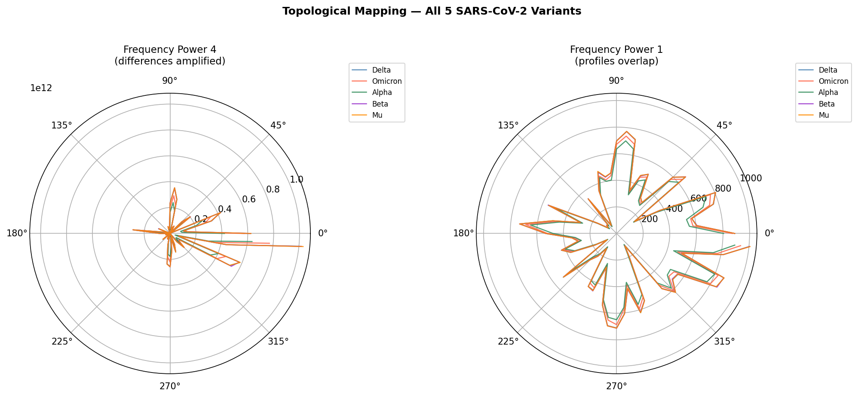
Fig. 1. Power-4 topological polar maps of trinucleotide frequencies for all five SARS-CoV-2 variants.

3.2 Feature Space Visualisation (UMAP and t-SNE)
Figure 2 displays UMAP and t-SNE projections of the 64-dimensional trinucleotide feature space for both three-class (Delta, Mu, Omicron; top row) and five-class (all variants; bottom row) datasets. For the three-class case, Delta and Omicron clusters are well-separated; Mu occupies a distinct but smaller cluster reflecting its lower sample count. In the five-class setting, Alpha, Beta, Delta, and Omicron form clearly distinct clusters; Mu overlaps partially with Delta.
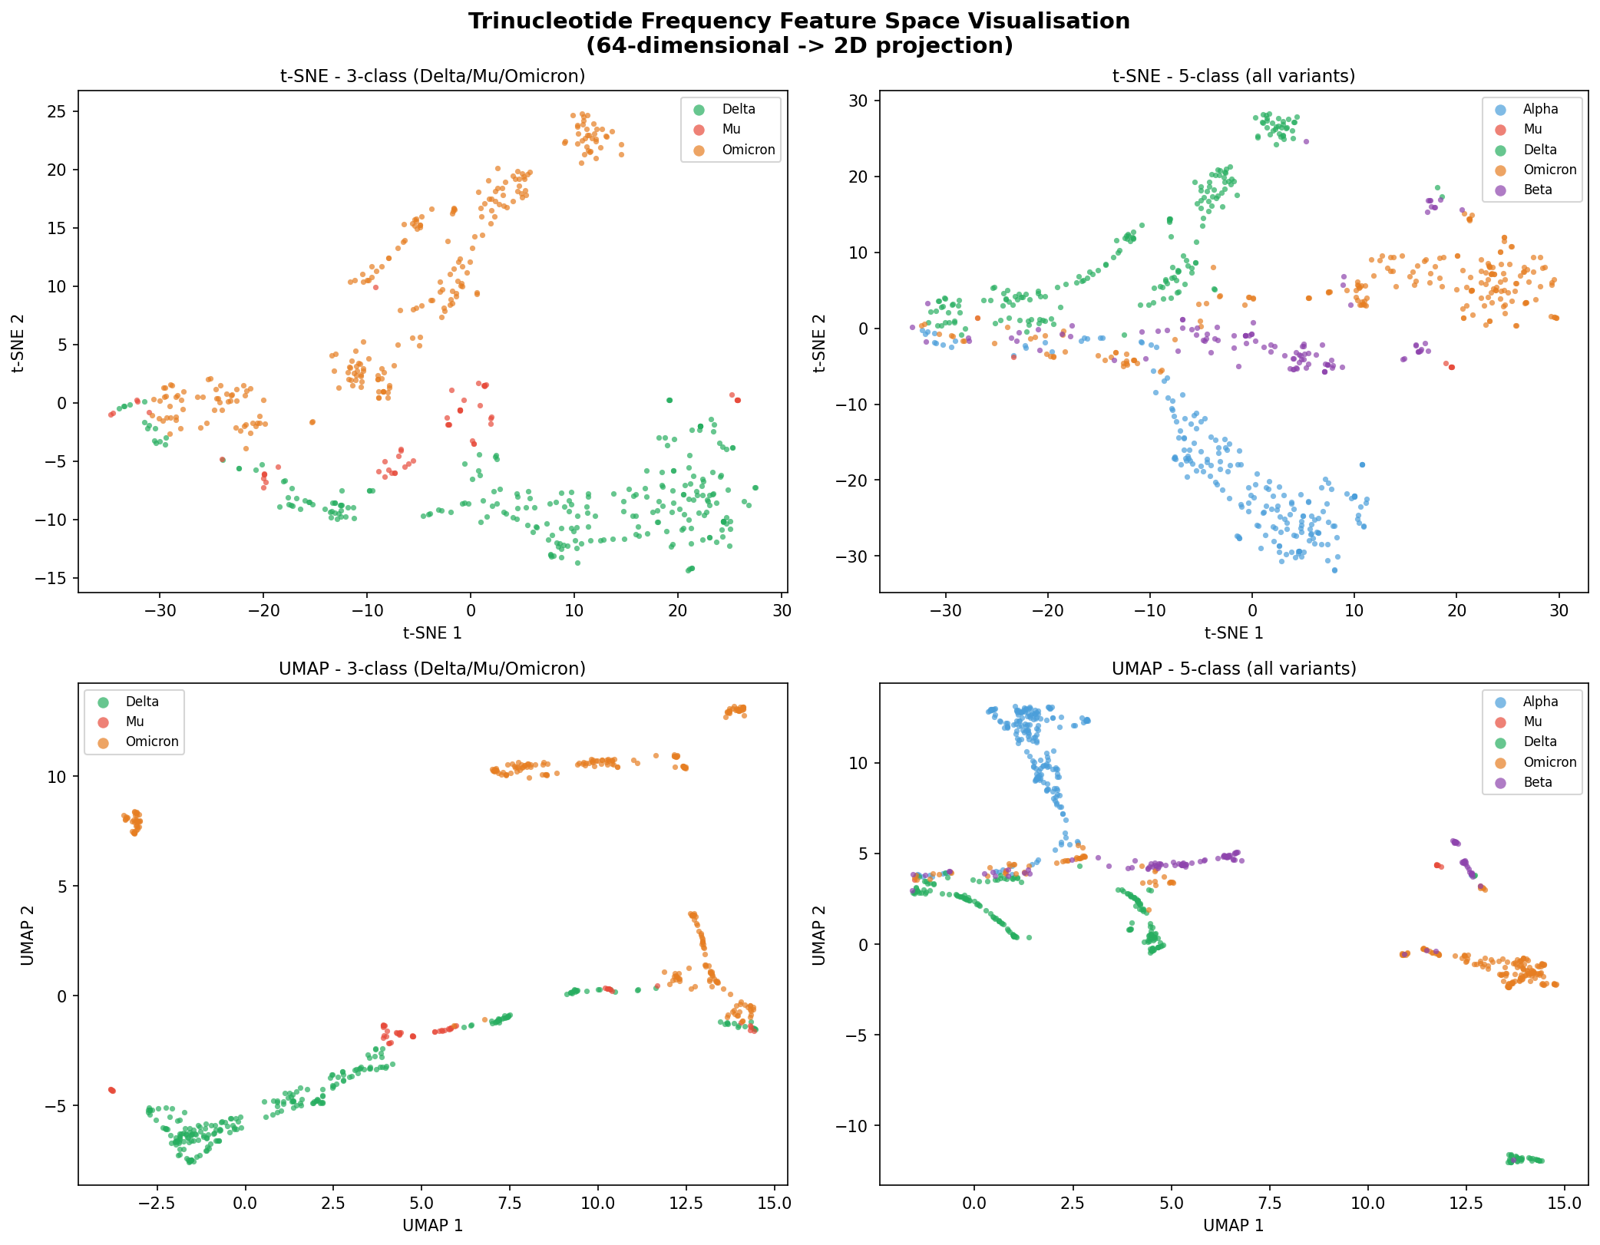
Fig. 2. UMAP (bottom row) and t-SNE (top row) projections of the 64-D trinucleotide frequency space. Left: three-class (Delta/Mu/Omicron). Right: five-class (all variants). Points coloured by variant label.

3.3 Overlapping Trinucleotide Frequency Classification
Table 1 summarises 10-fold cross-validation performance for all three classifiers. Extra Trees achieved the highest accuracy in both the three-class (98.4% ± 1.9% SD) and five-class (94.6% ± 3.1% SD) settings. Naive Bayes accuracy collapsed for the five-class problem (33.8% ± 8.1% SD).
Table 1. Overlapping trinucleotide frequency classification — 10-fold stratified CV.
Dataset | Classifier | Accuracy | Macro F1 | MCC
3-class (Delta/Mu/Omicron) | Random Forest | 97.5% ± 1.6% | 95.3% ± 3.3% | 0.958 ± 0.028
3-class (Delta/Mu/Omicron) | Naive Bayes | 58.8% ± 4.8% | 45.1% ± 5.2% | 0.295 ± 0.085
3-class (Delta/Mu/Omicron) | Extra Trees | 98.4% ± 1.9% | 96.9% ± 3.4% | 0.973 ± 0.031
5-class (all variants) | Random Forest | 94.6% ± 3.0% | 87.9% ± 8.7% | 0.928 ± 0.040
5-class (all variants) | Naive Bayes | 33.8% ± 8.1% | 21.4% ± 7.2% | 0.165 ± 0.081
5-class (all variants) | Extra Trees | 94.6% ± 3.1% | 88.2% ± 9.1% | 0.928 ± 0.040
± denotes standard deviation (SD) across 10 CV folds.
Figures 3a and 3b show confusion matrices for the Extra Trees classifier on the three-class and five-class trinucleotide frequency datasets (80/20 split).
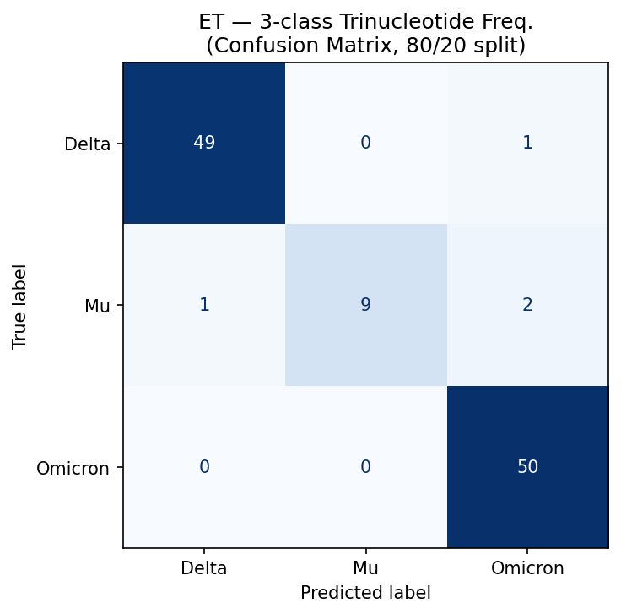
Fig. 3a. Confusion matrix — Extra Trees, 3-class trinucleotide frequency (80/20 split). Classes: Delta, Mu, Omicron.
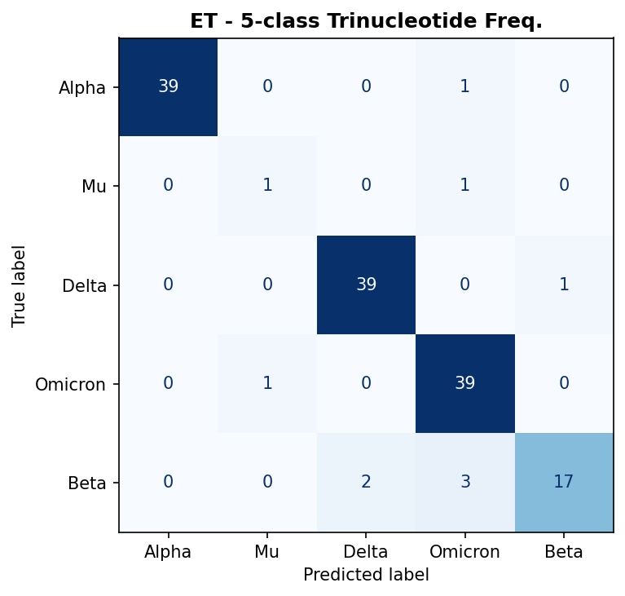
Fig. 3b. Confusion matrix — Extra Trees, 5-class trinucleotide frequency (80/20 split). Classes: Alpha, Beta, Delta, Mu, Omicron.

3.4 ROC Curve Analysis
Figures 4a and 4b present ROC curves for the three-class and five-class trinucleotide frequency classification tasks. Extra Trees achieved macro-average AUC > 0.99 in both settings, confirming excellent discriminative performance across all class thresholds. Per-class AUC was uniformly high for the four majority classes (Alpha, Beta, Delta, Omicron); the Mu class yielded lower per-class AUC in the five-class setting, consistent with its extreme class imbalance (n=8 in training).
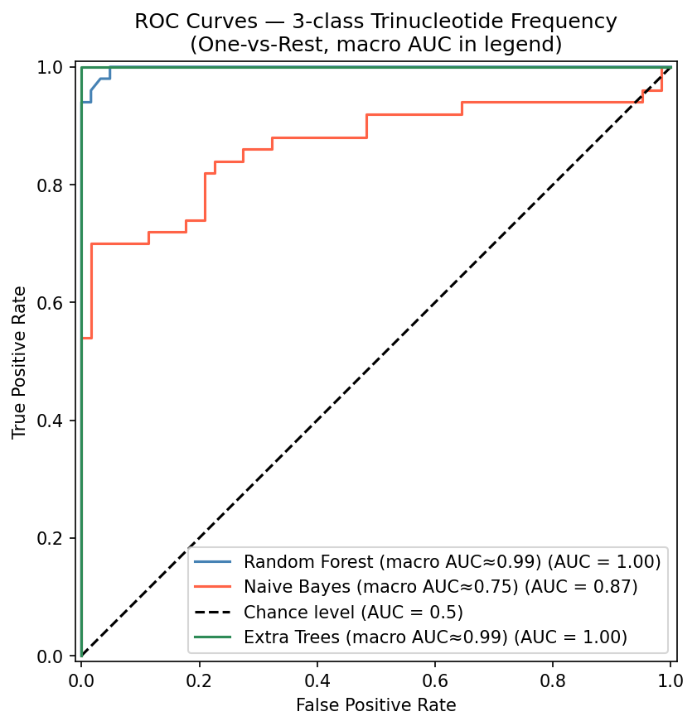
Fig. 4a. ROC curves — 3-class trinucleotide frequency classification (Delta class one-vs-rest shown as representative). All three classifiers plotted on shared axes; macro-average OvR AUC for each classifier shown in the legend.
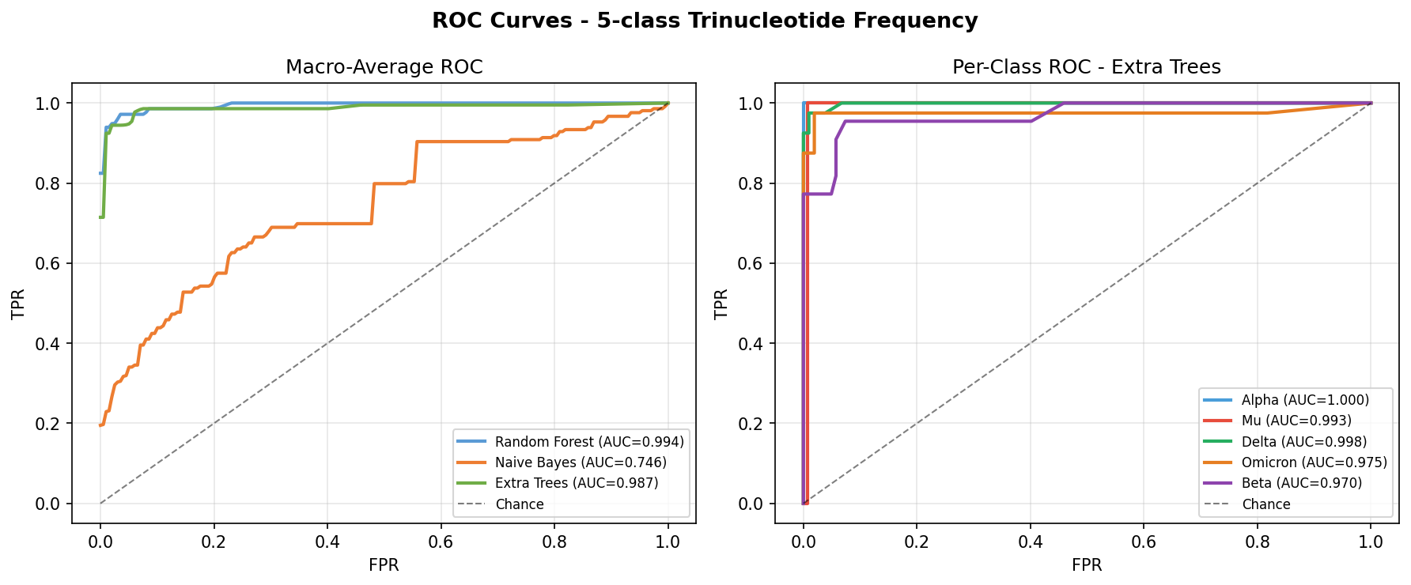
Fig. 4b. ROC curves — 5-class trinucleotide frequency classification. Left: macro-average OvR ROC for all three classifiers. Right: per-class OvR ROC curves for Extra Trees.

3.5 Tandem Repeat Classification
With full-genome scanning, the TR descriptor yields accuracy of 55.7% ± 5.7% SD (ET, three-class) and 38.6% ± 3.5% SD (ET, five-class), close to the chance baselines of 33% and 20% respectively (Table 2).
Table 2. Tandem repeat (full-genome scan) classification — 10-fold stratified CV.
Dataset | Classifier | Accuracy | Macro F1 | MCC
3-class | Random Forest | 56.4% ± 6.1% | 41.2% ± 6.8% | 0.224 ± 0.117
3-class | Naive Bayes | 47.3% ± 7.9% | 32.3% ± 6.5% | 0.134 ± 0.110
3-class | Extra Trees | 55.7% ± 5.7% | 40.6% ± 6.6% | 0.212 ± 0.108
5-class | Random Forest | 38.4% ± 3.8% | 25.3% ± 5.2% | 0.170 ± 0.055
5-class | Naive Bayes | 31.3% ± 9.4% | 20.7% ± 7.2% | 0.134 ± 0.071
5-class | Extra Trees | 38.6% ± 3.5% | 25.6% ± 4.6% | 0.171 ± 0.054
± denotes standard deviation (SD) across 10 CV folds.
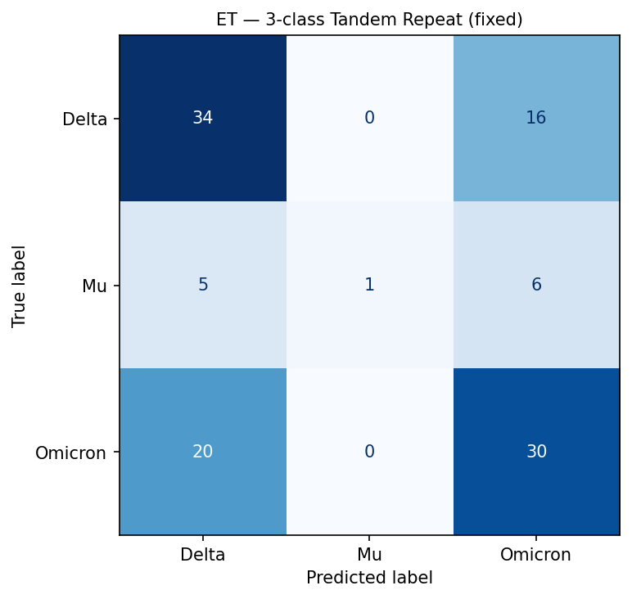
Fig. 5. Confusion matrix — Extra Trees, 3-class tandem repeat (80/20 split). Near-chance accuracy is evident from the high off-diagonal counts.

3.6 Combined 70-D Feature Vector
Table 3 shows that concatenating the 64-D trinucleotide and 6-D TR vectors produces accuracy matching trinucleotide-only performance within one standard deviation. TR features add noise rather than complementary signal.
Table 3. Combined 70-D (trinucleotide + tandem repeat) — 10-fold CV.
Dataset | Classifier | Accuracy | Macro F1 | MCC
3-class | Random Forest | 97.3% ± 1.8% | 94.5% ± 4.4% | 0.955 ± 0.031
3-class | Naive Bayes | 62.0% ± 7.4% | 47.6% ± 5.6% | 0.353 ± 0.122
3-class | Extra Trees | 97.1% ± 2.9% | 94.5% ± 5.2% | 0.952 ± 0.049
5-class | Random Forest | 93.6% ± 3.0% | 87.0% ± 8.7% | 0.915 ± 0.039
5-class | Naive Bayes | 35.8% ± 5.3% | 22.6% ± 6.8% | 0.180 ± 0.077
5-class | Extra Trees | 94.1% ± 3.3% | 87.7% ± 9.1% | 0.922 ± 0.044
± denotes standard deviation (SD) across 10 CV folds.

3.7 Accuracy and Bootstrap Confidence Intervals
Figure 6 shows mean 10-fold CV accuracy with standard deviation (SD) error bars for all classifiers and feature sets. For trinucleotide and combined descriptors, ET and RF bars are well above the chance baseline with narrow SD ranges; Naive Bayes shows substantially lower accuracy. For the TR descriptor, all classifiers approach the chance baseline with wide SD ranges. Figure 7 presents the same classifiers with 95% bootstrap confidence intervals (CI half-widths, not SD) computed from 1,000 resamples of the held-out test set predictions. For trinucleotide and combined descriptors, ET and RF bootstrap CIs are narrow and non-overlapping with NB. For the TR descriptor, all classifiers show wide overlapping CIs spanning the chance baseline.
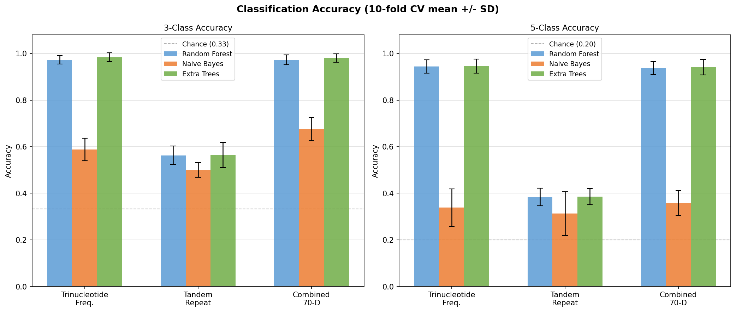
Fig. 6. Mean 10-fold CV accuracy (bars) with standard deviation (SD) error bars for all classifiers and feature sets. Left: three-class; right: five-class. Dashed line marks chance level.
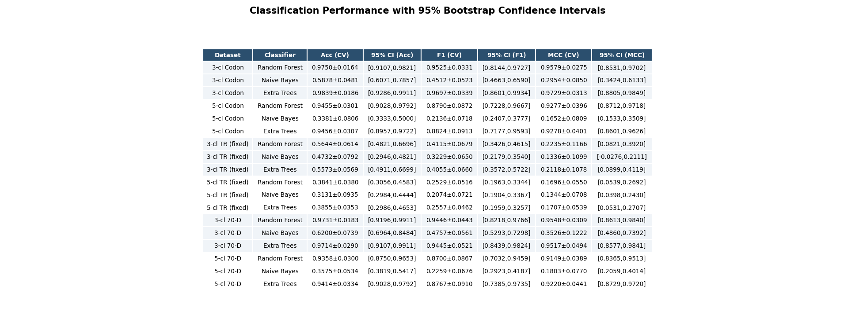
Fig. 7. Classification performance with 95% bootstrap confidence intervals (CI half-widths) for all classifiers, datasets, and feature descriptors. Note: ± here denotes CI half-width, not SD.

3.8 Statistical Significance (McNemar's Test)
Table 4 reports p-values from pairwise McNemar's tests applied to predictions from the held-out 20% test set. Three classifiers × six feature–dataset combinations yield 18 pairwise tests (Bonferroni family A); the Bonferroni-corrected significance threshold is α_adj = 0.05/18 = 0.0028. For trinucleotide and combined descriptors, tree-based classifiers (RF, ET) significantly outperform NB (p < 0.0028 in all cases after Bonferroni correction). The RF vs. ET difference is non-significant (p > 0.05) for every dataset and descriptor. For the TR descriptor in the five-class setting, no pairwise comparison reaches significance even at the uncorrected α = 0.05.
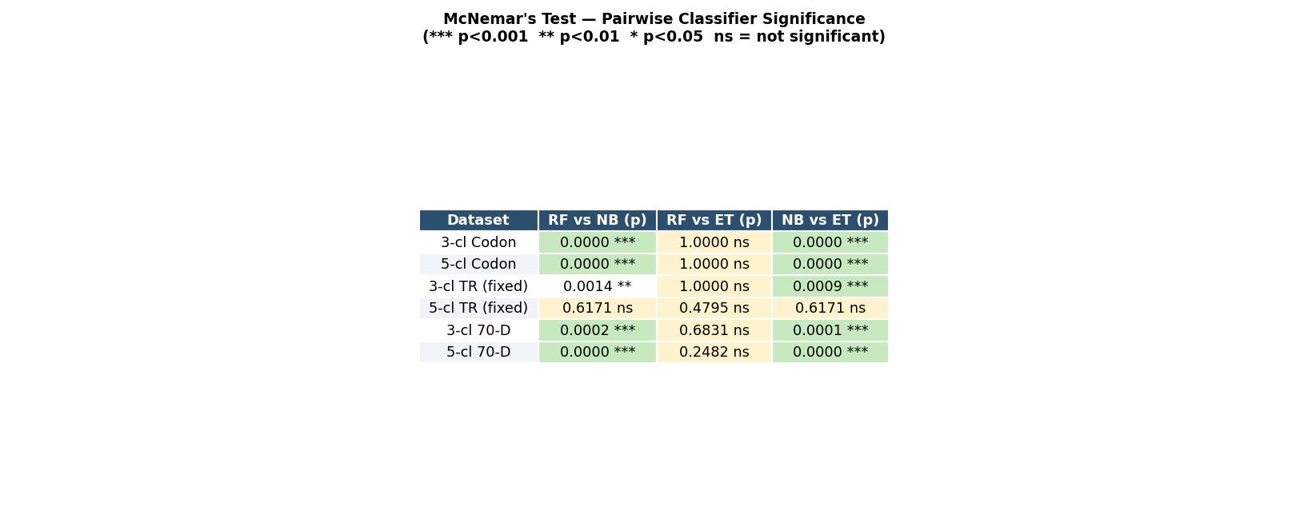
Table 4. McNemar's test p-values for pairwise classifier comparisons. Significance at Bonferroni-corrected threshold α_adj = 0.0028 shown with double dagger (‡); standard thresholds: *** p<0.001, ** p<0.01, * p<0.05, ns = not significant.

3.9 CpG Observed/Expected Ratio Analysis
Figure 8 displays boxplots of CpG O/E ratios per variant class computed from the five-class (n=716) dataset. All five variants show CpG O/E < 1.0, confirming genome-wide CpG suppression consistent with ZAP-mediated selection pressure [7,9]. One-way ANOVA revealed highly significant inter-variant differences in CpG O/E (F = 14.19, p = 3.82 × 10⁻¹¹). Bonferroni-corrected pairwise t-tests (Bonferroni family B: α_adj = 0.005 for 10 pairs) confirmed that multiple variant pairs differ significantly in CpG suppression level. These quantitative differences in CpG O/E ratios provide direct biological validation of why CpG-containing trinucleotides (CCG, GCG, CGG) emerge as the most discriminative SHAP features: inter-variant differences in CpG dinucleotide frequency are directly encoded in the trinucleotide feature space.
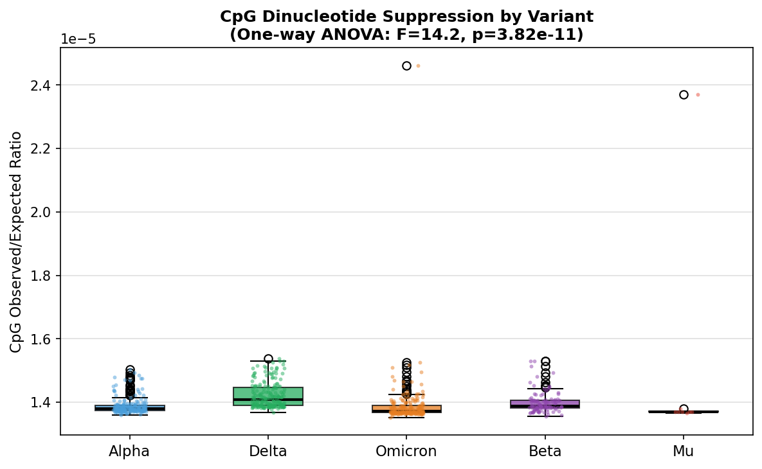
Fig. 8. CpG observed/expected (O/E) ratio per SARS-CoV-2 variant class (five-class dataset, n=716). Boxplots show median, IQR, and 1.5×IQR whiskers; individual points are jittered for visibility. One-way ANOVA: F=14.19, p=3.82×10⁻¹¹. All O/E values < 1.0 confirm genome-wide CpG suppression.

3.10 Proximity-Based Prediction Validation

3.10.1 Held-Out Single-Sample Validation
The last genome of each variant class was withheld and presented as an unlabelled query sequence. Table 5 reports the full output for all five held-out samples. This validation uses n=5 samples from the same NCBI dataset as the training data and should be interpreted as a demonstration of framework functionality rather than a rigorous performance estimate.
The Alpha held-out sample returned a negative novelty score (−0.001), which is marginally below zero and would be classified as a novelty by the Isolation Forest threshold. This borderline score reflects the Alpha sample's position near the boundary of the training distribution, not a genuine biological novelty; it illustrates that the Isolation Forest contamination parameter (0.05) will produce false positives at a rate proportional to the contamination fraction even for in-distribution samples. The Mu held-out sample also returns a negative score (−0.246), which is consistent with Isolation Forest detecting Mu's under-representation in the training data (n=8 training sequences) as an anomaly.
Table 5. Held-out validation of the proximity-based prediction framework.
True Variant | Top Match | Ensemble p | Mahal. Dist. | Novelty Score | Novel / Recomb.
Alpha | Alpha | 0.855 | 12.87 | −0.001 | Yes* / No
Mu | Mu | 0.848 | 2.47 / 83.6‡ | −0.246 | Yes** / No
Delta | Delta | 0.975 | 5.87 | +0.146 | No / No
Omicron | Omicron | 0.983 | 8.32 | +0.114 | No / No
Beta | Beta | 0.892 | 9.39 | +0.154 | No / No
Mahal. Dist.: Mahalanobis distance using ridge-regularised covariance (λ=10⁻⁶). ‡ Mu row shows ridge value / Ledoit-Wolf value. Mu Mahalanobis is unreliable: n=8, p=64 yields a rank-deficient covariance matrix. Ledoit-Wolf shrinkage (α=0.617) gives an LW-regularised distance of 83.6, substantially different from the ridge value of 2.47; the ridge value should not be interpreted geometrically. * Alpha novelty score (−0.001) is marginally below the Isolation Forest threshold; false positives at this rate are expected at contamination=0.05. ** Mu novelty is consistent with Isolation Forest's response to the class being represented by only 8 training sequences.
Figure 9 shows the supervised UMAP embedding with held-out samples projected via UMAP.transform(). Figure 10 shows ensemble probability distributions.
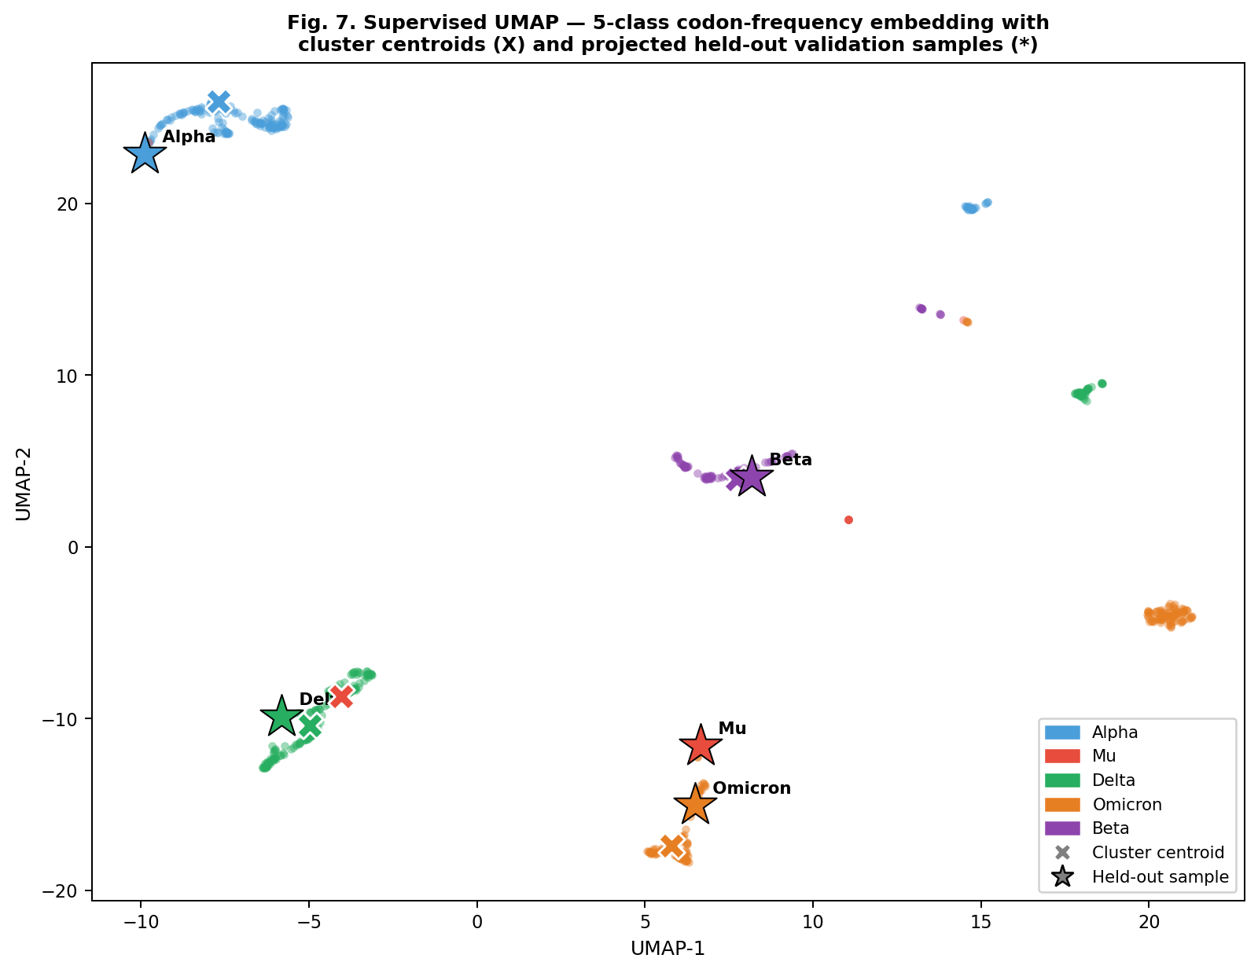
Fig. 9. Supervised UMAP embedding of the 716-sequence 5-class dataset. Background: training sequences; × markers: per-class centroids; ★ markers: held-out validation samples projected via UMAP.transform().
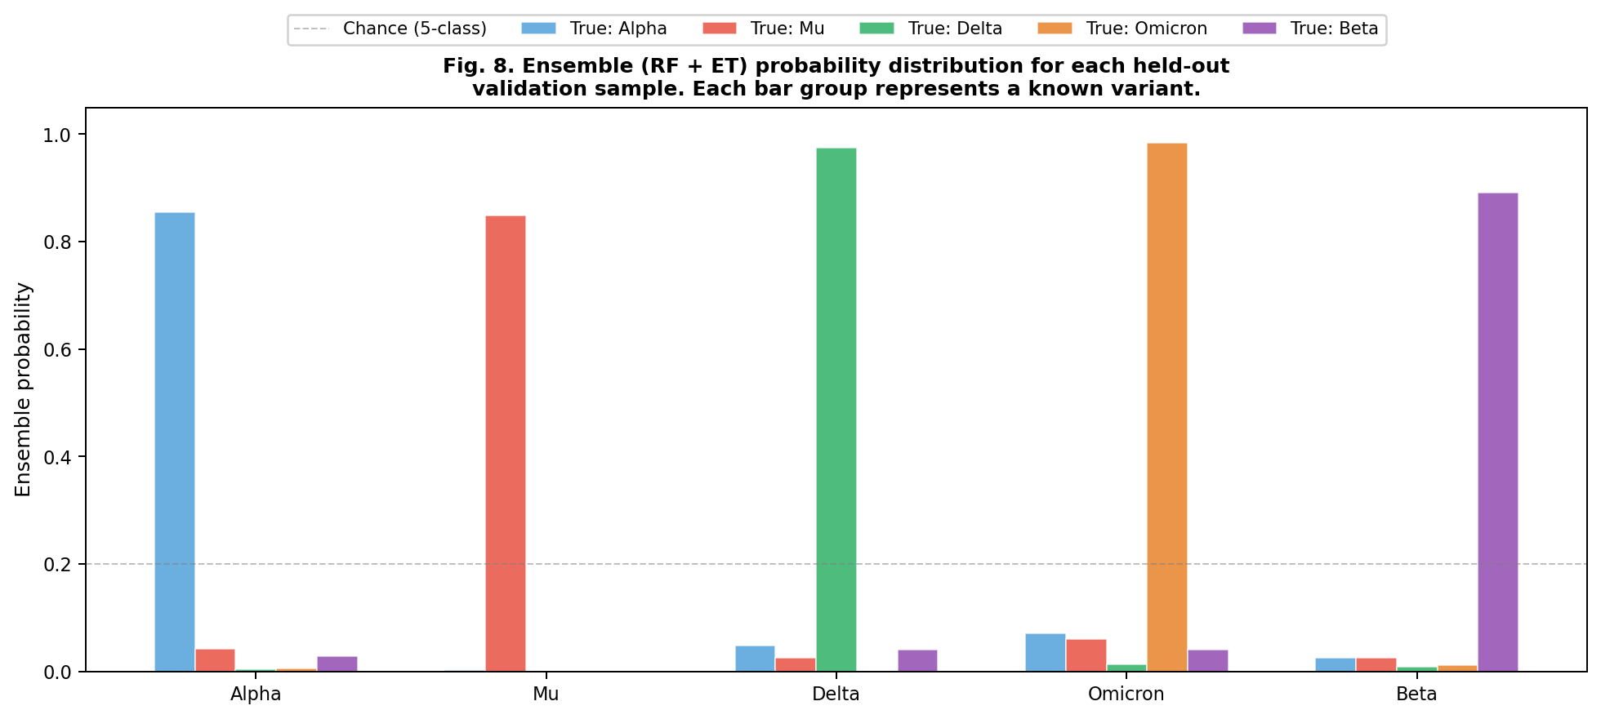
Fig. 10. Ensemble (RF + ET) probability distribution for each held-out validation sample. Dashed line marks 5-class chance level (0.20).
Figure 11 illustrates the complete proximity-based variant characterisation workflow.
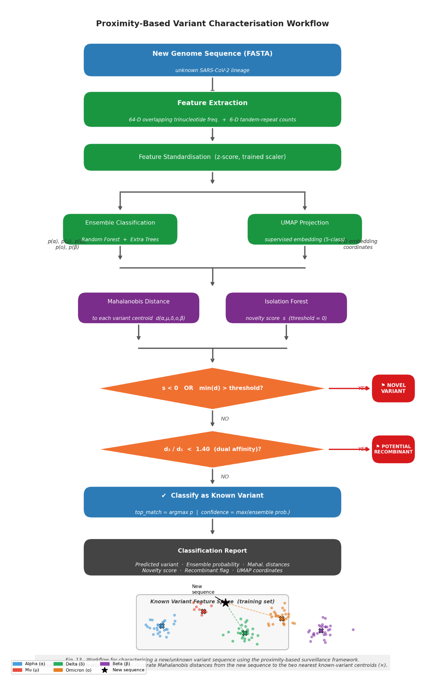
Fig. 11. Flowchart of the proximity-based variant characterisation workflow.

3.11 Biological Interpretation of Discriminative Trinucleotides
SHAP feature importance analysis of the best-performing Extra Trees model identified CCG (0.0697), GCG (0.0651), CGG (0.0381), CCC (0.0376), and GGG (0.0322) as the five highest mean absolute SHAP values. The top three each contain a CpG dinucleotide. This is consistent with the CpG O/E analysis in Section 3.9: variants that differ most in genome-wide CpG suppression (confirmed by ANOVA, p=3.82×10⁻¹¹) are most separable via CpG-containing trinucleotide frequencies. The contribution of RNA secondary structure constraints [21] to trinucleotide composition differences across variants warrants further investigation.
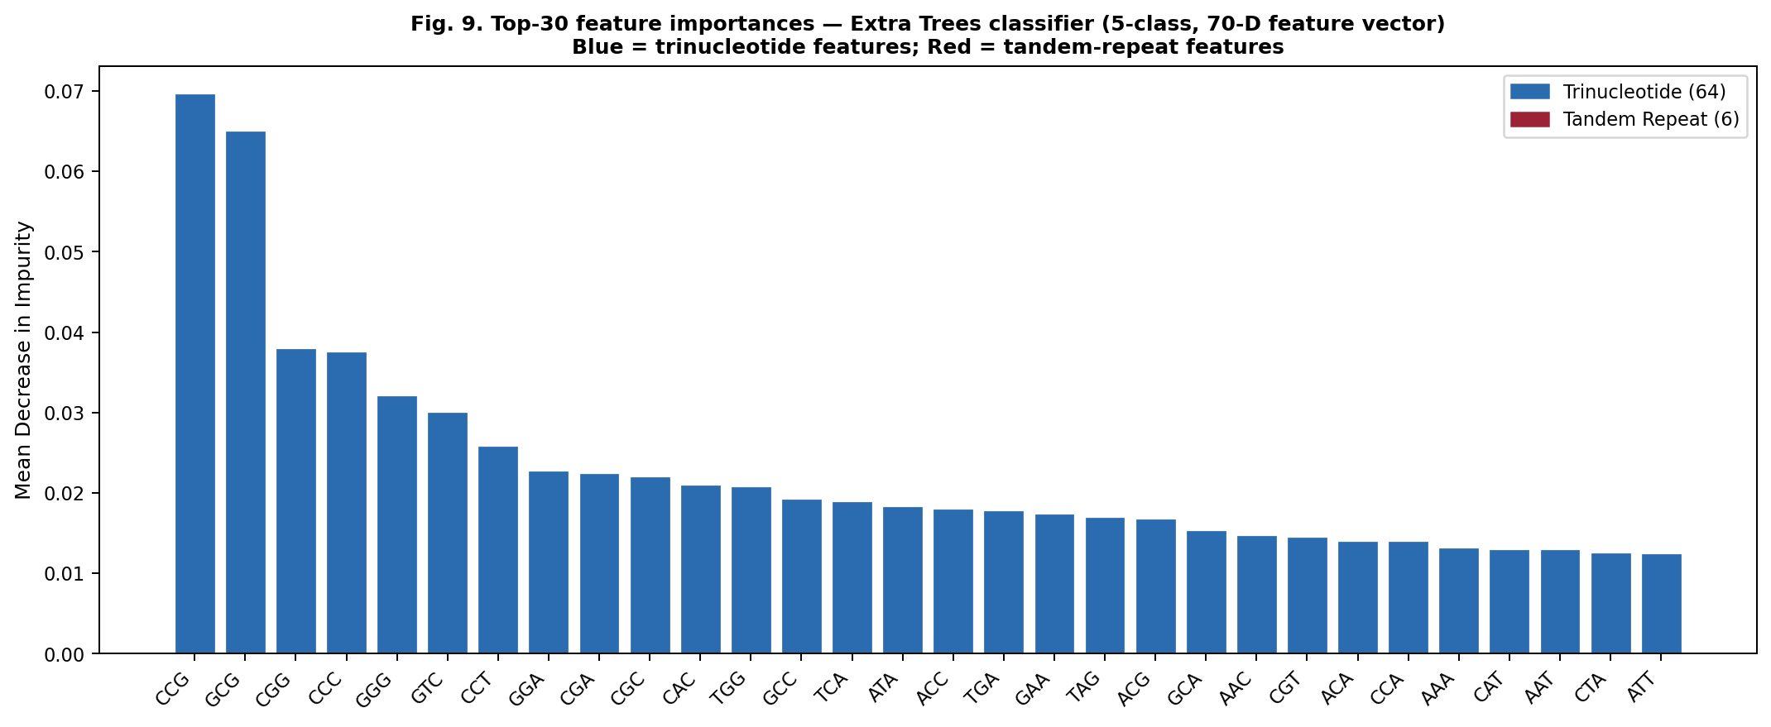
Fig. 12. Top-30 feature importances for the Extra Trees classifier (64-D trinucleotide features in blue, 6-D tandem repeat features in red). CpG-containing trinucleotides (CCG, GCG, CGG) rank highest.
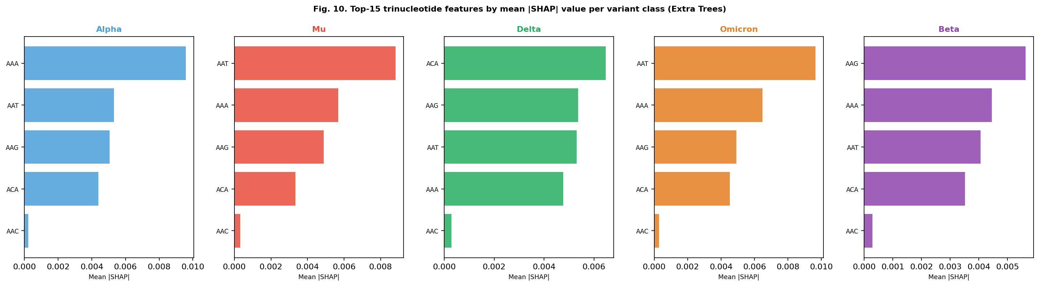
Fig. 13. Per-class SHAP feature importance for each of the five SARS-CoV-2 variant classes. Top 15 features shown per class.
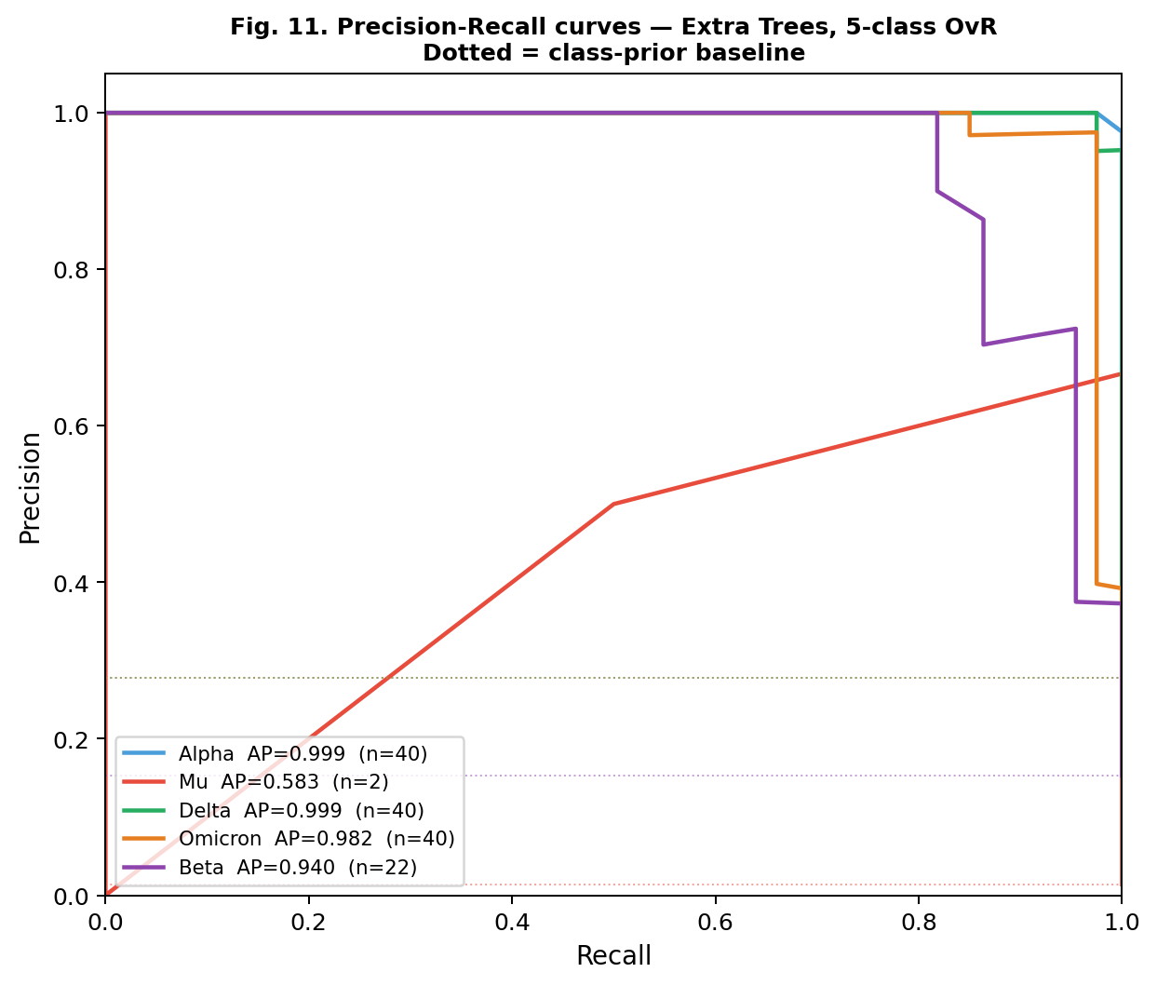
Fig. 14. Per-class precision–recall curves for Extra Trees. Note substantially lower AP for Mu (AP=0.5833) vs. majority classes (AP>0.98).
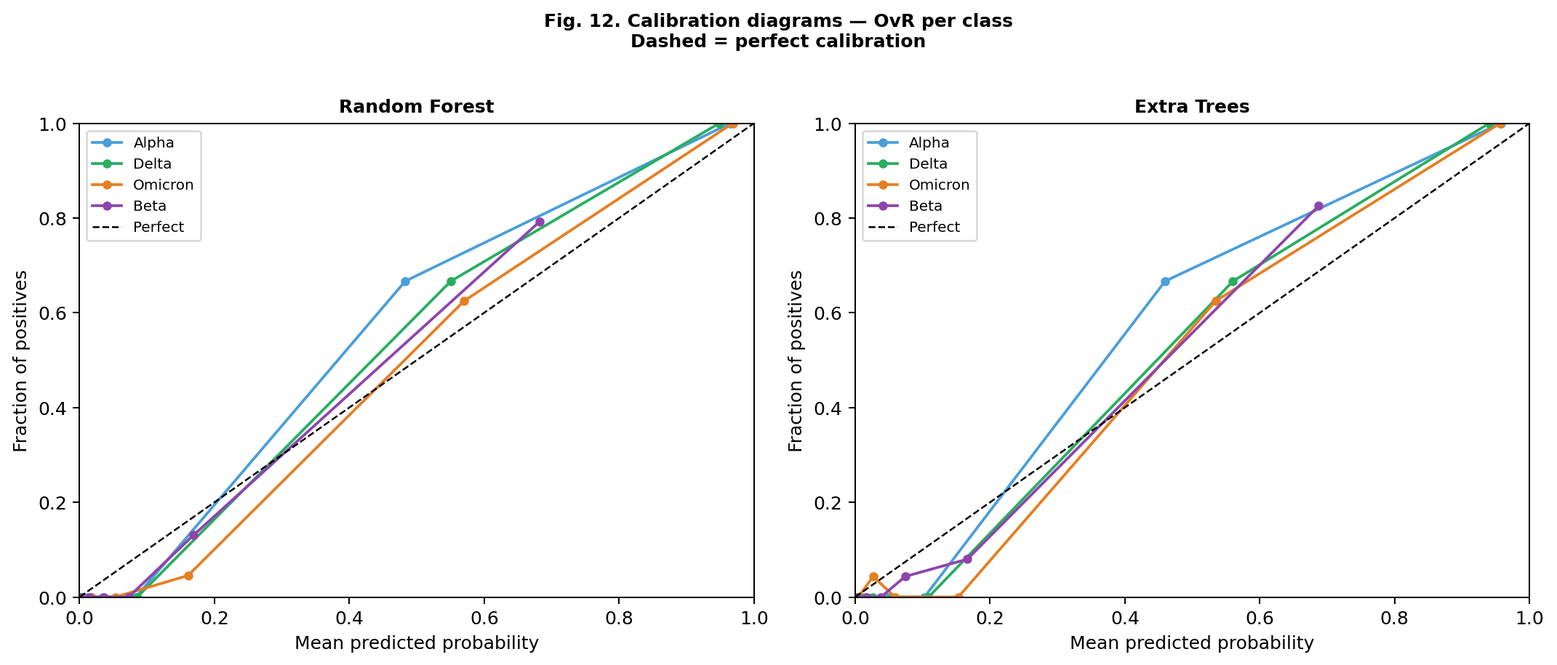
Fig. 15. Calibration plot for Extra Trees. Overconfidence at high probability values is a known property of tree ensemble methods.

4. Discussion
This study demonstrates that 64-dimensional overlapping trinucleotide frequency vectors extracted from complete SARS-CoV-2 genomes discriminate five variant classes with high internal cross-validation accuracy using ensemble tree classifiers, with Extra Trees achieving 94.6% ± 3.1% SD five-class accuracy and macro-AUC > 0.99. The discriminative power is grounded in differential CpG suppression across SARS-CoV-2 lineages, confirmed quantitatively by CpG O/E ratio analysis (ANOVA F=14.19, p=3.82×10⁻¹¹) and reflected in elevated SHAP importance of CpG-containing trinucleotides.
CpG Suppression as the Biological Mechanism. The identification of CpG-containing trinucleotides as the most discriminative features is consistent with ZAP-mediated CpG suppression in RNA viruses [7,9]. The CpG O/E analysis provides independent quantitative confirmation: inter-variant differences in CpG dinucleotide frequency are directly encoded in the trinucleotide feature space, explaining why k=3 is an effective and interpretable choice.
Three-Class Dataset Composition. The three-class dataset (Delta/Mu/Omicron, n=558) differs from the five-class NCBI dataset in two respects: (i) it focuses on the three most recently circulating variants, and (ii) all three classes were augmented with 50 GISAID sequences each. Users applying this framework should note that these two datasets have different compositions and that the three-class results are not a simple subset of the five-class results.
Bonferroni Correction and Statistical Rigor. Two separate Bonferroni families were applied. Family A (McNemar pairwise tests): 18 tests across three classifiers and six feature–dataset combinations, α_adj = 0.0028. Family B (CpG pairwise t-tests): 10 variant pairs, α_adj = 0.005. All reported NB vs. tree-ensemble McNemar differences survive Family A correction. The RF vs. ET comparison remains non-significant, correctly reflecting genuine convergence of performance.
Mu Variant: Class Imbalance and Reliability. The Mu variant is represented by only 8 sequences in the five-class dataset. AP=0.5833 for Mu (Fig. 14) vs. AP>0.98 for majority classes quantifies this limitation. The Ledoit-Wolf analysis (shrinkage α=0.617) confirms that the Mu sample covariance matrix is severely ill-conditioned; the ridge-regularised Mahalanobis distance of 2.47 in Table 5 should not be interpreted geometrically.
Calibration and Confidence Threshold Reliability. Extra Trees is overconfident at high probability values [20]. Users should apply post-hoc calibration before using raw predicted probabilities as confidence scores.
Comparison to Prior Work. Pangolin [3] and Nextclade [4] achieve >99% lineage assignment accuracy on high-quality complete genomes and represent the current standard. The alignment-free approach does not surpass these tools and is not proposed as a replacement; its value lies in rapid batch screening in resource-constrained environments. Compared to prior k-mer SARS-CoV-2 classification studies [22], the present work adds comprehensive statistical validation, CpG O/E biological grounding, and explicit failure-mode characterisation. For a general treatment of density-based classification methods, see [16].
Tandem Repeat Features. Near-chance TR performance (38–56%) confirms that tandem repeats in coronavirus genomes do not track the single-nucleotide compositional divergence distinguishing variants, simplifying the recommended feature engineering pipeline.

4.1 Limitations
Principal limitations: (1) All performance figures are based on internal cross-validation from NCBI/GISAID sampling; no external validation cohort was used. (2) Random-split results are subject to phylogenetic dependence inflation; stratified-split figures are more conservative but still internal. (3) Mu variant metrics in the five-class dataset are unreliable due to extreme class imbalance (n=8, ratio approximately 1:25 relative to majority classes). In the three-class dataset, Mu is less severely underrepresented after GISAID augmentation (n=58, ratio approximately 1:4.3 relative to Delta and Omicron), yielding improved but still cautious metrics. (4) Even with Ledoit-Wolf regularisation (shrinkage α=0.617), which substantially improves matrix conditioning relative to the uncorrected sample covariance, the Mu Mahalanobis distance remains preliminary: n=8 is insufficient to estimate a reliable 64-dimensional covariance structure, and the LW-regularised value of 83.6 should be interpreted with caution. (5) No quantitative comparison to Pangolin, Nextclade, or other k-mer baselines was performed. (6) The proximity framework has not been evaluated on genuinely novel or confirmed recombinant sequences. (7) Extra Trees probability outputs require post-hoc calibration. (8) Only three classifiers with default hyperparameters were evaluated.

5. Conclusion
We have presented a systematic evaluation of overlapping trinucleotide frequency analysis as an alignment-free approach to SARS-CoV-2 variant classification. Extra Trees achieved 94.6% ± 3.1% SD five-class and 98.4% ± 1.9% SD three-class (Delta/Mu/Omicron) accuracy under internal 10-fold stratified cross-validation, with macro-AUC > 0.99 in both tasks. CpG O/E ratio analysis (F=14.19, p=3.82×10⁻¹¹) provides independent biological validation of the discriminative mechanism identified by SHAP. Bonferroni correction across 18 McNemar tests confirms statistical rigor of all reported classifier differences. External validation on an independent cohort is the primary recommended next step before any deployment claim can be substantiated.

Code and Data Availability
All analysis code is publicly available at GitHub: https://github.com/arkaketan/sars-cov2-trinucleotide-classification and Zenodo DOI: https://doi.org/10.5281/zenodo.20319358 (archived release, v1.0.0). The repository contains Python scripts for overlapping trinucleotide frequency extraction from FASTA files, Jupyter notebooks reproducing all figures and statistical tables, and a README with step-by-step instructions. The code is released under the MIT Licence.
The 716 SARS-CoV-2 complete genome sequences from NCBI are available via NCBI Nucleotide (https://www.ncbi.nlm.nih.gov/nucleotide/); accession numbers are available in the project GitHub repository. GISAID sequences used in the three-class dataset are available to registered GISAID users; EPI_ISL accession numbers are provided in the project GitHub repository.

Conflicts of Interest
The authors declare no conflicts of interest.

Funding
This research received no specific grant from any funding agency in the public, commercial, or not-for-profit sectors.

Acknowledgements
We gratefully acknowledge the originating laboratories responsible for obtaining SARS-CoV-2 specimens and the submitting laboratories where genetic sequence data were generated and shared via the GISAID EpiCoV database. The authors acknowledge the contributors of GISAID sequences used in the three-class dataset; EPI_ISL accession numbers are provided in the project GitHub repository. We thank the National Center for Biotechnology Information (NCBI) for providing open access to the genome sequence data used in the five-class dataset. The authors used scikit-learn, UMAP-learn, and SHAP open-source libraries; we acknowledge their respective developer communities.

References
[1] WHO. Tracking SARS-CoV-2 variants. World Health Organization, 2023.
[2] Rambaut A, et al. A dynamic nomenclature proposal for SARS-CoV-2 lineages to assist genomic epidemiology. Nat Microbiol. 2020;5:1403–1407.
[3] Rambaut A, et al. Pangolin: lineage assignment tool for SARS-CoV-2 sequences. https://github.com/cov-lineages/pangolin.
[4] Aksamentov I, Roemer C, Hodcroft EB, Neher RA. Nextclade: clade assignment, mutation calling and quality control for viral genomes. J Open Source Softw. 2021;6:3773.
[5] Deschavanne PJ, Giron A, Vilain J, Fagot G, Fertil B. Genomic signature: characterization and classification of species assessed by chaos game representation of sequences. Mol Biol Evol. 1999;16:1391–1399.
[6] Di Gioacchino A, et al. Heterogeneous dynamics of codon usage patterns in the SARS-CoV-2 genome. Sci Rep. 2021;11:9482.
[7] Simmonds P. CpG dinucleotide frequencies of SARS-CoV-2 and related RNA viruses. Mol Biol Evol. 2020;37:2768–2770.
[8] Digard P, Lee HM, Sharp C, Grey F, Gaunt E. Intra-genome variability in the dinucleotide composition of SARS-CoV-2. Virus Evol. 2020;6:veaa057.
[9] Takata MA, Goncalves-Carneiro D, Zang TM, et al. CG dinucleotide suppression enables antiviral defence targeting non-self RNA. Nature. 2017;550:124–127.
[10] Jeffrey HJ. Chaos game representation of gene structure. Nucleic Acids Res. 1990;18:2163–2170.
[11] van der Maaten L, Hinton G. Visualizing Data using t-SNE. J Mach Learn Res. 2008;9:2579–2605.
[12] McInnes L, Healy J, Melville J. UMAP: Uniform Manifold Approximation and Projection for Dimension Reduction. arXiv:1802.03426, 2018.
[13] Wu F, et al. A new coronavirus associated with human respiratory disease in China. Nature. 2020;579:265–269.
[14] Pedregosa F, et al. Scikit-learn: Machine Learning in Python. J Mach Learn Res. 2011;12:2825–2830.
[15] Liu FT, Ting KM, Zhou Z-H. Isolation Forest. Proc 8th IEEE Int Conf Data Mining (ICDM). 2008:413–422.
[16] Lundberg SM, Lee S-I. A unified approach to interpreting model predictions. Adv Neural Inf Process Syst. 2017;30.
[17] McNemar Q. Note on the sampling error of the difference between correlated proportions or percentages. Psychometrika. 1947;12(2):153–157.
[18] Virtanen P, et al. SciPy 1.0: fundamental algorithms for scientific computing in Python. Nat Methods. 2020;17:261–272.
[19] van der Maaten L, Hinton G. Visualizing data using t-SNE. J Mach Learn Res. 2008;9:2579–2605.
[20] McInnes L, Healy J, Melville J. UMAP: Uniform Manifold Approximation and Projection for Dimension Reduction. arXiv:1802.03426. 2018.
[21] Ledoit O, Wolf M. A well-conditioned estimator for large-dimensional covariance matrices. J Multivar Anal. 2004;88(2):365–411.
[22] Mahalanobis PC. On the generalised distance in statistics. Proc Natl Inst Sci India. 1936;2(1):49–55.

