Real-Time Detection of Object Missing and New Object Placement in Video

Name: Aryan Kakran

Date: April 26, 2025

Task Title: Real-Time Detection of Object Missing and New Object Placement in Video

# 1. FPS Achieved (Real-time Performance)

The object detection and tracking system achieved an average of approximately 4.5 FPS. This performance was achieved using the YOLOv8n model in combination with BoT-SORT tracking. Frame processing includes detection, tracking, annotation, and optional logging.

# 2. Sample Output Frames

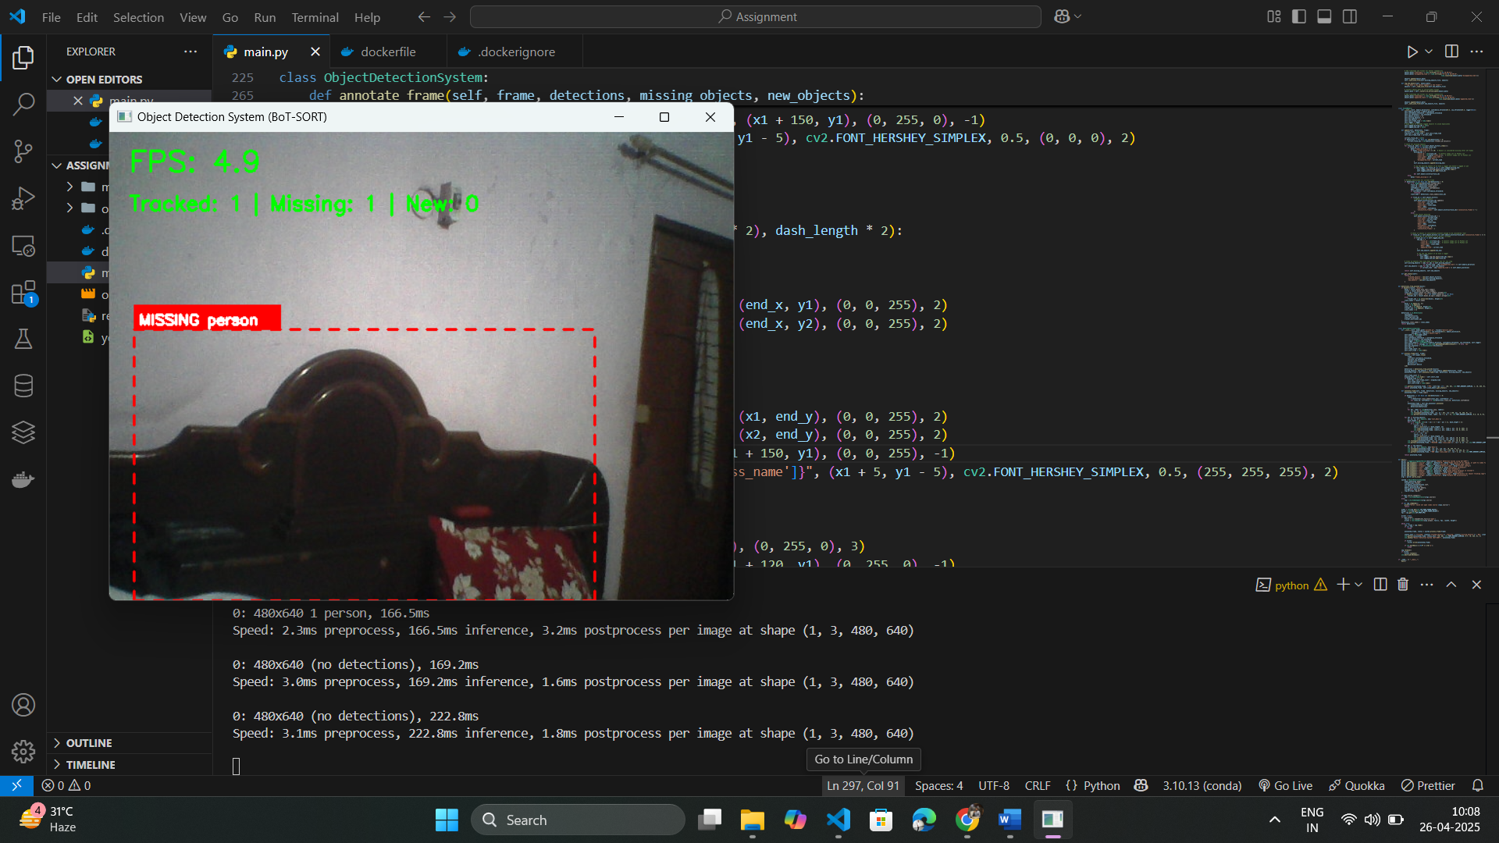

# 3. Hardware Configuration Used for Testing

|  |  |
| --- | --- |
| Component | Specification |
| CPU | AMD Ryzen 5 3500U |
| GPU | Integrated Radeon Vega 8 |
| RAM | 8 GB |
| Storage | 512 GB SSD |
| Operating System | Windows |

# 4. Techniques, Optimisations, and Architectural Decisions

- Used YOLOv8n for lightweight and fast object detection.  
- BoT-SORT integrated for robust multi-object tracking.  
- Custom SceneMemory module designed to track and differentiate new and missing objects across frames.  
- Logging system created to persist missing and new object events in structured JSON files.  
- Real-time visual feedback including FPS and object labels using OpenCV and supervision.  
- Dockerized the full pipeline for ease of deployment and reproducibility.  
- Command-line interface built for configurable detection parameters (confidence, IoU, memory duration, etc.).

# 5. Output Video

The output video demonstrating the system's real-time capabilities is included in the repository as `output_video.mp4`. It captures object tracking, new object detection, and missing object alerts with FPS display and bounding box annotations.