Phase 0: Wire Instruction Extraction
Initial Funding Automation · Return on investment · October 2026

Summary
Phase 0 reads the wire instructions in each funding package and fills in the beneficiary, bank, routing number and account number for the reviewer. Keying and checking those details by hand takes about 40 minutes a package. With Phase 0 the reviewer confirms prepared values instead, which takes about 6 minutes. At roughly 100 packages a month that frees about 684 staff hours a year, worth about $36k a year after running costs of about $1,800.
Phase 0 is built and has been tested on 18 live readings of six deliberately difficult wire instruction layouts. It read 200 of 200 routing and account numbers correctly and flagged every value it got wrong, so nothing incorrect reached the reviewer unmarked. Accounting still reviews every package, approves, enters payments in CashPro and releases funds.
40 → 6 min  staff time on wire details per package | 684 h  staff hours freed per year | $36k  net value per year at 100 packages a month | 100%  routing and account numbers read correctly in testing

Where the time goes
Today the reviewer finds each detail in the wire instructions, types it into the triage workbook and checks it back. With Phase 0 the details arrive filled in, and the fields that need a closer look are highlighted.
Staff time on wire instruction details, per package
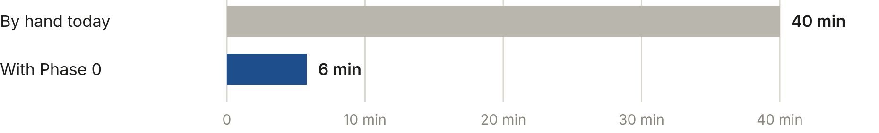
Figure 1. After Phase 0, about 4 minutes go to confirming the values against the document and about 2 to the 0.9 highlighted fields a package has on average. Over the whole four-hour package this is a 14% saving (240 to 206 minutes).

Accuracy
The wire step was tested on six synthetic wire instruction layouts chosen to be hard to read: repeated digits, small type in dense tables, fax-quality scans and details on a second page, all scanned to images. 18 live readings of those layouts were run 100 times through the production software, which scores every value and decides what to flag.
Fields read correctly, 100 test packages
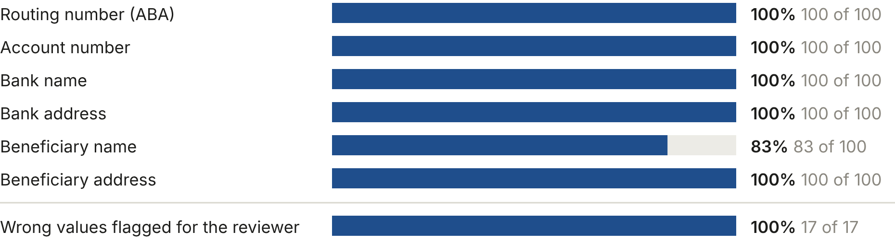
Figure 2. Below 100%: Beneficiary name, 83 of 100. Every beneficiary name miss came from one layout whose page text spelled “&” as “&amp;”, which was copied into the name. The software now converts it back before extraction; not yet re-tested. 83 of 100 packages had all six fields right.
Mistral Document AI turns each page into text and gpt-6-luna extracts the fields from that text. Mistral's own reading of the page serves as a check: a field is flagged when the two disagree, when its confidence is low, or, for routing numbers, when the ABA check digit fails. On average 0.9 of the six fields are flagged per package. A character misread when the page is turned into text would pass the other checks; the check digit catches that for routing numbers, and for the other fields the reviewer's comparison with the document remains the control.

Annual value
Staff hours freed per year | 684
Full-time equivalents | 0.4
Value of staff time at $55/hour | $37,600
Running cost (AI processing and hosting) | $1,800
Net value per year | $35,800

The build cost is not set yet. The table shows how much Phase 0 could cost to build and still pay for itself from its net value.
To pay for itself within | 6 months | 12 months | 24 months
The build can cost up to | $18k | $36k | $72k

The saving depends mainly on volume and on how long the reviewer spends confirming values and fixing highlighted fields. Net value per year:
Packages | Half the estimated review time | As estimated | 50% more review time
50 a month | $19k | $17k | $15k
100 a month | $39k | $36k | $33k
200 a month | $80k | $73k | $67k

Cumulative net value of Phase 0 over two years
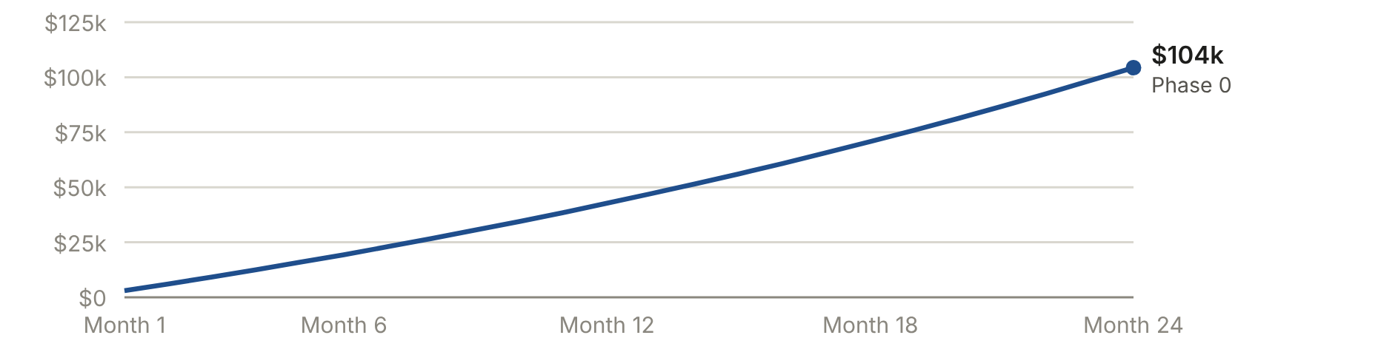
Figure 3. Volume starts at about 100 packages a month and grows 3% a month. With no growth the two-year figure is about $72k. Build cost is not included.

Speed and running cost
 | By hand today | With Phase 0
Reading the wire instructions | about 40 minutes | about 12 seconds, then review
Cost per package for this step | $37 staff time | $5.30 staff time + $0.0038 AI
AI processing per year | – | about $5
Azure hosting, storage and monitoring per year | – | about $1,800

Azure list prices: Mistral Document AI $3.00 per 1,000 pages; gpt-6-luna $0.10 and $0.50 per million input and output tokens. Hosting is an estimate and covers services Phase 1 will also use.

Basis of the figures
- Measured: accuracy, flagging, highlighted fields per package and processing time (see Accuracy).
- Provided by the business: about four hours of staff time per package today, and about 100 loans a month (from the Treasury loan volume).
- Estimated: 40 minutes of manual wire keying and checking within the four hours; 4 minutes to confirm a prepared package and 2 minutes per highlighted field; a loaded staff cost of $55 an hour; 3% monthly growth; hosting cost.
- Not included: the cost of building Phase 0, and the avoided cost of a misdirected wire. Staff hours freed are capacity for other work, not a budget reduction unless roles change.

