Phase 1: Package Processing Automation
Initial Funding Automation · Return on investment · October 2026

Summary
Phase 1 automates the rest of the funding package work around the wire instructions: collecting the request and its attachments, checking the settlement statement against the email and the wire, listing exceptions, and preparing the triage workbook, CashPro file and BCMP values. It builds on Phase 0, which already reads the wire instructions.
Once Phase 0 is in place a package takes about 206 minutes of staff time. Phase 1 is expected to bring that to about 61 minutes. At roughly 100 packages a month that frees a further 2,900 staff hours a year, the equivalent of 1.6 full-time positions, worth about $159k a year after running costs of about $600. Phase 1 is not built yet, so these figures are estimates to be confirmed in the pilot.
206 → 61 min  expected staff time per package, after Phase 0 | 2,900 h  additional staff hours freed per year | $159k  net value per year at 100 packages a month | $0.013  AI cost per package for the added steps

What Phase 1 adds
- Funding request emails and attachments collected into a standard SharePoint package for each loan.
- Automatic checks between the internal settlement statement, the request email and the wire instructions: amounts, fees, fund, dates, routing number format and masked accounts.
- A list of exceptions for Accounting, each with the reason it was raised.
- The IF triage workbook, the BOA CashPro import file and the BCMP wet-funding values, ready for review.
Accounting keeps the controls it has today: review of the source documents and outputs, resolution of flagged values, CashPro and ProMerit entry, second-person approval and final release. The system prepares payments. It does not send them.

Where the time goes
Staff time per funding package
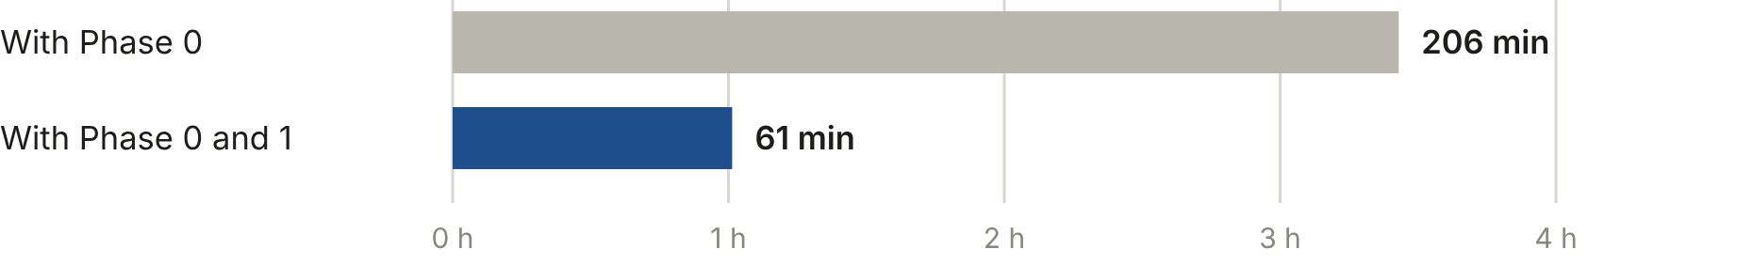
Figure 1. Phase 1 removes about 145 minutes from each package, 70% of the time left once Phase 0 is running.
Minutes per package, by task
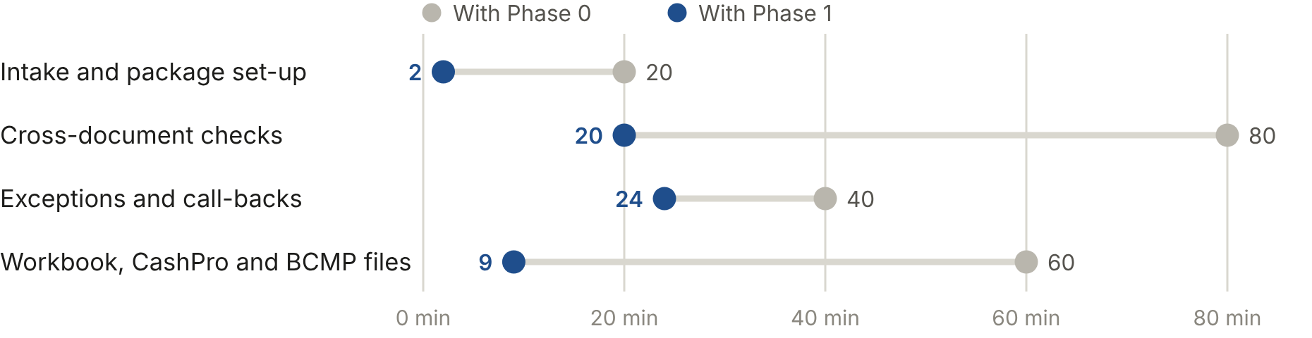
Figure 2. The largest reduction is in cross-document checks. Exceptions keep the most manual time, because call-backs to verify masked or changed wire details stay with a person.

Annual value
Staff hours freed per year | 2,900
Full-time equivalents | 1.6
Value of staff time at $55/hour | $159,500
Running cost (AI processing and hosting) | $600
Net value per year | $158,900

The build cost is not set yet. The table shows how much Phase 1 could cost to build and still pay for itself from its net value.
To pay for itself within | 6 months | 12 months | 24 months
The build can cost up to | $79k | $159k | $318k

The saving depends mainly on volume and on how much review work is left once each step is automated. Net value per year:
Packages | Half the estimated review work | As estimated | 50% more review work
50 a month | $94k | $79k | $64k
100 a month | $189k | $159k | $129k
200 a month | $379k | $318k | $258k

Cumulative net value of Phase 1 over two years
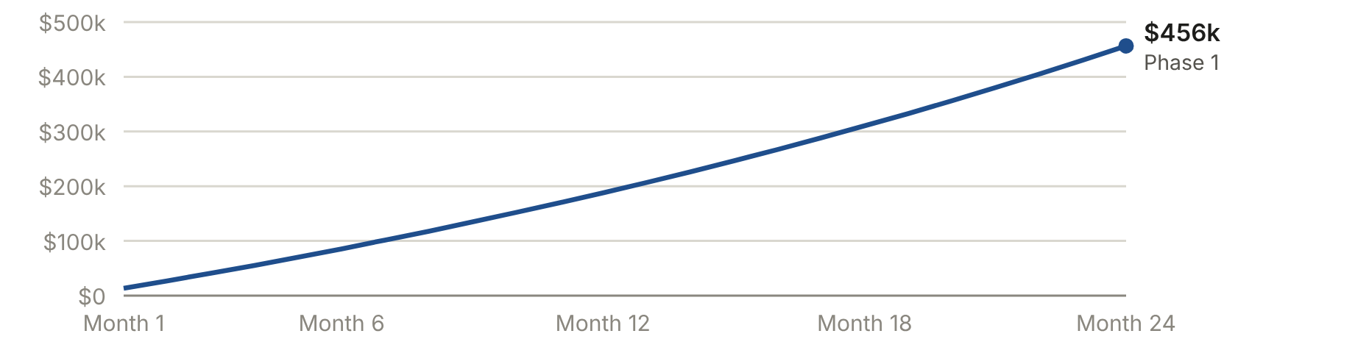
Figure 3. Volume starts at about 100 packages a month and grows 3% a month. With no growth the two-year figure is about $318k. Build cost is not included.

Running cost
AI reading of the settlement statement and email, per package | $0.0134
AI processing per year at 100 packages a month | about $16
Additional hosting: mailbox and SharePoint automation, storage | about $600 a year

Priced at the same Azure rates as Phase 0, assuming about 4 pages per package for the settlement statement and email. Phase 1 runs on the Azure services Phase 0 already pays for, so only the additional hosting is counted here.

Basis of the figures
- Provided by the business: about four hours of staff time per package today, and about 100 loans a month (from the Treasury loan volume).
- Estimated: how the four hours divide across tasks; the share of each task that remains with a person once it is automated (intake 10%, cross-document checks 25%, exceptions 60%, output files 15%); a loaded staff cost of $55 an hour; 3% monthly growth; AI pages per package and hosting cost.
- Not yet tested: the cross-document checks and exception rules. Their accuracy, and the time they save, will be measured in the pilot alongside the current process.
- Not included: the cost of building Phase 1, and the avoided cost of a misdirected wire. Staff hours freed are capacity for other work, not a budget reduction unless roles change.

