Use Case 1
Wire Instruction Extraction · Return on investment · October 2026

Summary
Each wire transaction comes with a wire instruction document. Today a person reads each document and keys the beneficiary, bank, routing number and account number, which takes about 1 minute per document: 20 minutes for the 20 documents that arrive on a typical day. Our system processes the same 20 documents in 1 minute, 20 times faster.
That returns about 19 minutes a day, or 79 staff hours a year, worth about $4k a year before running costs and $3k after them. The value grows in step with volume: at 160 documents a day the system needs 8 minutes where a person would need 2.7 hours. In testing it read 200 of 200 routing and account numbers correctly and flagged every value it got wrong for a person to check.
20 → 1 min  to process 20 wire documents | 20×  faster than processing by hand | 79 h  staff hours returned per year at 20 documents a day | 100%  routing and account numbers read correctly in testing

Time per day
A person finds each detail in the wire instruction, types it into the workbook and checks it back. The system reads the document, fills in the details and highlights any field that needs a closer look.
Time to process 20 wire documents
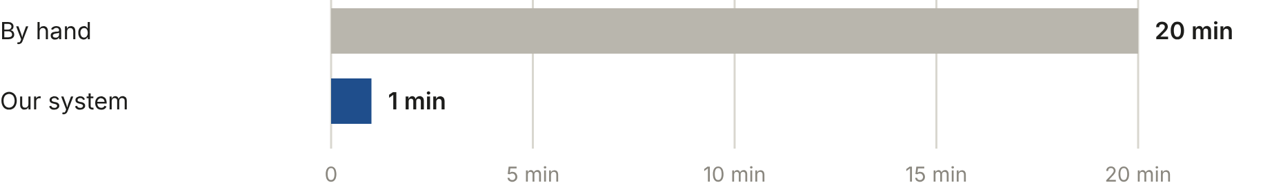
Figure 1. 20 documents at about 1 minute each by hand, against 20 documents a minute for the system.

Accuracy
The wire step was tested on six synthetic wire instruction layouts chosen to be hard to read: repeated digits, small type in dense tables, fax-quality scans and details on a second page, all scanned to images. 18 live readings of those layouts were run 100 times through the production software, which scores every value and decides what to flag.
Fields read correctly, 100 test documents
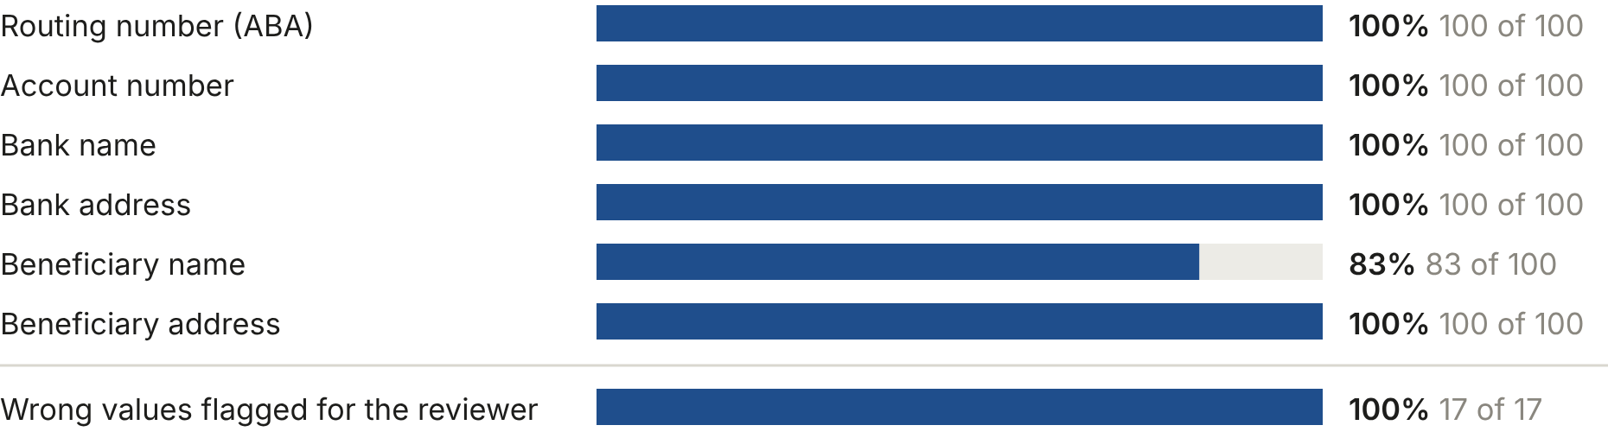
Figure 2. Below 100%: Beneficiary name, 83 of 100. Every beneficiary name miss came from one layout whose page text spelled “&” as “&amp;”, which was copied into the name. The software now converts it back before extraction; not yet re-tested. 83 of 100 documents had all six fields right.
Mistral Document AI turns each page into text and gpt-6-luna extracts the fields from that text. Mistral's own reading of the page serves as a check: a field is flagged when the two disagree, when its confidence is low, or, for routing numbers, when the ABA check digit fails. On average 0.9 of the six fields are flagged per document. A character misread when the page is turned into text would pass the other checks; the check digit catches that for routing numbers, and for the other fields the reviewer's comparison with the document remains the control.

Annual value
Documents per year (20 a day, 250 working days) | 5,000
Staff hours returned per year | 79
Value of staff time at $55/hour | $4,400
Running cost (AI processing and hosting) | $1,800
Net value per year | $2,500

Most of the running cost is hosting, which stays the same as volume rises, so the net value grows faster than volume. Per day and per year at different volumes:
Documents | By hand | Our system | Hours returned / year | Net value / year
10 a day | 10 min | 0.5 min | 40 h | $368
20 a day | 20 min | 1 min | 79 h | $3k
40 a day | 40 min | 2 min | 158 h | $7k
80 a day | 80 min | 4 min | 317 h | $16k
160 a day | 160 min | 8 min | 633 h | $33k

The build cost is not set yet. The table shows how much this use case could cost to build and still pay for itself at 20 documents a day.
To pay for itself within | 6 months | 12 months | 24 months
The build can cost up to | $1k | $3k | $5k

Running cost
AI processing per document | $0.0038
AI processing per year at 20 documents a day | about $19
Azure hosting, storage and monitoring per year | about $1,800

Azure list prices: Mistral Document AI $3.00 per 1,000 pages; gpt-6-luna $0.10 and $0.50 per million input and output tokens. Hosting is an estimate.

Basis of the figures
- Provided by the business: about 20 wire documents a day; 20 minutes for a person to process them; 1 minute for the system.
- Measured: accuracy and flagging, as described under Accuracy.
- Estimated: 250 working days a year, a loaded staff cost of $55 an hour, and hosting cost.
- Not included: time spent checking highlighted fields, the cost of building the system, and the avoided cost of a misdirected wire. Staff hours returned are capacity for other work, not a budget reduction unless roles change.

