

**By Isaam Rameez and Mohamed Mishyaau Nawaaz**

CatSync LRMS

Another IT Project



# Getting Started

## User Interface

CatSync is a LRMS (Library Resource Management System) that assists librarians in checking out books and other library resources. To startup start CatSync from the desktop. CatSync will load within a few seconds. After it loads you will be presented with a window with the button start on it. Similar to fig.1.1

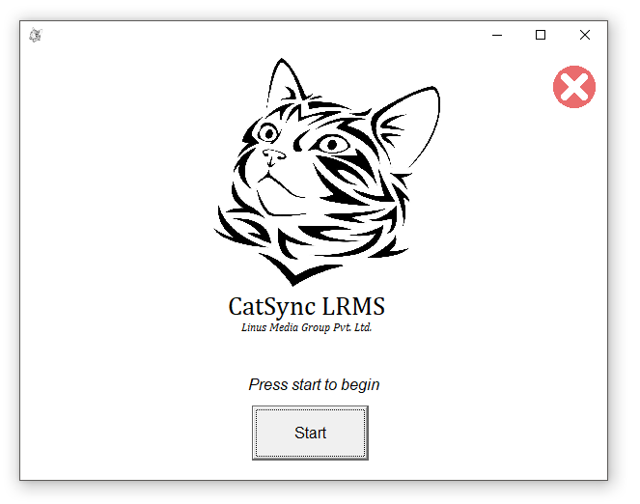

From here press start to proceed to the main page. The main page has 3 main parts; the Book Navigation, User Selection, User Rented Books (see fig1.2). The Book Navigation section allows the user to find books via searching or manual selection. The User Selection section allows the user to find library members via the Library ID. The User Rented Books will show the books the selected user has checked out.

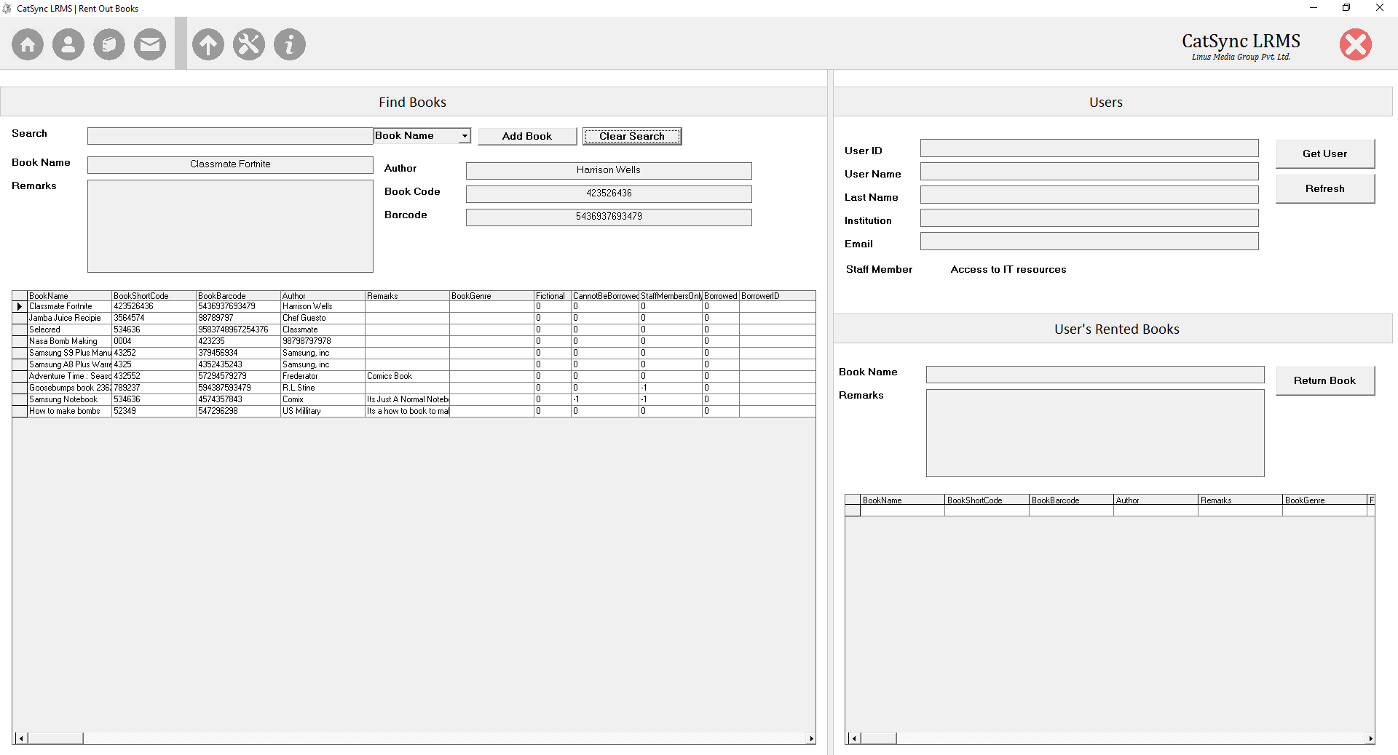

The settings page have 2 main heading, the email settings and the institution and monetary policy. The email page will contain all the configuration for the email notification module. The second page will configure the deep settings such as the institution name and the charges for the late books.

Instructions on how to use this page will be later described in this document. The other pages such as editing books and users are rather self-explanatory.

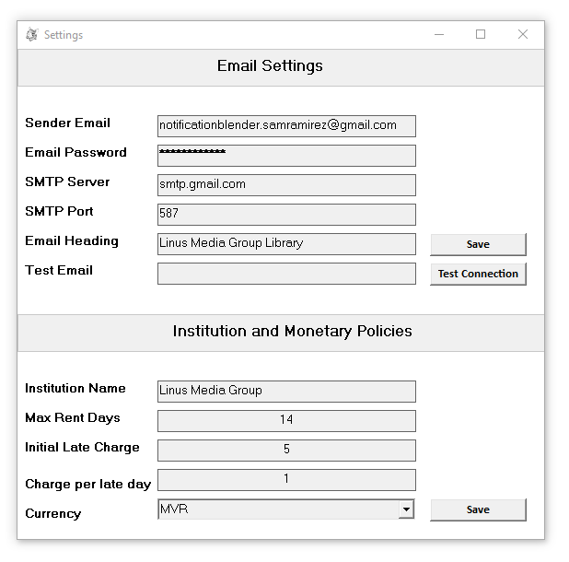

## Adding new books

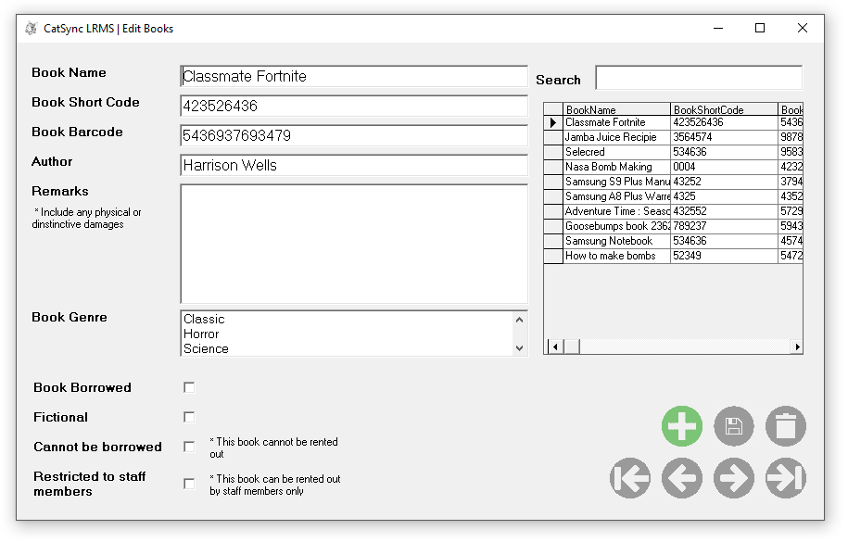To add new books, open the first page click on the book icon on top of the page. From here you will be greeted with the following page. This page will allow you edit and create new users to the system. To add a new user click the green (+) button in the right bottom corner of the screen. From here on you can start tying the details of the users.

The Book Name is the title of the book. The Book Short Code is the code used to identify the books uniquely. The Book Barcode is the barcode that is on the cover of the book, printed by the publisher. The remarks will contain if any damages to the books. The ‘cannot be borrowed’ field will determine whether the book can be borrowed by a staff member or a student. The ‘restricted to staff member’ will determine where if a book can be rented out a staff member only.

## Adding new users

To add or edit new users first select the edit users button (a silhouette of a person) which can be found at the top of the main page. The fields here a pretty explanatory.

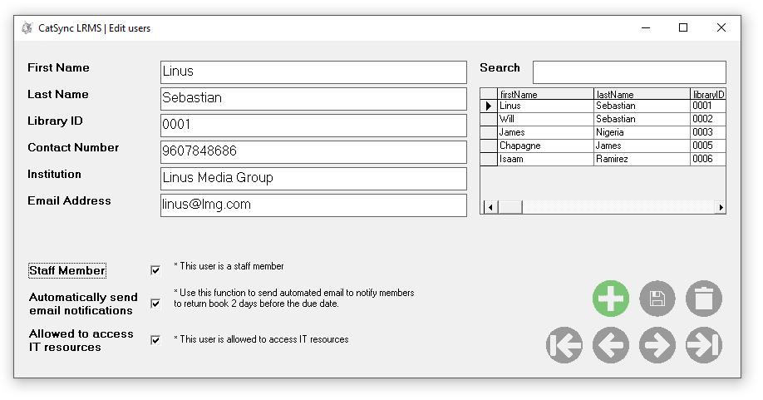

# Code

There are multiple module and forms to explain each part of the coding in this document

# Synopsis

The project works and we all know that no one their right mind would use it professionally. The project meets all the requirements set forth my MI College IT Department, and it has been briefly used and verified by Rehendhi School. If you don’t believe me you can call the number (+960 9936979) to verify the validity of our project.