☁️ AWS Load Balancer

This project demonstrates how to set up an Application Load Balancer (ALB) in AWS to distribute traffic across multiple EC2 instances — improving reliability, fault tolerance, and scalability.

🚀 Overview

The goal of this demo is to:
- Learn how a Load Balancer manages incoming requests.
- Use multiple EC2 instances to serve the same application.
- Understand Target Groups, Listeners, and Health Checks.
- See real-time load distribution in action.

🧩 Architecture

User → Application Load Balancer → Target Group → EC2 Instances

⚙️ Setup Summary

- Launch 2 EC2 Instances
- Install Apache (HTTP Server)
- Create a Target Group
- Create an Application Load Balancer (ALB)
- Test via ALB DNS URL

📂 File Structure

Folder | Description
scripts/ | Contains setup shell scripts for EC2 instances
docs/ | Contains detailed setup and troubleshooting guides
screenshots/ | Placeholder for setup images
.gitignore | Excludes unwanted files

🧰 Tools Used

- AWS EC2
- AWS Application Load Balancer (ALB)
- AWS Target Groups
- Amazon CloudWatch
- Linux / Apache HTTP Server

🧠 Reliable (Important) Points

🔹 Point | 💬 Description
Multiple AZs | Use instances in different AZs for high availability.
Health Checks | Ensure only healthy instances receive traffic.
Auto Scaling | Combine with ASG to auto-add/remove instances based on load.
Security Groups | Allow only HTTP (80) and SSH (22) where required.
Monitoring | Use CloudWatch to track latency, requests, and instance health.

📸 Example Output

$ curl <ALB-DNS>
Hello from Server 1
$ curl <ALB-DNS>
Hello from Server 2

📅 Future Improvements

- Integrate with Auto Scaling Group (ASG)
- Add HTTPS (SSL/TLS) support
- Automate setup using Terraform or AWS CLI

scripts/setup-server1.sh

#!/bin/bash
# setup-server1.sh
sudo yum install -y httpd
echo "Hello from Server 1" > /var/www/html/index.html
sudo systemctl start httpd
sudo systemctl enable httpd

scripts/setup-server2.sh

#!/bin/bash
# setup-server2.sh
sudo yum install -y httpd
echo "Hello from Server 2" > /var/www/html/index.html
sudo systemctl start httpd
sudo systemctl enable httpd

🛠️ AWS Load Balancer Setup Guide

This guide explains how to create an **Application Load Balancer (ALB)** in AWS from scratch.

---

Step 1: Launch EC2 Instances

1. Go to **EC2 → Launch Instances**
2. Choose **Amazon Linux 2**
3. Add a key pair for SSH access
4. Add the following **User Data** for Server 1:
```bash
#!/bin/bash
sudo yum install -y httpd
echo "Hello from Server 1" > /var/www/html/index.html
sudo systemctl start httpd
sudo systemctl enable httpd

• Launch another instance with "Hello from Server 2" text.
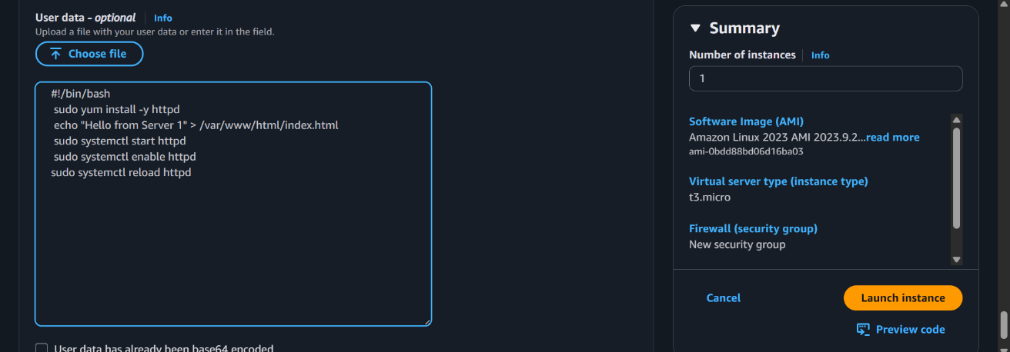
• Allow inbound HTTP (80) and SSH (22) traffic in the Security Group.

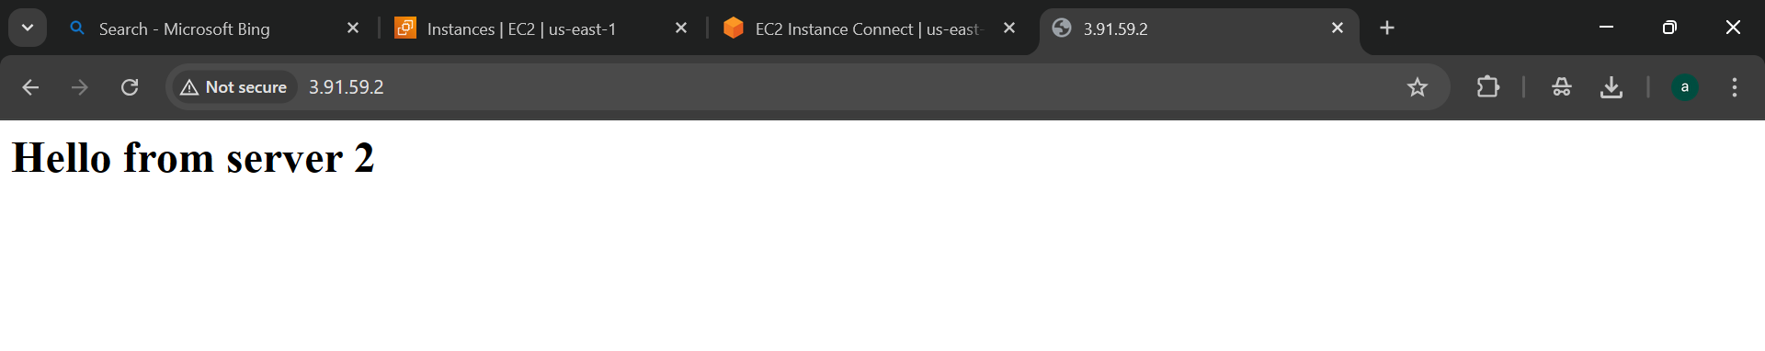

Step 2: Create the templet.

Create the AMI using the existed instances.

Create the templet using the existed instances.

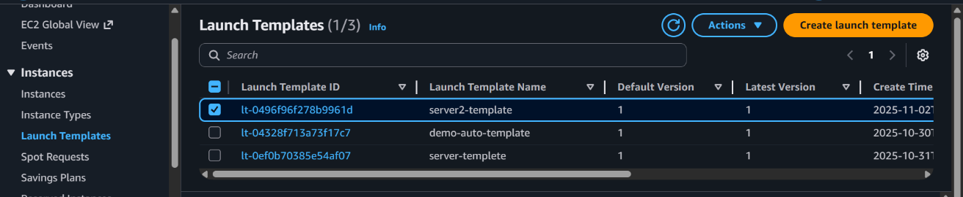

Step 3: Create a Target Group

- Navigate to EC2 → Target Groups → Create target group
- Target type: Instance

- Protocol: HTTP
- Port: 80
- Health check path: /index.html
- Register both EC2 instances.
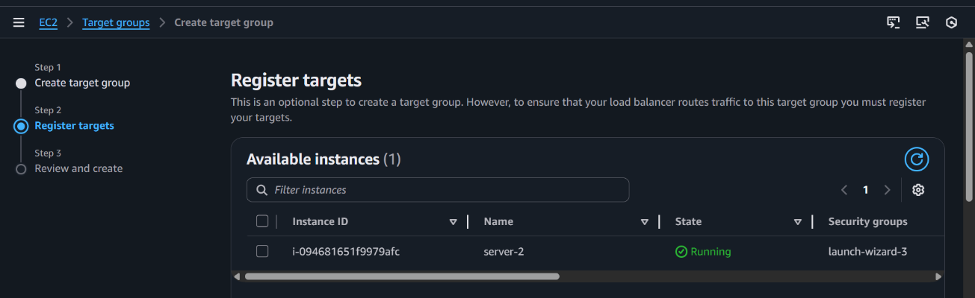

Step 4: Create Application Load Balancer

- Go to Load Balancers → Create Load Balancer
- Choose Application Load Balancer
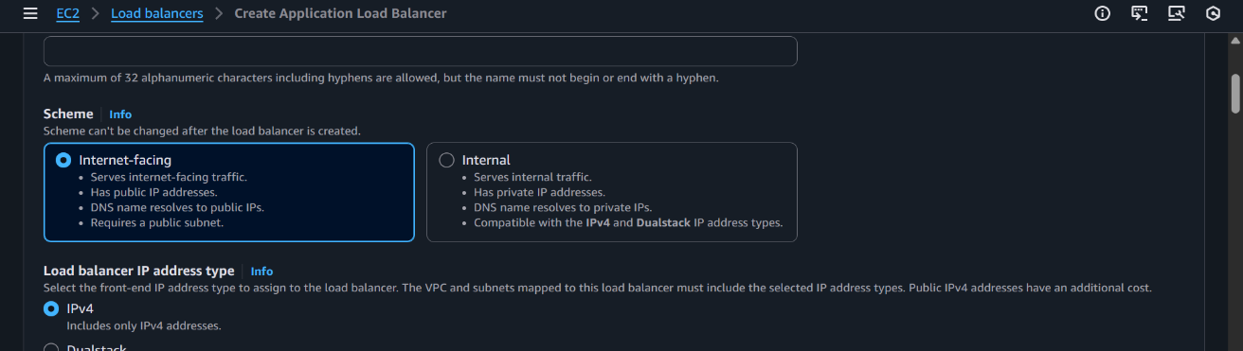
- Scheme: Internet-facing

- Listener: HTTP (Port 80)
- Select both AZs (Availability Zones) Atleast 2
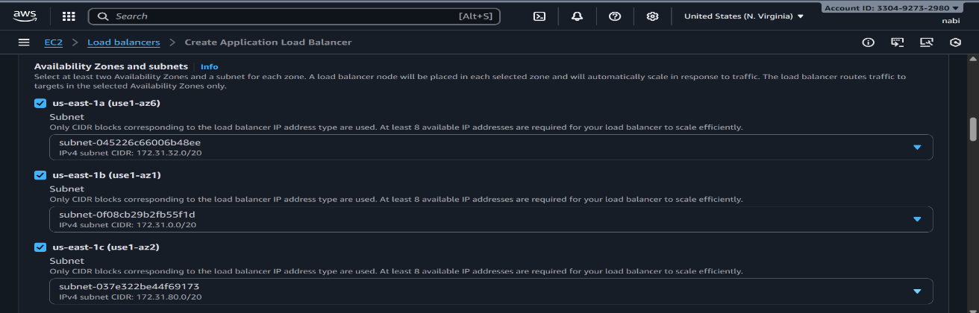

- Attach your target group.

Step 4: Test the Load Balancer

- Copy the DNS name of the ALB
- Open in browser or use curl:

- You should see alternating responses:

Hello from Server 1
Hello from Server 2

Step 5: Verify Health

- Check Target Group → Targets
- Both instances should show Healthy

Step 6: Monitor Traffic

- Open CloudWatch → Metrics → ALB
- Observe request count, latency, and healthy host count

10. Test the Load Balancer

- Copy the **DNS name** of your ALB
- Paste it into your browser as:

```
http://<load-balancer-dns>
```

Each refresh should show a different server (1st, 2nd), proving that the load balancer is distributing traffic evenly.

---

🧩 Result

Your setup now includes:

- **3 EC2 instances** running NGINX
- **1 Application Load Balancer** distributing HTTP traffic
- **Automatic failover and scalability**

Each refresh hits a different backend server, confirming that load balancing works as expected.

---

💰 Cost Optimization

- **Terminate unused instances**
- **Deregister AMIs** no longer needed
- **Delete unused load balancers** when testing is complete

---

📄 Author

Arkan Tandel

---

🏁 Summary

You’ve successfully deployed a scalable, fault-tolerant, and load-balanced web environment on AWS using EC2 and Httpd
Each server responds uniquely, confirming traffic is evenly distributed by the ALB.

