TEST OUTPUT

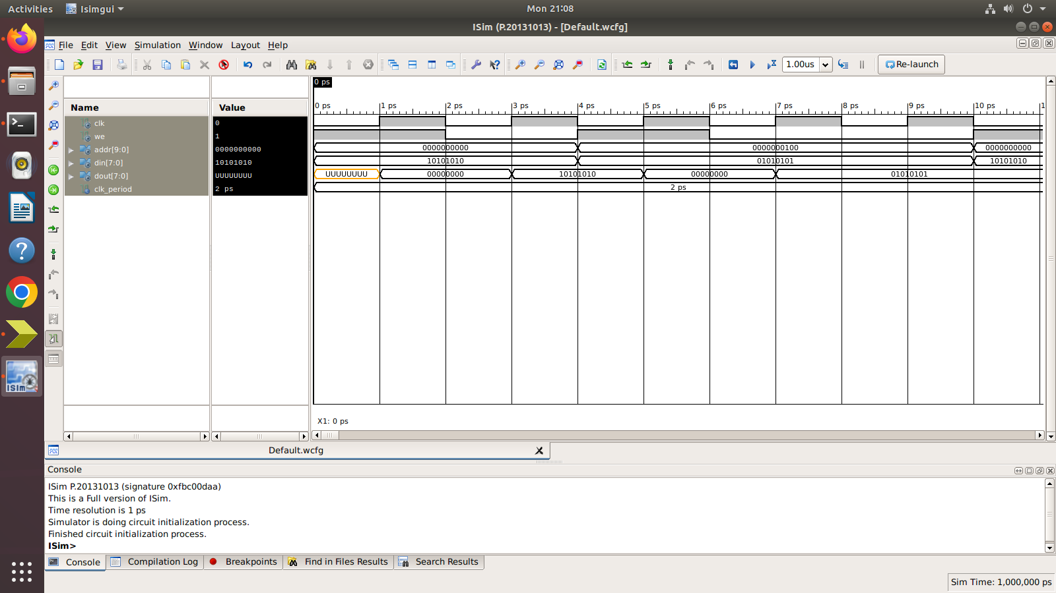

SCHEMATIC OUTPUT

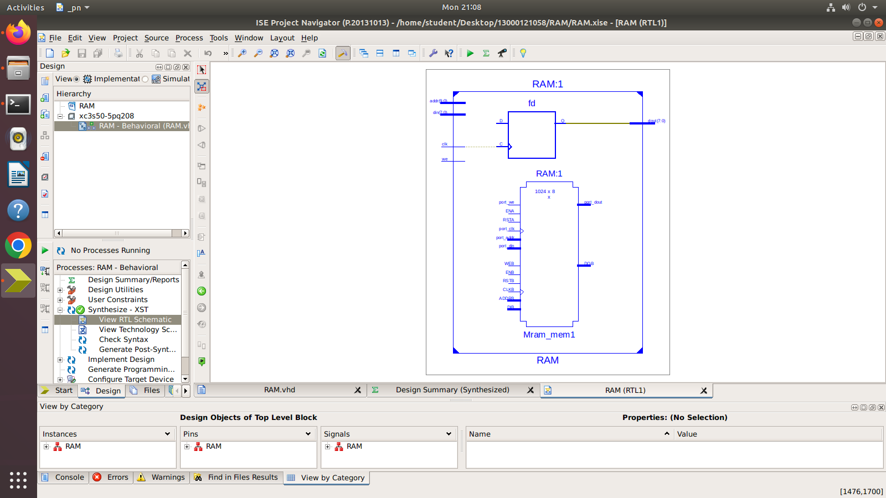

SCHEMATIC OUTPUT

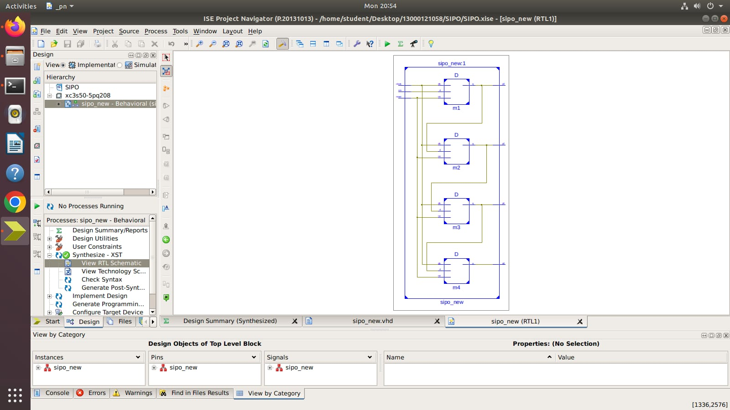

SCHEMATIC OUTPUT

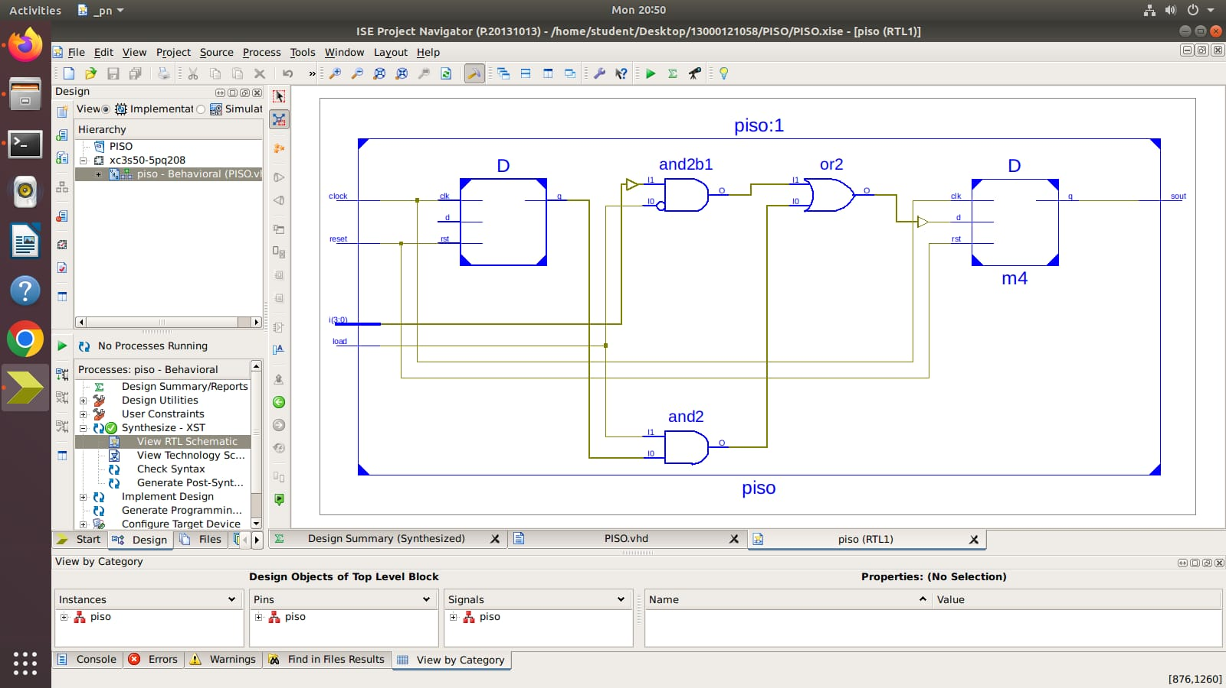

TEST OUTPUT

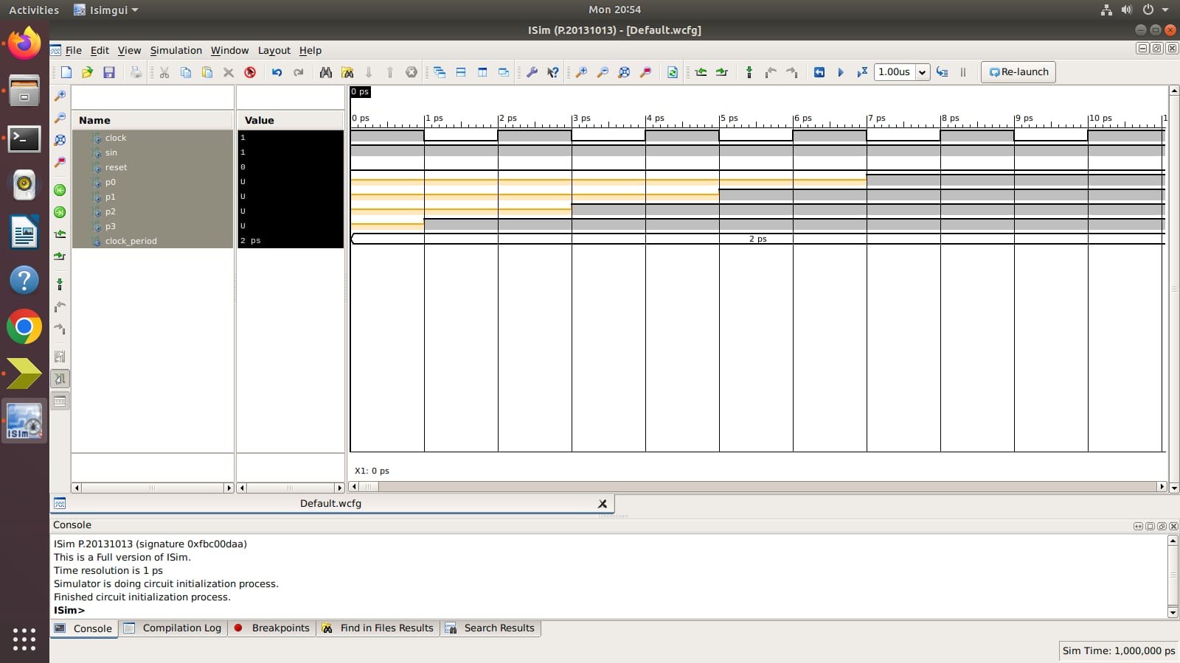

TEST OUTPUT

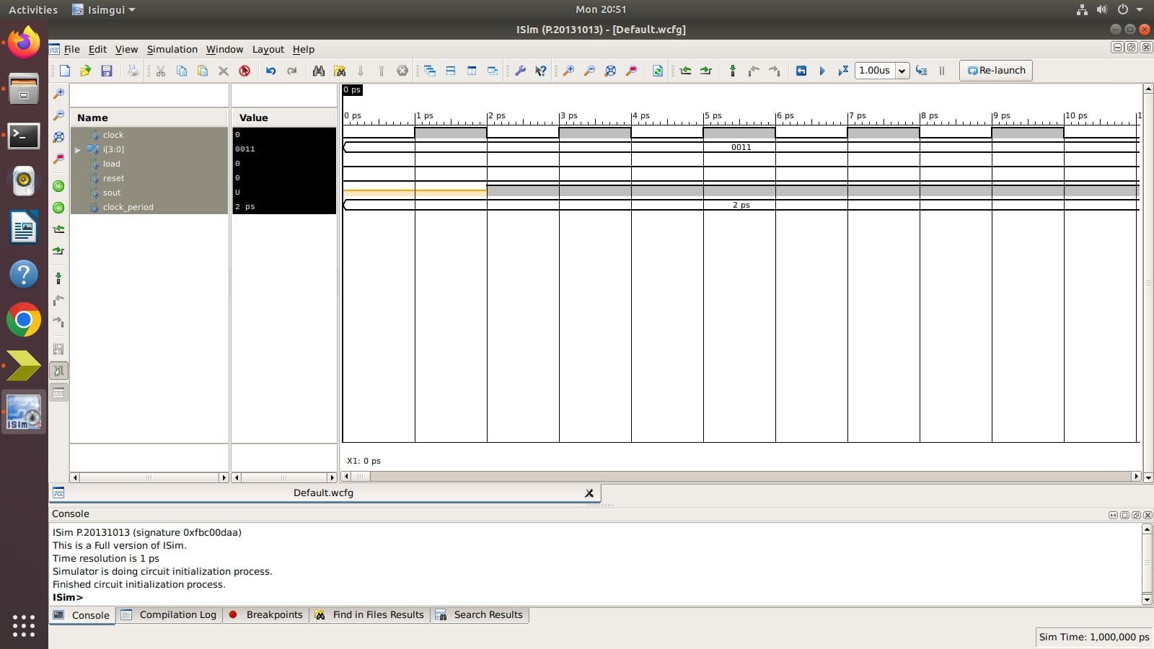

OUTPUT

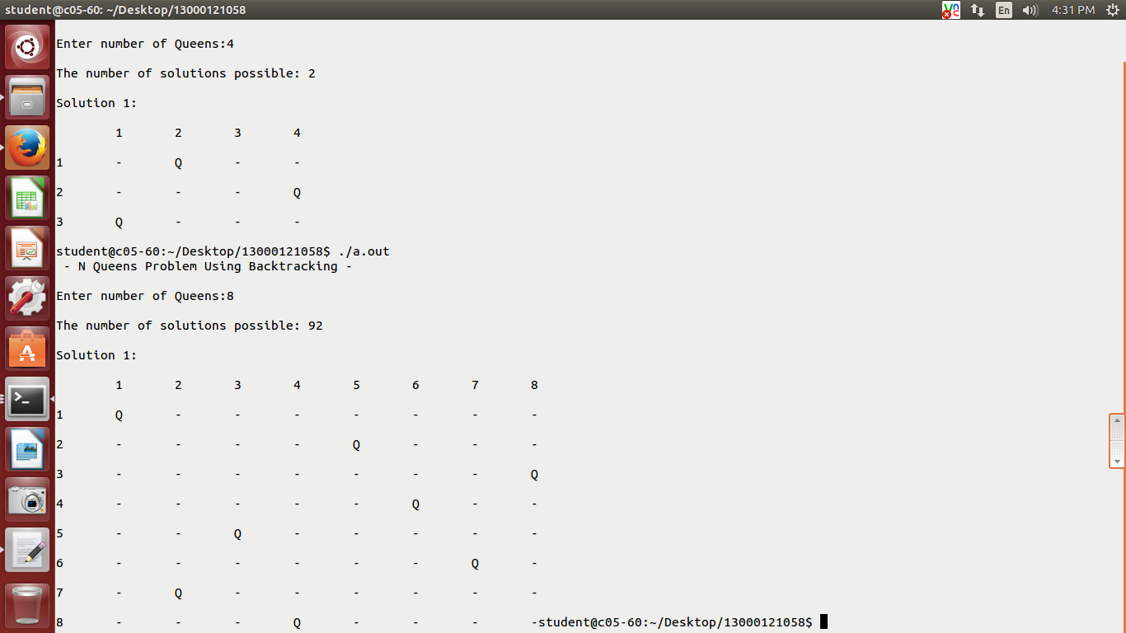

OUTPUT

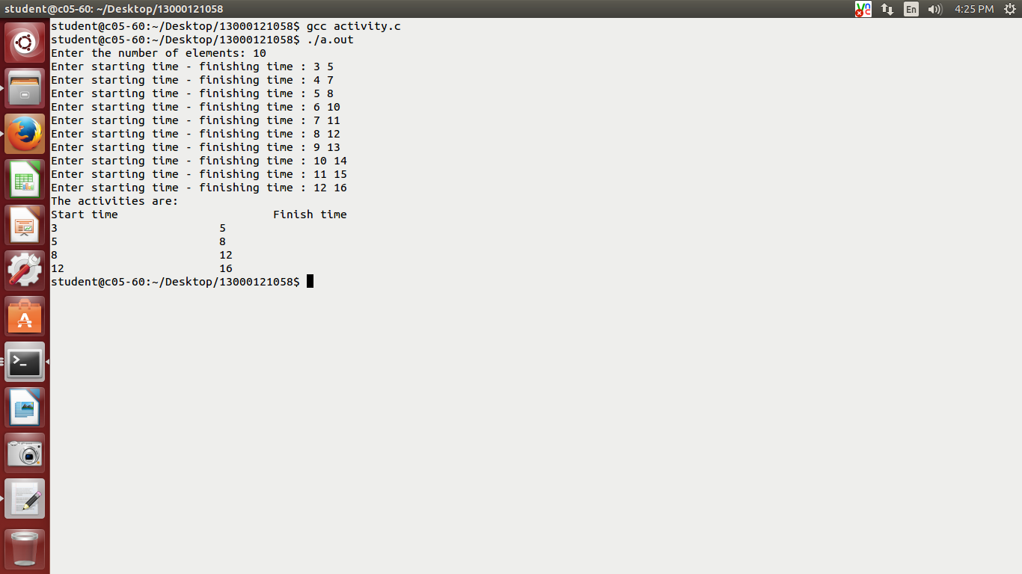

OUTPUT

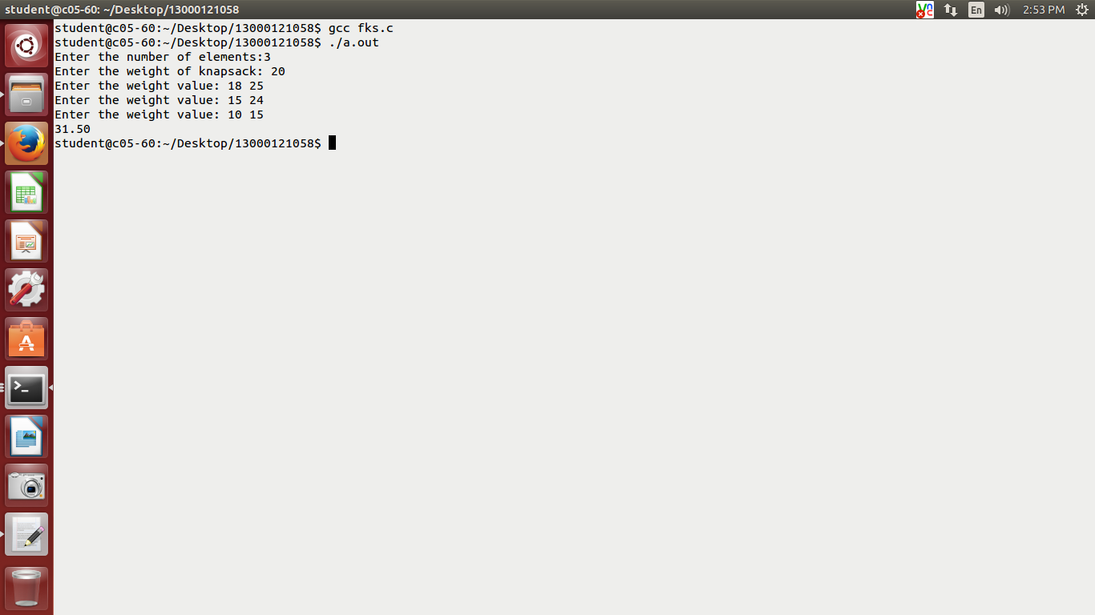

OUTPUT

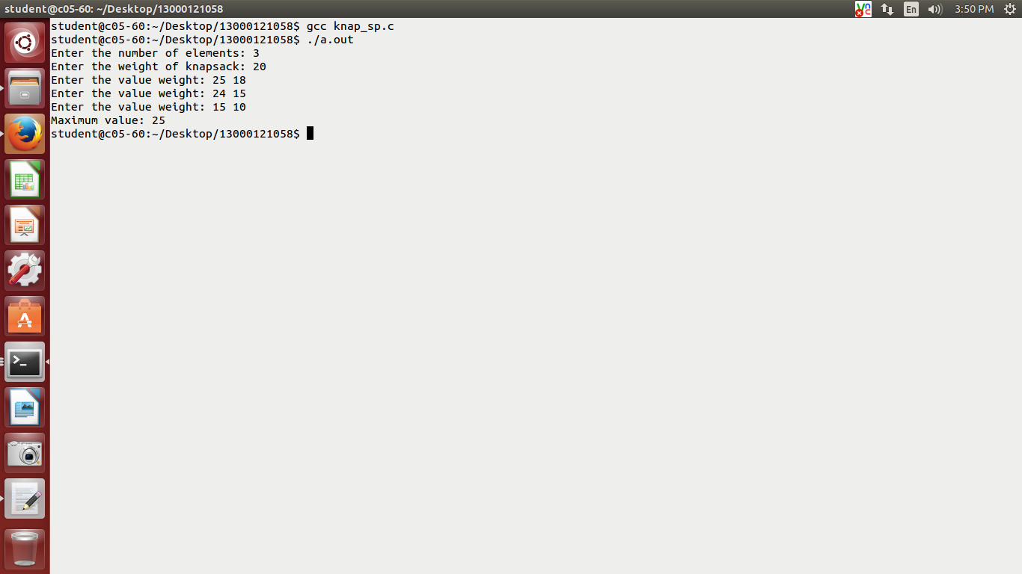

OUTPUT

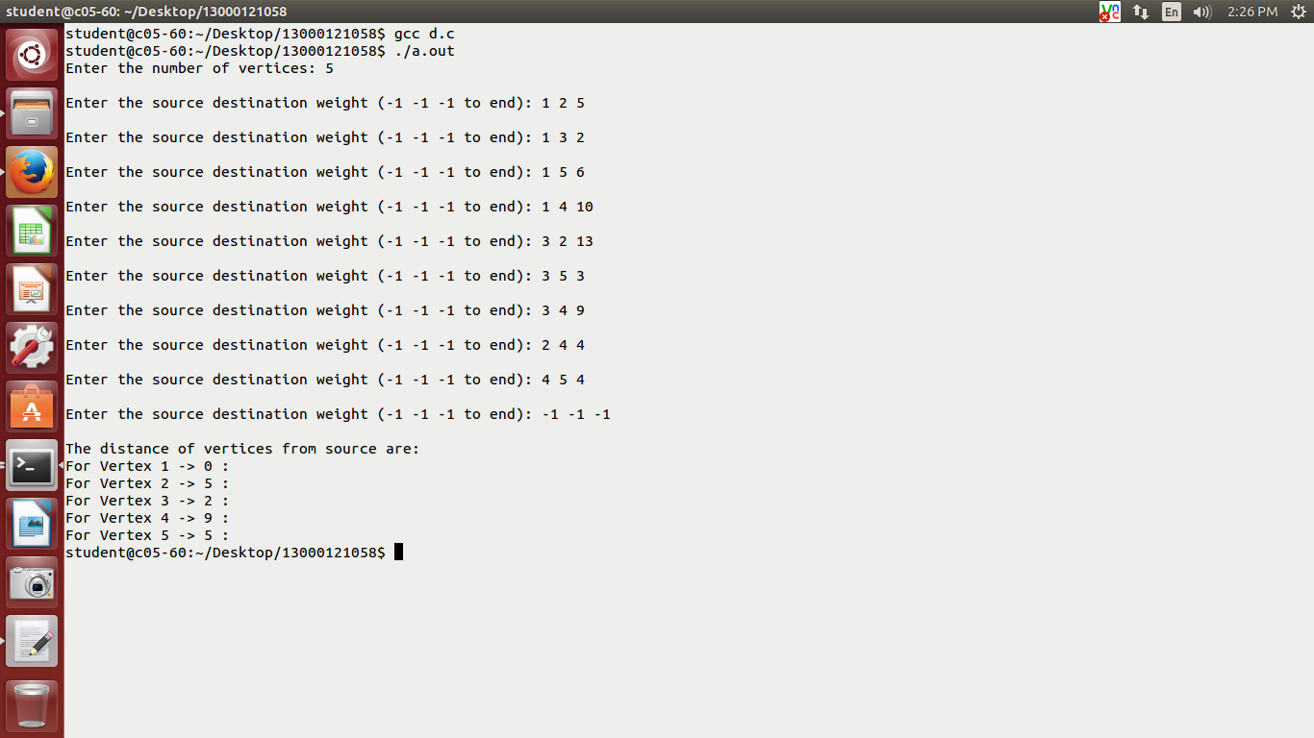

ASSIGNMENT 4.1
Implement Single Source shortest Path for a graph (Dijkstra Algorithm)problem to find out the shortest path from the source vertex ‘1’, using the Dijkstra’s algorithm, using the dynamic programming technique.
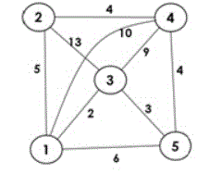

FLOWCHART
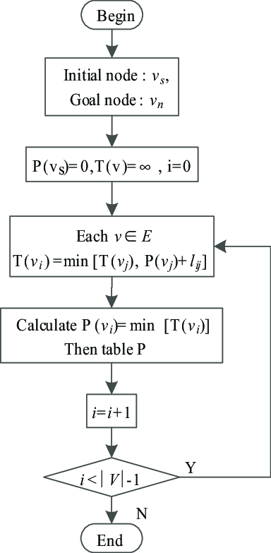

ASSIGNMENT 8.1
Consider the following knapsack problem where n = 3, W = 20 Kgs, (v1, v2, v3) = (25, 24, 15), and (w1, w2, w3) = (18, 15, 10). WAP to find the optimal solution by fractional knapsack (greedy method) as well as 0 / 1 knapsack (Dynamic programming method).

FLOWCHART
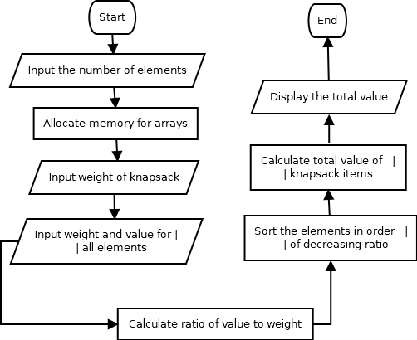
Fractional Knapsack

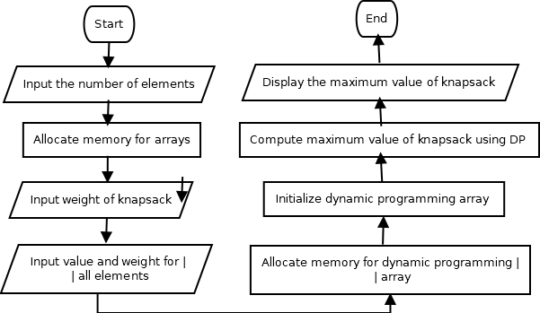
0/1 Knapsack

ASSIGNMENT 8.2
Given a set of ‘10’ jobs with their si and fi, find the optimal sequence of mutually compatible jobs using the greedy method: A = {1, 2, 3, 4, 5, 6, 7, 8, 9, 10}, si = {3, 4, 5, 6, 7, 8, 9, 10, 11, 12} and fi = {5, 7, 8, 10, 11, 12, 13, 14, 15, 16}.

FLOWCHART
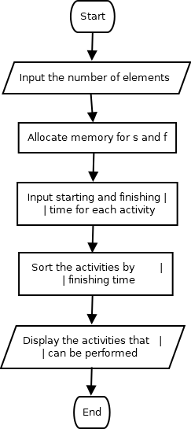

ASSIGNMENT 10.1

WAP to implement the N-Queen’s problem using the method of
backtracking.
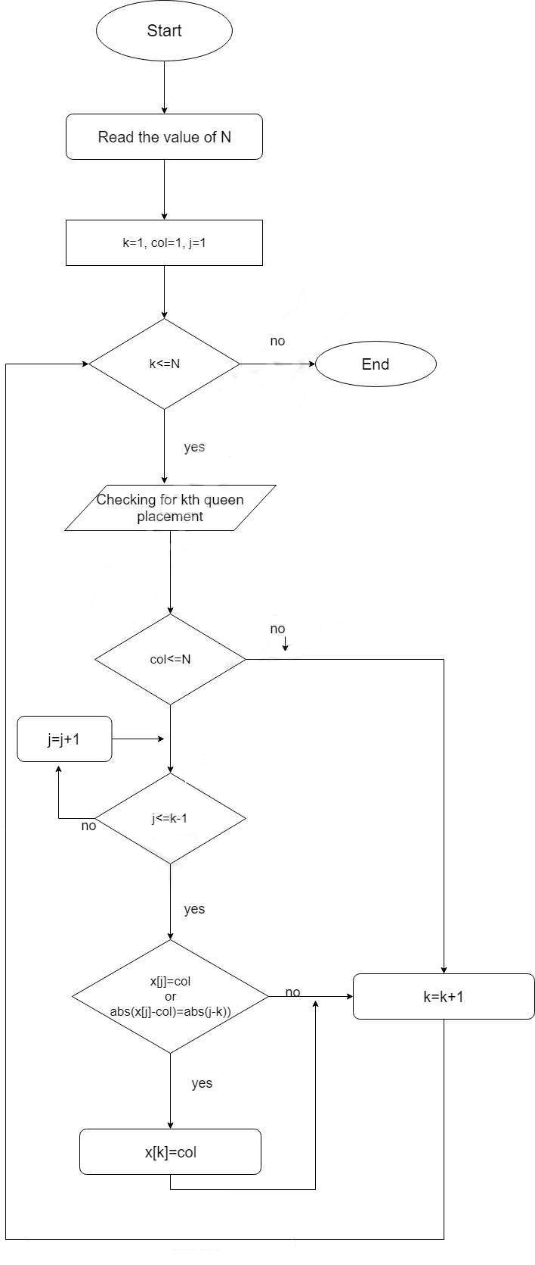
FLOWCHART

