**Digital Transmission**

**Bachelor of Technology**

**Computer Science and Engineering**

Submitted By

ARKAPRATIM GHOSH (13000121058)

FEBRUARY 2024



**Techno MainSalt Lake**

**EM-4/1, Sector-V, Kolkata- 700091**

**West Bengal**

**India**

**TABLE OF CONTENTS**

**1. Introduction 3**

**2. Body 4**

2.1. Digital to Digital Conversion 4

2.1.1. Line coding 4

2.1.2. Block Coding 6

2.1.3. Scrambling 7

2.2. Analog to Digital Conversion 9

2.2.1. Pulse Code Modulation 9

2.2.2. Delta Modulation 11

2.3. Transmission Modes 13

2.3.1. Parallel Transmission 13

2.3.2. Serial Transmission 15

**3. Conclusion 17**

**4. References 17**

# Introduction

Digital transmission is the process of sending digital data over a communication channel, such as cables, optical fibers, or wireless mediums, in the form of discrete signals. Unlike analog transmission, where signals are continuous and vary in amplitude or frequency, digital transmission involves encoding data into binary digits (bits), which are then transmitted and decoded at the receiving end.

**Key Components of Digital Transmission:**

* **Digital Data:** Digital data is represented in binary format, consisting of 0s and 1s. This data can be in various forms, such as text, images, audio, or video.
* **Modulation:** Modulation is the process of encoding digital data onto an analog carrier signal for transmission. There are different modulation techniques used, such as Amplitude Shift Keying (ASK), Frequency Shift Keying (FSK), and Phase Shift Keying (PSK), each altering different properties of the carrier signal to represent digital information.
* **Transmission Medium:** Transmission mediums can be wired (e.g., coaxial cables, twisted pair cables) or wireless (e.g., radio waves, microwaves, infrared). Each medium has its own characteristics, such as bandwidth, data rate, and susceptibility to noise, which influence the choice of modulation techniques and transmission protocols.
* **Transmission Protocols:** Transmission protocols define the rules and procedures for sending and receiving data over a communication channel. These protocols ensure reliable and efficient data transmission by incorporating techniques such as error detection and correction, flow control, and data framing.
* **Digital Signal Processing (DSP):** Digital signal processing techniques are used for signal conditioning, filtering, and equalization to improve the quality and reliability of digital transmission. DSP algorithms are employed both at the transmitter and receiver ends to compensate for channel impairments and noise.
* **Multiplexing:** Multiplexing is the technique of combining multiple digital signals into a single transmission stream, allowing efficient utilization of the communication channel. Techniques like Time Division Multiplexing (TDM), Frequency Division Multiplexing (FDM), and Code Division Multiplexing (CDM) are commonly used for multiplexing digital signals.

**Advantages of Digital Transmission:**

* **Noise Immunity:** Digital signals are less susceptible to noise and interference compared to analog signals, resulting in higher reliability and better signal quality over long distances.
* **Compression:** Digital data can be compressed more efficiently, allowing for higher data transmission rates within the available bandwidth.
* **Error Detection and Correction:** Digital transmission protocols incorporate error detection and correction techniques, ensuring data integrity and reliability.
* **Security:** Encryption techniques can be easily applied to digital data, providing enhanced security and privacy during transmission.
* **Flexibility:** Digital transmission allows for easy integration with other digital systems, facilitating interoperability and compatibility across different platforms and devices.

# Body

## Digital to Digital Conversion

Digital to digital transmission involves the encoding and transmission of digital data over communication channels using digital signaling techniques. In this process, digital data, typically represented in binary format, undergoes modulation to convert it into discrete signals suitable for transmission. Various modulation techniques, such as Amplitude Shift Keying (ASK), Frequency Shift Keying (FSK), or Phase Shift Keying (PSK), are utilized to encode the digital data onto carrier signals. The encoded signals are then transmitted over transmission mediums, such as cables, optical fibers, or wireless channels, employing transmission protocols and techniques like error detection and correction, multiplexing, and digital signal processing to ensure reliable and efficient data transmission. Digital to digital transmission offers advantages such as noise immunity, compression efficiency, error detection, and security, making it a fundamental aspect of modern communication systems and networks.

## Line coding

Line coding is a fundamental process in digital communication systems that transforms binary data into a suitable format for transmission over communication channels. It involves mapping a sequence of binary digits (0s and 1s) to corresponding signal waveforms that can be sent across a transmission medium. The purpose of line coding is to enable efficient and reliable communication by ensuring synchronization between the transmitter and receiver, controlling the bandwidth of the transmitted signal, and facilitating error detection.

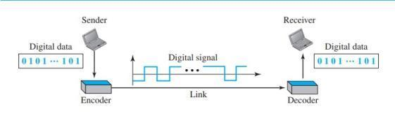

**Key Components of Line Coding:**

* **Signal Representation:** Line coding determines how binary data is represented as signal waveforms. Each bit or group of bits is mapped to a specific signal level or transition in the waveform.
* **Clock Recovery:** Many line coding schemes include mechanisms for recovering the clock signal at the receiver to synchronize the reception of data with the transmitter's timing.
* **Efficiency:** Line coding techniques aim to use the available bandwidth efficiently while minimizing the occurrence of long runs of consecutive bits with the same value, which can lead to difficulties in clock recovery and synchronization.
* **Error Detection**: Some line coding schemes incorporate built-in mechanisms for error detection, allowing the receiver to detect and correct transmission errors caused by noise or channel interference.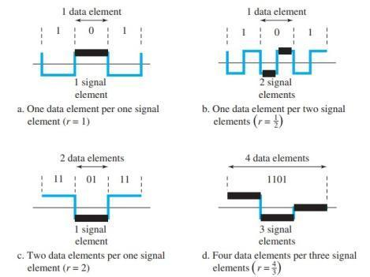

**Common Line Coding Techniques:**

* **Non-Return to Zero (NRZ):** In NRZ encoding, each binary digit is represented by a specific signal level, typically a high voltage for '1' and a low voltage for '0'. NRZ has a straightforward implementation but can suffer from baseline wander and lack of synchronization.
* **Manchester Encoding:** Manchester encoding ensures regular transitions in the signal waveform by encoding each bit as a transition from high to low or low to high within a fixed time interval. This technique simplifies clock recovery but requires twice the bandwidth of NRZ encoding.
* **Differential Manchester Encoding:** Differential Manchester encoding, like Manchester encoding, uses transitions to encode data. However, it distinguishes between '0' and '1' bits based on whether there is a transition at the beginning or middle of the bit interval, ensuring synchronization without requiring an explicit clock signal.
* **Bipolar Encoding:** Bipolar encoding includes both positive and negative signal levels, with the presence or absence of a signal transition indicating the value of the binary bit. This technique helps in maintaining a balanced signal and facilitates clock recovery.
* **4B/5B and 8B/10B Encoding:** These techniques expand the binary data to a larger code space to ensure a sufficient number of signal transitions for clock recovery while still maintaining efficient bandwidth usage.

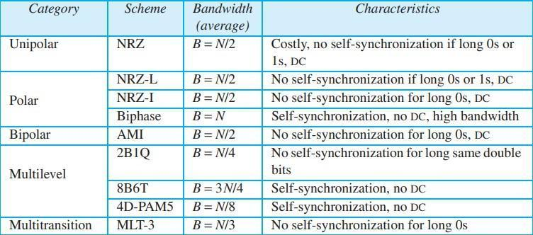

Line coding is a critical aspect of digital communication systems, influencing factors such as transmission efficiency, synchronization, and error detection. The choice of line coding technique depends on the specific requirements of the communication system, including bandwidth constraints, noise immunity, and synchronization capabilities.

## Block Coding

Block coding is a fundamental technique used in digital communication systems to improve the reliability of data transmission by adding redundancy to the original data stream. Unlike line coding, which deals with the conversion of individual bits into signal waveforms for transmission, block coding operates on a group of bits, known as a block, and adds additional bits to create codewords with specific properties. These additional bits, known as parity or redundancy bits, enable the detection and correction of errors that may occur during transmission.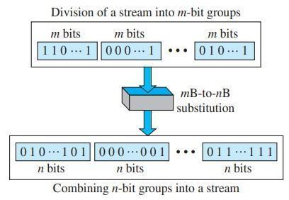

**Key Components of Block Coding:**

* **Block Size:** Block coding operates on fixed-size blocks of data. The block size determines the number of input bits processed together to form a codeword. Common block sizes include 4 bits, 8 bits, 16 bits, etc.
* **Parity/Redundancy Bits:** Parity bits are added to the original data block to introduce redundancy. The placement and calculation of these bits depend on the specific block coding scheme employed. Parity bits aid in error detection and sometimes correction.
* **Encoding Algorithm:** The encoding algorithm defines how the parity bits are calculated and appended to the original data block. Different block coding schemes use various algorithms, such as Hamming codes, Reed-Solomon codes, and BCH codes, each optimized for specific applications and error-correction capabilities.
* **Decoding Algorithm:** At the receiving end, the decoding algorithm is used to detect and, if possible, correct errors in the received codeword. The decoding algorithm interprets the received codeword, checks for errors, and attempts to recover the original data block. The complexity of the decoding algorithm varies depending on the block coding scheme and the level of error correction required.

**Advantages of Block Coding:**

* **Error Detection and Correction:** Block coding techniques enable the detection and correction of errors introduced during data transmission, thereby improving the reliability of communication systems.
* **Redundancy Efficiency:** Block coding adds redundancy only where necessary, optimizing the trade-off between error-correction capability and bandwidth efficiency.
* Versatility: Block coding schemes can be tailored to specific requirements, allowing for customization based on the desired level of error correction and the characteristics of the communication channel.

In conclusion, block coding is a fundamental technique in digital communication systems, providing error detection and correction capabilities essential for reliable data transmission. By adding redundancy to data blocks and employing sophisticated encoding and decoding algorithms, block coding enhances the robustness and integrity of modern communication systems across various applications.

## Scrambling

Scrambling is a technique used in digital communication systems to enhance the efficiency and reliability of data transmission over communication channels. It involves manipulating the data signal before transmission in such a way that it appears more random or evenly distributed across the frequency spectrum. This process helps in reducing the occurrence of long sequences of consecutive bits with the same value, which can be problematic for clock recovery and synchronization at the receiver's end. Scrambling is particularly useful in scenarios where the data being transmitted may contain patterns that could cause synchronization errors or introduce undesirable spectral characteristics.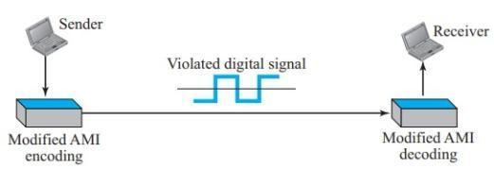

**Key Aspects of Scrambling:**

* **Randomization**: The primary objective of scrambling is to introduce randomness into the data signal while preserving its essential information content. This randomization process typically involves XOR-ing (exclusive OR operation) the data signal with a pseudo-random sequence generated by a scrambling algorithm. The resulting scrambled signal exhibits a more uniform distribution of signal transitions, reducing the likelihood of long runs of identical bits.
* **Clock Recovery**: Scrambling helps in improving clock recovery at the receiver's end by ensuring a sufficient number of transitions in the transmitted signal. Clock recovery circuits rely on these signal transitions to accurately extract the timing information necessary for decoding the received data. By reducing the occurrence of consecutive identical bits, scrambling enhances the robustness of clock recovery mechanisms, thereby improving overall system performance.
* **Spectral Characteristics:** Scrambling also plays a role in shaping the spectral characteristics of the transmitted signal. By spreading the energy of the signal across a wider frequency range, scrambling helps in reducing the concentration of spectral components at specific frequencies, which can cause interference with other communication channels or be susceptible to external noise sources. This spectral shaping property contributes to the efficient utilization of the available bandwidth and enhances the resilience of the transmission against channel impairments.
* **Synchronization**: In addition to aiding clock recovery, scrambling can assist in synchronization between the transmitter and receiver by mitigating the effects of burst errors or intermittent signal disruptions. By dispersing the energy of the transmitted signal more evenly, scrambling reduces the likelihood of prolonged periods of signal loss or distortion, thus facilitating faster re-synchronization following such events.
* **Reversible Operation:** It's important to note that scrambling is a reversible operation, meaning that the original data can be recovered at the receiver's end by applying the inverse scrambling process. The receiver uses the same pseudo-random sequence generated by the scrambling algorithm at the transmitter to reverse the scrambling operation and retrieve the original data signal.

By introducing randomness into the transmitted signal, scrambling helps in mitigating synchronization errors, improving spectral characteristics, and enhancing the overall robustness of communication channels.

## Analog to Digital Conversion

Analog to digital conversion (ADC) is a fundamental process in digital communication systems that involves converting continuous analog signals into discrete digital representations. This conversion enables the transmission, processing, and storage of analog data using digital techniques. The ADC process typically consists of three main stages: sampling, quantization, and encoding. First, the analog signal is sampled at regular intervals, capturing its amplitude values at discrete time points. Next, the sampled amplitude values are quantized, meaning they are mapped to a finite set of discrete levels. Finally, the quantized amplitude values are encoded into binary digits (bits) for digital representation. The resolution of the ADC, determined by the number of quantization levels, affects the accuracy and fidelity of the digital representation. Higher resolutions result in more accurate conversions but require more bits for encoding. ADC plays a crucial role in various applications, including telecommunications, audio processing, medical imaging, and industrial automation, enabling the seamless integration of analog signals into digital systems.

## Pulse Code Modulation

Pulse Code Modulation (PCM) is a widely used method for digitally representing analog signals. It involves sampling the amplitude of the analog signal at regular intervals, quantizing each sample into a discrete number of digital values, and encoding these values into binary code words. PCM is a fundamental technique in digital communication systems, audio recording, telecommunications, and various other applications where accurate representation and transmission of analog signals are essential.

**Key Components of PCM:**

* **Sampling**: The analog signal is sampled at a uniform rate known as the sampling frequency or sampling rate. According to the Nyquist theorem, the sampling frequency must be at least twice the highest frequency component of the analog signal to avoid aliasing and accurately reconstruct the original signal.
* **Quantization:** Each sample is quantized into a discrete number of levels. The number of quantization levels determines the resolution or fidelity of the PCM system. Higher resolution systems can represent a wider range of signal amplitudes with greater accuracy but require more bits for encoding.
* **Encoding:** The quantized samples are encoded into binary code words. This encoding process typically involves assigning a unique binary representation to each quantization level. The most common encoding scheme is linear pulse code modulation (LPCM), where the binary code words are linearly proportional to the amplitude of the quantized samples.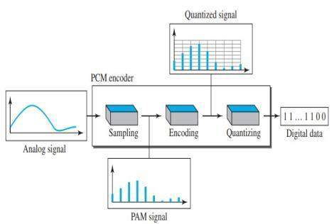

**Advantages of PCM:**

* **Accuracy:** PCM provides accurate representation of analog signals with minimal distortion, especially when using high-resolution quantization.
* **Noise Immunity:** Digital signals generated by PCM are less susceptible to noise and interference during transmission compared to analog signals, resulting in improved signal quality and reliability.
* **Compression:** PCM facilitates efficient data compression techniques, such as differential PCM (DPCM) and adaptive differential PCM (ADPCM), which reduce the data bandwidth required for transmission while maintaining signal integrity.
* **Compatibility:** PCM is compatible with various digital communication and storage systems, making it widely adopted in telecommunications, audio recording, and digital signal processing applications.
* **Versatility:** PCM supports multichannel audio transmission, allowing for the simultaneous encoding and transmission of multiple audio channels, which is essential for applications like surround sound and teleconferencing.

**Applications of PCM:**

* **Telecommunications:** PCM is used in telecommunication systems, such as digital telephone networks, where analog voice signals are converted into digital PCM signals for transmission over digital communication channels.
* **Audio Recording:** PCM is employed in digital audio recording systems, including CDs, DVDs, and digital audio workstations (DAWs), for capturing and storing high-fidelity audio recordings.
* **Medical Imaging:** PCM is utilized in medical imaging modalities, such as digital X-ray imaging and magnetic resonance imaging (MRI), for converting analog signals from imaging sensors into digital representations for diagnostic purposes.
* **Data Transmission:** PCM is used in data transmission systems, such as digital modems and satellite communication systems, for encoding and transmitting digital data over communication channels.

In conclusion, Pulse Code Modulation (PCM) is a versatile and widely adopted technique for digitally representing analog signals in various applications. Its accuracy, noise immunity, and compatibility make it indispensable in digital communication, audio recording, medical imaging, and data transmission systems.

## Delta Modulation

Delta modulation is a technique used in digital communication systems for analog-to-digital signal conversion. It is a type of differential pulse-code modulation (DPCM) where the difference between consecutive samples of the analog signal, known as the delta, is quantized and encoded. Delta modulation simplifies the encoding process by transmitting only the difference between successive samples rather than the absolute sample values. This technique is particularly useful for transmitting signals with slowly varying amplitudes or when the rate of change of the signal is relatively low.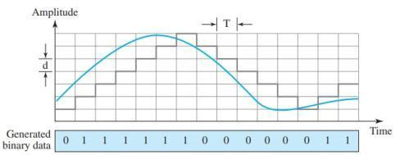

**Key Components of Delta Modulation:**

* **Sampler**: The analog input signal is sampled at regular intervals determined by the sampling frequency. The samples are compared with the previous sample to determine the delta, or the difference between consecutive samples.
* **Quantizer**: The delta, representing the difference between consecutive samples, is quantized into a finite number of levels. The quantization process divides the range of delta values into discrete intervals and assigns each interval a corresponding digital code.
* **Encoder**: The quantized delta values are encoded into digital bits for transmission. In delta modulation, only one bit is used to represent each quantized delta value, resulting in a binary stream of 1s and 0s.

**Operation of Delta Modulation:**

Delta modulation operates by continuously comparing the amplitude of the input analog signal with the reconstructed signal at the receiver's end. If the input signal amplitude increases, the delta becomes positive, and if it decreases, the delta becomes negative. The quantizer then maps this delta value to the nearest quantization level, and the resulting quantized delta is transmitted as a single binary bit. At the receiver's end, the received bit is used to adjust the reconstructed signal. If the bit is 1, the reconstructed signal is incremented by a step size; if it is 0, the reconstructed signal is decremented by the same step size.

**Advantages and Limitations of Delta Modulation:**

* Simplicity: Delta modulation is relatively simple to implement compared to other modulation techniques, requiring minimal hardware and computational resources.
* Low Complexity: Delta modulation operates with a single-bit encoder, making it suitable for low-power and low-complexity systems.
* Robustness to Channel Noise: Delta modulation is robust to channel noise to some extent because it transmits only one bit per sample. However, in the presence of significant noise, the performance of delta modulation may degrade due to error accumulation.
* Granular Noise: One limitation of delta modulation is the presence of granular noise, which occurs when the step size is too large relative to the signal variation. This noise can degrade the signal quality, particularly for signals with high-frequency components or rapid changes in amplitude.
* Adaptive Delta Modulation: To address the limitations of basic delta modulation, adaptive delta modulation techniques adjust the step size dynamically based on the signal characteristics, improving performance in varying signal conditions.

In conclusion, delta modulation is a simple and efficient technique for analog-to-digital conversion, particularly in applications where the signal variation is relatively slow or where simplicity and low complexity are desired. While it offers advantages such as simplicity and low complexity, delta modulation may suffer from limitations such as granular noise and susceptibility to channel noise, which need to be carefully considered in practical implementations.

## Transmission Modes

Transmission modes, also known as communication modes, define the direction of data flow between devices in a communication system. There are three primary transmission modes: simplex, half-duplex, and full-duplex. In simplex mode, data flows in only one direction, from the transmitter to the receiver, with no feedback or acknowledgment from the receiver. This mode is commonly used in applications where communication occurs unidirectionally, such as television broadcasting or keyboard-to-computer communication. Half-duplex mode allows data transmission in both directions, but not simultaneously. Devices can either transmit or receive data at any given time, but not both simultaneously. This mode is often found in walkie-talkies and some Ethernet networks. Full-duplex mode enables simultaneous two-way communication between devices, allowing data to flow in both directions simultaneously. This mode is commonly used in modern communication systems such as telephony, internet communication, and wireless networks, enabling efficient bidirectional data exchange. The choice of transmission mode depends on factors such as the nature of communication, data requirements, and system design considerations.

## Parallel Transmission

Parallel transmission is a method of data transfer where multiple bits are sent simultaneously over multiple parallel channels. Each bit of the data word is transmitted concurrently along separate physical channels, typically in the form of wires within a cable or traces on a printed circuit board. Parallel transmission contrasts with serial transmission, where bits are sent sequentially over a single channel.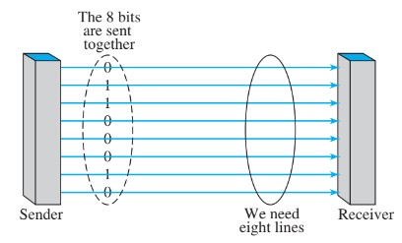

**Key Components of Parallel Transmission:**

* **Data Bus**: In parallel transmission, data is transmitted over a data bus, which consists of multiple parallel conductors. Each conductor carries one bit of the data word, allowing for simultaneous transmission of multiple bits.
* **Synchronization:** To ensure accurate data transmission, parallel transmission requires synchronization between the sender and receiver. Clock signals are used to coordinate the timing of data transfer, ensuring that each bit arrives at the receiver at the correct time.
* **Data Encoding**: Data encoding techniques such as Non-Return to Zero (NRZ) or Manchester encoding may be used to represent binary data on the parallel channels. These encoding schemes help in maintaining signal integrity and reducing errors during transmission.
* **Timing Constraints:** One of the challenges of parallel transmission is managing timing constraints, particularly for high-speed data transfer. As the number of parallel channels increases, maintaining precise synchronization becomes more critical to prevent timing skew and data corruption.

**Advantages of Parallel Transmission:**

* **Higher Data Transfer Rates**: Parallel transmission allows for higher data transfer rates compared to serial transmission, as multiple bits are sent simultaneously over parallel channels. This makes parallel transmission suitable for applications that require high-speed data transfer, such as computer memory buses and internal data communication within electronic devices.
* **Lower Latency:** Parallel transmission offers lower latency compared to serial transmission, as data bits can be transmitted and processed concurrently. This is advantageous in applications where real-time data processing is required, such as in multimedia streaming and high-performance computing.
* **Simplicity of Implementation**: Parallel transmission is relatively simple to implement, as it involves straightforward hardware interfaces and wiring configurations. This makes parallel transmission suitable for short-distance communication within electronic systems and devices.

**Limitations of Parallel Transmission:**

* **Signal Degradation**: As the number of parallel channels increases, signal degradation becomes a concern due to factors such as crosstalk and electromagnetic interference (EMI). This limits the maximum distance over which parallel transmission can be effectively used.
* **Complexity and Cost:** Implementing parallel transmission interfaces requires a greater number of conductors and connectors compared to serial transmission, leading to increased complexity and cost, particularly for long-distance communication.
* **Synchronization Challenges:** Achieving and maintaining precise synchronization between parallel channels can be challenging, especially at higher data rates. Timing skew between channels can result in data errors and signal degradation, requiring careful design and signal integrity analysis.

In conclusion, parallel transmission offers advantages such as higher data transfer rates and lower latency, making it suitable for applications that require high-speed, concurrent data transfer. However, it also has limitations such as signal degradation and synchronization challenges, which need to be carefully addressed in the design and implementation of parallel communication systems.

## Serial Transmission

Serial transmission is a method of data transfer in which data is sent sequentially, one bit at a time, over a single communication channel. Unlike parallel transmission, which sends multiple bits simultaneously over separate channels, serial transmission uses a single channel to transmit data bit by bit. This method of data transfer is widely used in various communication systems, including telecommunications, computer networking, and serial buses within electronic devices.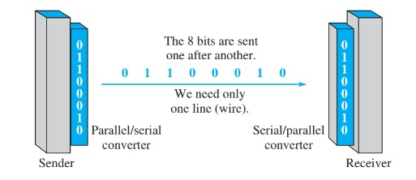

**Key Components of Serial Transmission:**

* **Serial Interface**: Serial transmission requires a serial interface, which typically consists of a transmitter (sender) and a receiver (receiver) connected by a communication channel. The transmitter converts parallel data into a serial stream of bits, while the receiver converts the received serial data back into parallel form.
* **Synchronization:** Synchronization between the transmitter and receiver is essential to ensure accurate data transmission. Clock signals or synchronization bits are used to synchronize the timing of data transmission and reception. The receiver uses these signals to sample the incoming data at the correct times, ensuring that each bit is interpreted correctly.
* **Data Encoding:** Data encoding techniques are used to represent binary data on the serial channel. Common encoding schemes include Non-Return to Zero (NRZ), Manchester encoding, and Differential Manchester encoding. These schemes help in maintaining signal integrity and improving error detection during transmission.
* **Error Detection and Correction:** To ensure reliable data transmission, serial communication systems often incorporate error detection and correction mechanisms. Techniques such as checksums, cyclic redundancy checks (CRC), and forward error correction (FEC) codes are used to detect and correct errors that may occur during transmission.

**Advantages of Serial Transmission:**

* **Simplicity and Cost-Effectiveness:** Serial transmission requires fewer conductors and connectors compared to parallel transmission, resulting in simpler and more cost-effective hardware implementations. This makes serial communication suitable for long-distance communication and interconnection between devices.
* **Improved Noise Immunity:** Serial transmission offers better noise immunity compared to parallel transmission, as data is sent sequentially over a single channel. This reduces the effects of crosstalk and electromagnetic interference (EMI), resulting in more reliable data transmission.
* **Scalability:** Serial transmission is highly scalable, allowing for easy expansion and integration of additional devices or communication channels. This scalability makes serial communication ideal for building complex communication networks and systems.

**Limitations of Serial Transmission:**

* **Lower Data Transfer Rates:** Serial transmission typically has lower data transfer rates compared to parallel transmission, as data is sent sequentially one bit at a time. This can result in slower data transmission speeds, particularly for applications that require high-speed data transfer.
* **Increased Latency:** Serial transmission may introduce higher latency compared to parallel transmission, as data bits are sent sequentially and may require additional processing at the receiver end. This can be a limitation in real-time applications where low latency is critical.
* **Complexity of Implementation:** Serial communication interfaces may require more complex hardware and software implementations compared to parallel interfaces, particularly for high-speed communication and error detection/correction. This complexity can increase the cost and complexity of serial communication systems.

In conclusion, serial transmission is a widely used method of data transfer in communication systems, offering advantages such as simplicity, scalability, and improved noise immunity. While it may have limitations in terms of data transfer rates and latency, serial communication remains a fundamental and versatile technique for transmitting data in various applications.

# Conclusion

In conclusion, both parallel and serial transmission methods play vital roles in modern communication systems, each offering distinct advantages and limitations. Parallel transmission enables high-speed data transfer and low latency by sending multiple bits simultaneously over separate channels, making it suitable for short-distance communication within electronic systems. On the other hand, serial transmission simplifies hardware implementations, reduces costs, and offers better noise immunity, making it ideal for long-distance communication and interconnection between devices. While parallel transmission may suffer from signal degradation and synchronization challenges, serial transmission may have limitations in terms of data transfer rates and latency. Understanding the characteristics and requirements of each transmission method is essential for designing efficient and reliable communication systems tailored to specific application needs. Ultimately, the choice between parallel and serial transmission depends on factors such as data transfer speed, distance, complexity, and cost, with both methods playing critical roles in shaping the landscape of modern communication technologies.

# References

Data Communications and Networking

Book by Behrouz A. Forouzan