**Recursive Binary Search**

**Dr. Rahul Das Gupta**

**Binary Search can only be performed on an array which is sorted either in ascending or descending order.**

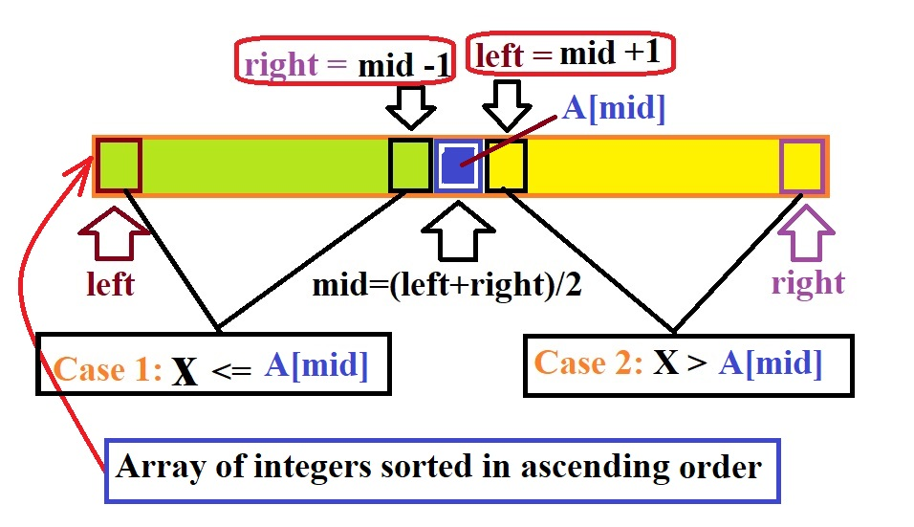

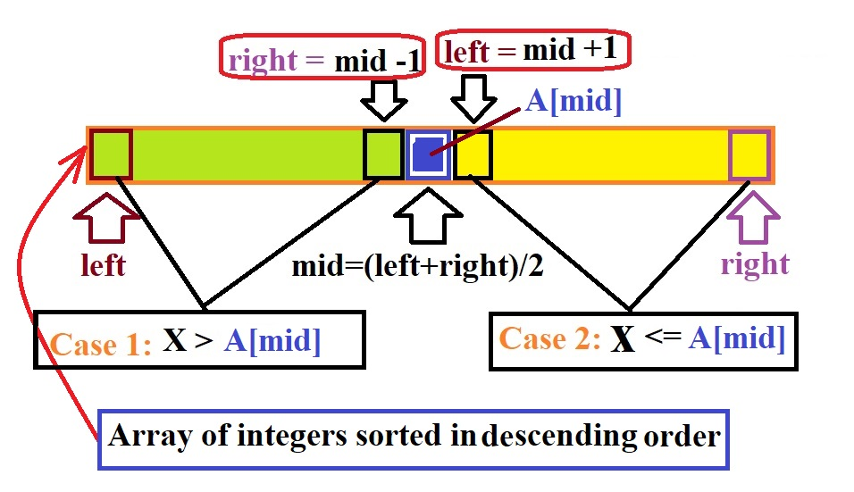

#include <stdio.h>

#include <conio.h>

**/*A recursive binary search functionreturns the**

**location of a key element x in a given sorted array**

**(sorted either in ascending order or descending order) arr[left…right] if it is present, otherwise -1.*/**

intBinarySearchAscending(int*, int , int , int);

intBinarySearchDescending(int*, int , int , int);

voidmain()

{

    intarr[] = { 2, 3, 4, 5, 7, 8, 10, 32, 35, 40 };

    int n = sizeof(arr) / sizeof(arr[0]);

    int x = 10;

int result;

if (arr[0]<arr[n-1])

result=BinarySearchAscending(arr, 0 , n-1 , x);

else

result=BinarySearchDescending(arr, 0 , n-1 , x);

clrscr( );

    if (result == -1)

printf("\n Element is not present in the array.");

else

printf("\n Element %d is present at index %d

inside the array.", x, result);

}

**/\***

**p = address of the first element (data type: int*).**

**p[i]=*(p+i) = ith element**

**p[i]=*(p+i)=*(i+p)=i[p]= ith element**

**\*/**

**int**BinarySearchAscending(**int \***p, **int** left, **int** right, **int** x)

{

        int mid = (left+right)/ 2;

if(left>right)

    return -1; **/* The condition left>right is Truewhen element is not present in array.*/**

**/*If the element is present at the middle**

**itself .*/**

        if (p[mid] == x)

            return mid;

**/*When searching element is smaller than the middle element, thenthe element will be searched in left sub array from lefttomid-1.*/**

        elseif (p[mid] > x)

            BinarySearchAscending(p, left, mid - 1, x);

**/*When searching element is greater than themiddle element,then the element will be searched in right sub array from mid+1 to right.*/**

else

BinarySearchAscending(p, mid+1, right, x);

}

**int**BinarySearchDescending(**int \***p, **int** left, **int** right, **int** x)

{

        int mid = (left+right)/ 2;

if(left>right)

    return -1; **/* The condition left>right is Truewhen element is not present in array.*/**

**/*If the element is present at the middle**

**itself .*/**

        if (p[mid] == x)

            return mid;

**/*When searching element is greater than the middle element, then the element will be searched in left sub array from lefttomid-1.*/**

        elseif (p[mid] < x)

            BinarySearchDescending (p, left, mid - 1, x);

**/*When searching element is smaller than themiddle element, then the element will be searched in right sub array from mid+1 to right.*/**

else

BinarySearchDescending(p, mid+1, right, x) ;

}

**Complexity Analysis of Binary Search**

**Go to next page and continue…**