**Output for TCP/IP Implementation**

One to One:

The given procedure is followed-

1. Client 1 (Top Left ) sends “hi from client 1” to client 2.
2. Client 2 (Bottom Left ) sends “hi from client 2 ” to client 3, and receives message from client 1.
3. Client 3 (Bottom Right ) sends “hi from client 3 ” to client 1, and receives message from client 2.
4. Client 1 (Top Left ) sends “bye from client 1 ” to client 2 and receives message from client 3.
5. Client 2 (Bottom Left ) sends “bye from client 2 ” to client 3 and receives message from client 1.
6. Client 3 (Bottom Right ) sends “bye from client 3 ” to client 1 and receives message from client 2.

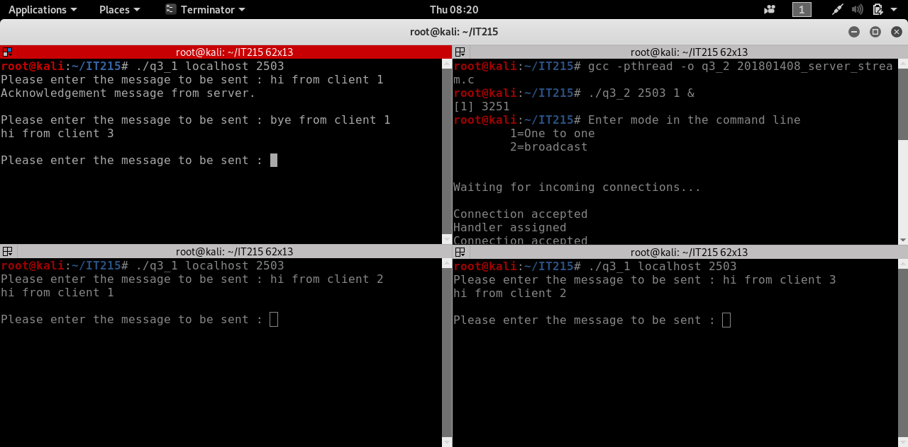

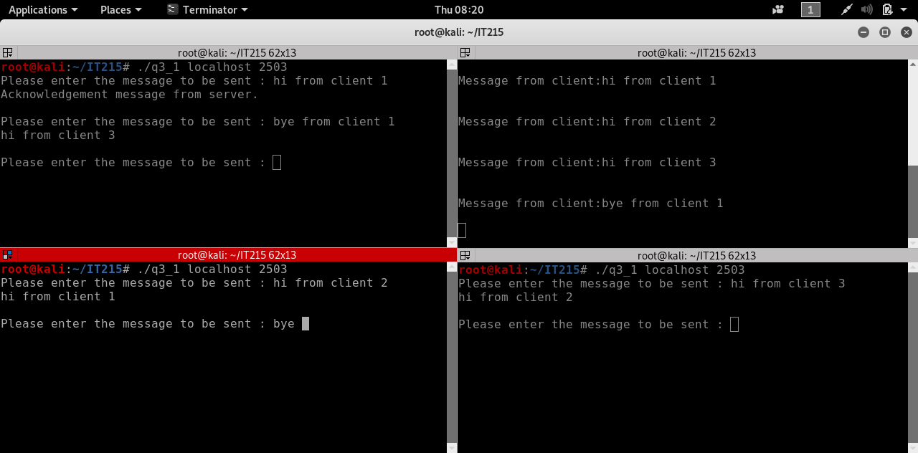

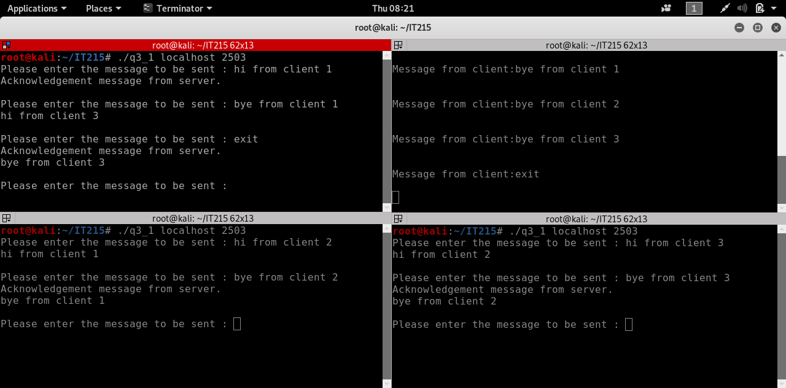

Broadcast

The given procedure is followed-

1. Client 1 (Top Left ) sends “hi from client 1” to client 2 and client 3.
2. Client 2 (Bottom Left ) sends “hi from client 2 ” to client 3 and client 1, and receives message from client 1.
3. Client 3 (Bottom Right ) sends “hi from client 3 ” to client 1 and client 2, and receives message from client 1 and client 2 .
4. Client 1 (Top Left ) sends “bye from client 1 ” to client 2 and client 3 and receives message from client 2 and client 3.
5. Client 2 (Bottom Left ) sends “bye from client 2 ” to client 3 and client 1 and receives message from client 1 and client 3.
6. Client 3 (Bottom Right ) sends “bye from client 3 ” to client 1 and client 2 and receives message from client 1 and client 2.

