**Output for Datagram Sockets Implementation**

**One to One :**

The given procedure is followed-

1. Client 1 (Top Left ) sends “hi from client 1” to client 2.
2. Client 2 (Bottom Left ) receives message from client 1 and ,sends “hi from client 2 ” to client 3.
3. Client 3 (Bottom Right ) receives message from client 2 and, sends “hi from client 3 ” to client 1.
4. Client 1 (Top Left ) receives message from client 3 and, sends “bye from client 1 ” to client 2.
5. Client 2 (Bottom Left ) receives message from client 1 and, sends “bye from client 2 ” to client 3 .
6. Client 3 (Bottom Right ) receives message from client 2 and, sends “bye from client 3 ” to client 1.
7. Client 1 receives message from Client 3.

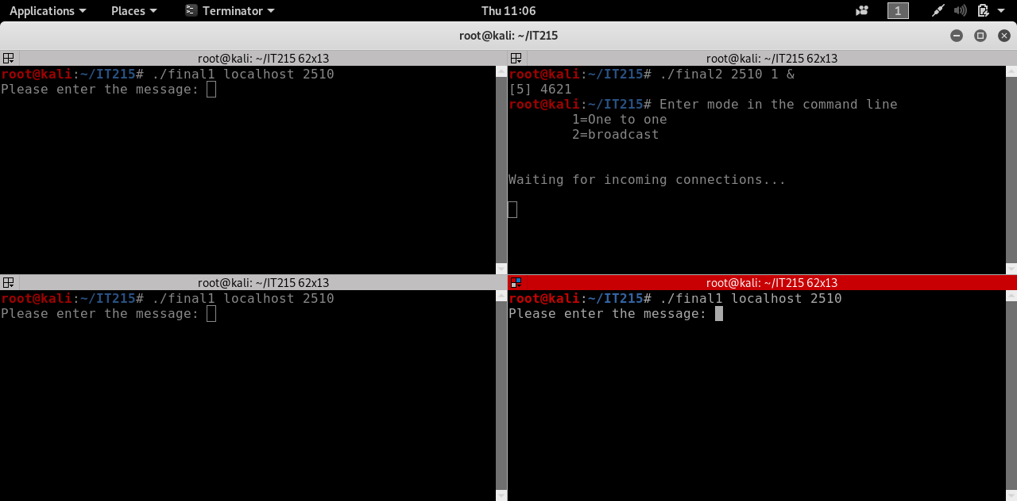

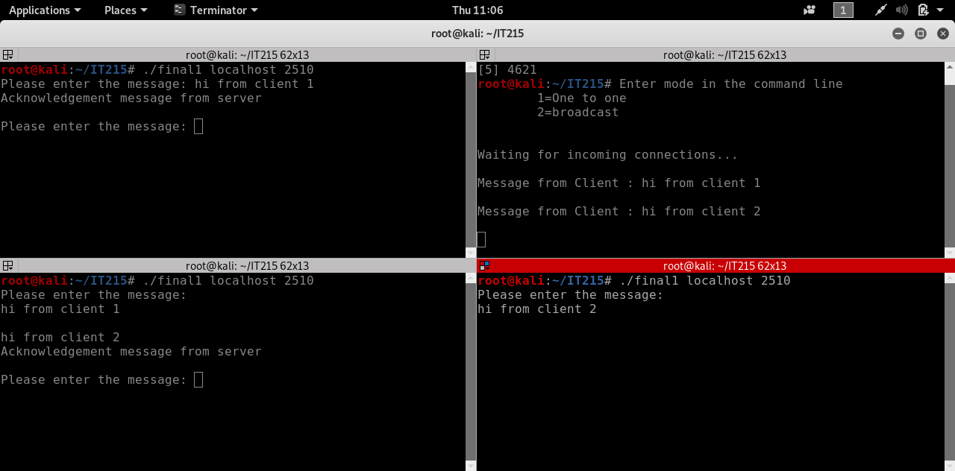

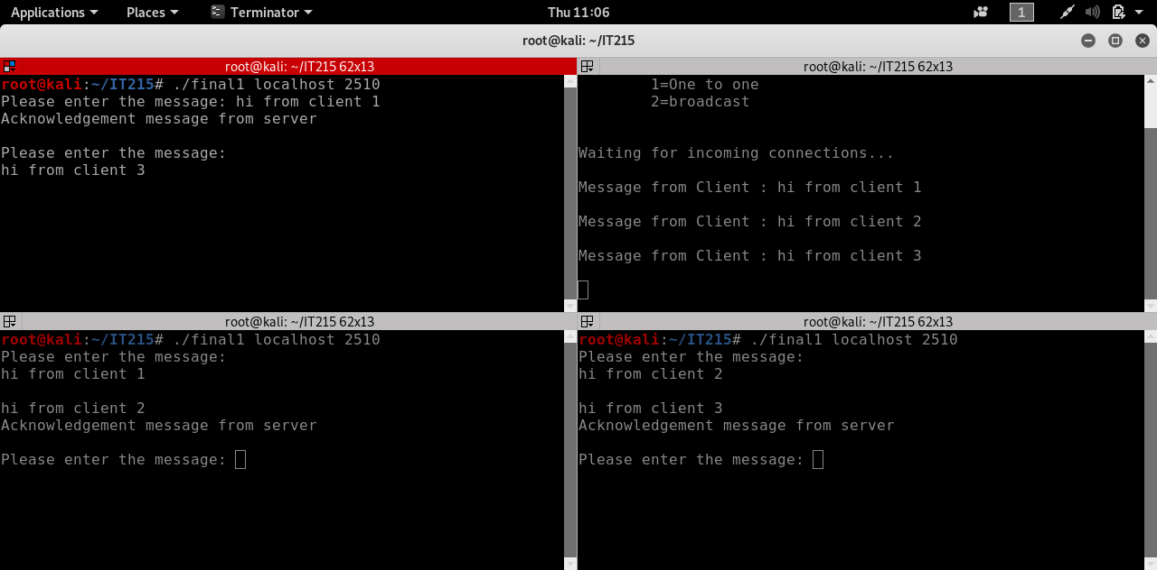

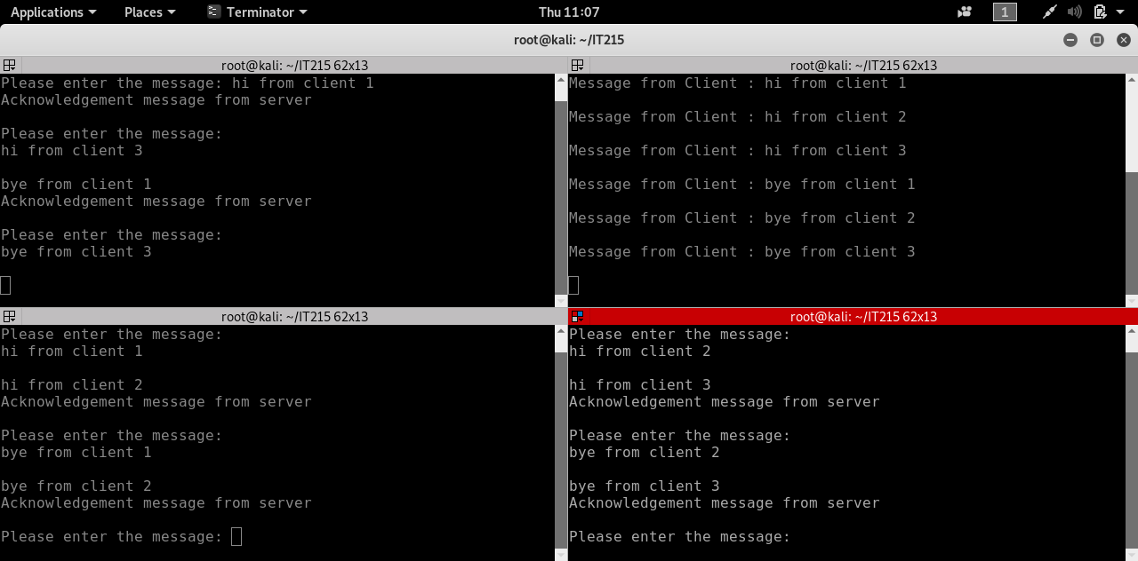

Broadcast Mode :

The given procedure is followed-

1. Client 1 (Top Left ) sends “hi from client 1” to client 2 and client 3.
2. Client 2 (Bottom Left ) and Client 3 receive message from client 1. Client 2 sends “hi from client 2 ” to client 3 and client 1.
3. Client 3 (Bottom Right ) and Client 1 receive message from client 2. Client 3 sends “hi from client 3 ” to client 1 and client 2.
4. Client 1 (Top Left ) and Client 2 receive message from client 3. Client 1 sends “bye from client 1” to client 2 and client 3.
5. Client 2 (Bottom Left ) and Client 3 receive message from client 1. Client 2 sends “bye from client 2” to client 1 and client 3.
6. Client 3 (Bottom Right ) and Client 1 receive message from client 2. Client 3 sends “bye from client 3” to client 1 and client 2.
7. Client 1 and Client 2 receive message from Client 3.

