Digital Nurture 5.0 | Angular (v20.0) | Hands-On Exercise BookDigital Nurture 5.0 | Angular (v20.0) | Hands-On Exercise Book

Hands-On 1: Environment Setup, Project Structure & First Component
Goal: install the Angular CLI, scaffold the Student Course Portal project, and create the first components (header, home, course-list, student-profile).

Task 1: Scaffold and Explore the Angular Project
Run: npm install -g @angular/cli, then ng new student-course-portal --routing --style=css, then cd student-course-portal && ng serve.
This generates angular.json, tsconfig*.json, package.json, src/main.ts, src/app/app.config.ts, src/app/app.component.ts and src/index.html.
ng serve then serves the app at http://localhost:4200, and ng build produces the compiled output in dist/.

Task 2: Create and Organise Components (HeaderComponent)
Generated components/header, pages/home, pages/course-list and pages/student-profile with the Angular CLI.
HeaderComponent renders the portal name and navigation links to Home, Courses and Profile.
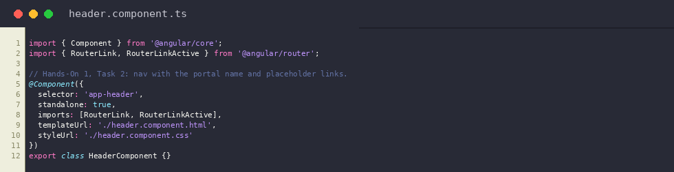
header.component.ts
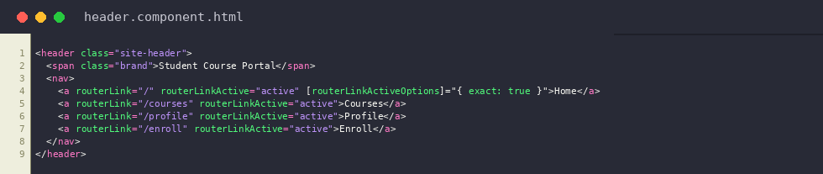
header.component.html
Output: Home page rendered with HeaderComponent (http://localhost:4200)
