Digital Nurture 5.0 | Angular (v20.0) | Hands-On Exercise BookDigital Nurture 5.0 | Angular (v20.0) | Hands-On Exercise Book

Hands-On 10: Unit Testing Angular Applications - Jasmine, Karma & TestBed
Goal: write unit tests for components and services using Jasmine, Karma and Angular's TestBed utilities. Run with: ng test (add --code-coverage for a coverage report).

Task 1: Testing CourseCardComponent
TestBed.configureTestingModule + compileComponents() sets up the standalone component under test.
Tests cover: component creation, @Input rendering (name/code shown in the template), @Output emission via spyOn for both enroll and unenroll, and the expanded/toggleDetails() state.
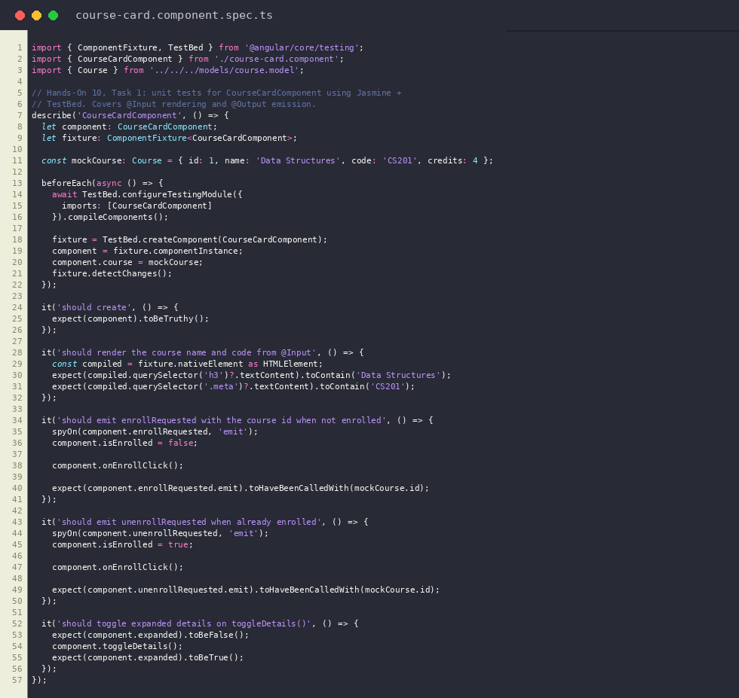
course-card.component.spec.ts
Output: Karma/Jasmine test run - all CourseCardComponent specs passing
