Digital Nurture 5.0 | Angular (v20.0) | Hands-On Exercise BookDigital Nurture 5.0 | Angular (v20.0) | Hands-On Exercise Book

Hands-On 2: Data Binding, Lifecycle Hooks & Component Communication
Goal: make the portal dynamic using Angular's four binding types, lifecycle hooks, and parent-child communication with @Input/@Output.

Task 1 & 2: Binding Types and Lifecycle Hooks (HomeComponent)
HomeComponent demonstrates interpolation ({{ portalName }}), property binding ([disabled]), event binding ((click)) and two-way binding ([(ngModel)]).
ngOnInit logs when the dashboard is ready and starts a periodic refresh timer; ngOnDestroy clears that timer to avoid memory leaks.
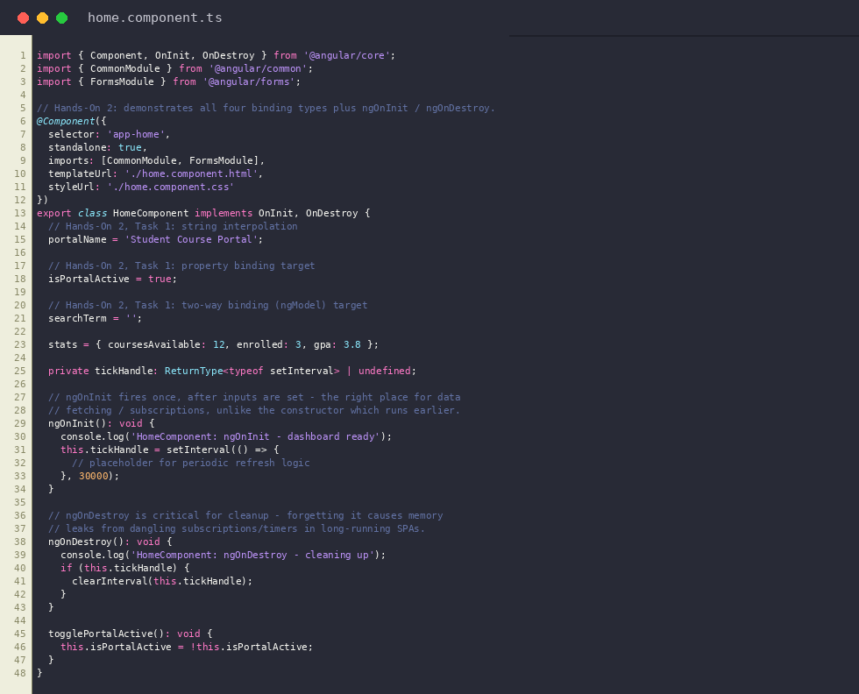
home.component.ts
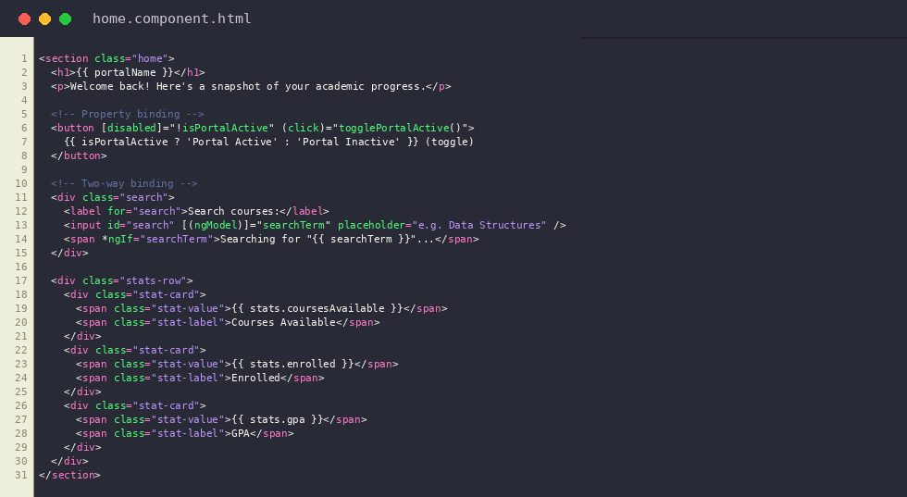
home.component.html
Output: HomeComponent showing interpolation, property binding (Portal Active toggle) and two-way binding (search box)
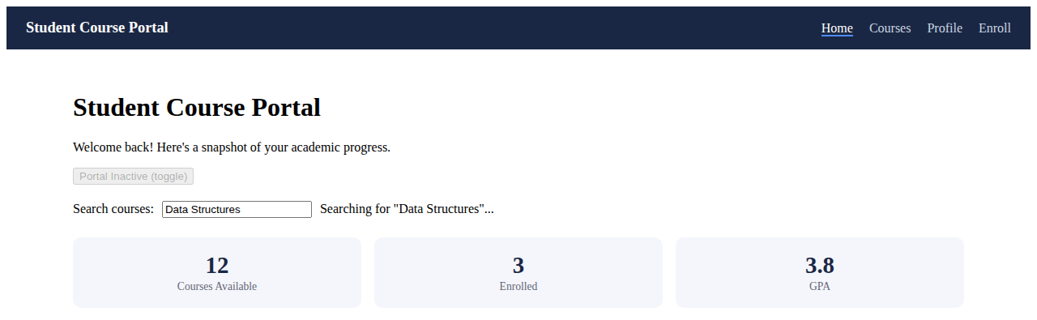

Task 3: @Input and @Output - Parent/Child Communication (CourseCardComponent)
CourseCardComponent receives course data via @Input() course, isEnrolled and grade.
It emits enrollRequested / unenrollRequested events via @Output() EventEmitter, which CourseListComponent listens for.
ngOnChanges logs the previous/current value whenever isEnrolled changes.
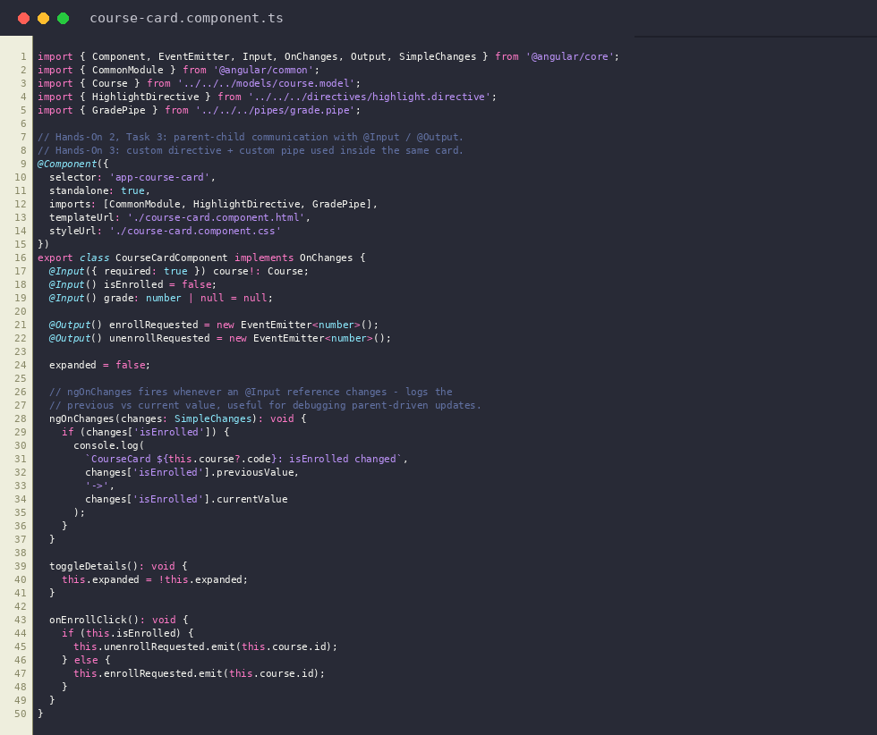
course-card.component.ts
Output: Clicking Enroll on a CourseCardComponent emits (enrollRequested) to the parent CourseListComponent
