Digital Nurture 5.0 | Angular (v20.0) | Hands-On Exercise BookDigital Nurture 5.0 | Angular (v20.0) | Hands-On Exercise Book

Hands-On 3: Directives & Pipes - Built-in and Custom
Goal: use built-in structural/attribute directives and pipes, then build one custom directive and one custom pipe.

Task 1: Structural Directives (*ngIf, *ngFor) in CourseListComponent
*ngIf shows a loading message while courses are being fetched, and an empty-state message when the list is empty.
*ngFor renders one <app-course-card> per course in the grid.
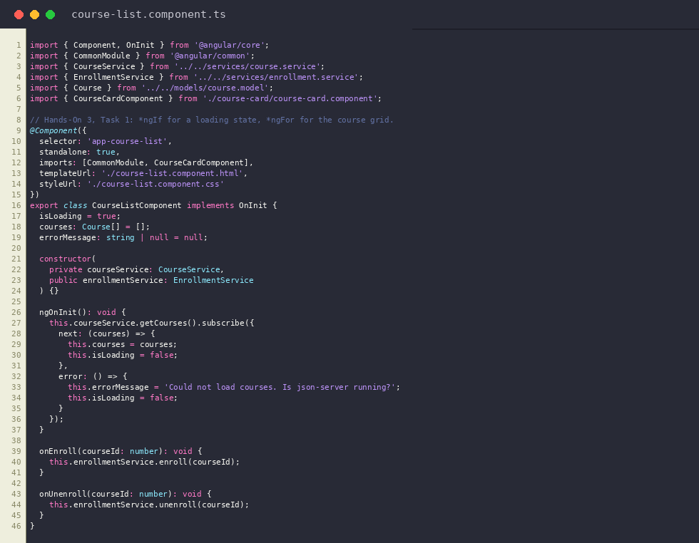
course-list.component.ts
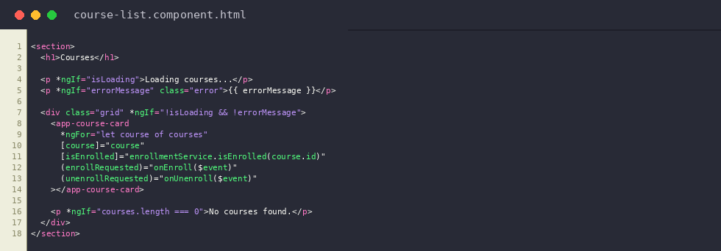
course-list.component.html
Output: Course grid rendered with *ngFor, loading/empty state handled by *ngIf
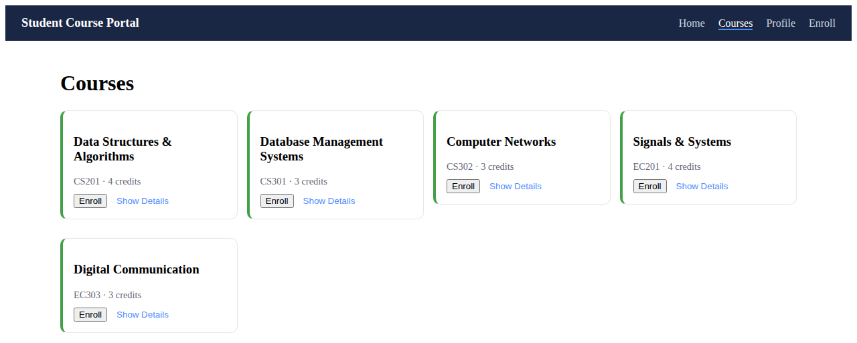

Task 2: Attribute Directives (ngClass, ngStyle) in CourseCardComponent
[ngClass] toggles the card--enrolled class based on isEnrolled.
[ngStyle] sets a dynamic border colour based on the grade, since that value cannot be expressed as a static class.
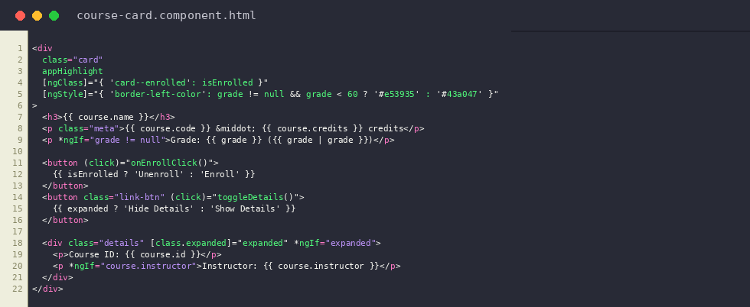
course-card.component.html
Output: [ngClass] applies card--enrolled (light green background) once a course is enrolled
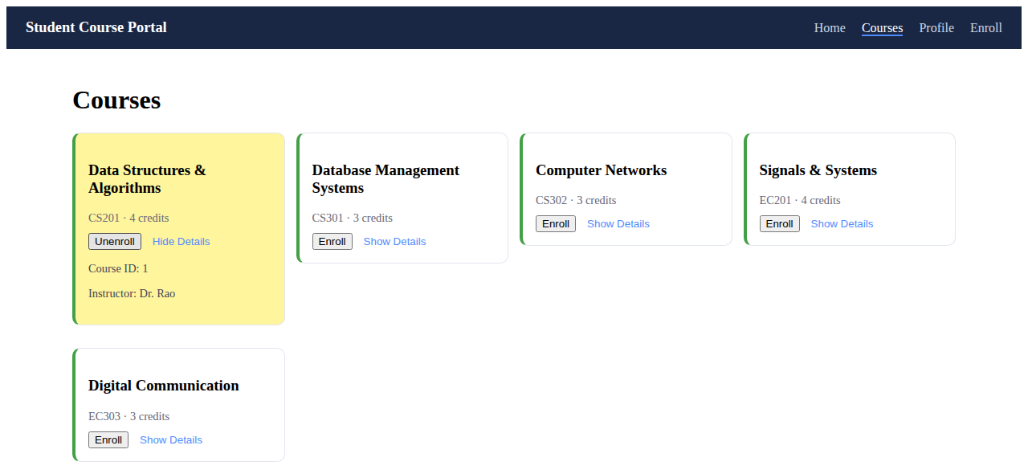

Task 3: Custom Directive and Custom Pipe
HighlightDirective (ng generate directive directives/highlight) adds a yellow background on mouseenter and removes it on mouseleave using @HostListener.
GradePipe (PipeTransform) converts a numeric score (0-100) into a letter grade, e.g. {{ 87 | grade }} -> "B".
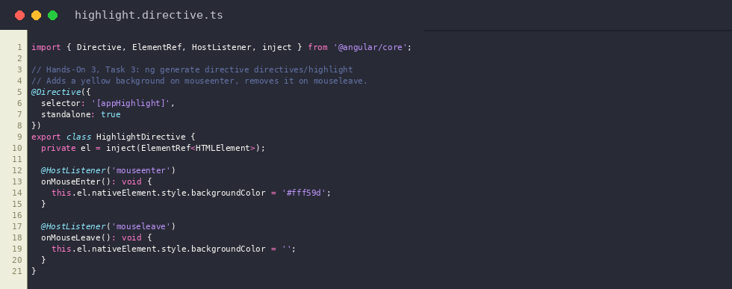
highlight.directive.ts
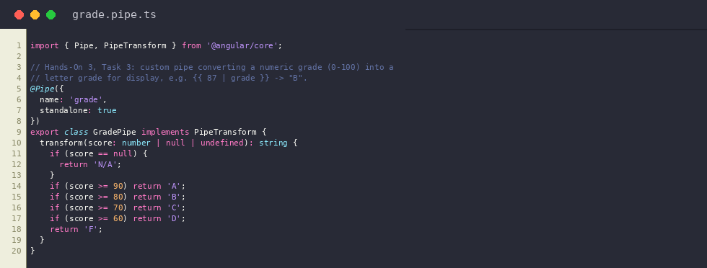
grade.pipe.ts
Output: HighlightDirective applies a yellow background on mouseenter
