Digital Nurture 5.0 | Angular (v20.0) | Hands-On Exercise BookDigital Nurture 5.0 | Angular (v20.0) | Hands-On Exercise Book

Hands-On 4: Template-Driven Forms & Validation
Goal: build the Student Enrollment Request form using template-driven forms (ngModel/ngForm), with built-in validators and contextual error messages.

Task 1 & 2: Build and Validate the Enrollment Request Form
FormsModule is imported to enable ngModel and ngForm.
Fields: studentName (required, minlength 2), email (required, email format), courseId (required).
Errors only show once a field is touched; a success message appears after submission, and Reset clears the form via enrollForm.resetForm().
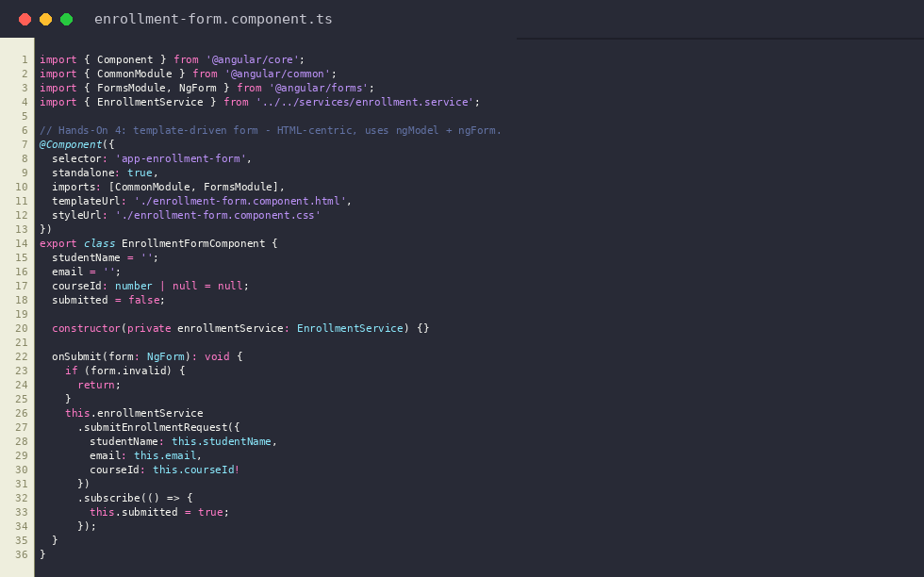
enrollment-form.component.ts
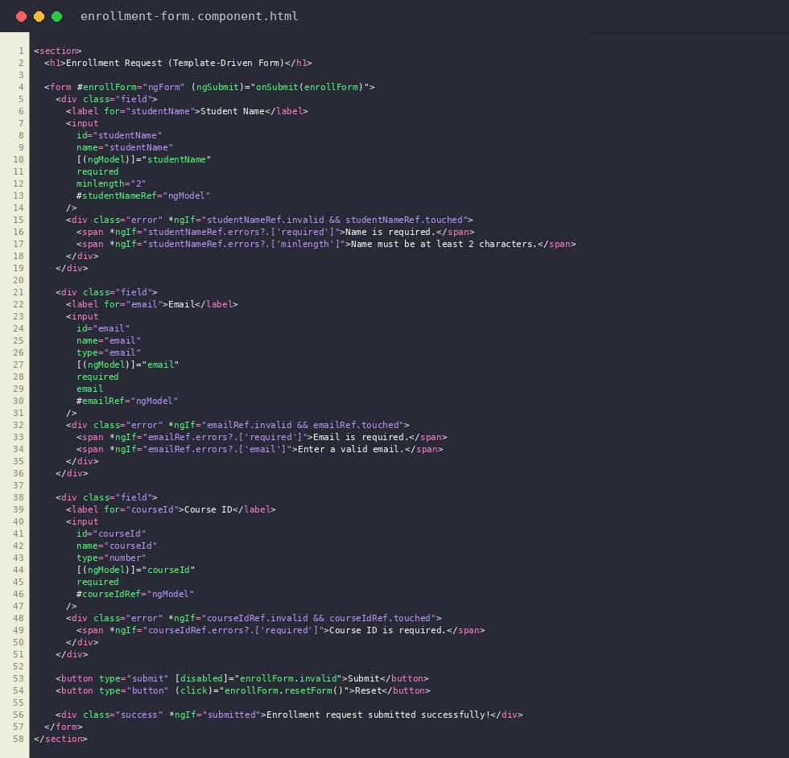
enrollment-form.component.html
Output: Validation errors shown once fields are touched and invalid
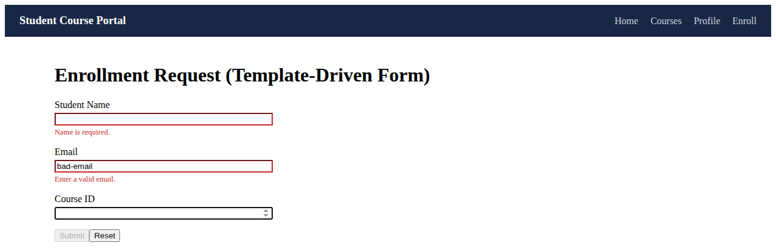
Output: Success message after a valid submission
