Digital Nurture 5.0 | Angular (v20.0) | Hands-On Exercise BookDigital Nurture 5.0 | Angular (v20.0) | Hands-On Exercise Book

Hands-On 5: Reactive Forms - FormBuilder, FormGroup, FormArray & Custom Validators
Goal: rebuild the enrollment form as a reactive form, defined in the component class, with custom sync/async validators and a dynamic FormArray.

Task 1: Reactive Form with Custom Validators and FormArray
ReactiveFormsModule + FormGroup/FormControl/FormArray define the form structure in the component class.
noTestEmailValidator is a custom synchronous validator; simulateEmailCheck is a custom async validator (simulated 800ms server round trip).
additionalCourses is a FormArray - "Add Another Course" pushes a new required FormControl; a typed getter avoids repeated "as FormArray" casts in the template.
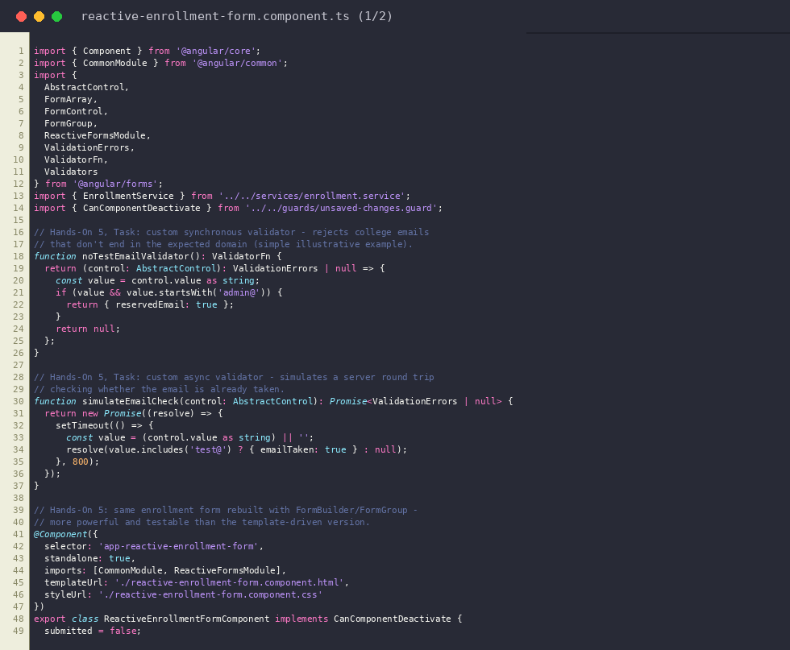
reactive-enrollment-form.component.ts (part 1/2)
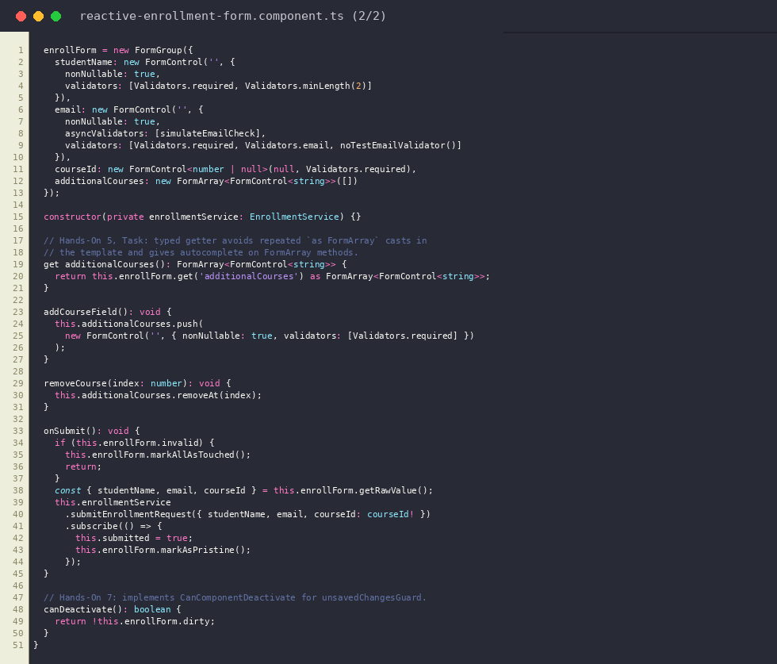
reactive-enrollment-form.component.ts (part 2/2)
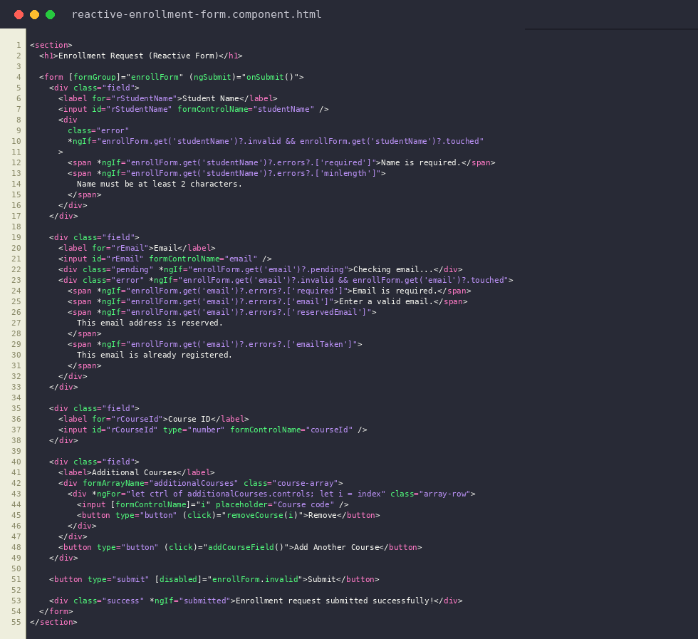
reactive-enrollment-form.component.html
Output: Reactive form validation errors, with an added FormArray course field
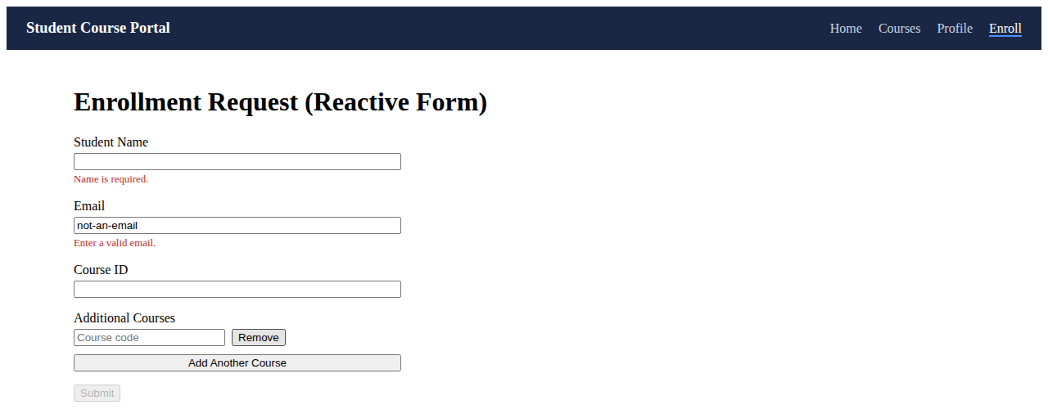
Output: Success message after a valid submission
