Digital Nurture 5.0 | Angular (v20.0) | Hands-On Exercise BookDigital Nurture 5.0 | Angular (v20.0) | Hands-On Exercise Book

Hands-On 6: Services & Dependency Injection
Goal: centralise shared logic/data in Angular services, understand providedIn: root vs component-level providers, and use a service as a shared state store.

Task 1: CourseService - Root-Provided Singleton
@Injectable({ providedIn: "root" }) means every component that injects CourseService shares the same singleton instance.
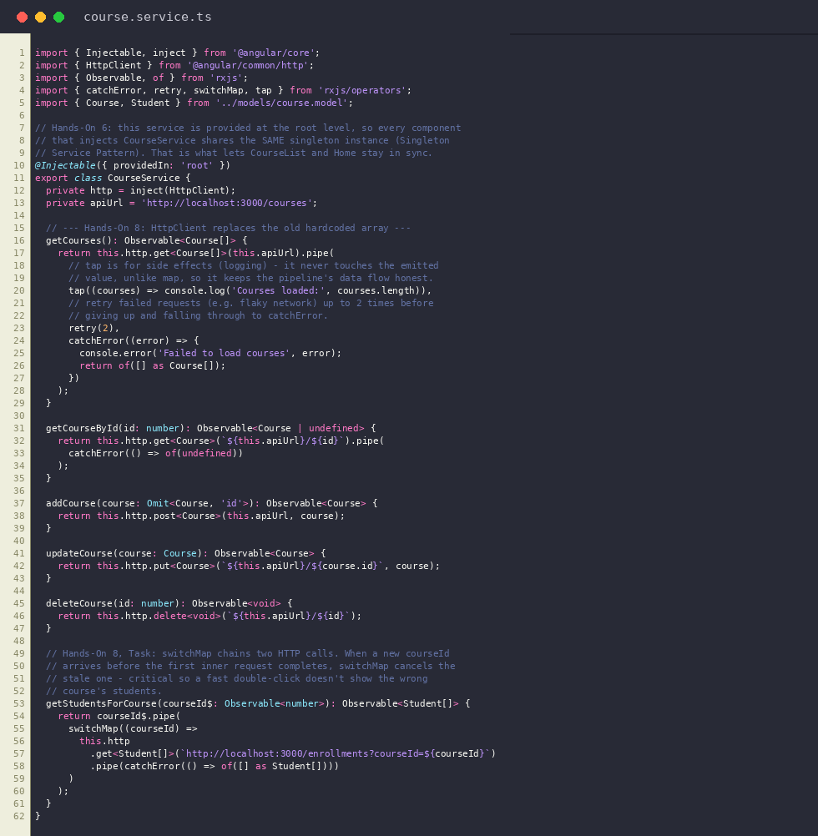
course.service.ts
Output: Courses loaded from the singleton CourseService
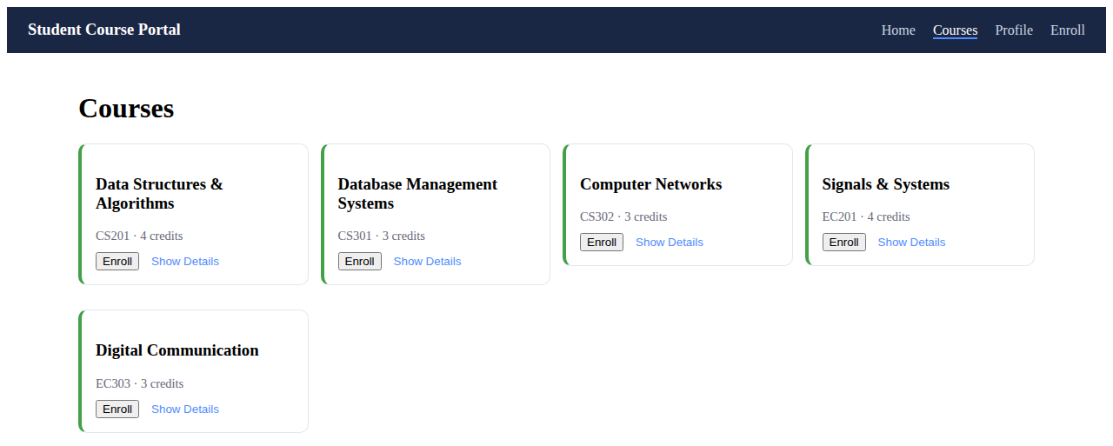

Task 2: EnrollmentService - Shared State Store
A BehaviorSubject of enrolled course IDs lets CourseCardComponent (writer) and StudentProfileComponent (reader) stay in sync without passing data through inputs.
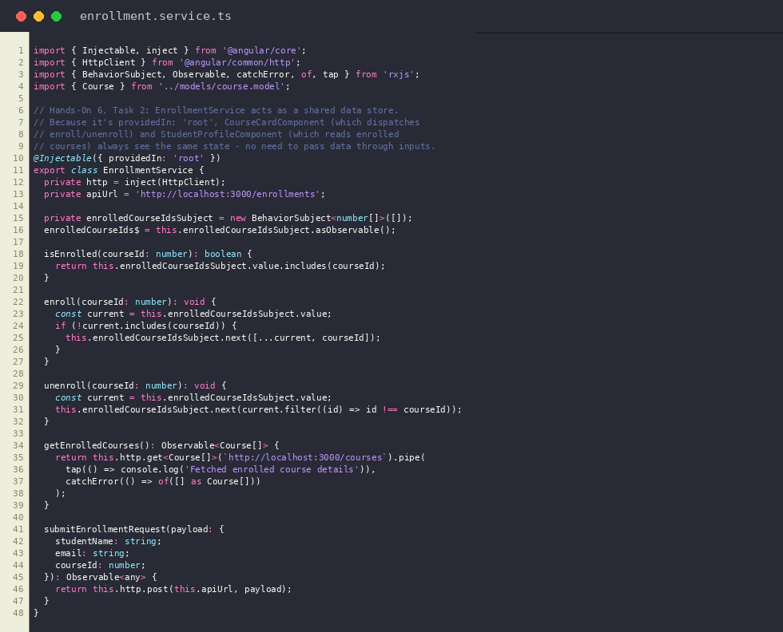
enrollment.service.ts
Output: Profile page reflects the enrolled course written by CourseCardComponent through the shared EnrollmentService


Task 3: NotificationService - Component-Level Provider
NotificationService is deliberately NOT providedIn: "root". NotificationComponent provides it locally (providers: [NotificationService]), so each instance gets its own isolated copy of messages.
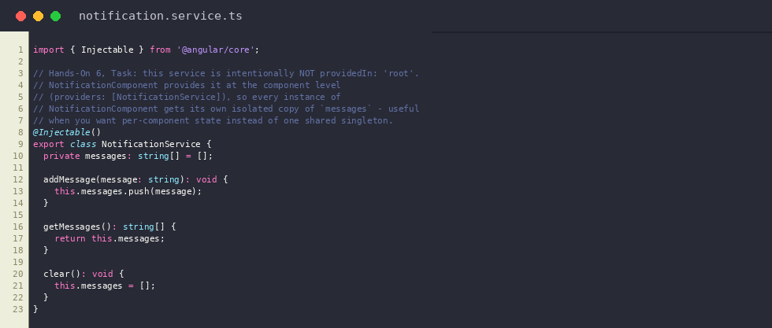
notification.service.ts
Output: Component-level NotificationService message displayed on the Profile page


