Digital Nurture 5.0 | Angular (v20.0) | Hands-On Exercise BookDigital Nurture 5.0 | Angular (v20.0) | Hands-On Exercise Book

Hands-On 7: Angular Routing - Guards, Lazy Loading & Route Data
Goal: configure all portal routes, lazy-load the enrollment feature, and protect routes with CanActivate / CanDeactivate guards.

Task 1: Route Configuration and Lazy Loading
Routes are defined with loadComponent() for standalone lazy loading - the /enroll chunk is only downloaded when the user navigates there.
Unknown paths fall back to Home via a wildcard route.
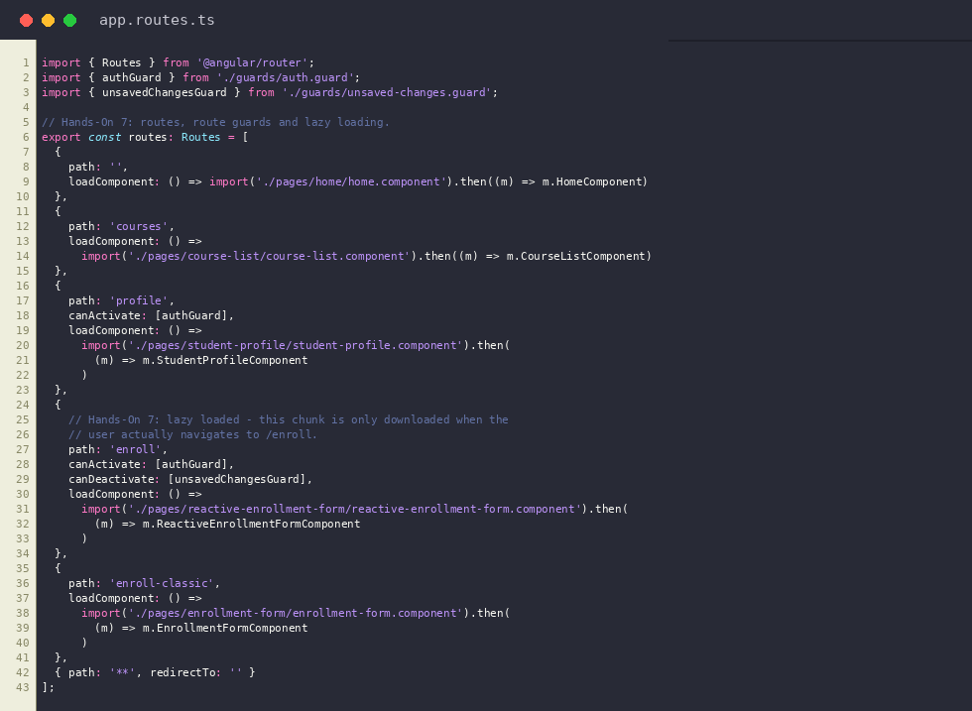
app.routes.ts
Output: Home route ('/')


Task 2: CanActivate Guard (authGuard)
authGuard checks AuthService.isLoggedIn (hardcoded true for now); if false it redirects to "/" and blocks navigation. Applied to /profile and /enroll.
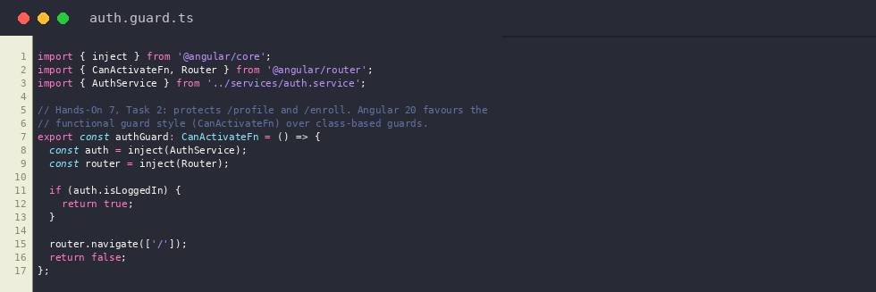
auth.guard.ts
Output: /profile route, accessible because authGuard sees AuthService.isLoggedIn = true


Task 3: CanDeactivate Guard (unsavedChangesGuard)
If the reactive enrollment form is dirty, window.confirm() asks the user before letting them navigate away, preventing accidental data loss.
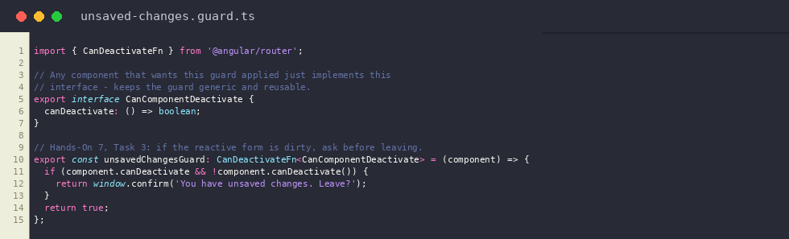
unsaved-changes.guard.ts
Output: /enroll route, lazy-loaded only when navigated to
