Digital Nurture 5.0 | Angular (v20.0) | Hands-On Exercise BookDigital Nurture 5.0 | Angular (v20.0) | Hands-On Exercise Book

Hands-On 8: HTTP Client - API Integration, Observables & Interceptors
Goal: replace hardcoded service data with live HttpClient calls against a json-server mock API, and add a functional interceptor for cross-cutting concerns.

Task 1: Mock Backend (json-server)
db.json defines courses, students and enrollments collections.
Output: json-server serving db.json at http://localhost:3000/courses
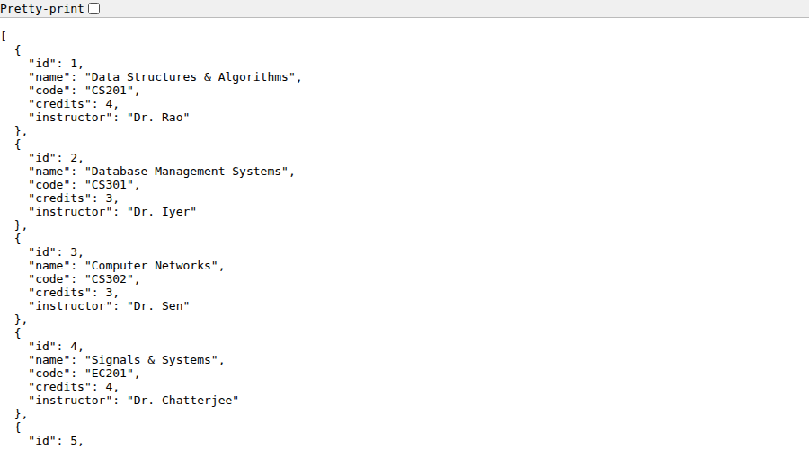
Run: npm run mock-api (json-server --watch db.json --port 3000) to serve it at http://localhost:3000.
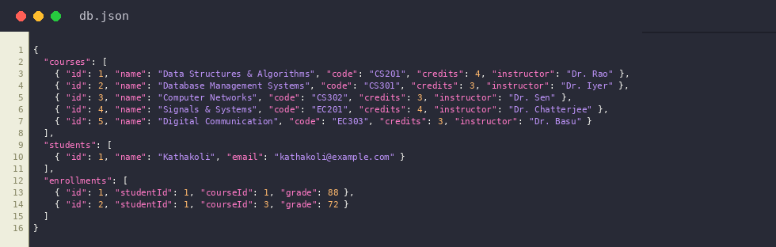
db.json

Task 2: CourseService with HttpClient, tap, retry, catchError, switchMap
getCourses() uses tap() for logging (side effects only, unlike map), retry(2) to retry flaky requests, and catchError() to fail gracefully.
getStudentsForCourse() uses switchMap so a new courseId cancels the previous in-flight request - critical for fast, repeated selections.
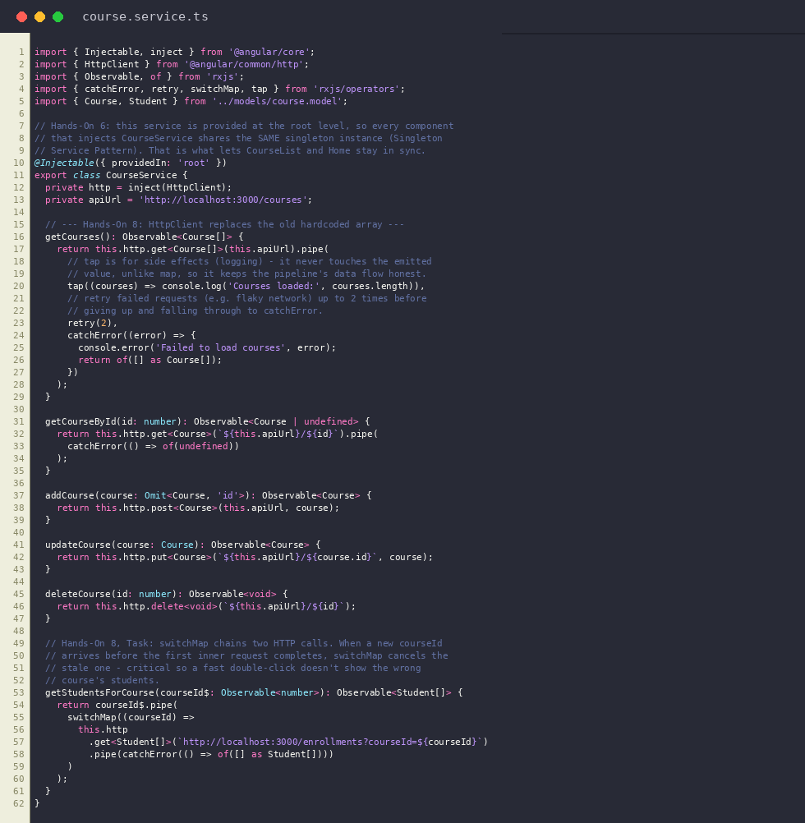
course.service.ts
Output: Course list rendered from the live HttpClient call (tap/retry/catchError)
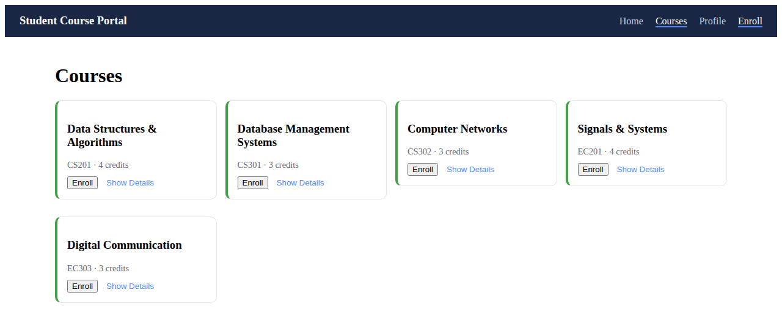

Task 3: Functional HTTP Interceptor
authInterceptor (registered via provideHttpClient(withInterceptors([...]))) attaches a fake auth token header and logs every outgoing request.
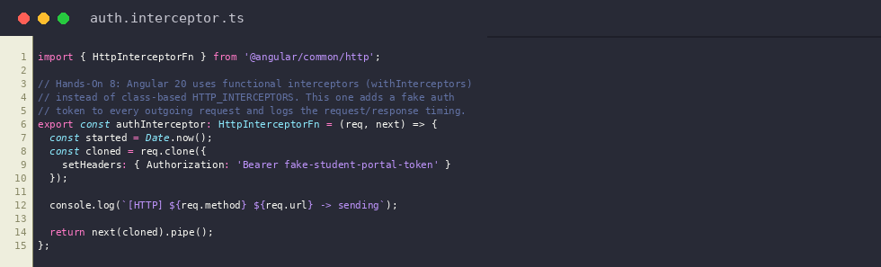
auth.interceptor.ts
Output: Same request now passing through authInterceptor, which attaches the auth header before it reaches json-server


