Digital Nurture 5.0 | Angular (v20.0) | Hands-On Exercise BookDigital Nurture 5.0 | Angular (v20.0) | Hands-On Exercise Book

Hands-On 9: State Management - NgRx Store, Actions, Reducers, Effects & Selectors
Goal: migrate course and enrollment state into NgRx (actions, reducers, effects, memoised selectors) instead of plain services.

Task 1: Course Actions, Reducer and Selectors
loadCourses / loadCoursesSuccess / loadCoursesFailure are the action set.
The reducer is a pure function - it never mutates state, always returns a new object.
createSelector memoises: selectAllCourses / selectCoursesLoading / selectCoursesError only recompute when the slice actually changes.
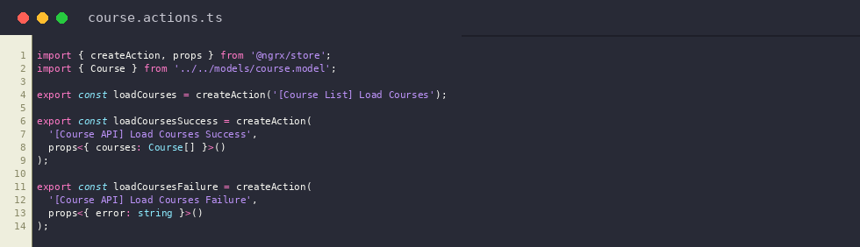
course.actions.ts
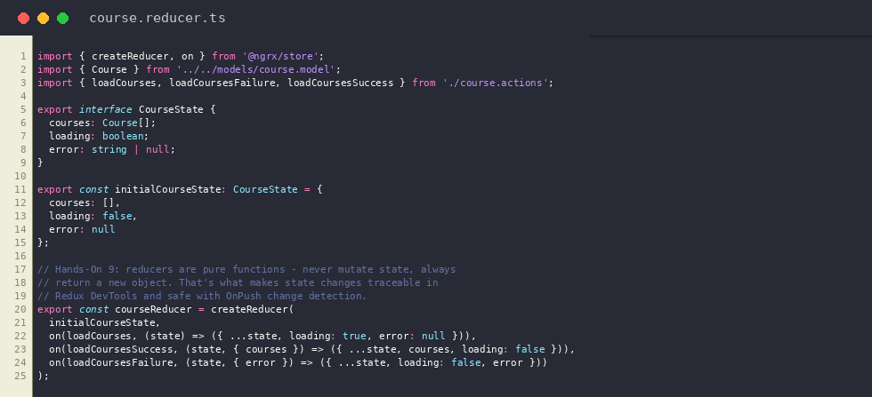
course.reducer.ts
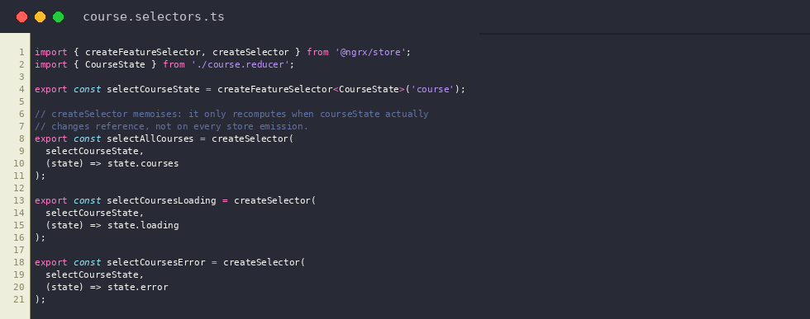
course.selectors.ts
Output: Course list rendered from NgRx store state via selectAllCourses
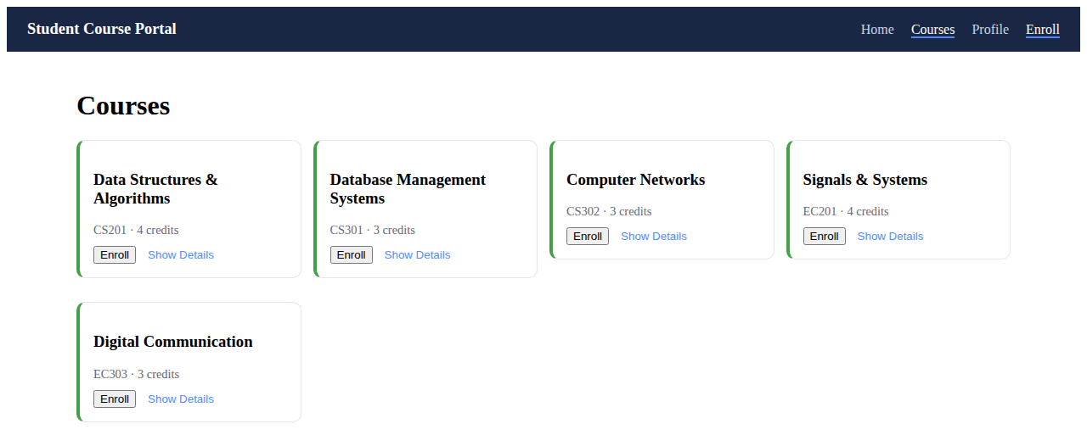

Task 2: Course Effects (Async Side Effects)
CourseEffects listens for loadCourses, calls CourseService.getCourses() via switchMap, then dispatches loadCoursesSuccess or loadCoursesFailure. The reducer stays pure; all side effects live here.
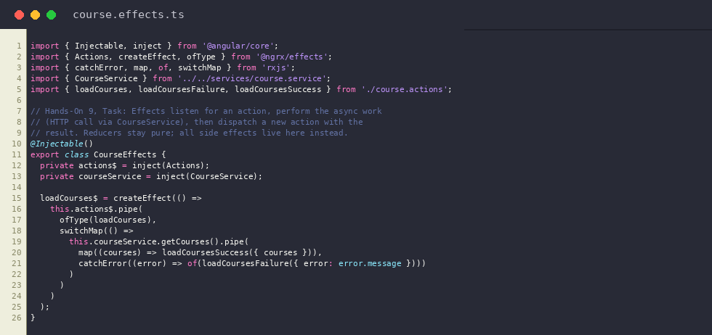
course.effects.ts
Output: CourseEffects dispatches loadCoursesSuccess after the HTTP call, populating the store


Task 3: Enrollment State (Cross-Slice Selector)
enrollInCourse / unenrollFromCourse / setEnrolledCourses update enrolledCourseIds. selectEnrolledCourses is a cross-slice selector combining the course slice and the enrollment slice into full Course objects.
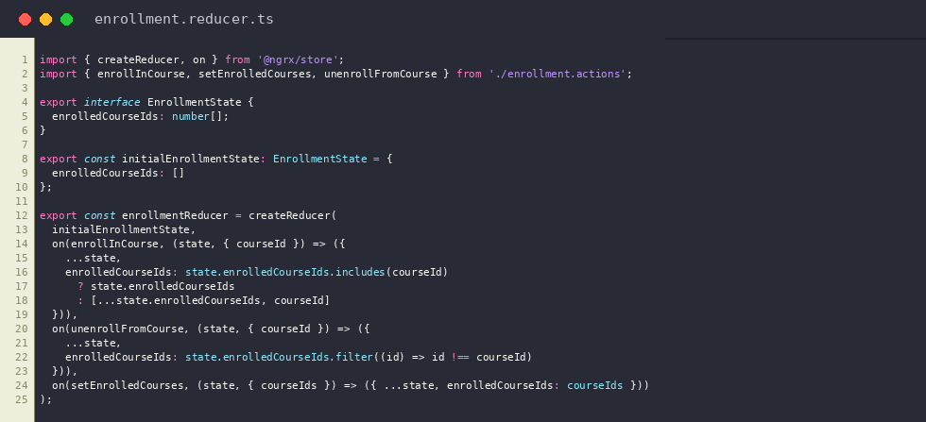
enrollment.reducer.ts
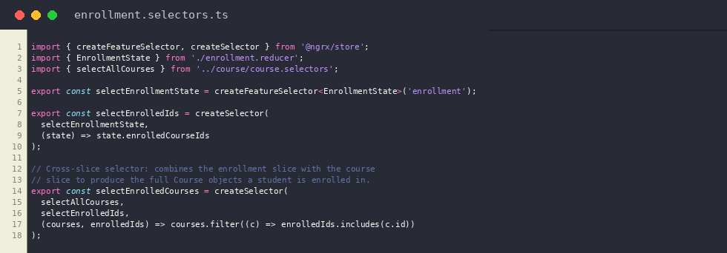
enrollment.selectors.ts
Output: Profile page driven by the cross-slice selectEnrolledCourses selector
