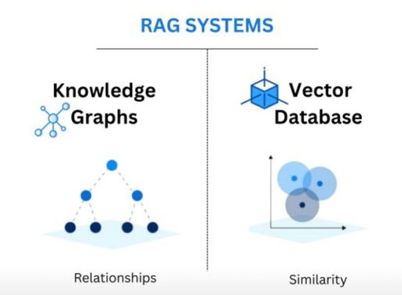“Can a schema-guided, temporally-aware knowledge graph improve the correctness and completeness of answers for enterprise queries compared to vector-only RAG systems?”

STEP 0 — PROBLEM FRAMING & DATASET GROUNDING

STEP 0.1: Problem Statement (What exactly is the problem?)

Problem Context
Retrieval-Augmented Generation (RAG) systems are widely used to improve the factual accuracy of large language models by retrieving relevant context from external knowledge sources. Most existing RAG systems rely on vector similarity search, where text chunks are embedded and the top-k most similar chunks are retrieved.
While effective for factoid queries, vector-based RAG systems struggle with enterprise-style queries that require:
- Temporal reasoning (e.g., time-bounded facts)
- Multi-hop relationships (e.g., employee → role → project → time)
- Complete enumeration rather than partial matches
This limitation arises because vector similarity retrieval selects a small subset of chunks, which may not collectively represent the full timeline or relational structure required to answer such queries correctly.

Concrete Failure Example
Query:
“List all positions held by an employee between 2010 and 2020.”
Vector RAG behaviour:
- Retrieves top-k chunks mentioning the employee
- Often misses intermediate roles or transitions
- Produces incomplete or partially correct answers
Expected behaviour:
- Identify all roles
- Respect start and end dates
- Return a complete timeline
This gap motivates the need for a structured, temporally-aware representation of knowledge.

Why this matters?
“Enterprise data is inherently relational and temporal. Treating it as independent text chunks leads to loss of global consistency.”

STEP 0.2: Dataset Selection and Justification
To study this problem in a controlled and reproducible manner, synthetic enterprise HR datasets are used. These datasets are suitable because they:
- Contain structured ground truth
- Include employment history and organizational relationships
- Avoid privacy concerns

Datasets Used
Dataset | Rows | Purpose
Employee/HR Dataset (All in One) | ~3000 | Employee attributes, departments, exit dates
Human Resources Data Set | ~312 | Organizational structure and role mapping
Synthetic Historical Workforce Data | ~471 | Time-stamped workforce transitions

Why multiple datasets?
“Using multiple datasets allows modelling both static attributes and temporal transitions, which is essential for evaluating time-aware knowledge graphs.”

STEP 0.3: Ground Truth Availability
A key advantage of these datasets is that ground truth is explicitly available:
- Employment start and end dates
- Role transitions
- Organizational hierarchy
Ground truth is derived directly from the datasets, enabling precise measurement of correctness and completeness.

STEP 0.4: Baseline Definition
To ensure a fair and meaningful comparison, a baseline system is defined.

Baseline System: Vector-Only RAG
- Data is chunked using a fixed-size strategy
- Chunks are embedded using an open-source embedding model
- Stored in Pinecone vector database
- Top-k chunks (k = 3 and k = 5) are retrieved
- Retrieved context is passed to a language model for answer generation
This baseline reflects common industry practice.

STEP 0.5: Research Hypothesis
Based on the problem analysis, the following hypothesis is proposed:
“A schema-guided, temporally-aware knowledge graph will provide higher answer completeness and correctness for enterprise HR queries than vector-only RAG systems.”

