Problem Statement

“How does an explicit Knowledge Graph representation improve factual completeness, multi-hop reasoning, and constraint satisfaction in enterprise question answering compared to vector-only RAG systems?”
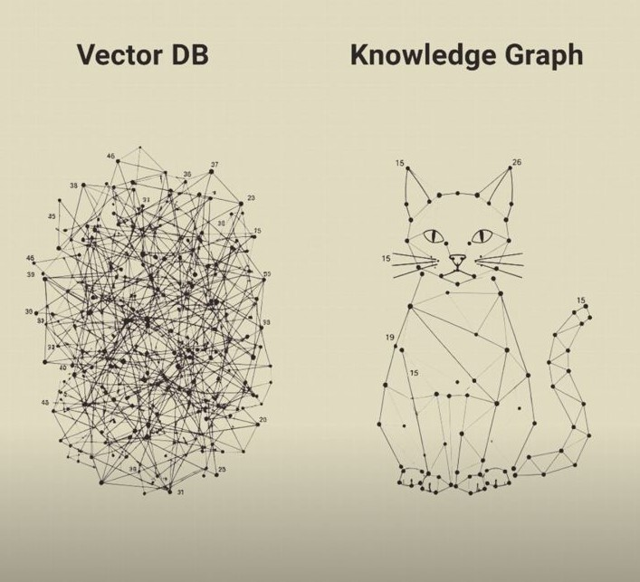

Enterprise HR data encodes time-bound role transitions, reporting structures, and performance events that are flattened when stored as text chunks, leading to partial or incorrect answers in vector-based RAG.

Novelty in Research

Innovation 1: Temporal KG construction from tabular HR data
- Not generic KG extraction from text
- Structured → Temporal Graph
- Uses employment intervals, not static facts
This is not what LLMGraphTransformer does out-of-the-box.

Innovation 2: Hybrid Retrieval Strategy (Graph → Vector)
Instead of:
Vector DB retrieves top-k chunks, here :
- Graph query constrains time & entities
- Only relevant subgraph-linked documents are embedded
- LLM answers over filtered context
This is a methodological change, not a simple API call.

Some proposed metrics

Instead of the generic evaluation metrics. I’ll use the following.
Metric | How computed
Temporal completeness | % of roles/events returned within a date range
Temporal correctness | Whether dates align with ground truth
Entity coverage | # of distinct positions/managers retrieved
Hallucination rate | Answers contradicting KG facts

As a part of the comparative study, I’ll extend the research on a few other datasets as well. We can accordingly introduce some more evaluation metrics further with progression of the study.

KG Schema:

A. Core Node Types:
1. Employee
- Attributes: EmpID, Employee_Name, DOB, Sex, RaceDesc, CitizenDesc, HispanicLatino, MaritalStatusID, MaritalDesc
- Note: Stable identity node
2. Position
- Attributes: PositionID, Position
- Note: Modeled as a node (not an attribute) because roles change over time.
3. Department
- Attributes: DeptID, Department
4. Manager (Employee-as-Role)
- Attributes: ManagerID, ManagerName
- Note: Represents the same "Employee" node, but linked via a reporting relationship.
5. PerformanceReview (Event Node)
- Attributes: PerformanceScore, PerfScoreID, LastPerformanceReview_Date, EngagementSurvey, EmpSatisfaction, SpecialProjectsCount, DaysLateLast30, Absences
- Note: Critical innovation—performance is treated as time-dependent data.
B. Relationship Types:
1. Position History
- Structure: (:Employee)-[:HELD_POSITION]->(:Position)
- Edge Properties: DateofHire, DateofTermination, PositionID
- Purpose: Directly supports temporal queries.
2. Department History
- Structure: (:Employee)-[:WORKED_IN]->(:Department)
- Edge Properties: DeptID, DateofHire, DateofTermination
3. Reporting Structure
- Structure: (:Employee)-[:REPORTED_TO]->(:Employee)
- Edge Properties: ManagerID (defines the relationship start/current status)

4. Performance History
- Structure: (:Employee)-[:HAS_REVIEW]->(:PerformanceReview)
- Edge Properties: LastPerformanceReview_Date
5. Recruitment Source
- Structure: (:Employee)-[:RECRUITED_VIA]->(:RecruitmentSource)
- Edge Properties: RecruitmentSource, FromDiversityJobFairID

