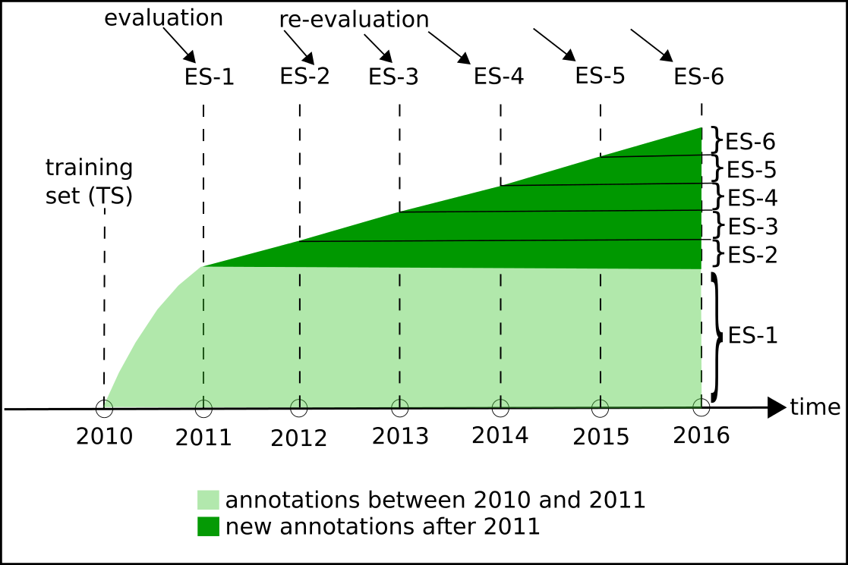

 | MFO |  | BPO |  | CCO
TS/ES | Proteins | GO terms | Proteins | GO terms | Proteins | GO terms
TS | 22,715 | 3,252 | 23,124 | 7,549 | 24,216 | 1,224
ES-1 | 3,546 | 4,639 | 3,669 | 7,439 | 3,160 | 4,146
ES-2 | 346 | 448 | 540 | 1,088 | 235 | 297
ES-3 | 202 | 290 | 445 | 1,553 | 191 | 333
ES-4 | 136 | 184 | 420 | 1,015 | 174 | 241
ES-5 | 136 | 294 | 411 | 2,052 | 172 | 548
ES-6 | 133 | 199 | 398 | 1,067 | 162 | 298

Species: 9606, 10090, 3702, 10116, 559292, 9913, 284812, 83333, 224308, 44689

# of proteins and GO terms in training sets
(UniProt/SwissProt time point 2010_01)
 | MFO |  | BPO |  | CCO
Organism | Proteins | GO terms | Proteins | GO terms | Proteins | GO terms
9606 | 5,252 | 1,450 | 3,567 | 2,700 | 4,446 | 552
10090 | 3,682 | 1,104 | 4,265 | 3,588 | 3,847 | 446
3702 | 1,876 | 685 | 2,374 | 1,126 | 2,848 | 185
10116 | 2,253 | 1,252 | 2,327 | 1,955 | 1,962 | 374
559292 | 0 | 0 | 0 | 0 | 0 | 0
9913 | 103 | 80 | 62 | 85 | 65 | 38
284812 | 0 | 0 | 0 | 0 | 0 | 0
83333 | 786 | 12 | 12 | 10 | 160 | 6
224308 | 0 | 0 | 0 | 0 | 0 | 0
44689 | 284 | 184 | 469 | 353 | 474 | 112

# of proteins and GO terms in evaluation set 1 (ES-1)
(UniProt/SwissProt time points 2010_01 and 2011_01)
 | MFO |  | BPO |  | CCO
Organism | Proteins | GO terms | Proteins | GO terms | Proteins | GO terms
9606 | 16 | 24 | 8 | 16 | 16 | 25
10090 | 4 | 3 | 2 | 3 | 1 | 1
3702 | 10 | 11 | 21 | 36 | 22 | 37
10116 | 0 | 0 | 0 | 0 | 1 | 5
559292 | 0 | 0 | 0 | 0 | 0 | 0
9913 | 3 | 1 | 0 | 0 | 0 | 0
284812 | 0 | 0 | 0 | 0 | 0 | 0
83333 | 1 | 1 | 0 | 0 | 0 | 0
224308 | 0 | 0 | 0 | 0 | 0 | 0
44689 | 0 | 0 | 0 | 0 | 1 | 1

# of proteins and GO terms in evaluation set 2 (ES-2)
(based on ES-1 and UniProt/SwissProt time point 2012_01)
 | MFO |  | BPO |  | CCO
Organism | Proteins | GO terms | Proteins | GO terms | Proteins | GO terms
9606 | 2 | 4 | 3 | 3 | 5 | 8
10090 | 0 | 0 | 1 | 8 | 0 | 0
3702 | 1 | 1 | 3 | 4 | 2 | 1
10116 | 0 | 0 | 0 | 0 | 0 | 0
559292 | 0 | 0 | 0 | 0 | 0 | 0
9913 | 0 | 0 | 0 | 0 | 0 | 0
284812 | 0 | 0 | 0 | 0 | 0 | 0
83333 | 0 | 0 | 0 | 0 | 0 | 0
224308 | 0 | 0 | 0 | 0 | 0 | 0
44689 | 0 | 0 | 0 | 0 | 1 | 1

# of proteins and GO terms in evaluation set 3 (ES-3)
(based on ES-2 and UniProt/SwissProt time point 2013_01)
 | MFO |  | BPO |  | CCO
Organism | Proteins | GO terms | Proteins | GO terms | Proteins | GO terms
9606 | 1 | 1 | 3 | 7 | 4 | 4
10090 | 0 | 0 | 1 | 1 | 0 | 0
3702 | 0 | 0 | 3 | 5 | 2 | 14
10116 | 0 | 0 | 0 | 0 | 0 | 0
559292 | 0 | 0 | 0 | 0 | 0 | 0
9913 | 0 | 0 | 0 | 0 | 0 | 0
284812 | 0 | 0 | 0 | 0 | 0 | 0
83333 | 0 | 0 | 0 | 0 | 0 | 0
224308 | 0 | 0 | 0 | 0 | 0 | 0
44689 | 0 | 0 | 0 | 0 | 0 | 0

# of proteins and GO terms in evaluation set 4 (ES-4)
(based on ES-3 and UniProt/SwissProt time point 2014_01)
 | MFO |  | BPO |  | CCO
Organism | Proteins | GO terms | Proteins | GO terms | Proteins | GO terms
9606 | 1 | 3 | 3 | 5 | 4 | 8
10090 | 0 | 0 | 1 | 8 | 0 | 0
3702 | 0 | 0 | 3 | 5 | 2 | 1
10116 | 0 | 0 | 0 | 0 | 0 | 0
559292 | 0 | 0 | 0 | 0 | 0 | 0
9913 | 0 | 0 | 0 | 0 | 0 | 0
284812 | 0 | 0 | 0 | 0 | 0 | 0
83333 | 0 | 0 | 0 | 0 | 0 | 0
224308 | 0 | 0 | 0 | 0 | 0 | 0
44689 | 0 | 0 | 0 | 0 | 0 | 0

# of proteins and GO terms in evaluation set 5 (ES-5)
(based on ES-4 and UniProt/SwissProt time point 2015_01)
 | MFO |  | BPO |  | CCO
Organism | Proteins | GO terms | Proteins | GO terms | Proteins | GO terms
9606 | 1 | 2 | 3 | 10 | 4 | 12
10090 | 0 | 0 | 1 | 2 | 0 | 0
3702 | 0 | 0 | 3 | 9 | 2 | 15
10116 | 0 | 0 | 0 | 0 | 0 | 0
559292 | 0 | 0 | 0 | 0 | 0 | 0
9913 | 0 | 0 | 0 | 0 | 0 | 0
284812 | 0 | 0 | 0 | 0 | 0 | 0
83333 | 0 | 0 | 0 | 0 | 0 | 0
224308 | 0 | 0 | 0 | 0 | 0 | 0
44689 | 0 | 0 | 0 | 0 | 0 | 0

# of proteins and GO terms in evaluation set 6 (ES-6)
(based on ES-5 and UniProt/SwissProt time point 2016_01)
 | MFO |  | BPO |  | CCO
Organism | Proteins | GO terms | Proteins | GO terms | Proteins | GO terms
9606 | 1 | 3 | 3 | 7 | 4 | 10
10090 | 0 | 0 | 1 | 8 | 0 | 0
3702 | 0 | 0 | 3 | 4 | 2 | 1
10116 | 0 | 0 | 0 | 0 | 0 | 0
559292 | 0 | 0 | 0 | 0 | 0 | 0
9913 | 0 | 0 | 0 | 0 | 0 | 0
284812 | 0 | 0 | 0 | 0 | 0 | 0
83333 | 0 | 0 | 0 | 0 | 0 | 0
224308 | 0 | 0 | 0 | 0 | 0 | 0
44689 | 0 | 0 | 0 | 0 | 0 | 0

Training dataset, TS
Evaluation dataset, ES-1
Reevaluation datasets, ES-2, ES-3, …,ES-6
- ES-2, ES-3, …, and, ES-6 are created based on the growth of UniProtKB/SwissProt database.
Reevaluation datasets, ES-2', ES-3', …, ES-6'
- ES'-2, ES'-3, …, and , ES'-6 are created based on the monthly growth of TrEMBL database.
- This enables us to collect larger number of proteins for each set.

Creating Training Dataset, TS
Command: python xTract_trainingSet -I1=uniprot_sprot.dat.2010_01
Input file: UniProtKB/SwissProt file January 2010
Output files:
Three pairs of output files – one FASTA and one corresponding map file, a pair for each of MFO, BPO, and CCO ontological categories. Each FASTA file contains the protein sequences in FASTA format. On the other hand, the map file contains the sequence id used in the FASTA file and GO annotations that define the functions of the protein.
- MFO
  - uniprot_sprot.dat.2010_01.tfa_mfo.1
  - uniprot_sprot.dat.2010_01.tfa_mfo.1.map
- BPO
  - uniprot_sprot.dat.2010_01.tfa_bpo.1
  - uniprot_sprot.dat.2010_01.tfa_bpo.1.map
- CCO
  - uniprot_sprot.dat.2010_01.tfa_cco.1
  - uniprot_sprot.dat.2010_01.tfa_cco.1.map

Creating Evaluation Datasets: ES-1, ES-2, ES-3, ES-4, ES-5, and ES-6
ES-1. This dataset is used for evaluation of the prediction models. The set has those sequences that did not have Exp validation in January 2010 but gained such validation in January 2011.
Command:
python xTract_testSet -I1=uniprot_sprot.dat.2010_01 -I2=uniprot_sprot.dat.2011_01
Input files:
- UniProtKB/SwissProt file January 2010: uniprot_sprot.dat.2010_01
- UniProtKB/SwissProt file January 2011: uniprot_sprot.dat.2011_01
Output files:
Three pairs of output files – one FASTA and one corresponding map file, a pair for each of MFO, BPO, and CCO ontological categories. Each FASTA file contains the protein sequences in FASTA format. On the other hand, the map file contains the sequence id used in the FASTA file, the corresponding protein name, and GO annotations that define the functions of the protein.
- MFO
  - uniprot_sprot.dat.2010_01-2011_01.tfa_LK_bpo.1
  - uniprot_sprot.dat.2010_01-2011_01.tfa_LK_bpo.1.map
- BPO
  - uniprot_sprot.dat.2010_01-2011_01.tfa_LK_mfo.1
  - uniprot_sprot.dat.2010_01-2011_01.tfa_LK_mfo.1.map
- CCO
  - uniprot_sprot.dat.2010_01-2011_01.tfa_LK_cco.1
  - uniprot_sprot.dat.2010_01-2011_01.tfa_LK_cco.1.map

