CUSTOMER CHURN ANALYSIS & EXCEL DASHBOARD
Data Analytics Project Report
Prepared by
Vijay Kumar A G
Microsoft Excel | Data Analysis | Data Visualization

Abstract
This project analyzes customer churn using customer, subscription, support-ticket, and churn-event data in Microsoft Excel. The analysis calculates key performance indicators, compares churn across business dimensions, summarizes support activity and refunds, and presents the results through a professional dashboard. The completed analysis contains 500 customers, a 22% customer churn rate, total MRR of 11,338,747, total ARR of 136,064,964, 2,000 support tickets, and 600 churn events.

1. Introduction
Customer churn analysis helps organizations understand how and why customers leave a product or service. This project demonstrates a practical Excel-based workflow from structured business data to KPI calculations, segmentation analysis, visualization, and dashboard communication.

2. Problem Statement
The objective is to measure customer churn and identify meaningful patterns across customer segments, subscriptions, support activity, churn reasons, and refunds, then communicate the results through a compact dashboard.

3. Objectives
- Measure overall customer churn.
- Compare churn by industry and country.
- Analyze churn by subscription plan, trial status, and referral source.
- Analyze support-ticket performance, priority, satisfaction, and escalation.
- Summarize churn reasons, events, and refunds.
- Build a professional Excel dashboard.

4. Tools and Technologies
- Microsoft Excel
- Excel formulas and aggregation
- Data analysis and KPI calculation
- Charts and dashboard design

5. Analysis Areas
Area | Purpose | Output
Accounts | Customer-level analysis | Customer count and segmentation
Subscriptions | Subscription and revenue analysis | MRR, ARR, churn metrics
Feature Usage | Usage-related analysis | Usage patterns
Support Tickets | Support performance | Tickets, response, satisfaction, escalation
Churn Events | Churn and refund analysis | Reasons, events, refunds
Dashboard | Business communication | KPI cards and charts

6. Methodology
- Organize structured business tables.
- Calculate counts, sums, averages, rates, and ratios using Excel formulas.
- Segment churn across industry, country, plan, trial status, and referral source.
- Summarize support-ticket and churn-event metrics.
- Create charts and KPI cards.
- Arrange the outputs into a final dashboard.

7. Key Performance Indicators
KPI | Value
Total Customers | 500
Customer Churn Rate | 22%
Total MRR | 11,338,747
Total ARR | 136,064,964
Total Support Tickets | 2,000
Average Satisfaction Score | 3.98
Total Churn Events | 600
Total Refund Amount | 8,652.25

8. Dashboard Visualizations
- Churn Rate by Industry
- Churn Rate by Country
- Churn Rate by Trial Status
- Churn Rate by Subscription Plan
- Churn Rate by Referral Source
- Support Tickets by Priority
- Support Tickets by Escalation Status

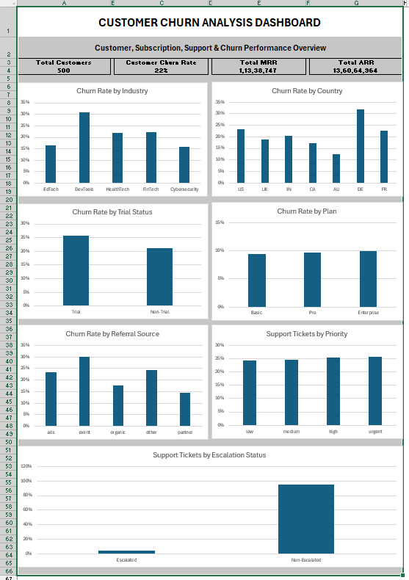
9. Dashboard Preview

Figure 1. Customer Churn Analysis Dashboard

10. Key Findings
- Overall customer churn rate is 22%.
- DevTools has the highest displayed industry churn rate.
- Germany has the highest displayed country churn rate.
- Trial customers show higher churn than non-trial customers.
- Features is the leading churn reason with 114 events.
- The highest refund amount is 1,905.90 and is associated with Features.
- There are 600 churn events and total refunds of 8,652.25.

11. Support Ticket Analysis
The support-ticket analysis contains 2,000 tickets. Average resolution time is approximately 35.86, average first response time is 88.48, and average satisfaction is approximately 3.98. There are 95 escalated tickets, giving an escalation rate of approximately 4.75%, displayed as 5% when rounded to a whole percentage.

12. Churn Event and Refund Analysis
The churn-event analysis contains 600 events. Total refund amount is 8,652.25. Features is the top churn reason with 114 events and is associated with the highest refund amount of 1,905.90 in the analyzed summary. The analysis also identifies 123 events following an upgrade flag and 53 following a downgrade flag.

13. Conclusion
The project demonstrates an end-to-end Excel customer churn analytics workflow combining KPI calculation, segmentation, support analysis, churn-event analysis, and visualization. The dashboard provides a concise business view suitable for portfolio presentation.

14. Limitations and Future Enhancements
- The analysis is descriptive and does not establish causality.
- Build a Power BI version with slicers and drill-through.
- Use SQL and Python for automated data preparation.
- Develop a machine-learning churn prediction model.
- Add time-series churn and revenue trends.
- Perform statistical testing to validate potential churn drivers.

