WEEK 2 TASK
Titanic Data Visualization and
Insight Communication using R
Data Visualization Project Report
Submitted by: Vijay Kumar A G
M.Tech – Data Science

Table of Contents
1. Introduction
2. Task Objective
3. Dataset Overview
4. Data Cleaning and Preparation
5. Tools and Technologies
6. Exploratory Data Analysis
7. Data Visualizations and Insight Communication
8. Overall Key Findings
9. Conclusion
10. Future Scope

1. Introduction
Data visualization converts raw data into graphical representations that make trends, patterns, differences and anomalies easier to understand. This project uses R and ggplot2 to communicate important findings from the Titanic passenger dataset to both technical and non-technical audiences.

2. Task Objective
The objective is to prepare the Titanic dataset, create multiple visualization types, identify meaningful patterns and communicate the resulting insights clearly.
- Understand the dataset and its important variables.
- Prepare the data for reliable visualization.
- Create bar charts, a histogram, a scatter plot and box plots.
- Identify trends, comparisons and potential outliers.
- Explain the analytical meaning of each visualization.

3. Dataset Overview
The cleaned dataset contains 891 passenger records and 16 variables.
Variable | Type | Description
PassengerId | Numeric | Unique passenger identifier
Survived | Binary | 0 = did not survive, 1 = survived
Pclass | Categorical/Numeric | Passenger class
Name | Text | Passenger name
Sex | Categorical | Passenger gender
Age | Numeric | Passenger age
SibSp | Numeric | Siblings/spouses aboard
Parch | Numeric | Parents/children aboard
Ticket | Text | Ticket identifier
Fare | Numeric | Ticket fare
Cabin | Text | Cabin information
Embarked | Categorical | Port of embarkation
Survived_Label | Categorical | Readable survival label
Pclass_Label | Categorical | Readable class label
FamilySize | Numeric | SibSp + Parch + 1
AgeGroup | Categorical | Child to Senior age categories

4. Data Cleaning and Preparation
The dataset was cleaned before visualization. Missing Age values were imputed using the median within passenger-class and gender groups, with the overall median as a fallback. Missing Embarked values were filled using the mode, while missing Cabin values were represented as Unknown. Readable labels for survival and passenger class were added, along with FamilySize and AgeGroup.
- All 891 passenger records were retained.
- Categorical text values were standardized.
- No missing values remain in the cleaned dataset.
- Additional derived variables were created for clearer analysis.

5. Tools and Technologies
- R – analysis and visualization programming
- RStudio – development environment
- ggplot2 – visualization
- dplyr – data manipulation
- readr – CSV import
- scales – percentage formatting

6. Exploratory Data Analysis
Metric | Result
Total passengers | 891
Survivors | 342
Non-survivors | 549
Overall survival rate | 38.38%
Average age | 29.11 years
Median age | 26.0 years
Average fare | 32.20
Median fare | 14.45
Age–fare correlation | 0.123
The dataset contains 342 survivors and 549 non-survivors. The overall survival rate is 38.38%. The average passenger age is 29.1 years.

7. Data Visualizations and Insight Communication

Visualization 1: Titanic Passenger Survival Distribution

Objective
Bar chart used to establish the overall survival outcome.

R Code
ggplot(titanic, aes(x = Survived_Label)) +
geom_bar() +
geom_text(stat = "count", aes(label = after_stat(count)), vjust = -0.5) +
labs(title = "Titanic Passenger Survival Distribution",
x = "Survival Status", y = "Number of Passengers") +
theme_minimal()

Visualization Output
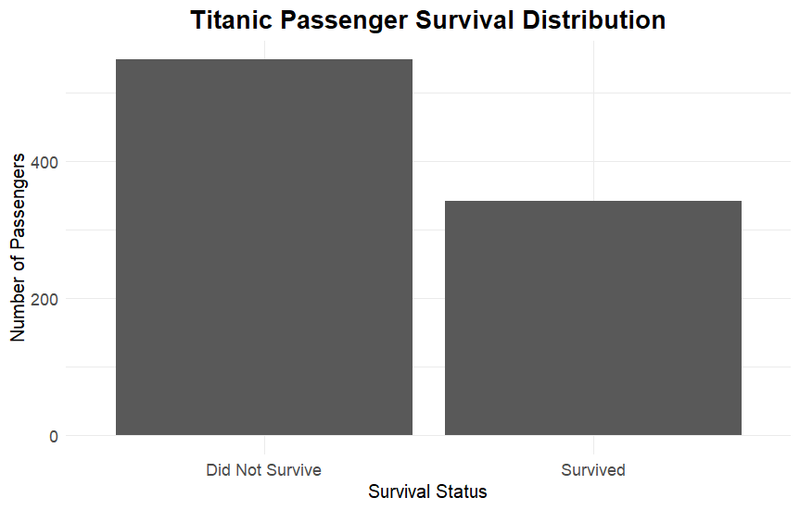

Interpretation
The chart shows 549 passengers did not survive and 342 survived. The survival rate was 38.38%.

Key Insight
Survival was not evenly distributed, providing a baseline for investigating other factors.

Visualization 2: Titanic Survival Distribution by Gender

Objective
Grouped bar chart used to compare survival counts by gender.

R Code
ggplot(titanic, aes(x = Sex, fill = Survived_Label)) +
geom_bar(position = position_dodge(width = 0.9)) +
labs(title = "Titanic Survival Distribution by Gender",
x = "Gender", y = "Number of Passengers") +
theme_minimal()

Visualization Output
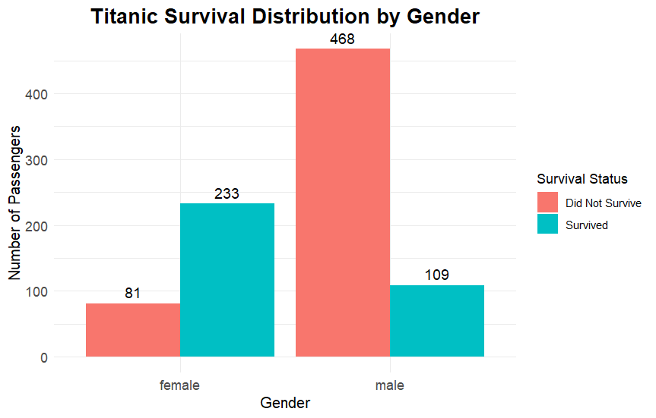

Interpretation
Female passengers had 233 survivors, while male passengers had 109. The non-survivor counts were 81 female and 468 male passengers.

Key Insight
Gender shows a strong association with survival outcomes.

Visualization 3: Titanic Survival Rate by Gender

Objective
Bar chart used to compare survival proportions rather than raw counts.

R Code
gender_rate <- titanic %>% group_by(Sex) %>%
summarise(Total_Passengers = n(),
Survivors = sum(Survived),
Survival_Rate = mean(Survived))
ggplot(gender_rate, aes(x = Sex, y = Survival_Rate)) +
geom_col() +
geom_text(aes(label = scales::percent(Survival_Rate, accuracy = 0.1)),
vjust = -0.5) +
theme_minimal()

Visualization Output
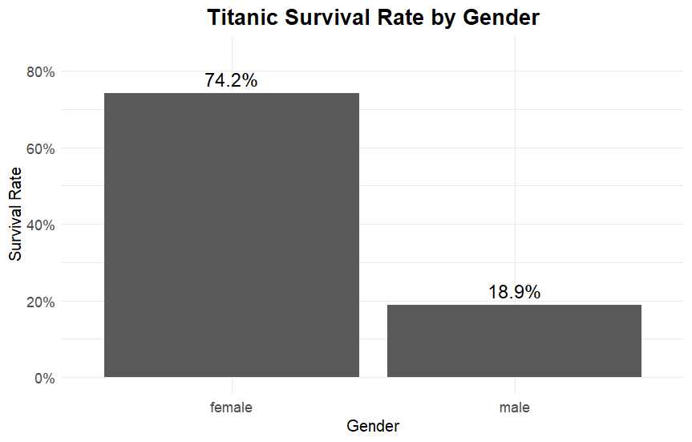

Interpretation
Female survival was 74.2% compared with 18.9% for males.

Key Insight
Percentage comparison clearly shows the large difference while accounting for unequal group sizes.

Visualization 4: Age Distribution of Titanic Passengers

Objective
Histogram used to understand the distribution of passenger ages.

R Code
average_age <- mean(titanic$Age)
ggplot(titanic, aes(x = Age)) +
geom_histogram(bins = 30, na.rm = TRUE) +
geom_vline(xintercept = average_age, linetype = "dashed") +
labs(title = "Age Distribution of Titanic Passengers",
x = "Age", y = "Number of Passengers") +
theme_minimal()

Visualization Output
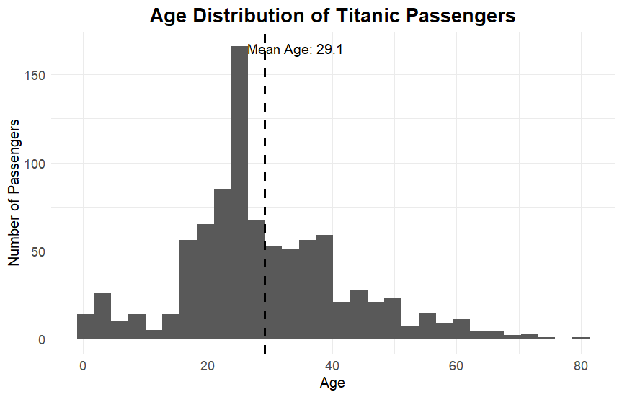

Interpretation
Passenger ages span a broad range. The mean age is approximately 29.1 years, and the largest concentration is around young-adult and adult ages.

Key Insight
Age is broadly distributed, with both children and elderly passengers represented.

Visualization 5: Titanic Passenger Distribution by Class

Objective
Bar chart used to compare the number of passengers in each class.

R Code
ggplot(titanic, aes(x = Pclass_Label)) +
geom_bar() +
geom_text(stat = "count", aes(label = after_stat(count)), vjust = -0.5) +
labs(title = "Titanic Passenger Distribution by Class",
x = "Passenger Class", y = "Number of Passengers") +
theme_minimal()

Visualization Output
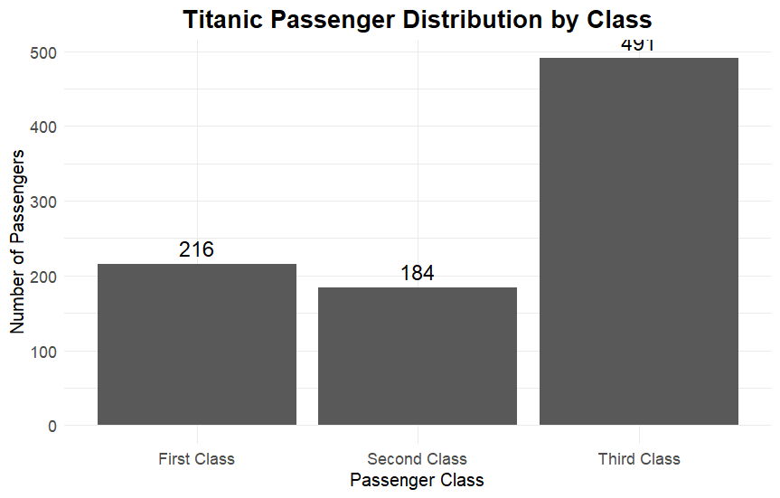

Interpretation
Third Class contained 491 passengers, compared with 216 First Class and 184 Second Class passengers.

Key Insight
Third Class is the largest passenger group and is therefore important in survival analysis.

Visualization 6: Titanic Survival Distribution by Passenger Class

Objective
Grouped bar chart used to compare survival outcomes across passenger classes.

R Code
ggplot(titanic, aes(x = Pclass_Label, fill = Survived_Label)) +
geom_bar(position = position_dodge(width = 0.9)) +
labs(title = "Titanic Survival Distribution by Passenger Class",
x = "Passenger Class", y = "Number of Passengers") +
theme_minimal()

Visualization Output
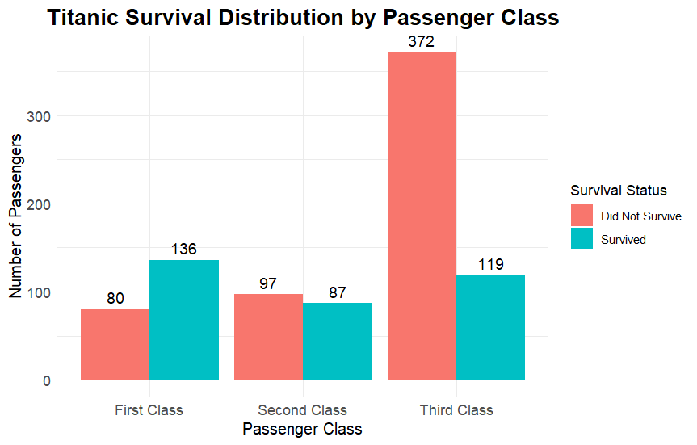

Interpretation
First Class had 136 survivors and 80 non-survivors; Second Class had 87 survivors and 97 non-survivors; Third Class had 119 survivors and 372 non-survivors.

Key Insight
Passenger class was strongly associated with survival, with Third Class showing the largest number of non-survivors.

Visualization 7: Relationship Between Passenger Age and Fare

Objective
Scatter plot used to examine the relationship between two numerical variables and identify outliers.

R Code
ggplot(titanic, aes(x = Age, y = Fare)) +
geom_point(alpha = 0.5) +
geom_smooth(method = "lm", se = TRUE) +
labs(title = "Relationship Between Passenger Age and Fare",
x = "Age", y = "Fare") +
theme_minimal()

Visualization Output
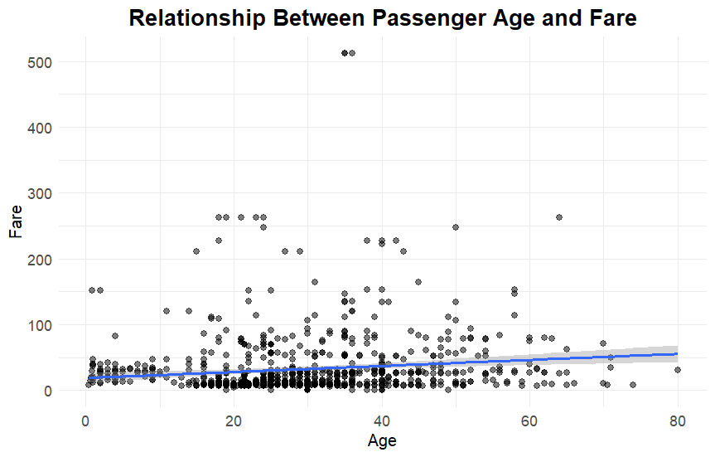

Interpretation
The age–fare correlation is approximately 0.123, indicating a weak linear relationship. Several high-fare observations are visible.

Key Insight
Age alone does not strongly explain fare; passenger class is likely more influential.

Visualization 8: Age Distribution by Survival Status

Objective
Box plot used to compare median, spread and potential outliers in age.

R Code
ggplot(titanic, aes(x = Survived_Label, y = Age)) +
geom_boxplot(na.rm = TRUE) +
labs(title = "Age Distribution by Survival Status",
x = "Survival Status", y = "Age") +
theme_minimal()

Visualization Output
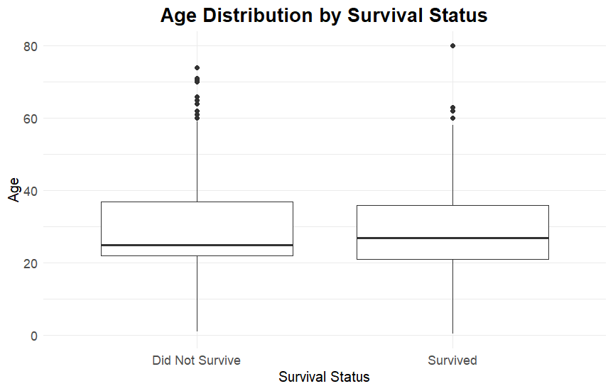

Interpretation
The two survival groups have overlapping age distributions, with medians in the mid-to-late twenties and several older observations.

Key Insight
Age alone does not clearly separate survivors from non-survivors.

Visualization 9: Fare Distribution by Survival Status

Objective
Box plot used to compare fare distributions for survivors and non-survivors.

R Code
ggplot(titanic, aes(x = Survived_Label, y = Fare)) +
geom_boxplot(na.rm = TRUE) +
labs(title = "Fare Distribution by Survival Status",
x = "Survival Status", y = "Fare") +
theme_minimal()

Visualization Output
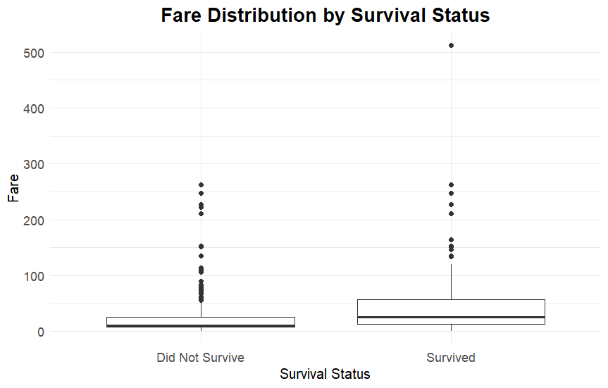

Interpretation
Survivors generally show a higher median fare and wider fare distribution, with high-fare outliers in both groups.

Key Insight
Higher fare is associated with more favorable survival outcomes, but this may reflect passenger class.

Visualization 10: Titanic Survival Rate by Age Group

Objective
Bar chart used to compare survival rates across meaningful age categories.

R Code
titanic$AgeGroup <- factor(
titanic$AgeGroup,
levels = c("Child", "Teenager", "Young Adult", "Adult", "Senior")
)
age_group_rate <- titanic %>% group_by(AgeGroup) %>%
summarise(Total_Passengers = n(),
Survivors = sum(Survived),
Survival_Rate = mean(Survived))
ggplot(age_group_rate, aes(x = AgeGroup, y = Survival_Rate)) +
geom_col() +
geom_text(aes(label = scales::percent(Survival_Rate, accuracy = 0.1)),
vjust = -0.5) +
theme_minimal()

Visualization Output
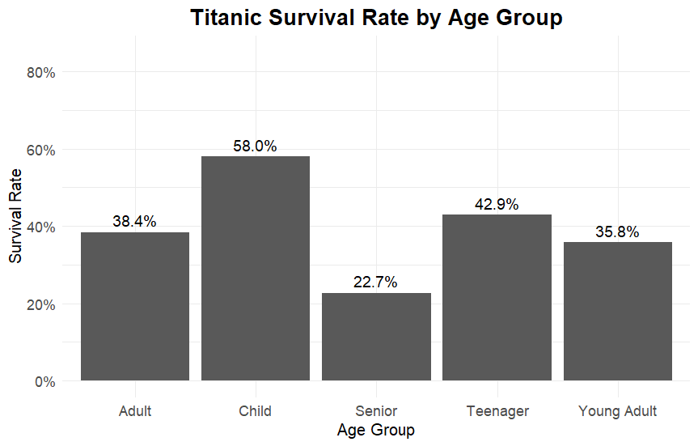

Interpretation
Survival rates differ across age groups. Children show the highest rate among the defined groups, while seniors show the lowest.

Key Insight
Age group is associated with survival differences, but it should be interpreted together with gender and class.

8. Overall Key Findings
- The overall survival rate was 38.38%.
- Female survival rate was 74.2%, compared with 18.9% for males.
- Third Class was the largest passenger group and had the highest number of non-survivors.
- First Class showed the most favorable survival outcome by passenger class.
- Passenger age covered a wide range, with a strong concentration around young-adult and adult ages.
- Age and fare had only a weak linear correlation (r ≈ 0.123).
- Survivors generally had higher fare distributions than non-survivors, which is likely connected to passenger class.
- Age-group survival rates differed, but age should be considered alongside other passenger characteristics.

9. Conclusion
The project demonstrates how R and ggplot2 can transform a raw dataset into clear, interpretable visual information. Ten visualizations were used to examine survival outcomes, gender, age, class, fare and relationships between numerical variables. The analysis shows particularly strong survival differences by gender and passenger class.
The project also highlights an important principle of data communication: visualization should be combined with careful interpretation. The graphs reveal associations and patterns, but they do not by themselves establish causation. Using multiple chart types provided a more complete understanding of the Titanic dataset.

10. Future Scope
- Create an interactive Shiny dashboard.
- Build a machine-learning model to predict survival.
- Study interactions among gender, age and passenger class.
- Analyze family size and embarkation port.
- Use statistical tests to formally evaluate observed associations.
- Compare static ggplot2 charts with interactive Plotly visualizations.

