DATA SCIENCE FOR LOGISTICS
Strategic Planning and Data Exploration in Logistics
DataCo Smart Supply Chain Dataset
Week 1 Strategic Planning Report

1. Executive Summary
This report presents the Week 1 strategic planning and data exploration phase of a logistics analytics project using the DataCo Smart Supply Chain dataset. The cleaned analytical dataset contains 180,519 order records and 52 variables. The project focuses on delivery risk, shipping performance, order segmentation, and risk-based resource allocation.
The baseline analysis produced a late-delivery rate of 54.83% and an on-time/non-late rate of 45.17%. Average actual shipping time was 3.50 days compared with 2.93 scheduled days, giving an average schedule deviation of 0.57 days.
Predictive analysis covered two business questions: whether an order is at risk of late delivery and how many days an order is likely to require for shipping. K-Means clustering was used to segment orders, and a risk score was used to prioritize operational resources.

2. Background Research and Logistics Scenario
The project simulates an e-commerce logistics organization handling high volumes of orders across multiple markets, regions, products, customers, and shipping modes. The organization needs to improve service reliability, identify sources of delivery delays, estimate shipping time, and allocate limited operational resources effectively.
Data science provides a structured approach through descriptive analytics, statistical testing, classification, regression, clustering, and optimization-oriented decision support. The DataCo dataset is appropriate because it combines shipping, delivery, commercial, product, and geographic information.

3. Project Definition and Objectives
Business question: How can data science be used to identify, predict, and reduce late deliveries while improving logistics efficiency and resource allocation?
- Understand and prepare the supply-chain dataset.
- Measure logistics performance using KPIs.
- Explore delivery patterns across shipping modes, markets, and regions.
- Engineer logistics features such as shipping delay, shipping efficiency, and profit margin.
- Predict late-delivery risk using classification.
- Predict actual shipping time using regression.
- Segment orders into operationally similar groups using K-Means.
- Prioritize high-risk orders for resource allocation.
- Translate analytical results into practical logistics recommendations.

4. Dataset Description
The main cleaned dataset used in the notebook contains 180,519 records and 52 columns. The project also included a data-description/data-dictionary file and a tokenized access-log file. The access-log file was not required for the logistics analysis.
Category | Representative Variables
Delivery | Late_delivery_risk, Delivery_Status, Order_Status
Shipping | Days_for_shipping_(real), Days_for_shipment_(scheduled), Shipping_Mode
Geography | Order_Region, Order_Country, Market
Commercial | Sales, Order_Profit_Per_Order, Order_Item_Quantity
Product | Product_Category_Id

5. Data Cleaning and Preprocessing
- Loaded the original CSV with Pandas.
- Standardized column names and cleaned text values.
- Removed completely empty rows and columns.
- Removed duplicate records.
- Converted suitable date-like and numeric-looking columns.
- Handled remaining numeric missing values using median imputation.
- Handled remaining categorical missing values using mode or Unknown.
- Exported the cleaned dataset for subsequent analysis.
The resulting cleaned file used for the project contained 180,519 rows and 52 columns, with zero duplicate records and zero remaining missing cells.

6. Logistics KPIs
KPI | Value
Total Orders | 180519.00
Late Delivery Rate (%) | 54.83
On-Time / Non-Late Rate (%) | 45.17
Average Actual Shipping Days | 3.50
Average Scheduled Shipping Days | 2.93
Average Shipping Delay | 0.57
Average Sales per Order | 203.77
Average Profit per Order | 21.97
These KPIs establish the operational baseline for the project and can be reused as recurring supply-chain performance measures.

7. Exploratory Data Analysis
EDA examined delivery status, late-delivery risk, shipping delay, shipping mode, market, region, sales, and profit. The purpose was to identify operational patterns before predictive modeling.
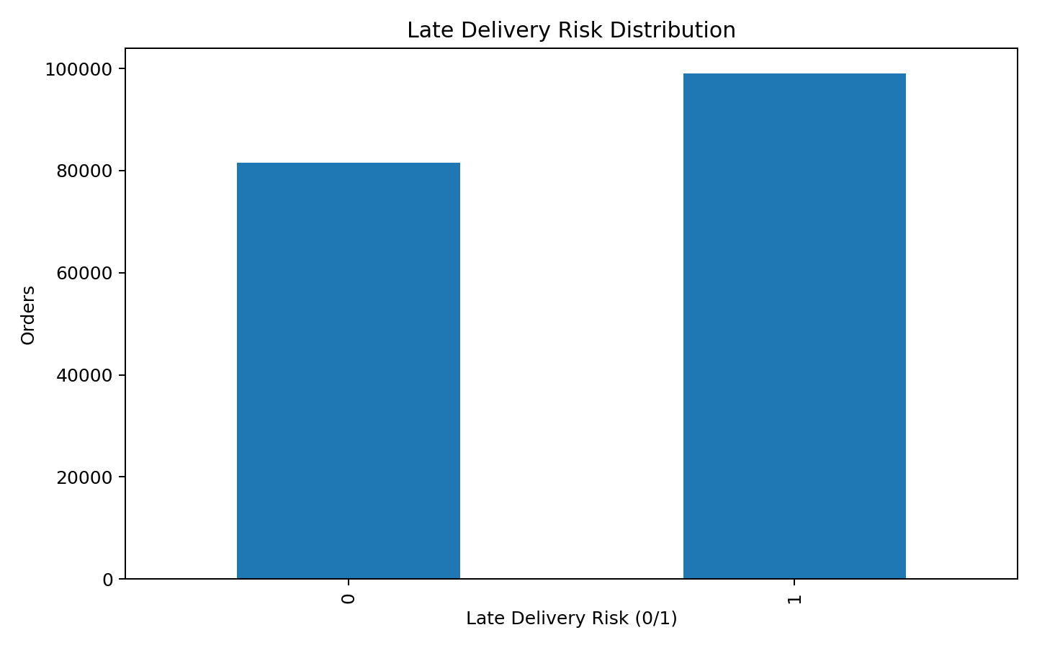
Figure 1. Late-delivery risk distribution.
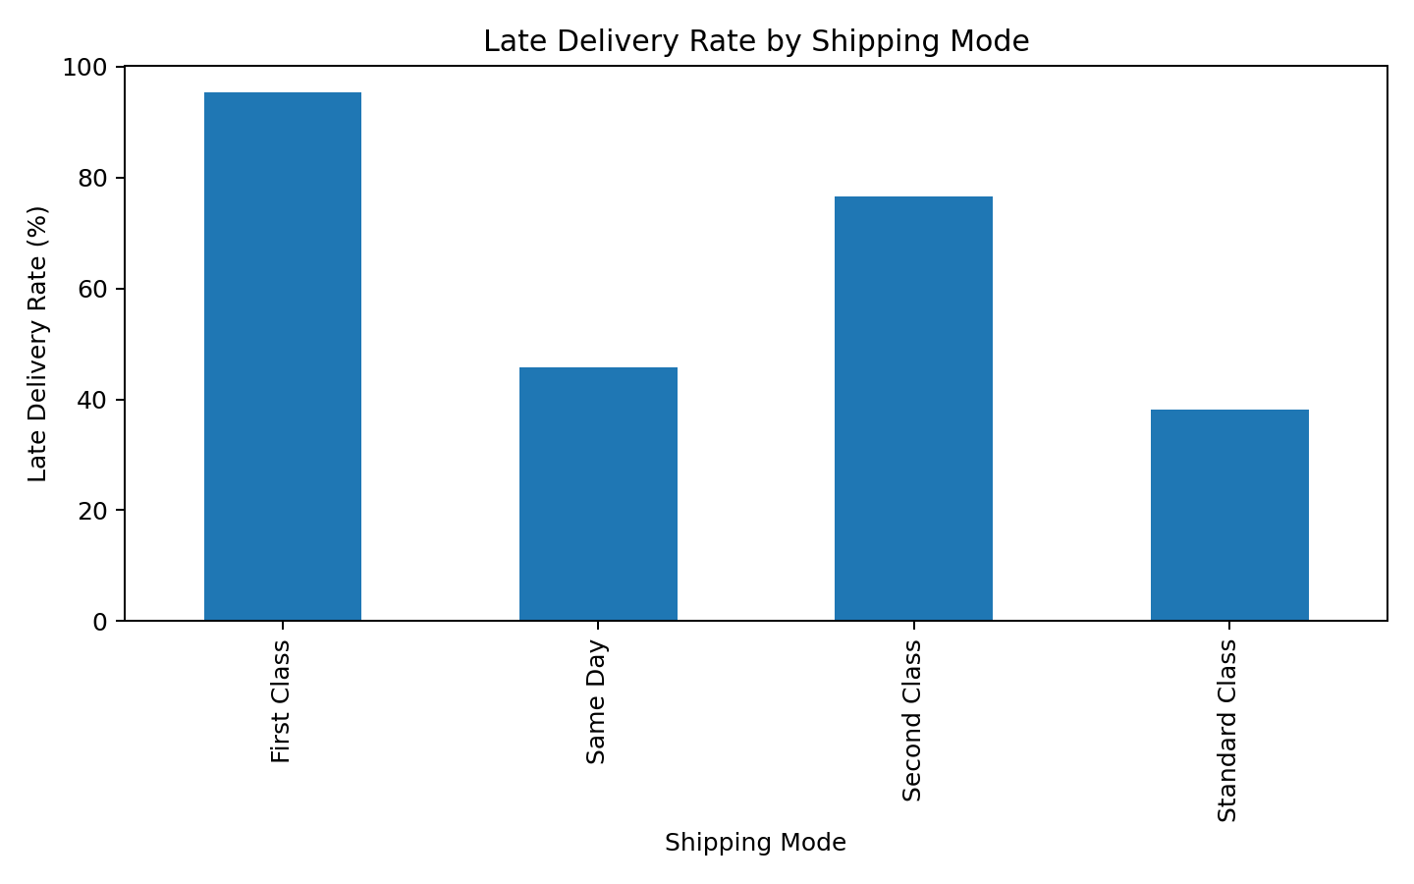
Figure 2. Late-delivery rate by shipping mode.
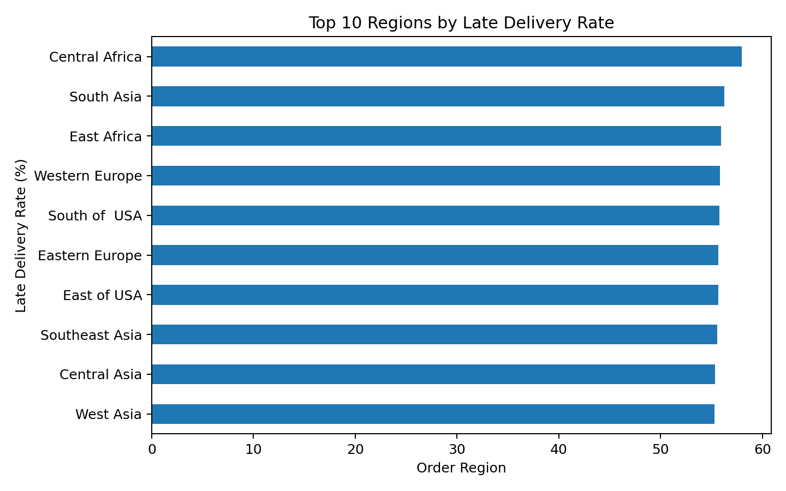
Figure 3. Top 10 regions by late-delivery rate.

8. Feature Engineering
Feature | Definition
Shipping_Delay | Actual shipping days minus scheduled shipping days
Delivery_Performance | Delayed if Shipping_Delay > 0; otherwise On_Time_or_Early
Shipping_Efficiency | Scheduled shipping days divided by actual shipping days
Profit_Margin | Order profit per order divided by sales × 100
Shipping_Delay was used for operational analysis. Shipping_Delay and Shipping_Efficiency were excluded from the final late-delivery prediction features because they depend on actual shipping performance and could introduce post-event data leakage.

9. Statistical Analysis
An independent two-sample t-test compared Shipping_Delay between late-risk and non-late-risk orders. Mean delay for risk-positive orders was 1.62 days versus -0.71 days for risk-negative orders. The t-statistic was 519.2561 and the p-value was 0. This provided an exploratory statistical check of the difference in shipping-delay behavior between the two groups.

10. Late Delivery Risk Classification
The target variable was Late_delivery_risk. Logistic Regression was used as a baseline and Random Forest was used to model more complex relationships. The final prediction features were scheduled shipping time, order quantity, sales, order profit per order, and profit margin.
Model | Accuracy | Precision | Recall | F1 Score
Logistic Regression | 0.6919 | 0.7968 | 0.5880 | 0.6767
Random Forest | 0.6334 | 0.6759 | 0.6369 | 0.6558
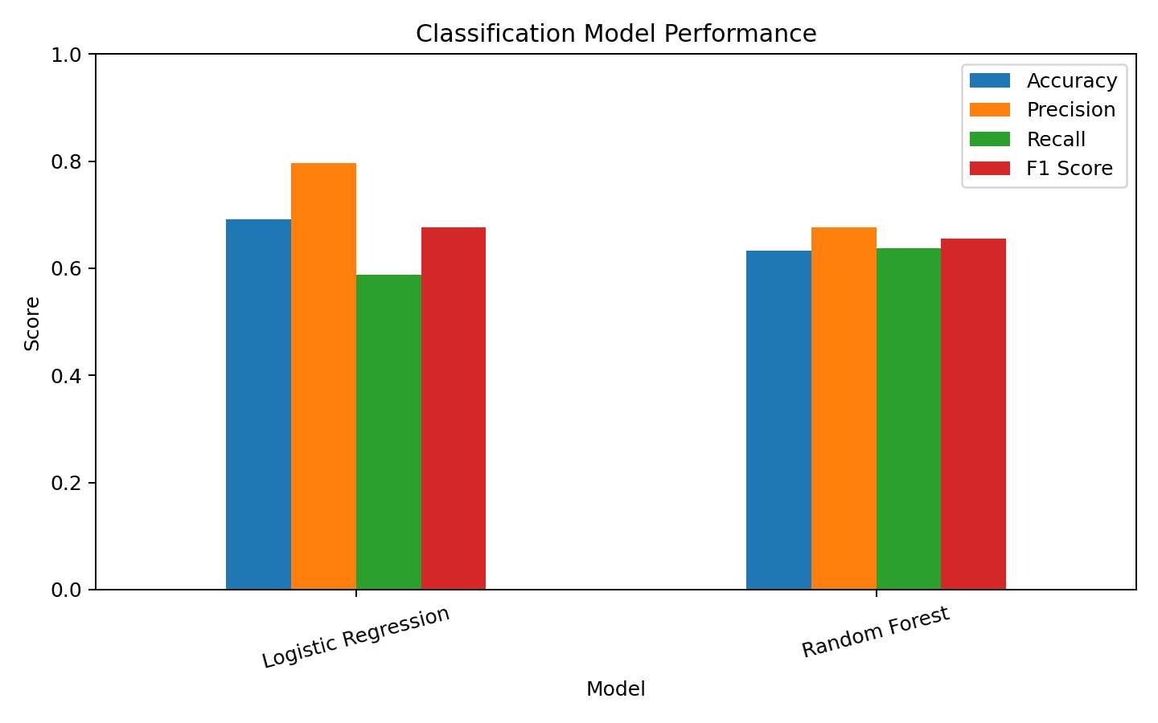
Figure 4. Classification model performance.
The model with the highest F1 score in the executed comparison was Logistic Regression. Accuracy, precision, recall, and F1 score were used for evaluation.

11. Shipping Time Regression
The regression target was Days_for_shipping_(real). Linear Regression provided a baseline, while Random Forest Regression provided a nonlinear alternative.
Model | MAE | RMSE | R2 Score
Linear Regression | 1.1296 | 1.3875 | 0.2697
Random Forest Regression | 1.0807 | 1.4068 | 0.2492
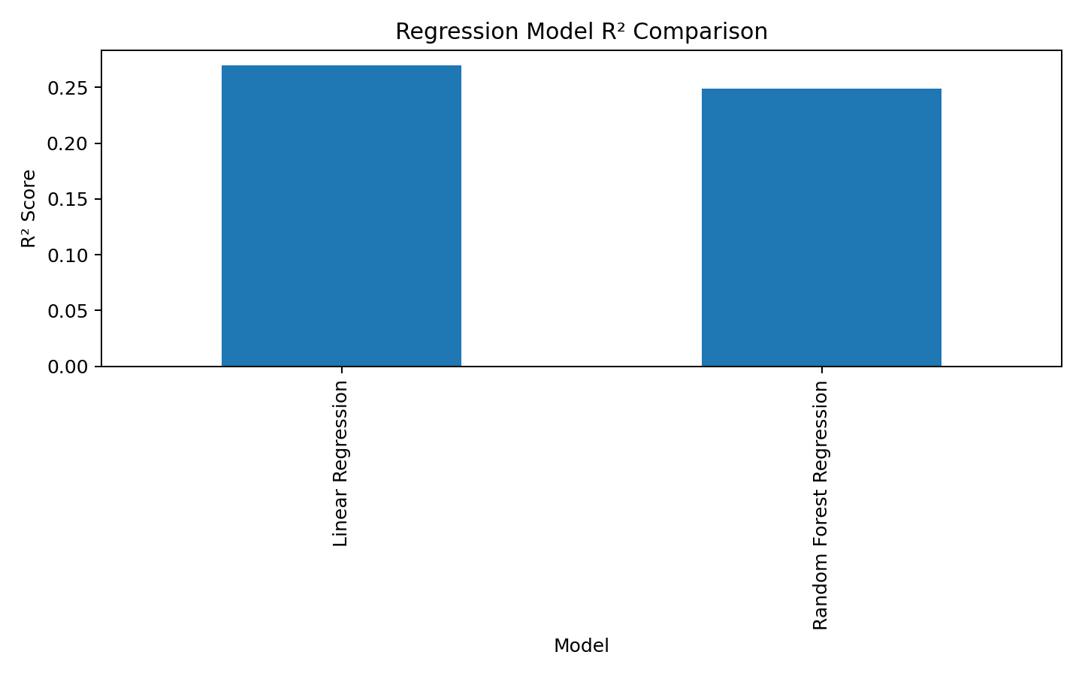
Figure 5. Regression model R² comparison.
The model with the highest R² score was Linear Regression. MAE and RMSE measure prediction error, while R² measures explained variance.

12. Logistics Order Clustering
K-Means clustering was used to segment orders using sales, profit, quantity, scheduled shipping time, actual shipping time, and shipping delay. The variables were standardized. The Elbow Method was used to select a practical cluster count, and four clusters were used for the final segmentation.
Order_Cluster | Orders | Avg_Sales | Avg_Profit | Avg_Quantity | Avg_Delay | Late_Rate
0.00 | 53227.00 | 187.02 | 18.04 | 1.64 | 2.06 | 95.92
1.00 | 45329.00 | 188.97 | 18.79 | 1.77 | 0.76 | 72.79
2.00 | 52098.00 | 185.83 | 19.79 | 1.54 | -1.05 | 0.00
3.00 | 29865.00 | 287.39 | 37.64 | 4.55 | 0.41 | 49.99
Cluster 0 had the highest observed late-delivery rate among the four segments. Cluster profiling supports differentiated logistics strategies.

13. Logistics Optimization and Resource Allocation
Because the dataset does not contain all fleet, route, warehouse-capacity, and cost constraints required for a full vehicle-routing optimization model, the project implemented a practical risk-based resource allocation strategy. A Logistics_Risk_Score combined late-delivery risk, positive shipping delay, and scheduled shipping time. Orders were divided into Normal, High, and Critical priority groups using the 50th and 75th percentiles of the risk score.
Resource_Priority | Orders | Avg_Risk | Avg_Delay | Late_Rate
Normal | 110995 | 2.24 | -0.28 | 27.90
High | 35263 | 4.77 | 1.26 | 95.71
Critical | 34261 | 6.20 | 2.59 | 100.00
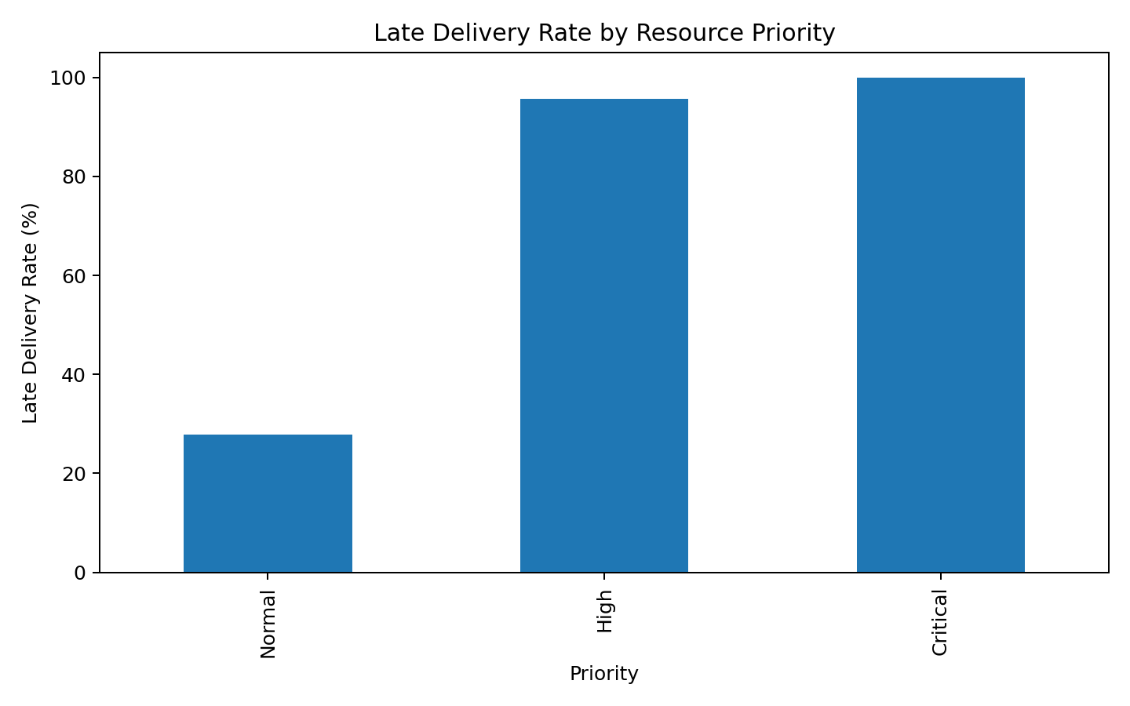
Figure 6. Late-delivery rate by resource priority.
The framework directs the highest attention toward Critical shipments, proactive monitoring toward High-priority shipments, and standard processing toward Normal shipments.

14. End-to-End Strategic Roadmap
- Data collection and documentation
- Data understanding and data dictionary review
- Data cleaning and preprocessing
- Exploratory data analysis
- Logistics KPI calculation
- Feature engineering
- Statistical analysis
- Late-delivery classification
- Shipping-time regression
- Logistics order clustering
- Risk-based resource allocation
- Model evaluation and comparison
- Business insights and recommendations
- Final reporting and decision support

15. Python Implementation
The notebook used Python with Pandas and NumPy for data processing; Matplotlib and Seaborn for visualization; SciPy for statistical testing; and Scikit-learn for scaling, classification, regression, and clustering.
# Load cleaned data
df = pd.read_csv("DataCoSupplyChainDataset_Cleaned.csv")
# Create shipping delay
df["Shipping_Delay"] = (
df["Days_for_shipping_(real)"]
- df["Days_for_shipment_(scheduled)"]
)
# Calculate late-delivery KPI
late_delivery_rate = (
df["Late_delivery_risk"].mean() * 100
)

16. Key Findings and Business Recommendations
- Monitor the 54.83% late-delivery rate as a core service KPI.
- Review shipping modes and regions with comparatively high late-delivery rates.
- Use the selected classification model to identify orders with elevated delivery risk.
- Use the selected regression model to improve shipping-time estimates and scheduling.
- Use order clusters to apply differentiated operational strategies.
- Prioritize Critical shipments when allocating scarce logistics resources.
- Use the KPI framework for regular operational monitoring.
- Retrain and re-evaluate predictive models when new operational data becomes available.

17. Limitations and Future Scope
- The analysis is based on historical data and depends on the completeness and quality of the source dataset.
- The resource-allocation component is a risk-prioritization framework, not a full vehicle-routing optimization solver.
- Operational deployment would benefit from real-time carrier status, fleet capacity, inventory, route, warehouse, and cost information.
- Future work can include hyperparameter tuning, time-aware validation, real-time monitoring, and additional operational variables.
- A future optimization model can minimize cost or delay subject to fleet, capacity, service-level, and geographic constraints.

18. Conclusion
The Week 1 project established a complete logistics analytics workflow using 180,519 cleaned order records. The work progressed from data understanding and cleaning through EDA, KPI analysis, feature engineering, statistical testing, classification, regression, clustering, and risk-based resource allocation.
The resulting framework demonstrates how Python-based data science can support proactive logistics decision-making. It can help organizations identify delivery risk earlier, estimate shipping time, understand operational segments, and direct limited resources toward the shipments that require the greatest attention.

19. References and Data Resources
- DataCo Smart Supply Chain Dataset — Kaggle: https://www.kaggle.com/datasets/shashwatwork/dataco-smart-supply-chain-for-big-data-analysis
- Pandas Documentation: https://pandas.pydata.org/docs/
- Scikit-learn Documentation: https://scikit-learn.org/stable/
- Matplotlib Documentation: https://matplotlib.org/stable/
- Seaborn Documentation: https://seaborn.pydata.org/
- SciPy Documentation: https://docs.scipy.org/doc/scipy/

20. Appendix — Project Outputs
- DataCoSupplyChainDataset.csv — original dataset
- DescriptionDataCoSupplyChain.csv — data description/data dictionary
- tokenized_access_logs.csv — access-log file, not used in analysis
- DataCoSupplyChainDataset_Cleaned.csv — cleaned dataset
- DataCo_Final_Analysis_Dataset.csv — final analytical dataset
- Logistics_KPI_Summary.csv — KPI results
- Classification_Model_Results.csv — classification results
- Regression_Model_Results.csv — regression results
- Logistics_Cluster_Profile.csv — cluster profile
- Final_Logistics_KPI_Summary.csv — final KPI summary
- DataCo_Supply_Chain_Analysis.ipynb — Jupyter Notebook

