Week 3: Advanced Data Analysis and Visualization in Logistics
Python-based Exploratory Data Analysis and Visualization

1. Introduction
This project applies advanced exploratory data analysis and visualization techniques to a logistics shipment dataset. The analysis focuses on understanding numerical distributions, relationships between variables, shipment activity over time, and potential outliers. The objective is to demonstrate how Python-based analytics can support logistics performance monitoring and data-driven decision-making.

2. Objective
The main objectives are to inspect and summarize the logistics data, measure central tendency and variability, examine correlations, visualize shipment trends, identify unusual observations, and translate the analytical results into practical logistics insights.

3. Dataset Description
The cleaned dataset contains 32,065 records and 27 variables. The dataset was prepared for logistics analysis by standardizing column names, converting the timestamp field to datetime format, checking for duplicate records, and checking missing values.

4. Data Cleaning and Preparation
- Standardized column names for consistent Python analysis.
- Converted the timestamp field to datetime where available.
- Checked for duplicate records.
- Checked for missing values.
- Created a date field from the timestamp for time-based shipment analysis.
After cleaning, the dataset contained 32,065 records. The final dataset contained 0 duplicate rows and 0 missing values.

5. Exploratory Data Analysis

5.1 Central Tendency and Descriptive Statistics
Mean, median, minimum, maximum, and standard deviation were calculated for the numerical variables. These measures provide a compact view of the typical values, spread, and range of logistics measurements.
Variable | Mean | Median | Std. Dev. | Minimum | Maximum
vehicle_gps_latitude | 38.02 | 36.41 | 6.92 | 30.00 | 50.00
vehicle_gps_longitude | -90.12 | -86.29 | 17.37 | -120.00 | -70.00
fuel_consumption_rate | 8.01 | 5.64 | 4.26 | 5.00 | 20.00
eta_variation_hours | 2.89 | 3.88 | 2.27 | -2.00 | 5.00
traffic_congestion_level | 4.99 | 4.98 | 3.53 | 0.00 | 10.00
warehouse_inventory_level | 299.25 | 157.29 | 323.44 | 0.00 | 1000.00
loading_unloading_time | 2.29 | 1.92 | 1.55 | 0.50 | 5.00
handling_equipment_availability | 0.30 | 0.16 | 0.33 | 0.00 | 1.00
order_fulfillment_status | 0.60 | 0.68 | 0.35 | 0.00 | 1.00
weather_condition_severity | 0.50 | 0.50 | 0.35 | 0.00 | 1.00
port_congestion_level | 6.98 | 8.38 | 3.25 | 0.00 | 10.00
shipping_costs | 459.37 | 389.00 | 312.18 | 100.00 | 1000.00
supplier_reliability_score | 0.50 | 0.50 | 0.35 | 0.00 | 1.00
lead_time_days | 5.23 | 3.30 | 4.52 | 1.00 | 15.00
historical_demand | 6022.00 | 6785.12 | 3427.64 | 100.00 | 10000.00
iot_temperature | 0.04 | -7.86 | 14.19 | -10.00 | 40.00
cargo_condition_status | 0.30 | 0.15 | 0.32 | 0.00 | 1.00
route_risk_level | 7.00 | 8.39 | 3.24 | 0.00 | 10.00
customs_clearance_time | 2.30 | 1.94 | 1.56 | 0.50 | 5.00
driver_behavior_score | 0.50 | 0.50 | 0.35 | 0.00 | 1.00
fatigue_monitoring_score | 0.60 | 0.68 | 0.35 | 0.00 | 1.00
disruption_likelihood_score | 0.80 | 0.96 | 0.28 | 0.00 | 1.00
delay_probability | 0.70 | 0.84 | 0.32 | 0.00 | 1.00
delivery_time_deviation | 5.18 | 6.11 | 4.16 | -2.00 | 10.00

5.2 Distribution Analysis
Histograms were used to examine the distributions of numerical logistics variables. They help identify concentration of observations, skewness, variability, and possible unusual values. Understanding these distributions is useful when evaluating operational performance and selecting appropriate analytical methods.
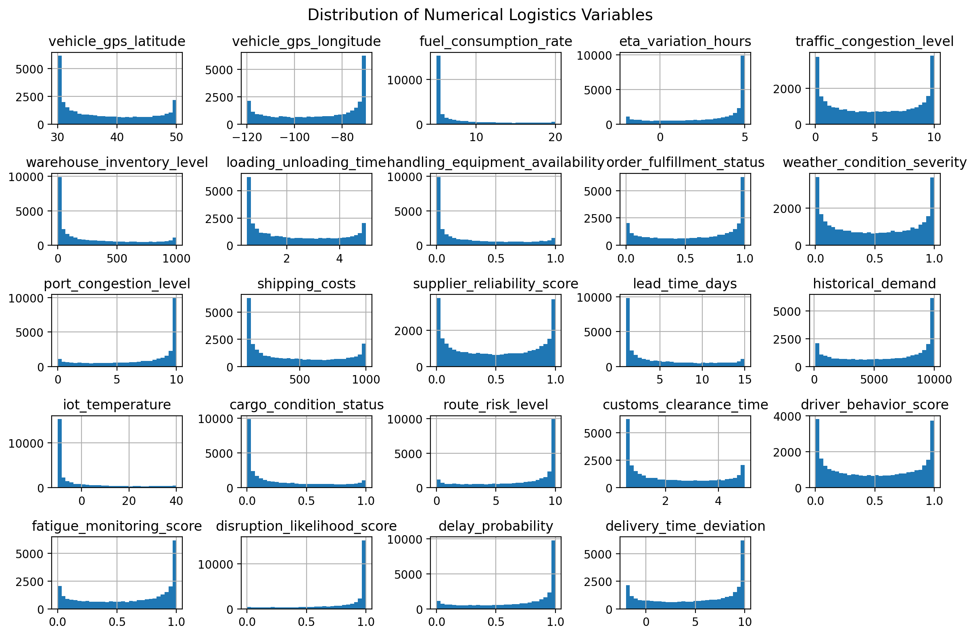

5.3 Correlation Analysis
A correlation matrix was used to measure the strength and direction of linear relationships between numerical variables. Correlation does not prove causation, but strong relationships can identify variables that deserve further operational investigation.
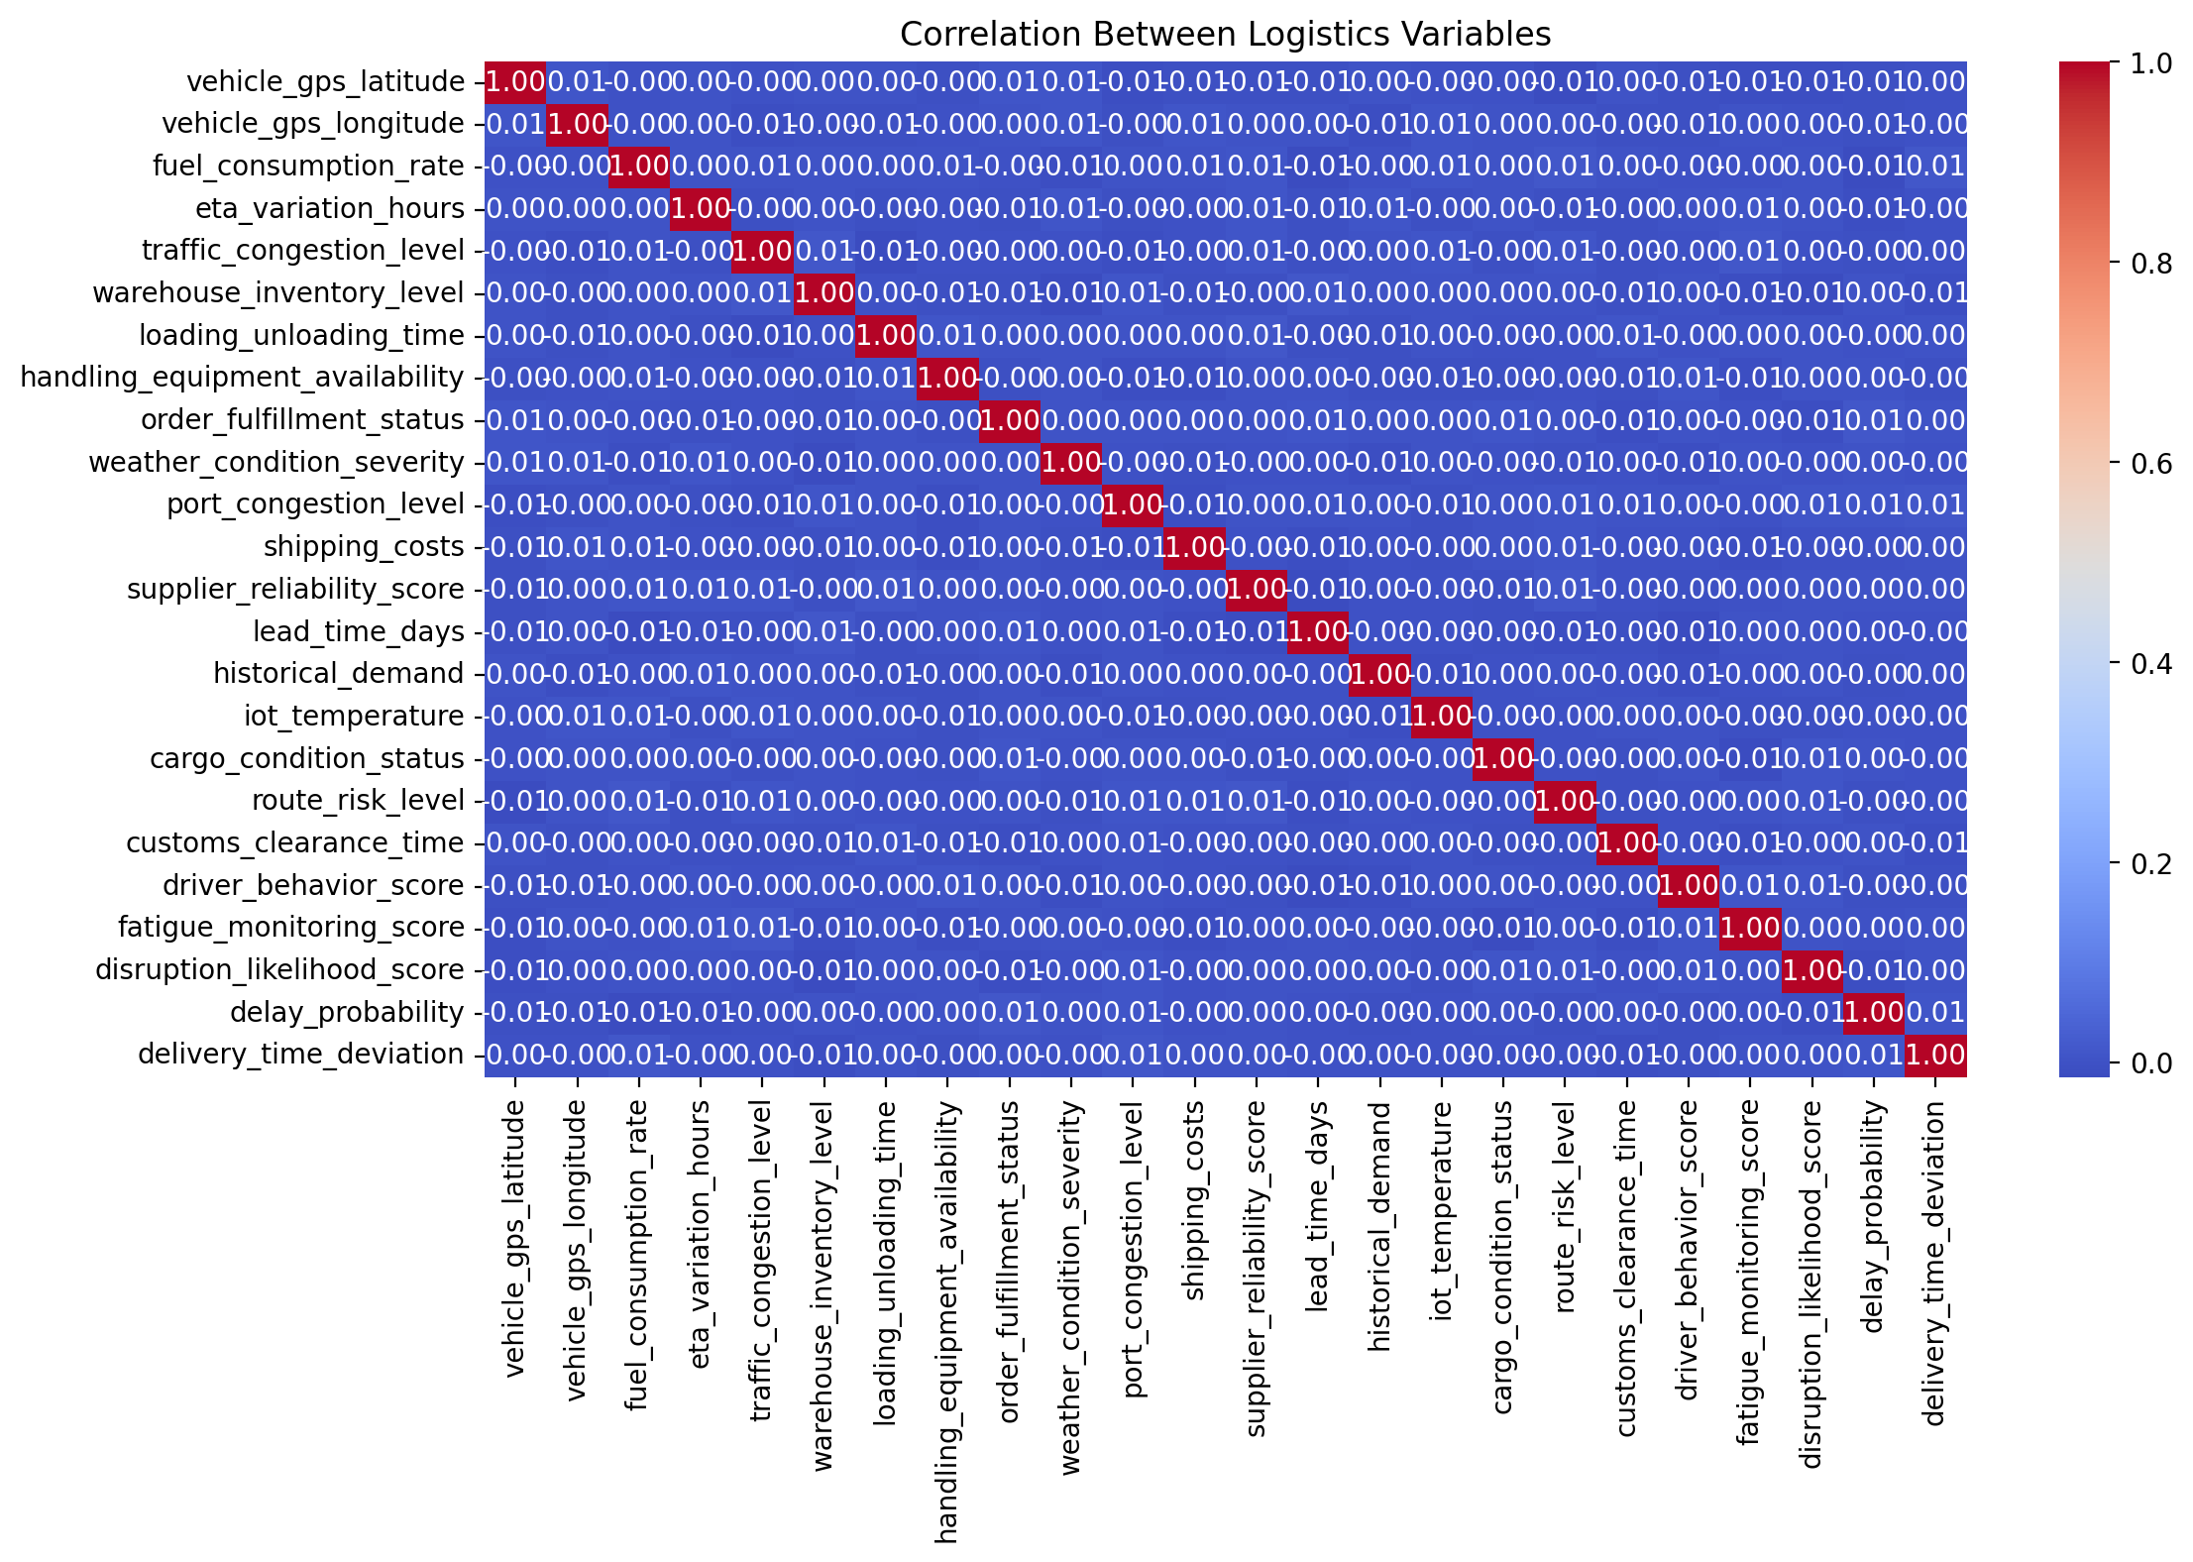
The strongest absolute correlation identified in the dataset was between 'traffic_congestion_level' and 'loading_unloading_time', with a correlation coefficient of -0.01. This relationship indicates that these two variables move together to the degree shown by the coefficient and may warrant further logistics investigation.
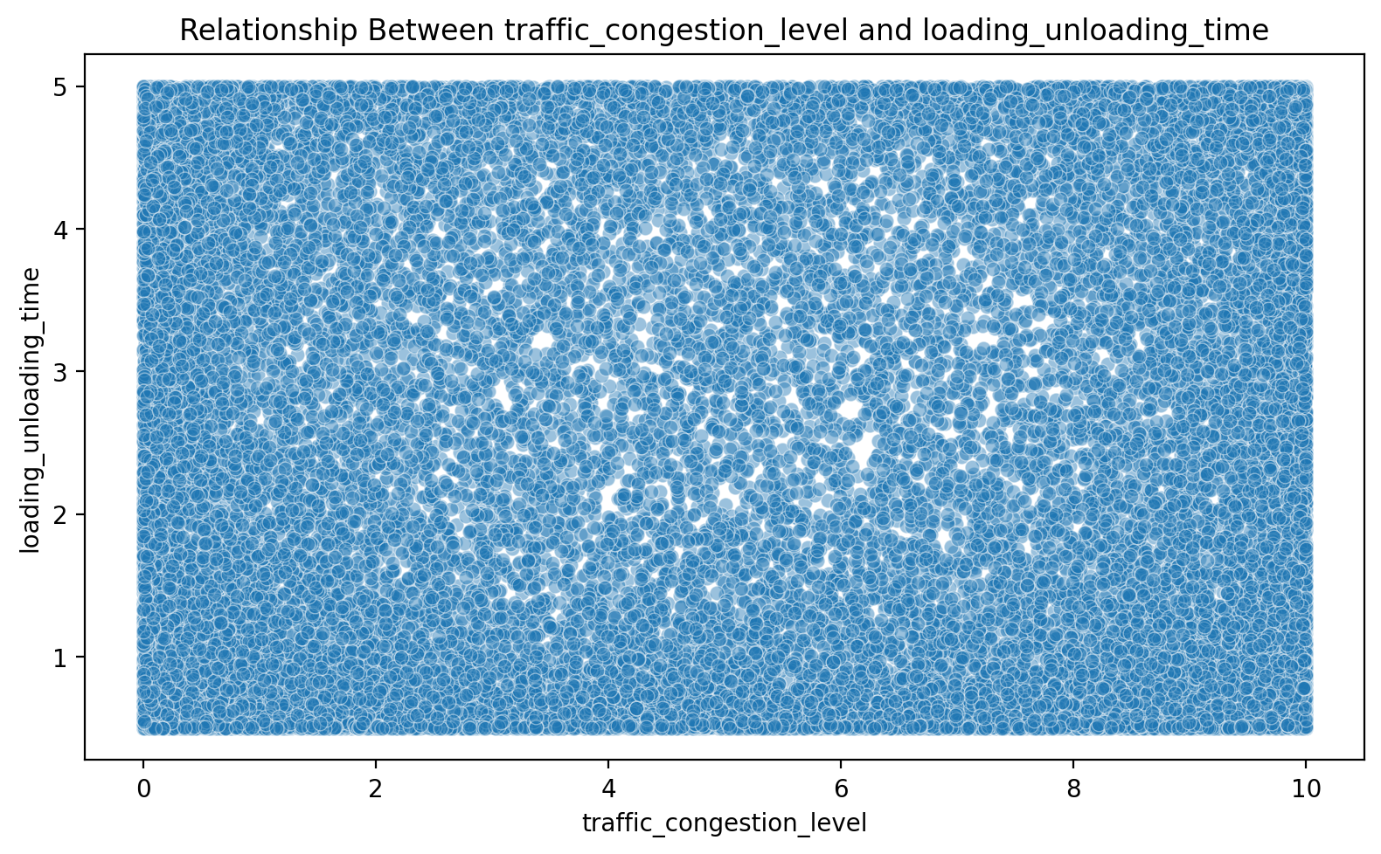

5.4 Shipment Trend Analysis
The dataset contains 1,337 observed dates. Average daily shipment volume was 23.98, with a maximum of 24 shipments and a minimum of 1 shipments in a day. The time-series visualization helps identify fluctuations in shipment activity and periods that may require additional operational capacity.
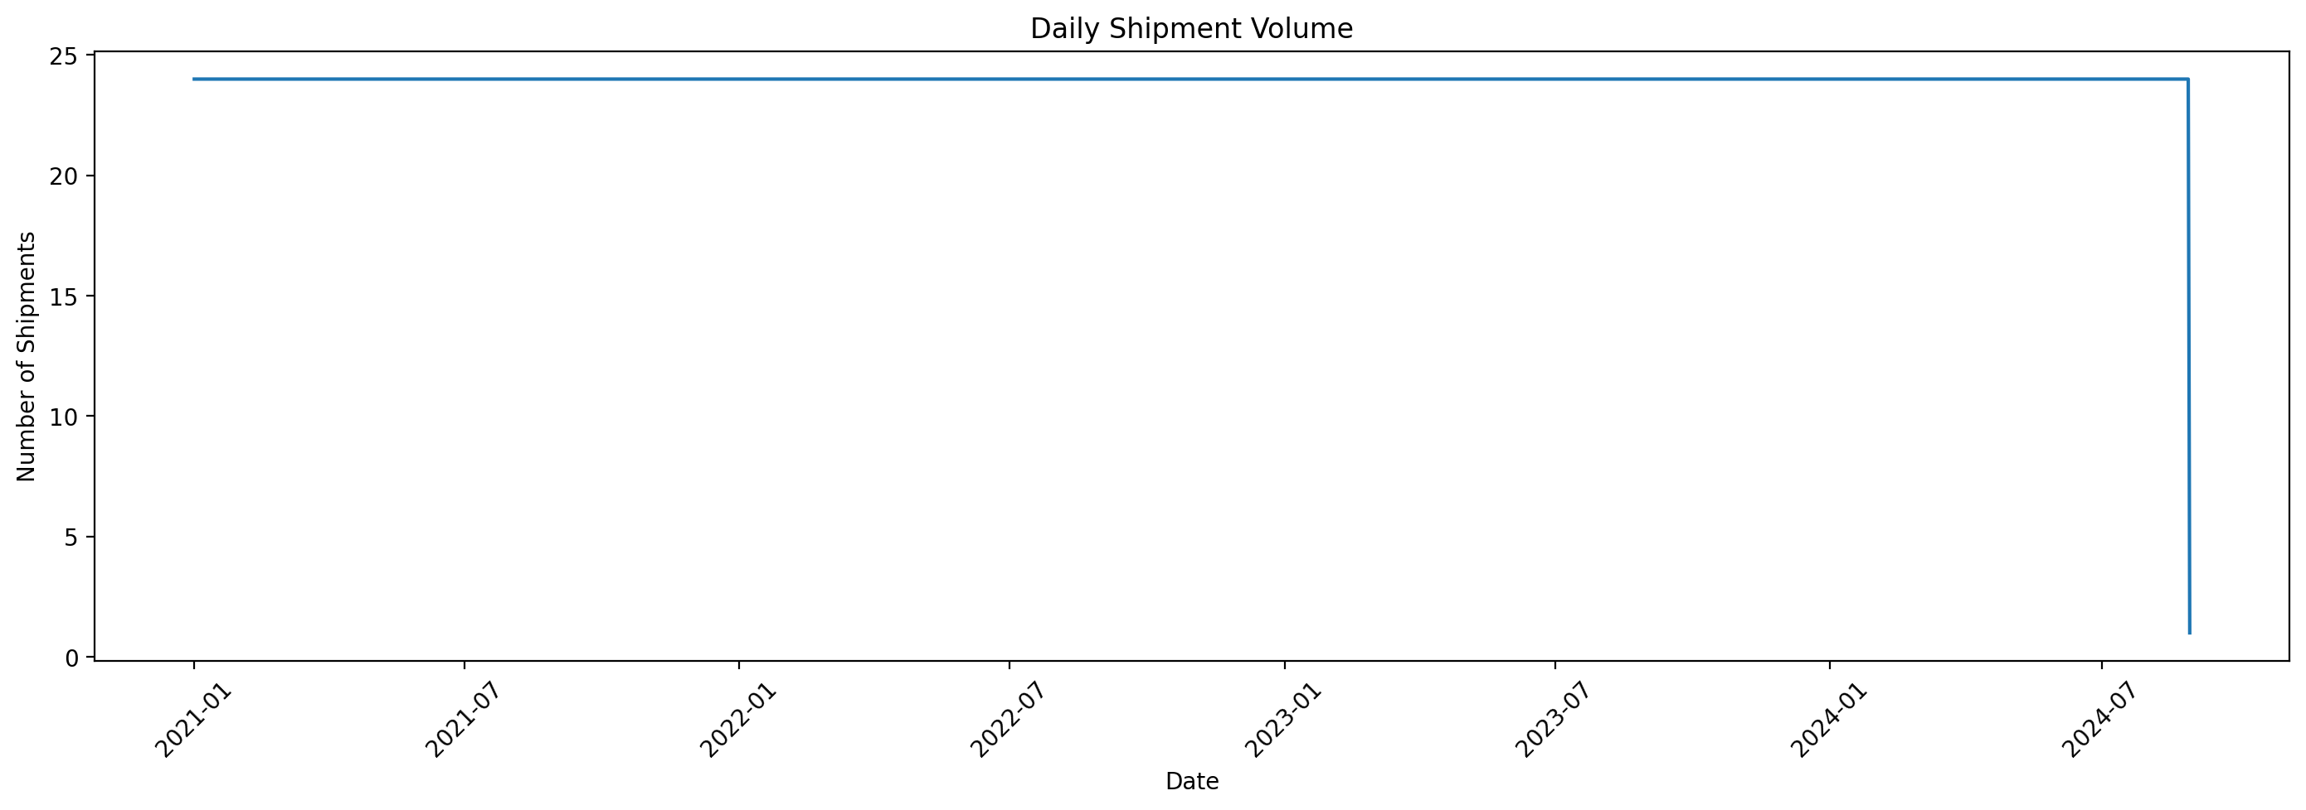

5.5 Outlier Analysis
Box plots were used to identify unusually high or low observations in numerical variables. Outliers were not automatically removed because extreme logistics observations can represent genuine high-volume, high-distance, or high-cost shipments rather than data errors.
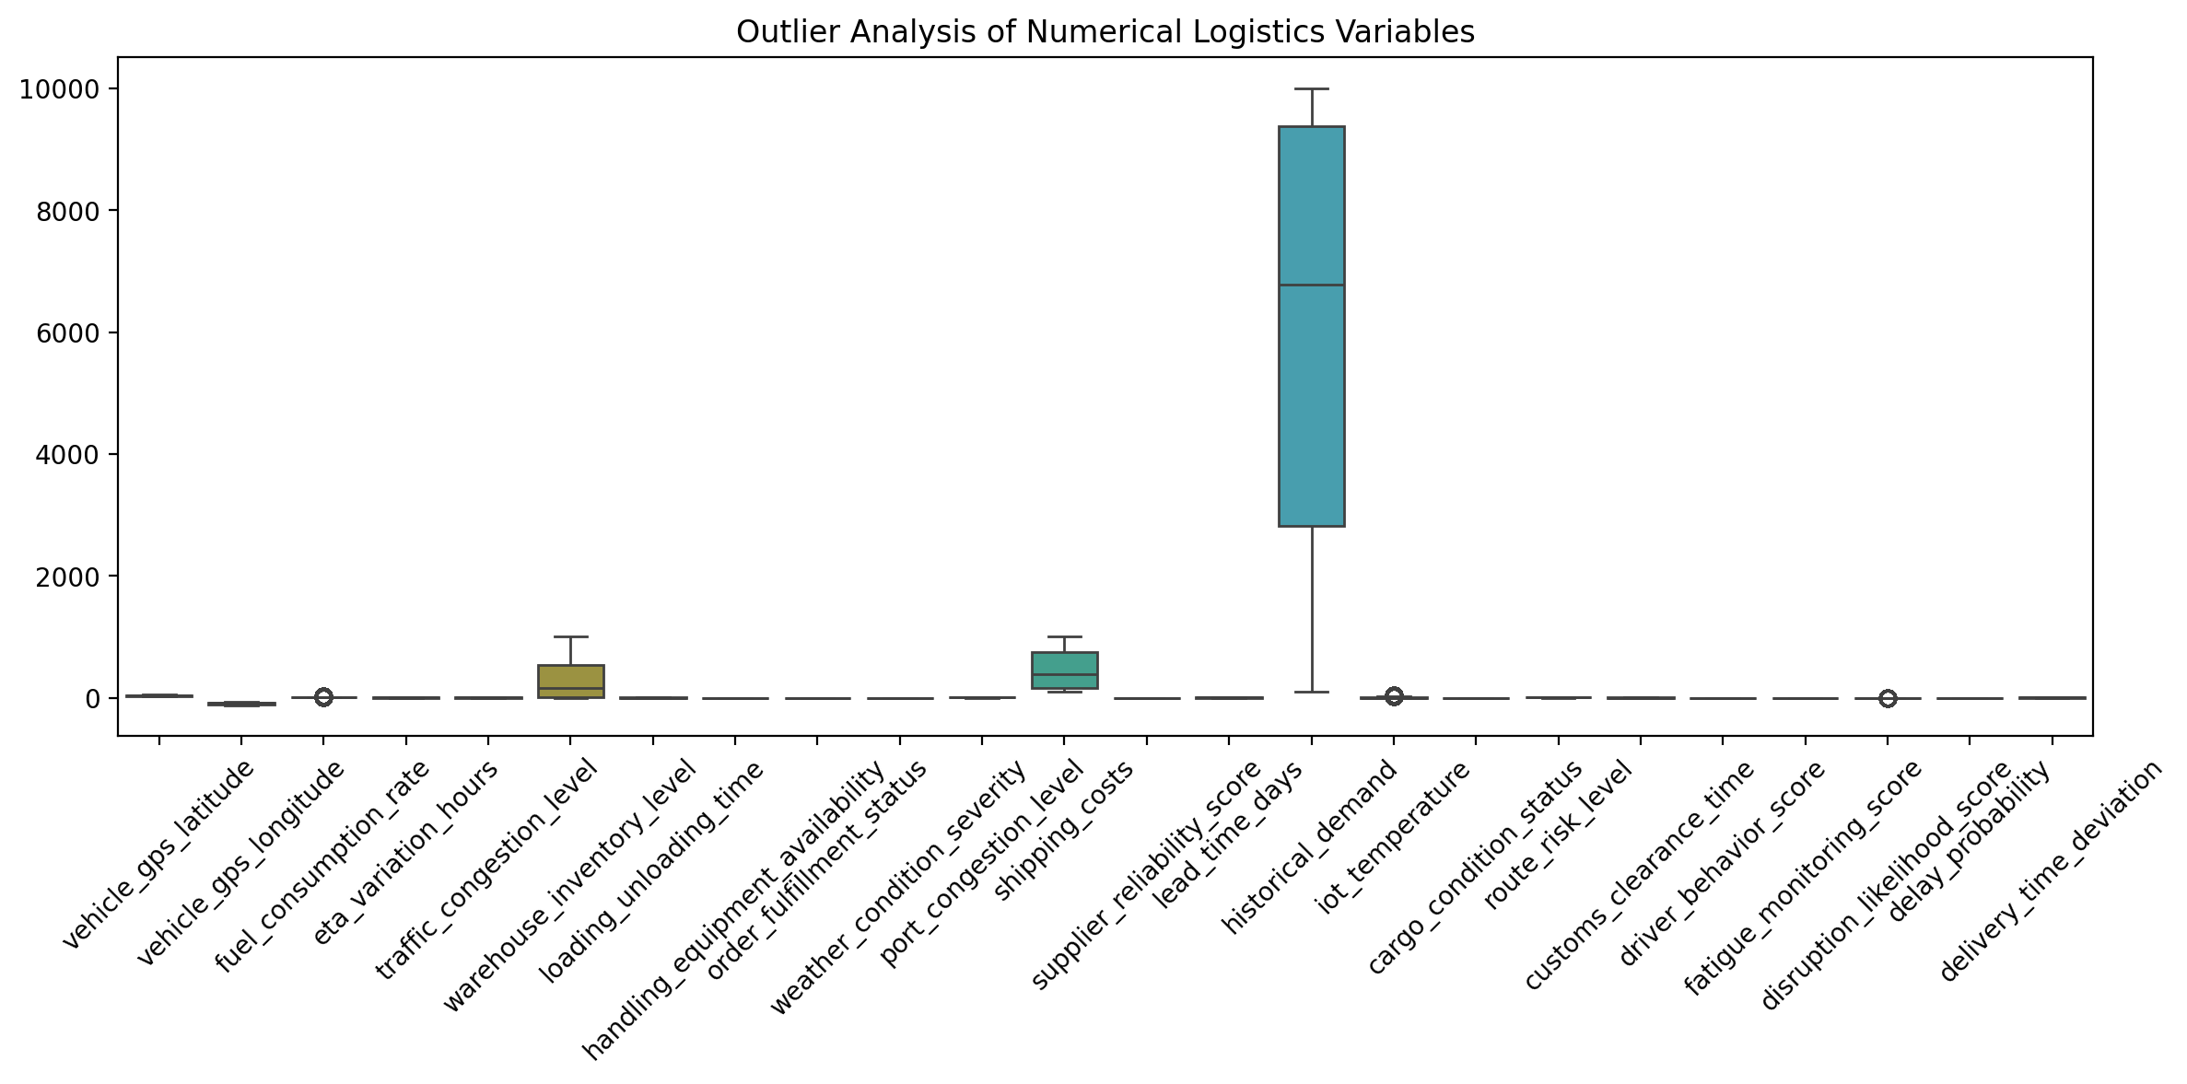

6. Key Analytical Insights
- The analysis covers 32,065 logistics records across 27 variables.
- The descriptive statistics provide a baseline for understanding the typical level and variability of each numerical logistics measure.
- The strongest observed numerical relationship was traffic_congestion_level versus loading_unloading_time (correlation = -0.01).
- Daily shipment volume averaged 23.98 shipments per observed date.
- The outlier analysis highlights observations that should be investigated as potential operational exceptions rather than removed automatically.

7. Logistics Recommendations
- Monitor variables with strong correlations because they may indicate important operational or cost relationships.
- Use shipment-volume trends to plan staffing, vehicle availability, warehouse capacity, and dispatch resources during high-volume periods.
- Investigate extreme observations separately to distinguish genuine operational exceptions from data-quality issues.
- Use the EDA results as a baseline for future predictive analysis of delivery performance, cost, or shipment demand.
- Repeat the analysis periodically so that logistics decisions are based on current operational patterns.

8. Python Tools Used
Python, Pandas, NumPy, Matplotlib, and Seaborn were used for data loading, cleaning, statistical analysis, correlation analysis, and visualization. Jupyter Notebook was used as the analysis environment.

9. Conclusion
The project demonstrates how exploratory data analysis and visualization can transform logistics shipment data into actionable information. Descriptive statistics explain the underlying data, visualizations reveal distributions and trends, correlation analysis highlights relationships, and outlier analysis identifies observations requiring further investigation. Together, these techniques provide a practical foundation for improving logistics monitoring and supporting data-driven operational decisions.

