PREDICTIVE MODELING AND OPTIMIZATION
IN LOGISTICS SYSTEMS
Week 4 Task Report
Machine Learning-Based Logistics Risk Classification
Python • Pandas • Scikit-learn • Matplotlib/Seaborn

Predictive Analytics → Validation → Leakage Detection → Optimization

Abstract
This project develops a predictive modeling framework for logistics risk classification using a dynamic supply-chain logistics dataset containing 32,065 shipment records and 26 variables. The objective was to predict High Risk, Moderate Risk, and Low Risk logistics conditions and convert predictive findings into practical optimization strategies. The workflow included data inspection, exploratory analysis, preprocessing, feature encoding and scaling, train-test splitting, supervised model development, five-fold validation, and hyperparameter tuning.
An important target-leakage issue was discovered during validation. The variable disruption_likelihood_score almost directly determined risk_classification, which explained the initial near-perfect model results. Leakage-prone variables were removed and the models were rebuilt using operational predictors that are more appropriate for early risk assessment. Among the corrected models, the Decision Tree achieved the highest weighted F1-score of 0.6404, with accuracy of 0.7441 and ROC-AUC of approximately 0.5006. The ROC results show that the remaining synthetic predictors provide limited class discrimination. This limitation is explicitly documented rather than masked by the earlier leaked results.

Keywords
Logistics analytics; predictive modeling; risk classification; Decision Tree; Random Forest; Logistic Regression; cross-validation; hyperparameter tuning; target leakage; optimization.

Table of Contents
1. Introduction
2. Problem Definition and Objectives
3. Dataset Description
4. Data Preparation and Preprocessing
5. Exploratory Data Analysis
6. Predictive Modeling
7. Validation and Hyperparameter Tuning
8. Target Leakage Detection and Correction
9. Final Model Evaluation
10. Feature Importance and Logistics Insights
11. Logistics Optimization Strategies
12. Limitations
13. Conclusion
14. References

List of Figures
Figure 1. Distribution of Logistics Risk Classification
Figure 2. Correlation Matrix of Logistics Variables
Figure 3. Traffic Congestion by Risk Classification
Figure 4. Loading and Unloading Time by Risk Classification
Figure 5. Final Decision Tree – Leakage-Free Confusion Matrix
Figure 6. Top 15 Feature Importances – Final Decision Tree
Figure 7. ROC Curve – Final Decision Tree

1. Introduction
Logistics systems generate large volumes of operational information from transportation, warehouses, suppliers, ports, drivers, environmental monitoring, and shipment activity. Predictive analytics can use these records to identify potentially risky operations before resources are committed or service levels are affected.
This project treats logistics risk prediction as a multiclass classification problem. Machine-learning models are used to distinguish High Risk, Moderate Risk, and Low Risk conditions. The prediction layer is then connected to optimization strategies such as route review, risk-based resource allocation, warehouse planning, supplier management, and proactive exception handling.

2. Problem Definition and Objectives

2.1 Problem Statement
The objective is to predict the risk_classification of a logistics record using operational variables available from transportation, warehouse, supplier, route, environmental, cargo, and driver processes.

2.2 Objectives
- Inspect and understand the logistics dataset.
- Prepare numerical and categorical variables for machine learning.
- Train Logistic Regression, Decision Tree, and Random Forest classifiers.
- Evaluate models using accuracy, precision, recall, weighted F1-score, and ROC-AUC.
- Apply stratified five-fold cross-validation and hyperparameter tuning.
- Identify and remove target leakage before final evaluation.
- Interpret the final model and identify important operational factors.
- Propose actionable logistics optimization strategies.

3. Dataset Description
The dataset used for this assignment is the dynamic supply-chain logistics dataset. The working dataset contains 32,065 records and 26 variables. The variables describe transportation, warehouse, supplier, route, environmental, cargo, and driver-related conditions.
The target distribution contains 23,944 High Risk records, 5,011 Moderate Risk records, and 3,110 Low Risk records. The strong class imbalance was considered during evaluation through stratified splitting and weighted metrics.
Category | Representative variables
Transportation | fuel_consumption_rate, traffic_congestion_level, route_risk_level
Warehouse | warehouse_inventory_level, loading_unloading_time, handling_equipment_availability
Supplier | supplier_reliability_score, lead_time_days
Environment | weather_condition_severity, iot_temperature
Shipment/Cargo | historical_demand, cargo_condition_status, shipping_costs
Driver | driver_behavior_score, fatigue_monitoring_score
Target | risk_classification
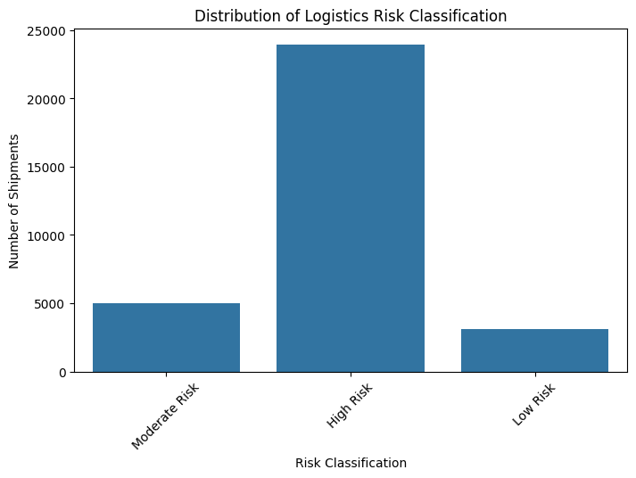
Figure 1. Distribution of Logistics Risk Classification

4. Data Preparation and Preprocessing
Numerical and categorical predictors were separated. Numerical variables were standardized using StandardScaler and categorical variables were one-hot encoded using OneHotEncoder with handle_unknown='ignore'. The target was encoded with LabelEncoder. The dataset was divided into 80% training and 20% testing data using stratification and random_state=42.

4.1 Leakage-Free Predictor Set
After the leakage investigation, the final operational feature set contained: fuel_consumption_rate, traffic_congestion_level, warehouse_inventory_level, loading_unloading_time, handling_equipment_availability, weather_condition_severity, port_congestion_level, shipping_costs, supplier_reliability_score, lead_time_days, historical_demand, iot_temperature, cargo_condition_status, route_risk_level, customs_clearance_time, driver_behavior_score, and fatigue_monitoring_score.
features_clean = [
"fuel_consumption_rate", "traffic_congestion_level",
"warehouse_inventory_level", "loading_unloading_time",
"handling_equipment_availability", "weather_condition_severity",
"port_congestion_level", "shipping_costs",
"supplier_reliability_score", "lead_time_days",
"historical_demand", "iot_temperature", "cargo_condition_status",
"route_risk_level", "customs_clearance_time",
"driver_behavior_score", "fatigue_monitoring_score"
]
X_clean = df[features_clean].copy()
y_clean = df["risk_classification"].copy()

5. Exploratory Data Analysis
Exploratory analysis was used to understand the target distribution, inspect relationships among numerical variables, and examine whether selected operational variables differed visibly across risk categories.
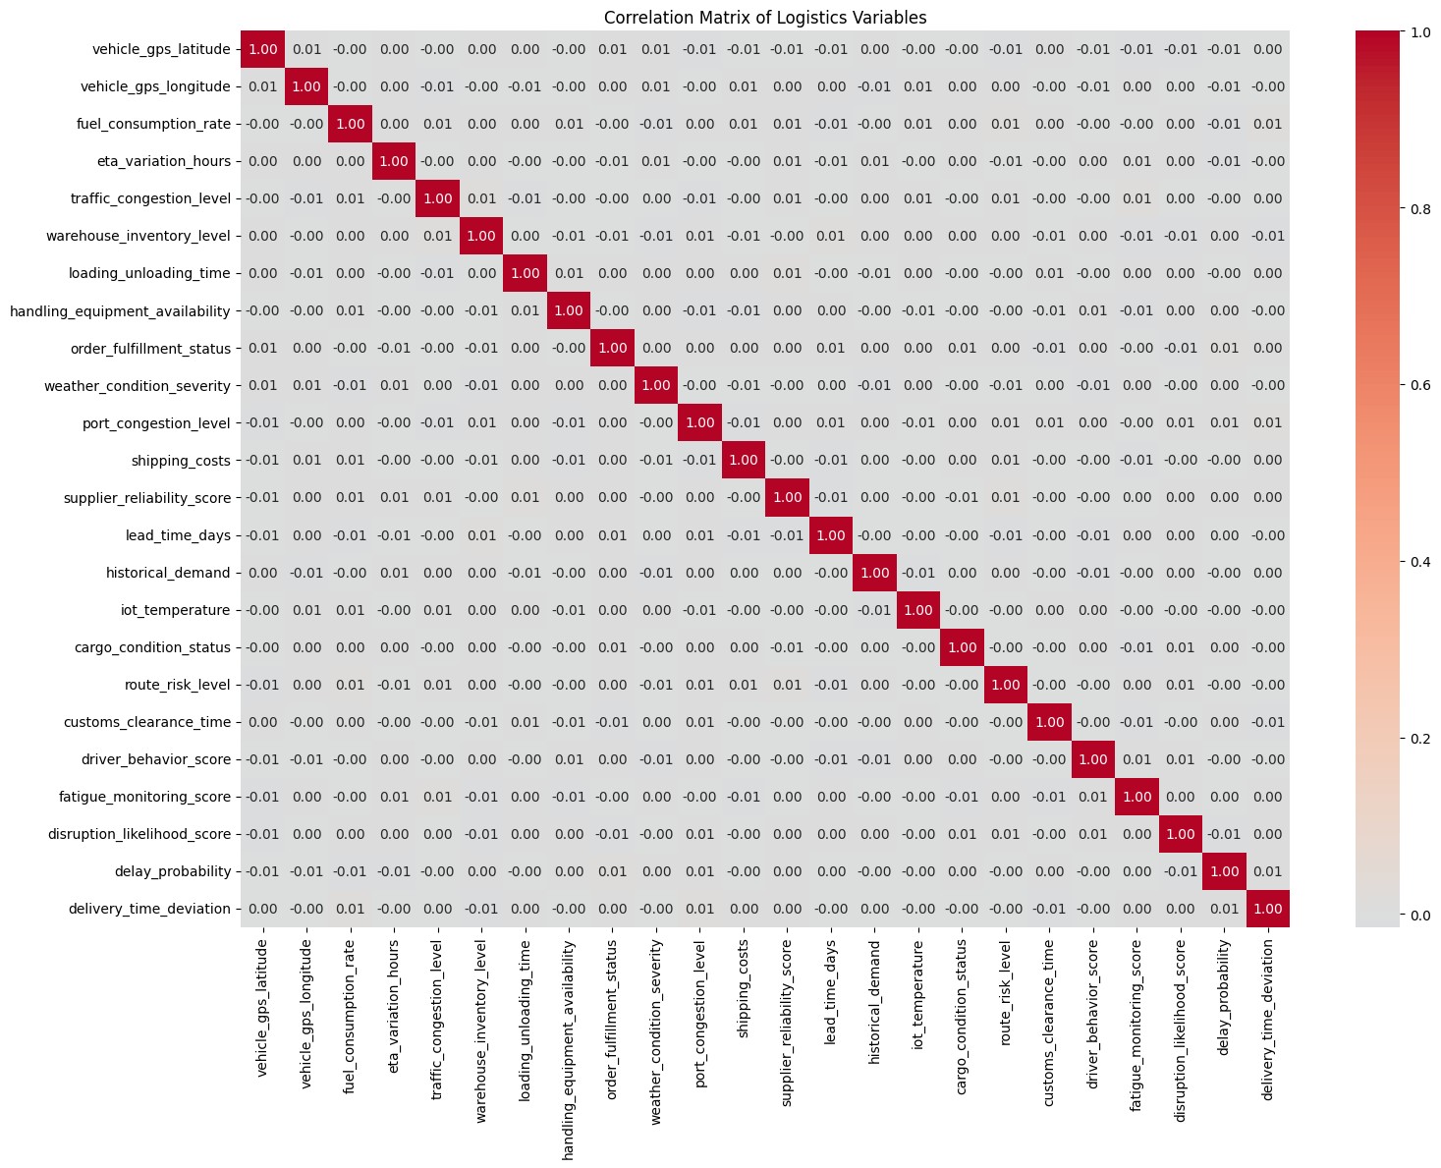
Figure 2. Correlation Matrix of Logistics Variables
The correlation matrix shows generally weak pairwise linear correlations among the numerical variables. This supports evaluating both linear and nonlinear classifiers rather than assuming that risk can be explained by a small number of strongly correlated variables.
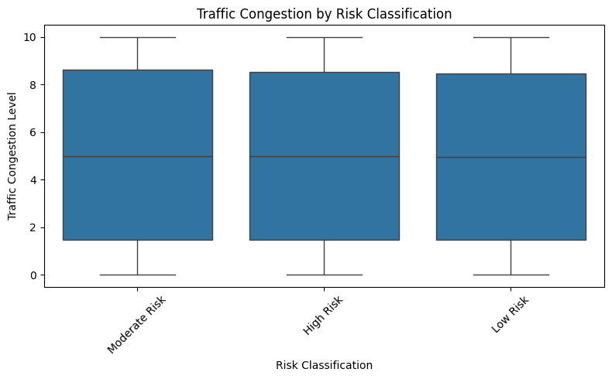
Figure 3. Traffic Congestion by Risk Classification
Traffic congestion distributions overlap across the risk classes. Therefore, traffic conditions should be combined with other operational variables instead of being treated as a standalone predictor.
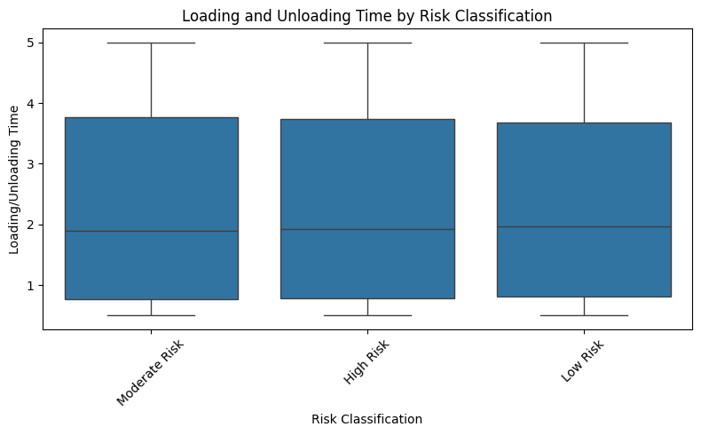
Figure 4. Loading and Unloading Time by Risk Classification
Loading and unloading time also shows substantial overlap among classes. This indicates that warehouse processing time alone does not provide a strong separation of risk categories.

6. Predictive Modeling
Three models were selected to provide a baseline, an interpretable nonlinear model, and an ensemble model.
Model | Rationale
Logistic Regression | Linear baseline and simple interpretable classifier.
Decision Tree | Captures nonlinear thresholds and provides interpretable rules.
Random Forest | Ensemble method that can capture nonlinear interactions and reduce single-tree instability.

6.1 Training Configuration
logistic_clean = LogisticRegression(max_iter=1000, random_state=42)
tree_clean = DecisionTreeClassifier(
max_depth=8, min_samples_split=10,
min_samples_leaf=5, random_state=42
)
rf_clean = RandomForestClassifier(
n_estimators=150, max_depth=10,
min_samples_split=10, min_samples_leaf=5,
class_weight="balanced", random_state=42, n_jobs=-1
)

7. Validation and Hyperparameter Tuning
Five-fold StratifiedKFold cross-validation was used to preserve the class distribution in each fold. Weighted F1-score was used as the principal selection metric because the target classes are imbalanced.
Metric | Purpose
Accuracy | Overall proportion of correct predictions.
Precision | Correctness of predicted class assignments.
Recall | Ability to identify actual class members.
Weighted F1-score | Balances precision and recall while accounting for class support.
ROC-AUC | One-vs-rest class discrimination; approximately 0.50 indicates weak discrimination.

7.1 Hyperparameter Tuning
The Decision Tree GridSearchCV evaluated 12 parameter combinations across five folds, resulting in 60 fits. The Random Forest search evaluated 8 combinations across five folds, resulting in 40 fits. The objective for both searches was weighted F1-score.
cv_clean = StratifiedKFold(
n_splits=5, shuffle=True, random_state=42
)
tree_search_clean = GridSearchCV(
DecisionTreeClassifier(random_state=42),
tree_param_grid_clean,
scoring="f1_weighted", cv=cv_clean, n_jobs=-1
)
rf_search_clean = GridSearchCV(
RandomForestClassifier(
class_weight="balanced",
random_state=42, n_jobs=-1
),
rf_param_grid_clean,
scoring="f1_weighted", cv=cv_clean, n_jobs=-1
)

8. Target Leakage Detection and Correction
The first model experiment produced approximately 99.89% to 100% accuracy. Such near-perfect performance required investigation. Analysis showed that disruption_likelihood_score was almost a direct encoding of risk_classification: low score ranges mapped to Low Risk, middle ranges to Moderate Risk, and high ranges to High Risk. This explains why the initial Decision Tree and Random Forest feature-importance results assigned essentially all importance to that single variable.
To avoid reporting an artificially inflated model, the following variables were removed from the final predictive experiment.
Variable | Action | Reason
disruption_likelihood_score | Removed | Almost directly encoded the target risk class.
delay_probability | Removed | Potentially derived from the same risk/delay process.
delivery_time_deviation | Removed | Represents observed delivery outcome information.
eta_variation_hours | Removed | Can reflect updated/outcome-related ETA information.
This correction is an important part of the project because model validity depends on using predictors that would reasonably be available at prediction time. The final reported performance is therefore based on the leakage-free feature set.

9. Final Model Evaluation
The corrected models were evaluated on the held-out 20% test set. The Decision Tree achieved the highest weighted F1-score among the five evaluated configurations.
Model | Accuracy | Precision | Recall | F1-Score | ROC-AUC
Logistic Regression | 0.7468 | 0.5577 | 0.7468 | 0.6385 | 0.5000
Decision Tree | 0.7441 | 0.6253 | 0.7441 | 0.6404 | 0.5006
Optimized Decision Tree | 0.7455 | 0.5913 | 0.7455 | 0.6389 | 0.5057
Random Forest | 0.6295 | 0.5969 | 0.6295 | 0.6116 | 0.5031
Optimized Random Forest | 0.7054 | 0.5893 | 0.7054 | 0.6322 | 0.4987
Based on weighted F1-score, the final selected model is the Decision Tree with F1 = 0.6404. Its accuracy is 0.7441 and its ROC-AUC is 0.5006. The ROC-AUC result is close to random discrimination, so the model should be considered a limited-risk classifier rather than a highly reliable automated decision maker.
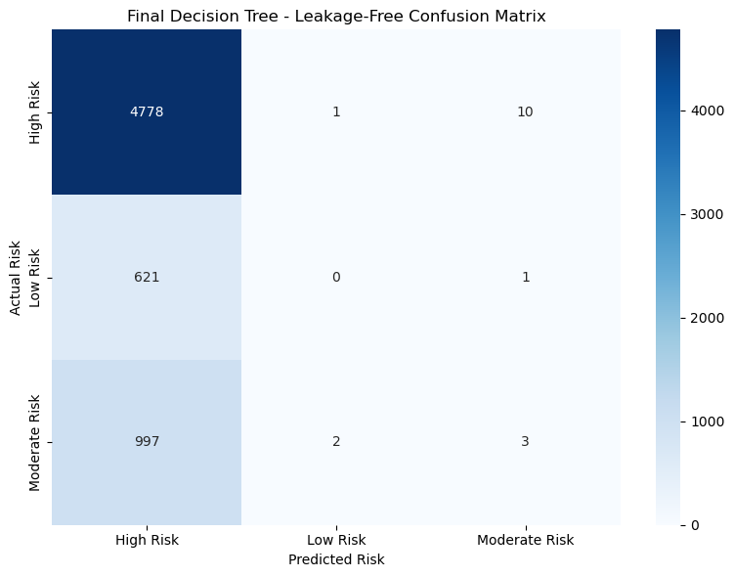
Figure 5. Final Decision Tree – Leakage-Free Confusion Matrix
The final test set contains 6,413 records. The confusion matrix shows that the Decision Tree identifies most High Risk observations but tends to classify many Low Risk and Moderate Risk observations as High Risk. This behavior is consistent with the imbalanced target distribution and the limited class-separation power of the remaining predictors.
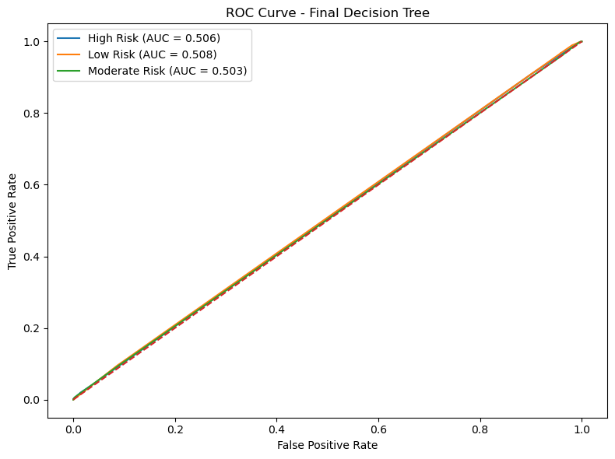
Figure 7. ROC Curve – Final Decision Tree
The class-specific ROC-AUC values are approximately 0.506 for High Risk, 0.508 for Low Risk, and 0.503 for Moderate Risk. These values confirm that the leakage-free feature set does not strongly discriminate among the three classes.

10. Feature Importance and Logistics Insights
The final Decision Tree feature-importance analysis no longer contains the leakage variable. The most influential predictors are route risk, lead time, supplier reliability, historical demand, handling equipment availability, traffic congestion, IoT temperature, fatigue monitoring, warehouse inventory, and port congestion.
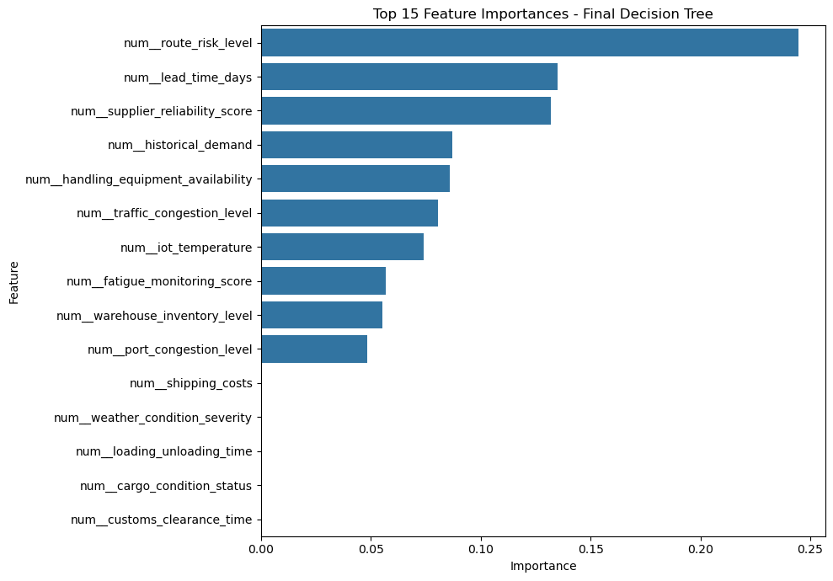
Figure 6. Top 15 Feature Importances – Final Decision Tree
Important factor | Operational interpretation
Route risk level | Monitor route-specific exposure and consider safer alternatives.
Lead time | Use lead-time uncertainty when planning schedules and buffers.
Supplier reliability | Review low-reliability suppliers and consider alternative sourcing.
Historical demand | Use demand history for inventory and capacity planning.
Handling equipment availability | Prevent warehouse bottlenecks by balancing equipment and workload.
Traffic congestion | Support dynamic route and dispatch decisions.
IoT temperature | Monitor environmental conditions for sensitive cargo.
Fatigue monitoring | Support proactive driver safety and assignment decisions.
Warehouse inventory | Improve fulfillment readiness and reduce stock-related delays.
Port congestion | Adjust schedules and prioritize shipments around congestion.

11. Logistics Optimization Strategies
The predictive model should be treated as a decision-support component. The following strategies translate the analysis into operational actions.

Risk-Based Resource Allocation
High-risk shipments can receive priority handling, additional monitoring, route review, and contingency preparation. Moderate-risk shipments can receive enhanced monitoring, while low-risk shipments can follow standard workflows.

Route Planning Optimization
Combine route-risk level with traffic and port conditions when selecting routes. Distance alone should not determine route choice.

Lead-Time and Schedule Optimization
Use lead-time information to create realistic dispatch windows and buffers for uncertain shipments.

Supplier Management
Use supplier reliability as an input to sourcing, vendor review, and contingency planning.

Warehouse and Equipment Optimization
Balance workload and handling resources to reduce bottlenecks in loading and unloading operations.

Traffic and Port Congestion Management
Avoid high-congestion periods when feasible and prioritize urgent shipments during constrained periods.

Driver and Safety Management
Use driver behavior and fatigue indicators to support proactive assignment, training, and safety interventions.

Demand and Inventory Planning
Use historical demand to improve stock planning and reduce fulfillment problems.

11.1 Operational Decision Framework
Predicted risk | Recommended action
High Risk | Priority handling, enhanced monitoring, route review, contingency preparation, additional resources where justified.
Moderate Risk | Enhanced monitoring, schedule review, inventory/equipment check, exception tracking.
Low Risk | Normal processing with standard operational controls.
The overall workflow is: predictive risk assessment → shipment prioritization → route/resource review → exception monitoring → operational feedback. This supports a shift from reactive logistics management toward more proactive decision support.

12. Limitations
- The dataset is synthetic/dynamic and performance on real operational data may differ.
- The target classes are strongly imbalanced toward High Risk.
- Several original variables were found to be leakage-prone and were excluded.
- After leakage removal, ROC-AUC values were close to 0.50, showing limited predictive discrimination.
- Feature importance indicates model usage, not causal influence.
- Real deployment would require temporal validation, data-drift monitoring, and continuous retraining.
- Operational decisions must also consider cost, safety, service-level agreements, and resource constraints.

13. Conclusion
This project implemented a complete predictive modeling and optimization workflow for logistics risk classification. The process covered data preparation, exploratory analysis, multiple machine-learning models, cross-validation, hyperparameter tuning, leakage detection, final evaluation, feature interpretation, and operational recommendations.
The most important methodological result was the detection and correction of target leakage. The initial near-perfect performance was caused primarily by a variable that almost directly encoded the target. After removing leakage-prone variables, the Decision Tree achieved the best weighted F1-score of 0.6404, but the ROC-AUC results near 0.50 showed that the remaining synthetic variables do not provide strong discrimination.
Therefore, the main practical value of the project is not claiming perfect prediction, but demonstrating a responsible predictive-analytics workflow and showing how operational variables can be connected to route, resource, inventory, supplier, warehouse, and safety optimization. Future work should use real historical logistics data, richer predictors, temporal validation, and explicit mathematical optimization for cost and service-level objectives.

14. References
- Pedregosa, F. et al. (2011). Scikit-learn: Machine Learning in Python. Journal of Machine Learning Research, 12, 2825–2830.
- Breiman, L. (2001). Random Forests. Machine Learning, 45, 5–32.
- Quinlan, J. R. (1986). Induction of Decision Trees. Machine Learning, 1, 81–106.
- James, G., Witten, D., Hastie, T., & Tibshirani, R. An Introduction to Statistical Learning. Springer.
- McKinney, W. Python for Data Analysis. O'Reilly Media.
- The dynamic supply-chain logistics dataset supplied for the Week 4 assignment.

Appendix A – Reproducibility Summary
Load cleaned dataset
→ select leakage-free predictors
→ encode target
→ 80/20 stratified train-test split
→ standardize numerical variables / one-hot encode categorical variables
→ train Logistic Regression, Decision Tree, Random Forest
→ evaluate accuracy, precision, recall, weighted F1, ROC-AUC
→ five-fold StratifiedKFold validation
→ GridSearchCV hyperparameter tuning
→ select highest weighted F1 model
→ final confusion matrix and ROC analysis
→ feature-importance interpretation
→ logistics optimization recommendations

