STATISTICAL ANALYSIS AND
PREDICTIVE MODELING USING R
Week 3 Task Report
Breast Cancer Wisconsin (Diagnostic) Dataset
Predictive Model: Logistic Regression
Statistical Analysis Environment: R / RStudio
Dataset: 569 observations, 30 predictive features + diagnosis
Prepared for Week 3 Statistical Analysis and Predictive Modeling Task

Table of Contents
1. Abstract
2. Introduction
3. Objectives
4. Dataset Identification
5. Dataset Selection Rationale
6. Dataset Description
7. Tools and Technologies
8. Data Loading and Preparation
9. Data Quality Analysis
10. Exploratory Statistical Analysis
11. Normality Testing
12. Hypothesis Formulation
13. Hypothesis Testing
14. Correlation Analysis
15. Predictive Modeling
16. Train/Test Split
17. Logistic Regression Model
18. Model Predictions and Confusion Matrix
19. Model Performance
20. 5-Fold Cross-Validation
21. ROC Curve and AUC
22. Model Diagnostics
23. Strengths of the Model
24. Limitations
25. Potential Improvements
26. Conclusion
27. References
Appendix A – R Code and Evidence

1. Abstract
This project presents a statistical analysis and predictive modeling workflow implemented in R using the Breast Cancer Wisconsin (Diagnostic) dataset. The dataset contains 569 observations and 32 original variables, including an identifier, a diagnosis label, and 30 numerical tumor measurements derived from digitized images of fine needle aspirate samples. The diagnosis variable was used as the target, with cases classified as Benign or Malignant. The analysis began with data quality checks, descriptive statistics, distribution analysis, normality testing, hypothesis testing, and correlation analysis. An independent two-sample t-test and a Wilcoxon rank-sum test were used to investigate whether mean tumor radius differs between diagnosis groups. Pearson correlation was used to study the relationship between mean tumor radius and mean tumor area. For predictive modeling, an interpretable logistic regression model was trained using radius_mean, texture_mean, smoothness_mean, compactness_mean, and concavity_mean. The data were divided into training and testing sets using an 80:20 split, followed by 5-fold cross-validation. On the independent test set, the model achieved 95.58% accuracy, 95.24% sensitivity, 95.77% specificity, 93.02% precision, and 94.12% F1 score. The ROC-AUC was 0.9906, indicating excellent discrimination. Cross-validation produced an average accuracy of approximately 93.42% with a Kappa value of 0.8584. Diagnostic plots and Cook's distance were also examined to identify potential influential observations. The results demonstrate that logistic regression can provide strong predictive performance on this dataset while remaining relatively interpretable.

2. Introduction
Statistical analysis is an essential component of data science because it helps transform raw data into evidence-based conclusions. Predictive modeling extends this process by learning relationships between input variables and an outcome that can be used to classify or predict new observations. This Week 3 task combines both approaches by applying statistical tests and a classification model to a publicly available medical dataset.
The Breast Cancer Wisconsin (Diagnostic) dataset is appropriate for this task because it contains a clearly defined binary outcome and a set of numerical measurements that can be explored statistically and used as predictors. The project therefore provides an opportunity to demonstrate data cleaning, descriptive analysis, hypothesis testing, correlation analysis, model development, validation, and diagnostic evaluation in a single workflow.

3. Objectives
- Identify and prepare a publicly available dataset suitable for predictive classification.
- Perform exploratory statistical analysis and assess important data characteristics.
- Test statistical hypotheses concerning differences between benign and malignant observations.
- Measure the relationship between selected numerical variables using Pearson correlation.
- Build a logistic regression classification model in R.
- Evaluate the model using a held-out test set and standard classification metrics.
- Use 5-fold cross-validation to assess the stability of model performance.
- Evaluate discrimination using an ROC curve and area under the curve (AUC).
- Examine model diagnostics and influential observations.
- Identify limitations and propose practical improvements for future modeling.

4. Dataset Identification
The selected dataset is the Breast Cancer Wisconsin (Diagnostic) dataset, commonly associated with the UCI Machine Learning Repository. The downloaded raw file used in the R project was named wdbc.data. The dataset contains 569 records. Each record has an identifier, a diagnosis label, and 30 numerical features describing characteristics of cell nuclei computed from digitized images.

5. Dataset Selection Rationale
The dataset was selected because it satisfies the requirements of the Week 3 task particularly well. First, the target variable is binary, making classification with logistic regression appropriate. Second, the numerical predictors allow descriptive statistics, normality testing, correlation analysis, and hypothesis testing. Third, the dataset is large enough to support a train/test split and cross-validation. Finally, the medical classification context provides a meaningful interpretation of false positives and false negatives, which makes evaluation metrics such as sensitivity, specificity, precision, and F1 score especially useful.

6. Dataset Description
Item | Description
Dataset | Breast Cancer Wisconsin (Diagnostic)
Original observations | 569
Original variables | 32
Identifier | Patient/sample identifier
Target variable | Diagnosis
Target classes | Benign (357), Malignant (212)
Predictor variables after removing ID | 30 numerical features
Missing values | 0
Duplicate rows | 0
The diagnosis values were originally encoded as B and M. In R they were converted once to the factor levels Benign and Malignant. The identifier column was removed before predictive modeling so that it could not influence the classification model.

7. Tools and Technologies
- R programming language
- RStudio
- Base R statistical functions
- ggplot2 for visualization
- caret for data partitioning, confusion matrices, and cross-validation
- pROC for ROC curve and AUC analysis
- CSV files for storing model results

8. Data Loading and Preparation
The raw wdbc.data file was imported into R using read.csv() with header = FALSE because the downloaded file did not contain column names. Meaningful column names were then assigned according to the dataset feature definitions. The data were inspected using head(), dim(), and str(). The resulting dataset contained 569 observations and 32 columns before the identifier was removed.
Data quality was assessed before modeling. Missing values were counted using is.na() and column-wise missing-value counts. Duplicate rows were checked using duplicated(). The analysis found zero missing values and zero duplicate records. The diagnosis variable was then converted from B/M codes into a two-level factor. Finally, the ID column was removed, leaving 569 observations and 31 variables: 30 predictors and one target variable.

9. Data Quality Analysis
The data quality checks produced a clean dataset. No missing observations were detected and no duplicate rows were identified. The class distribution was 357 benign cases and 212 malignant cases, corresponding to approximately 62.7% benign and 37.3% malignant observations. Although the classes are not perfectly balanced, both classes have sufficient observations for model training and testing.

10. Exploratory Statistical Analysis
Descriptive statistics were calculated using summary(), mean(), median(), and sd(). Variables including radius_mean, texture_mean, perimeter_mean, area_mean, smoothness_mean, compactness_mean, and concavity_mean were examined. A diagnosis distribution plot and a boxplot of radius_mean by diagnosis were also created.
The exploratory analysis focused particularly on mean tumor radius because it provides an intuitive measure for comparing the two diagnosis groups. The analysis also examined mean tumor area because radius and area are expected to have a strong positive relationship.

11. Normality Testing
The Shapiro-Wilk test was applied to radius_mean for the complete dataset and separately within the Benign and Malignant groups. Q-Q plots were also generated to visually assess distributional behavior. The tests and plots were used as evidence when deciding how to interpret the assumptions underlying parametric and non-parametric comparisons.
Because normality is a distributional assumption and the sample sizes are substantial, the analysis did not rely on a single diagnostic. Instead, the Shapiro-Wilk results, Q-Q plot, and the complementary Wilcoxon test were considered together.

12. Hypothesis Formulation
The main hypothesis investigated whether mean tumor radius differs between benign and malignant cases.
- Null hypothesis (H0): The mean tumor radius is the same for benign and malignant tumors.
- Alternative hypothesis (H1): The mean tumor radius differs between benign and malignant tumors.
- Significance level: α = 0.05.

13. Hypothesis Testing

13.1 Independent Two-Sample t-Test
An independent two-sample t-test was performed using t.test(radius_mean ~ diagnosis, data = data). The test evaluates whether the average tumor radius differs between the two independent diagnosis groups. The resulting statistical evidence was used to determine whether the null hypothesis should be rejected at the 5% significance level.

13.2 Wilcoxon Rank-Sum Test
A Wilcoxon rank-sum test was also performed using wilcox.test() as a non-parametric alternative. This provides a robustness check because it does not require the same normality assumption as the two-sample t-test. The agreement of evidence from complementary tests strengthens the statistical interpretation.

14. Correlation Analysis
Pearson correlation was used to evaluate the linear relationship between radius_mean and area_mean. The analysis was complemented by a scatter plot with a fitted linear trend. Because tumor area is mathematically related to tumor size, a strong positive association is expected. This analysis also illustrates why correlated predictors must be considered carefully when constructing multivariable models.

15. Predictive Modeling
Logistic regression was selected because the target variable has two possible classes: Benign and Malignant. Logistic regression estimates the probability of the positive class and converts that probability into a classification using a decision threshold.
For the baseline model, five predictors were selected: radius_mean, texture_mean, smoothness_mean, compactness_mean, and concavity_mean. This provides an interpretable model while avoiding an immediate use of all highly correlated variables in the dataset.

16. Train/Test Split
The dataset was divided using an 80:20 split. A fixed random seed of 123 was used to make the analysis reproducible. The training set contained 456 observations and the test set contained 113 observations. The test set was kept separate from model fitting and was used as an independent evaluation set.

17. Logistic Regression Model
The logistic regression model was fitted using glm() with family = binomial. The model was trained only on the training data. Predicted probabilities were generated for the test set using type = 'response'. Probabilities greater than or equal to 0.5 were classified as Malignant; otherwise they were classified as Benign.

18. Model Predictions and Confusion Matrix
The final test-set confusion matrix was:
Reference / Actual | Predicted Benign | Predicted Malignant
Benign | 68 | 2
Malignant | 3 | 40
The model correctly classified 68 benign cases and 40 malignant cases. It produced 2 false positives and 3 false negatives. In a medical screening context, the false-negative cases are particularly important because they represent malignant observations predicted as benign.

19. Model Performance
Metric | Test-set result
Accuracy | 95.58%
Sensitivity / Recall | 95.24%
Specificity | 95.77%
Precision | 93.02%
F1 Score | 94.12%
ROC-AUC | 99.06%
The model achieved an accuracy of 95.58%, meaning that 95.58% of the 113 test observations were classified correctly. Sensitivity of 95.24% indicates that the model detected most malignant cases. Specificity of 95.77% indicates that most benign cases were correctly recognized. Precision of 93.02% shows that most cases predicted as malignant were actually malignant. The F1 score of 94.12% demonstrates a strong balance between precision and recall.

20. 5-Fold Cross-Validation
To assess model stability beyond a single train/test split, 5-fold cross-validation was performed on the training data using caret. The training data were divided into five folds. Each fold was used once as validation data while the remaining four folds were used for training. This process was repeated so that every training observation contributed to validation once.
Cross-validation measure | Result
5-fold CV Accuracy | 93.42%
Kappa | 0.8584
The cross-validation accuracy of approximately 93.42% is slightly lower than the independent test accuracy of 95.58%, a difference of about 2.16 percentage points. This relatively small difference suggests that the model's performance is reasonably stable across resampled training/validation splits. The Kappa value of 0.8584 also indicates strong agreement beyond chance.

21. ROC Curve and AUC
The ROC curve was generated from the predicted probabilities, and the area under the curve was calculated using pROC. The resulting AUC was 0.9906. An AUC close to 1 indicates that the model can distinguish between benign and malignant cases very effectively across classification thresholds. The result therefore indicates excellent discrimination on the evaluated test set.

22. Model Diagnostics
Four standard diagnostic plots were examined: Residuals vs Fitted, Q-Q Residuals, Scale-Location, and Residuals vs Leverage. These plots help identify unusual observations, potential non-constant variance, and observations with high leverage or influence.
The diagnostic plots highlighted several observations, including 298, 41, 74, 113, and 153. Cook's distance was calculated to quantify the influence of individual observations. Influential observations should be investigated carefully in future work, but they should not be removed automatically without a domain-based justification.

23. Strengths of the Model
- High test-set accuracy of 95.58%.
- Strong sensitivity and specificity, both above 95%.
- High precision and F1 score, indicating balanced classification performance.
- Excellent ROC-AUC of 0.9906.
- 5-fold cross-validation accuracy of approximately 93.42%, supporting reasonable stability.
- Logistic regression provides an interpretable baseline classification approach.
- The workflow combines statistical inference, predictive modeling, validation, and diagnostics.

24. Limitations
- The model was evaluated on the same dataset family from which it was trained; independent external validation was not performed.
- Several dataset variables are strongly related to each other, creating potential multicollinearity concerns.
- Only five predictors were used in the baseline logistic regression model, so potentially useful information from other features was not exploited.
- The test set contains 113 observations, so performance estimates may vary with another random split.
- The analysis is educational and should not be interpreted as a clinical diagnostic system.
- Diagnostic plots indicate that some observations may have relatively high influence and deserve further investigation.

25. Potential Improvements
- Apply feature selection methods to identify the most informative variables.
- Use regularized logistic regression such as LASSO or Ridge to control multicollinearity.
- Compare logistic regression with Random Forest, Support Vector Machine, Gradient Boosting, and other classifiers.
- Use repeated cross-validation and hyperparameter tuning to obtain more robust performance estimates.
- Apply dimensionality reduction such as PCA when appropriate.
- Perform external validation on an independent dataset.
- Investigate influential observations and assess whether they represent legitimate cases or data-quality issues.
- Evaluate calibration in addition to discrimination if predicted probabilities are intended for decision support.

26. Conclusion
This Week 3 project successfully demonstrated a complete statistical analysis and predictive modeling workflow using R. The Breast Cancer Wisconsin (Diagnostic) dataset was loaded, inspected, cleaned, and analyzed using descriptive statistics, normality testing, hypothesis tests, and correlation analysis. A logistic regression model was then developed using five selected tumor characteristics and evaluated using an independent test set and 5-fold cross-validation.
The final model achieved 95.58% test accuracy, 95.24% sensitivity, 95.77% specificity, 93.02% precision, and a 94.12% F1 score. The ROC-AUC of 0.9906 demonstrates excellent classification discrimination. Cross-validation produced 93.42% accuracy and a Kappa value of 0.8584, supporting the general consistency of the model. Diagnostic analysis and Cook's distance were also performed to identify observations that could influence the fitted model.
Overall, the project demonstrates how statistical reasoning and predictive modeling can be combined to analyze a real-world classification problem. Future work should focus on feature selection, regularization, comparison with alternative machine-learning algorithms, repeated validation, and external testing before considering any practical deployment.

27. References
- UCI Machine Learning Repository. Breast Cancer Wisconsin (Diagnostic) Dataset. https://archive.ics.uci.edu/dataset/17/breast+cancer+wisconsin+diagnostic
- R Core Team. R: A Language and Environment for Statistical Computing. R Foundation for Statistical Computing.
- Kuhn, M. caret: Classification and Regression Training. R package documentation.
- Robin, X., Turck, N., Hainard, A., et al. pROC: an open-source package for R and S+ to analyze and compare ROC curves.
- James, G., Witten, D., Hastie, T., & Tibshirani, R. An Introduction to Statistical Learning. Springer.

Appendix A – R Code and Evidence
The R script developed for this project contains the complete workflow from data loading through model diagnostics and result export. Key functions used include read.csv(), summary(), shapiro.test(), t.test(), wilcox.test(), cor.test(), createDataPartition(), glm(), confusionMatrix(), train(), roc(), auc(), plot(), cooks.distance(), and write.csv().

Final Results Snapshot
Result | Value
Test accuracy | 95.58%
Sensitivity | 95.24%
Specificity | 95.77%
Precision | 93.02%
F1 score | 94.12%
5-fold CV accuracy | 93.42%
5-fold CV Kappa | 0.8584
ROC-AUC | 0.9906

RStudio Evidence Screenshot
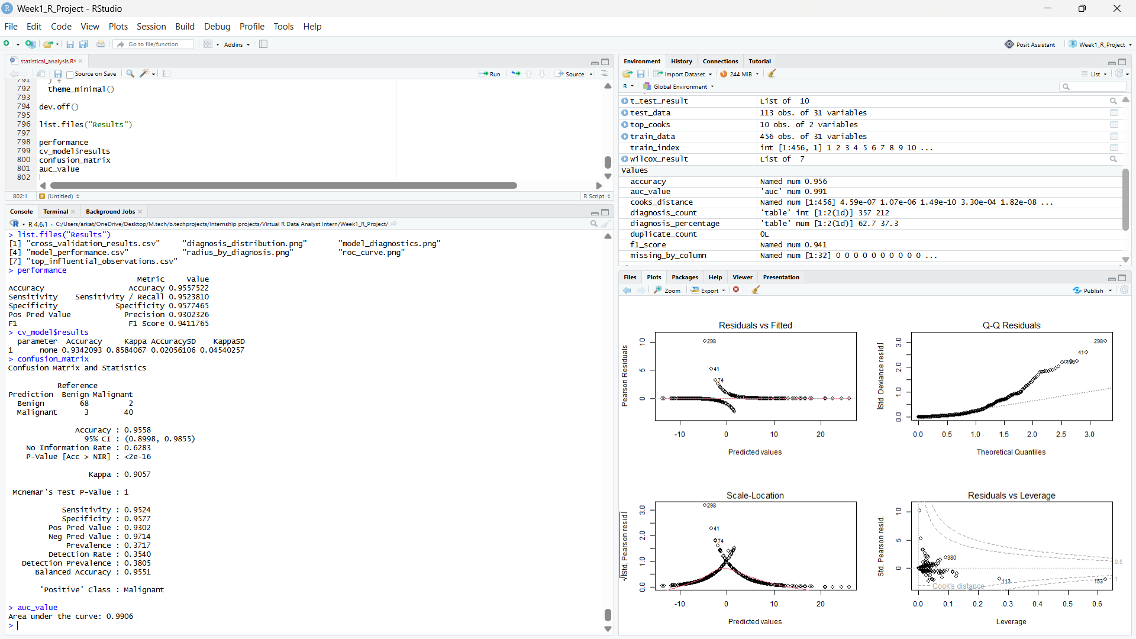
The following screenshot records the final model-performance output, cross-validation result, confusion matrix, ROC-AUC, and model diagnostic plots produced in RStudio.

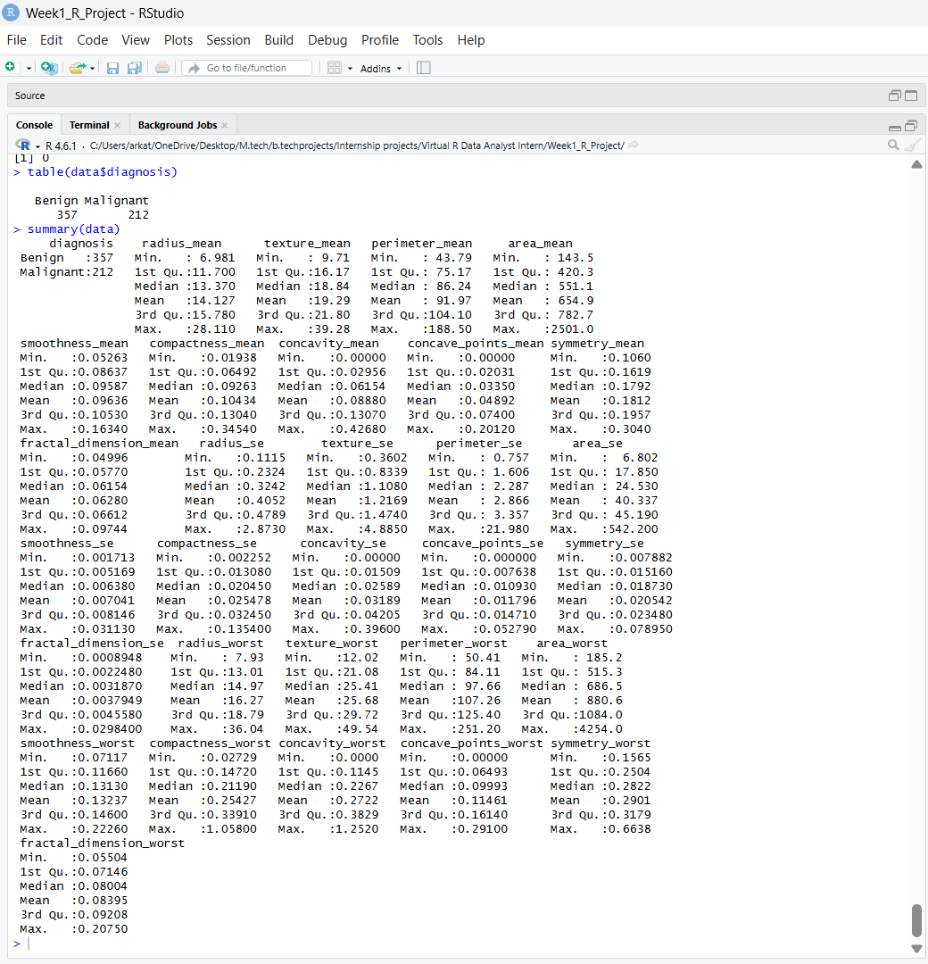
Summary Statistics :

Model Performance :
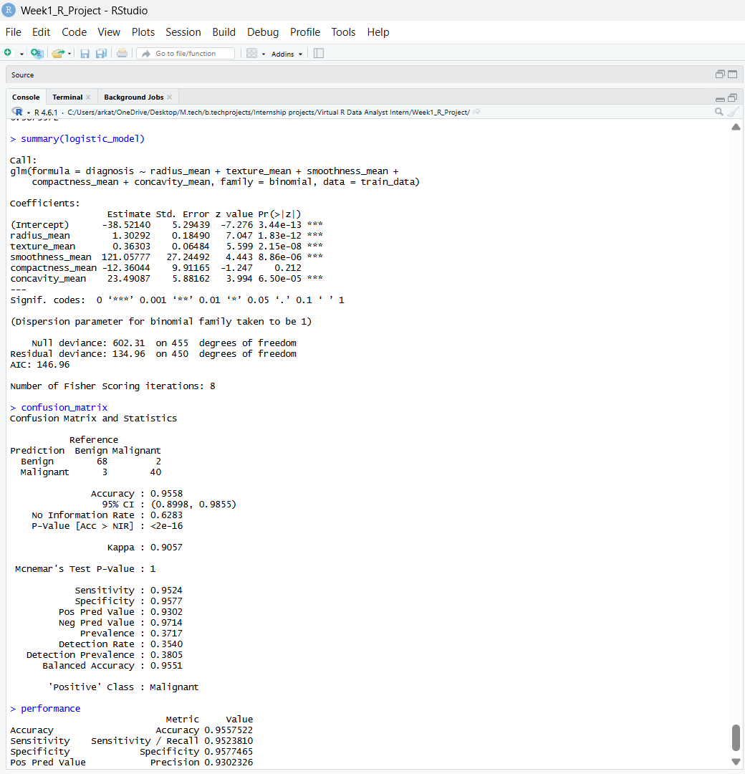
Logistic Regression :
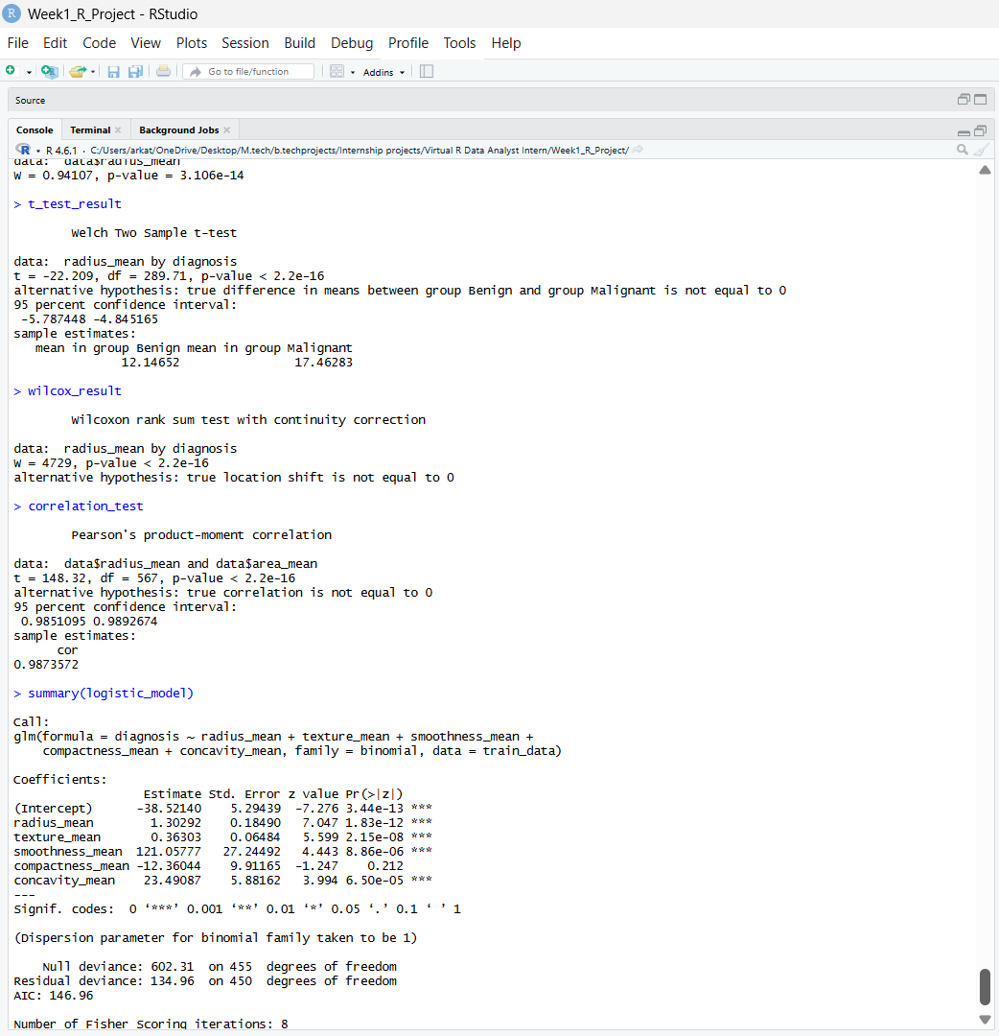

Dataset Structure :
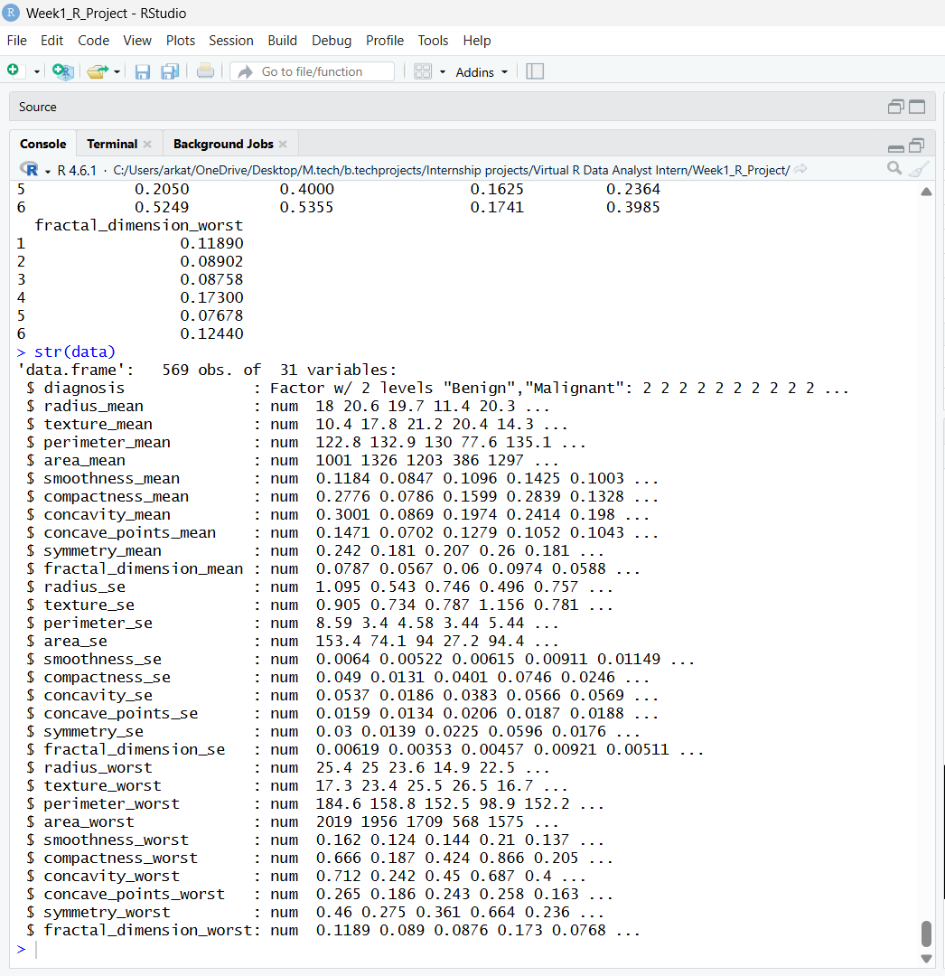

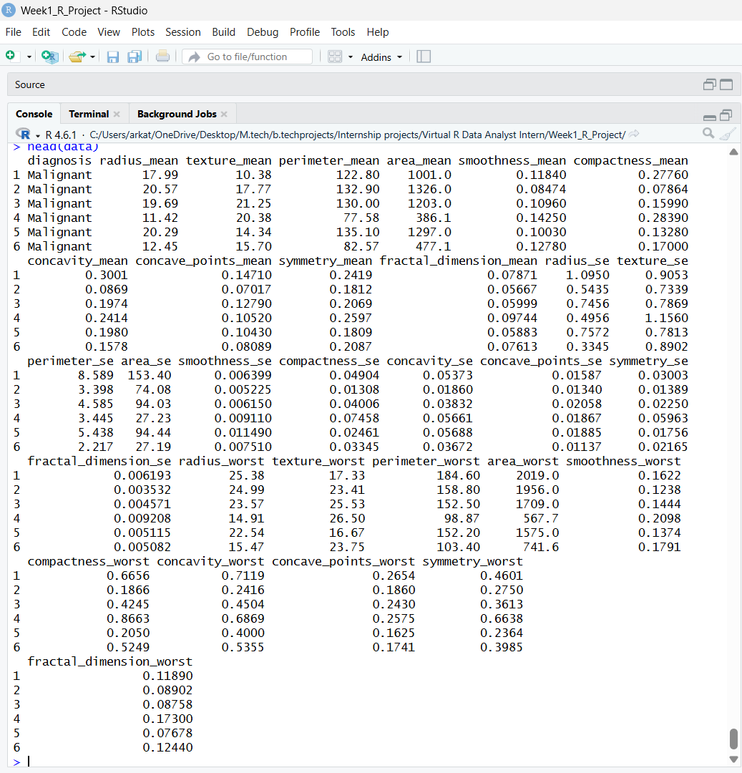
Dataset Results :

