WEEK 2 TASK
Data Collection, Cleaning, and Preprocessing for Logistics Analysis
Python-Based Logistics Data Preprocessing Report
Prepared for Internship Task – Week 2

1. Objective
The objective of this task is to demonstrate a practical data collection, cleaning, and preprocessing pipeline for logistics analysis using Python. The work focuses on understanding the structure and quality of a publicly available logistics dataset, identifying common data-quality issues, validating data types, detecting statistical outliers, and applying normalization to numerical variables. The resulting dataset is prepared for reliable exploratory analysis and future predictive or machine-learning applications.

2. Dataset Selection and Data Collection Simulation
A publicly available Dynamic Supply Chain Logistics dataset was selected because it represents operational information relevant to transportation and supply-chain analysis. The dataset includes 32,065 records and 26 columns. It contains timestamp information, logistics and operational measurements, and categorical attributes that can be used to study delivery performance, transportation conditions, inventory-related factors, and other supply-chain characteristics.
Dataset source: Kaggle – Logistics and Supply Chain Dataset
Link: https://www.kaggle.com/dsv/9673933

3. Dataset Characteristics
Characteristic | Result
Number of records | 32,065
Number of columns | 26
Missing values before cleaning | 0
Duplicate rows before cleaning | 0
Numerical columns | 24
Categorical/text columns | 1
Final cleaned records | 32,065

4. Methodology
- Load the CSV dataset using pandas.
- Inspect the first records, dimensions, column names, data types, and descriptive statistics.
- Check missing values and duplicate records.
- Validate numerical and categorical data types.
- Convert the timestamp field to datetime format.
- Detect potential numerical outliers using the Interquartile Range (IQR) method.
- Investigate outliers rather than deleting them automatically, because extreme logistics observations may represent genuine operational events.
- Create a cleaned working copy and apply appropriate missing-value treatment if missing values are encountered.
- Apply Min-Max normalization to numerical variables.
- Use visualizations and a correlation matrix to assess the processed data.
- Export the cleaned and normalized datasets for future analysis.

5. Data Quality Assessment

5.1 Missing Values
The initial inspection identified 0 missing values across the dataset. Because no missing observations were present, no imputation was required. The Python pipeline nevertheless includes median imputation for numerical variables and mode imputation for categorical variables as a reusable safeguard if missing values occur in future versions of the dataset.
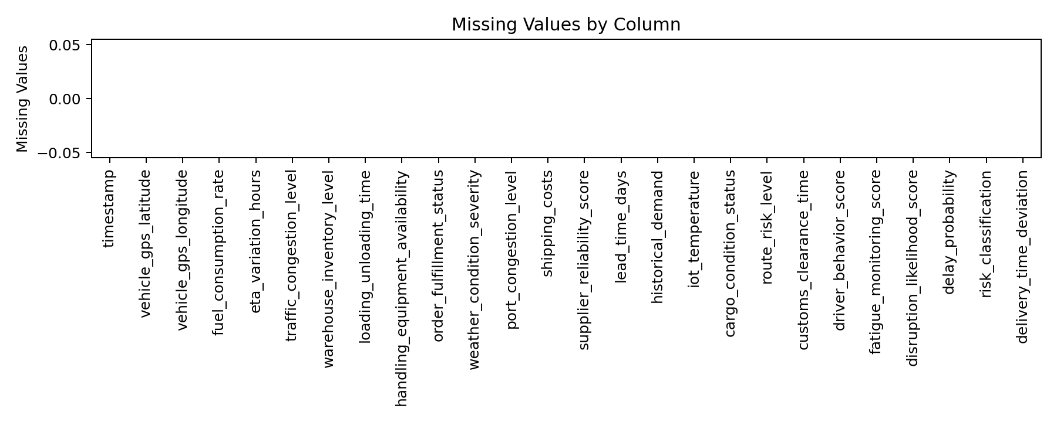

5.2 Duplicate Records
The dataset contained 0 duplicate rows. Therefore, duplicate removal did not change the number of observations. A drop_duplicates() step was retained in the pipeline so the workflow remains robust for future datasets.
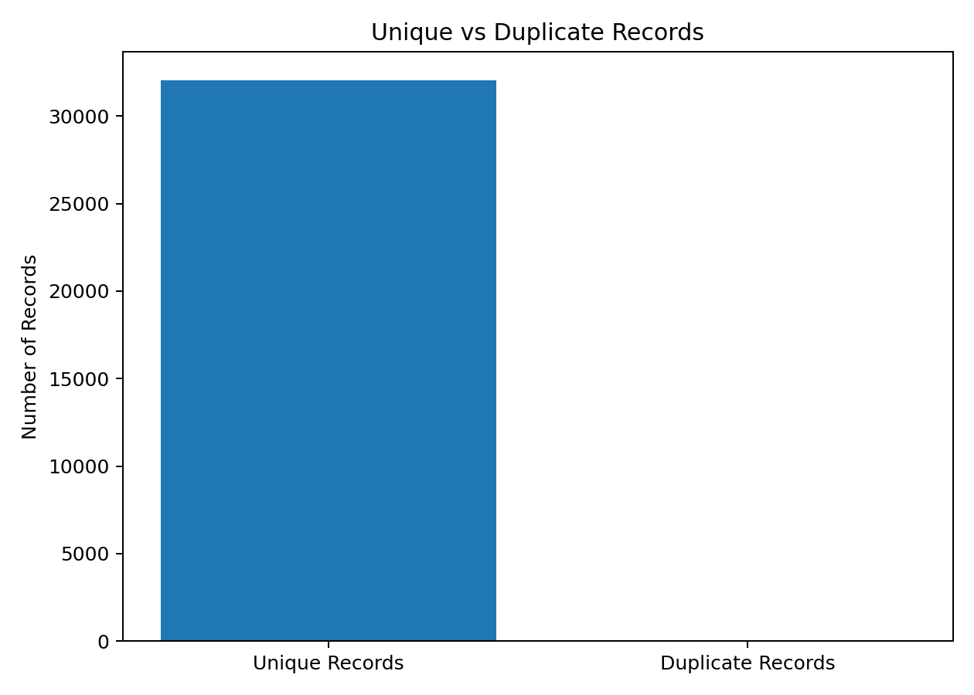

5.3 Data Type Validation
Numerical fields were validated using pandas numeric conversion, while the timestamp field was converted to datetime format. This is important because incorrect data types can prevent arithmetic operations, statistical analysis, time-based grouping, and visualization.

6. Outlier Detection and Treatment
Potential outliers were identified using the IQR method. For each numerical variable, Q1 and Q3 were calculated and IQR was defined as Q3 − Q1. Observations below Q1 − 1.5×IQR or above Q3 + 1.5×IQR were flagged as potential outliers. The important methodological decision was not to delete all flagged records automatically. In logistics, unusually high costs, delays, loading times, fuel consumption, or congestion can be genuine events. Therefore, outliers should be investigated and removed only when there is evidence of data-entry or measurement error.
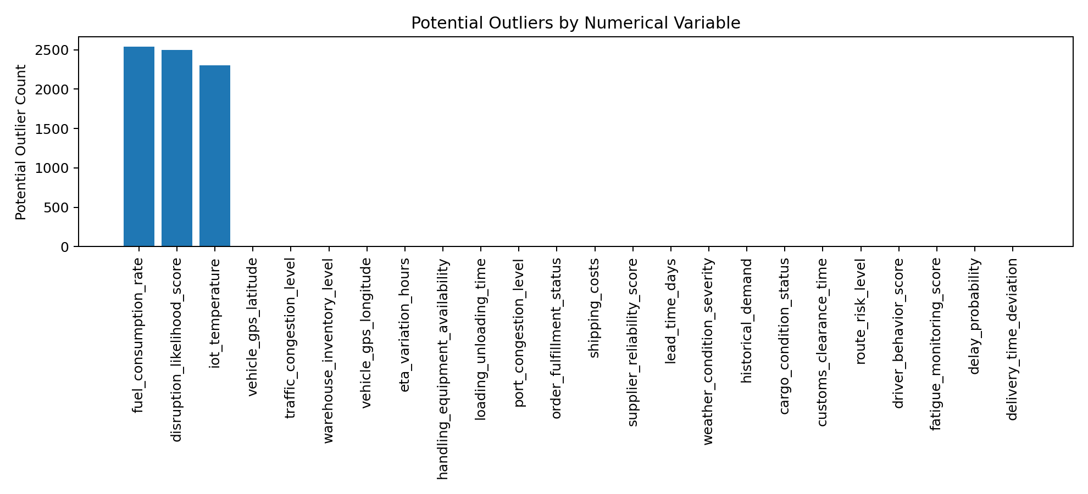
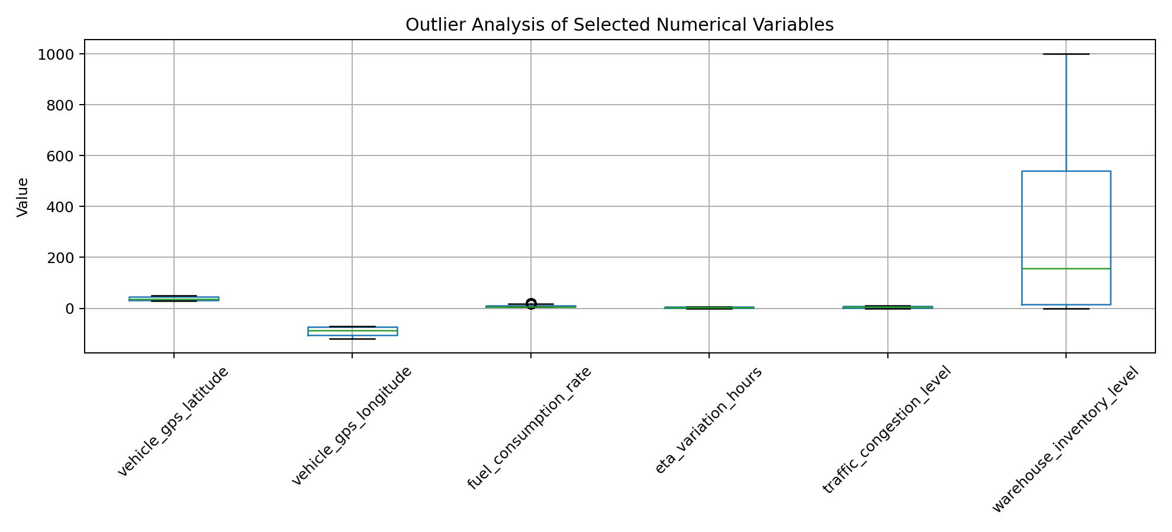

7. Normalization
Min-Max normalization was applied to numerical variables in a separate normalized dataset. The transformation scales values to a common range using the formula X' = (X − Xmin) / (Xmax − Xmin). This approach is useful when variables have very different units or numerical ranges. It preserves the relative ordering of observations while reducing the effect of scale differences in subsequent analytical or machine-learning workflows.
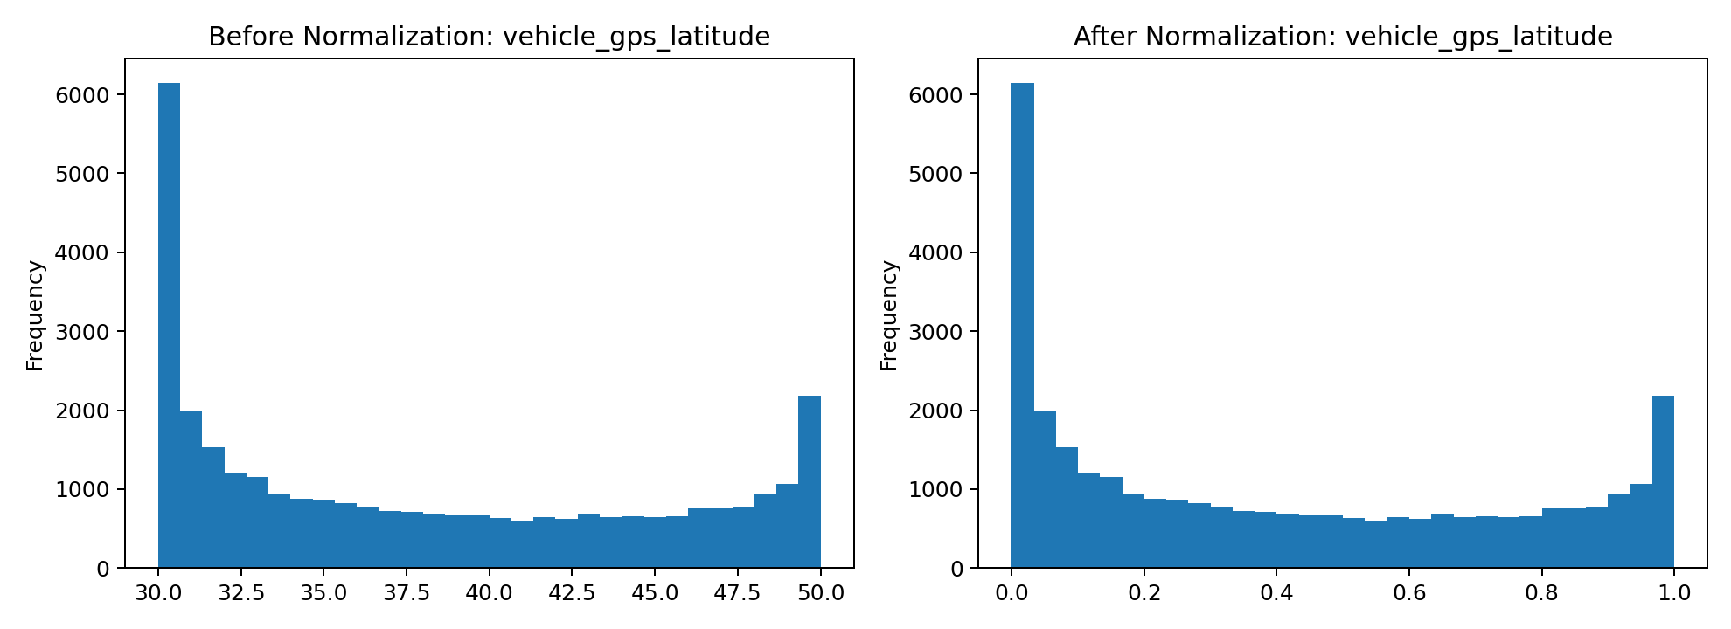

8. Distribution Analysis
Distribution plots were generated for selected numerical logistics variables. These visualizations help identify concentration, spread, skewness, and unusual observations. Understanding distributions before modeling helps analysts select suitable transformations and interpret summary statistics correctly.
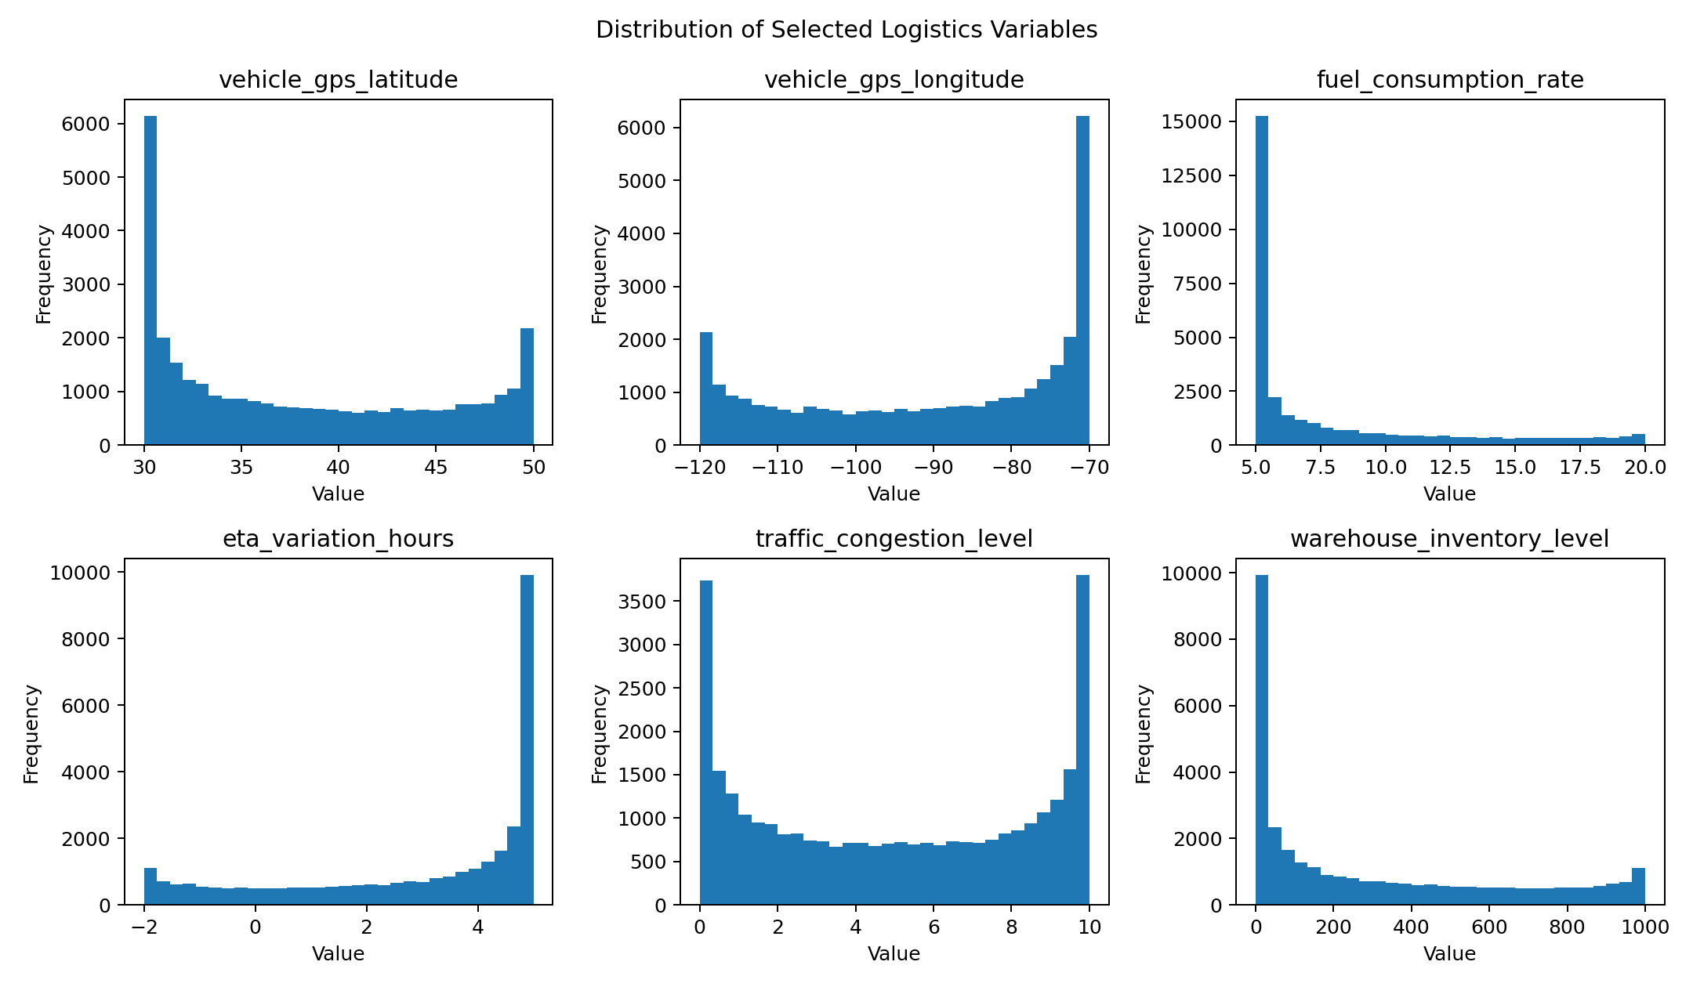

9. Correlation Analysis
A correlation matrix was calculated for numerical variables. Correlation measures the strength and direction of linear association between pairs of variables. Positive values indicate that variables tend to increase together, negative values indicate an inverse linear relationship, and values near zero indicate weak linear association. Correlation does not by itself establish causation.
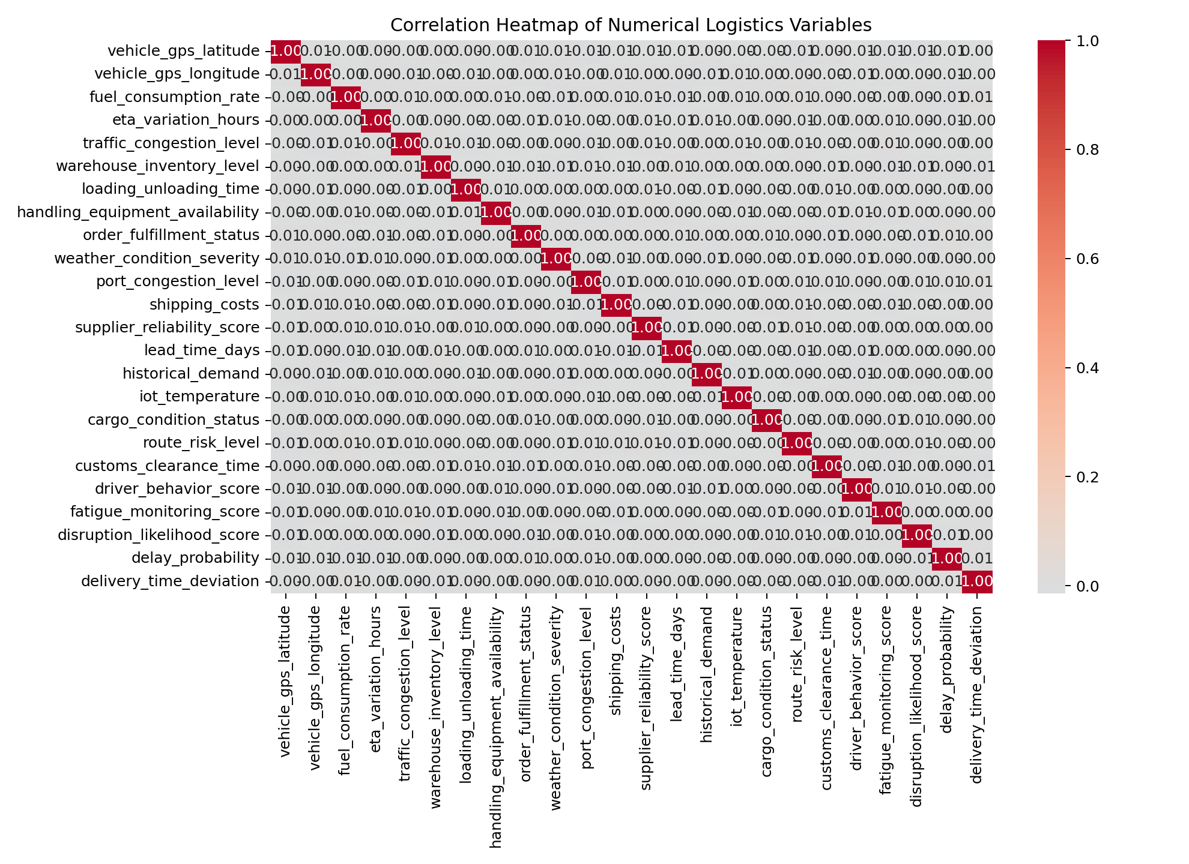

10. Python Code Snippets
import pandas as pd
import numpy as np
df = pd.read_csv("dynamic_supply_chain_logistics_dataset.csv")
print(df.shape)
print(df.head())
print(df.info())
# Missing-value and duplicate checks
print(df.isnull().sum())
print("Duplicates:", df.duplicated().sum())
# Timestamp conversion
df["timestamp"] = pd.to_datetime(
df["timestamp"], errors="coerce"
)
# IQR outlier detection
Q1 = df[column].quantile(0.25)
Q3 = df[column].quantile(0.75)
IQR = Q3 - Q1
lower = Q1 - 1.5 * IQR
upper = Q3 + 1.5 * IQR
outliers = df[
(df[column] < lower) |
(df[column] > upper)
]
# Min-Max normalization
df[column] = (
df[column] - df[column].min()
) / (
df[column].max() - df[column].min()
)

11. Results and Final Output
After preprocessing, the working dataset contains 32,065 records and 26 columns. The final quality check recorded 0 missing values and 0 duplicate rows. A cleaned CSV and a separately normalized CSV were generated. The original dataset was preserved so that the preprocessing decisions remain reproducible.

12. Impact of Data Quality on Logistics Analytics
Data quality has a direct impact on logistics analytics and operational decision-making. Incomplete, duplicated, incorrectly typed, or inconsistent data can produce misleading performance measures and unreliable predictive models. For example, an incorrect timestamp can distort delivery-time analysis, while an invalid transportation cost can affect cost optimization. Outliers require special attention because they may either represent genuine business events or measurement errors. A disciplined preprocessing pipeline improves data consistency, makes variables suitable for analysis, and increases confidence in conclusions drawn from the data. In logistics environments, better-quality data can support improved route planning, inventory decisions, delivery performance monitoring, cost analysis, and resource allocation.

13. Reflection
This task demonstrated that preprocessing is not simply a technical step performed before analysis; it is an important analytical decision-making process. The dataset was already complete with no missing or duplicate observations, so the main work focused on validation, timestamp conversion, outlier identification, visualization, and normalization. A key learning outcome was that statistical outliers should not automatically be treated as errors. In logistics, extreme observations can provide valuable information about unusual operational conditions. The preprocessing workflow therefore balances statistical methods with business context. The final outputs are more structured and suitable for future exploratory analysis and predictive modeling.

14. Conclusion
The Week 2 logistics data preprocessing task successfully implemented a complete Python-based data preparation workflow. The dataset was collected from a public source, inspected for quality issues, validated, checked for missing and duplicate observations, analyzed for potential outliers, and normalized using Min-Max scaling. Visualizations were used to communicate the data-quality findings and preprocessing effects. The resulting cleaned and normalized datasets provide a reliable foundation for subsequent logistics analysis, visualization, and machine-learning tasks.

15. References
1. Kaggle. Logistics and Supply Chain Dataset. https://www.kaggle.com/dsv/9673933
2. pandas documentation. https://pandas.pydata.org/docs/
3. NumPy documentation. https://numpy.org/doc/
4. scikit-learn preprocessing documentation. https://scikit-learn.org/stable/modules/preprocessing.html
5. Matplotlib documentation. https://matplotlib.org/stable/
6. Seaborn documentation. https://seaborn.pydata.org/

