**Name: Abdullah Khatri.**

**Project Title:**

Video Game Sales & Engagement Analysis

**The Tools Which Were Used:**Python, Pandas, Matplotlib, Seaborn, PostgreSQL, Power BI

**Step-by-Step Summary:**

|  |  |
| --- | --- |
| Step | Description |
| 1. Data Collection | Loaded games.csv and vgsales.csv |
| 2. Cleaning | # Dropped rows with missing Rating  # Filled missing Team with ['Unknown']  # Filled missing Summary with default text  # Convert Release Date to datetime  &   Dropped 2 NaT rows  # Cleaned “21K” style columns (Plays, Wishlist…)  # Cleaned Genres and Team from ['...'] to readable strings  # left Reviews untouched  # dropped unnamed column |
| 3. Merging | Combined datasets on  Title and Name for games & vgsales csvs |
| 4. EDA (Python) | Answered 30 questions using matplotlib and seaborn |
| 5. SQL Migration | Created 3 tables and inserted cleaned CSVs using psycopg |
| 6. Power BI | Built dashboards to visualize all 30 insights interactively |

**Key Insights from the Project:**

1. **Adventure, RPG, and Action** are the most engaging genres based on user plays, wishlists, and active sessions.
2. **Disco Elysium** and **Outer Wilds** consistently appear in the top-rated games, showing strong user reception.
3. **PlayStation 2 (PS2)**, **Xbox 360**, and **Wii** are the top 3 platforms with the highest global sales — showing their dominance in the 2000s.
4. **North America** leads in overall game sales, followed by Europe. Japan shows distinct genre preferences (e.g., RPG-heavy market).
5. The number of games released and overall sales peaked around **2008–2010**, then gradually declined in the following years.
6. **Highly wishlisted games** generally have higher ratings, suggesting wishlist count can reflect user excitement and trust.
7. Some genres like **Puzzle and Simulation** show high user engagement but relatively **low global sales**, pointing to a niche but loyal audience.
8. Developer studios like **FromSoftware** and **ZA/UM** have some of the **highest-rated games** despite producing fewer titles.

* **Screen Shots from PowerBI:**

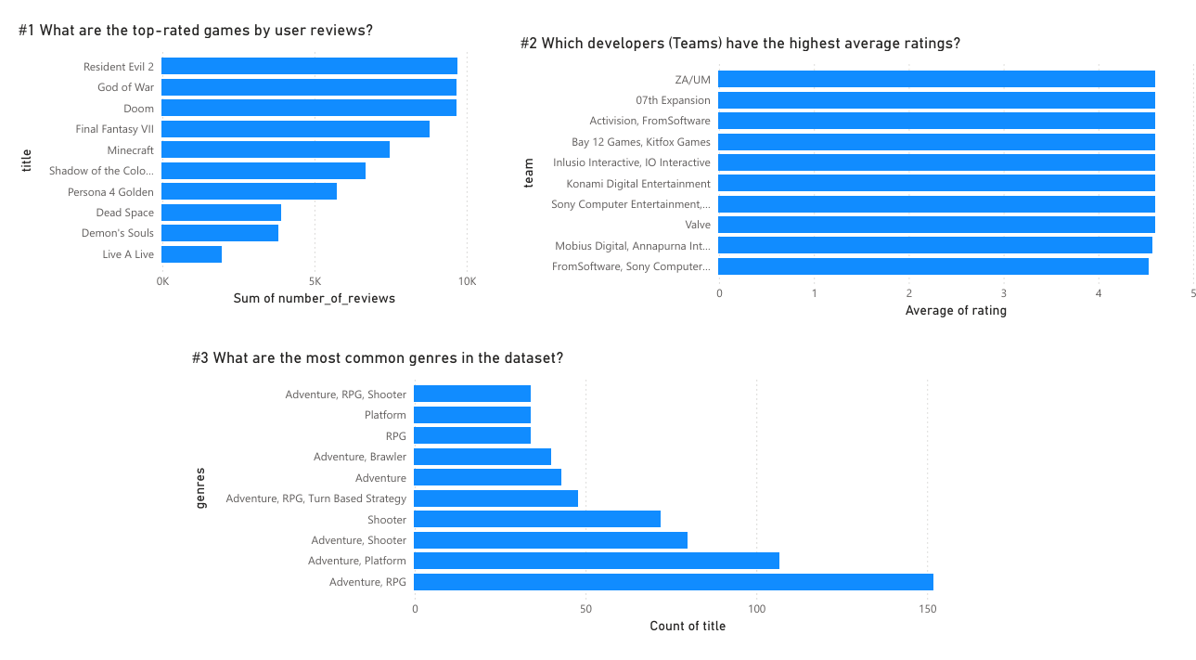

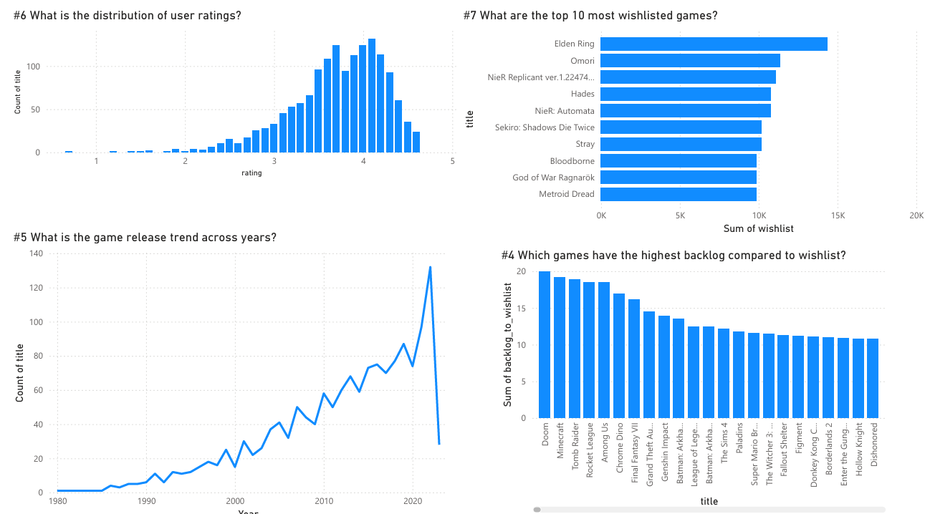

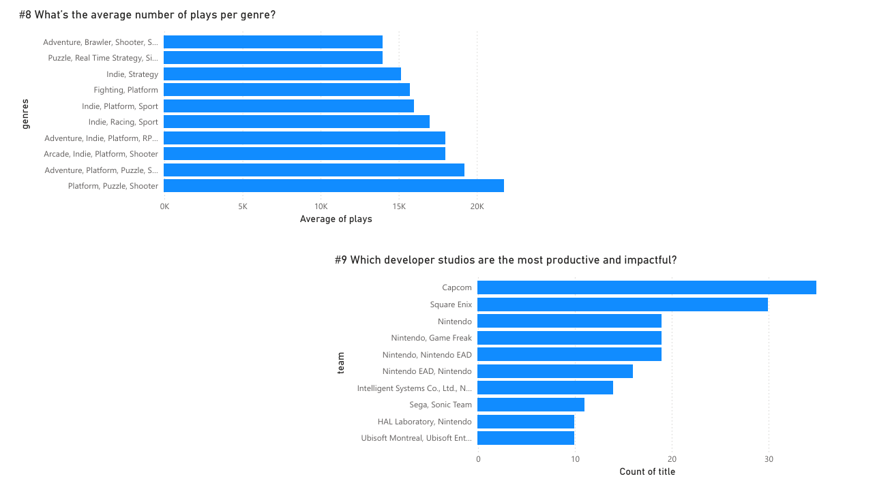

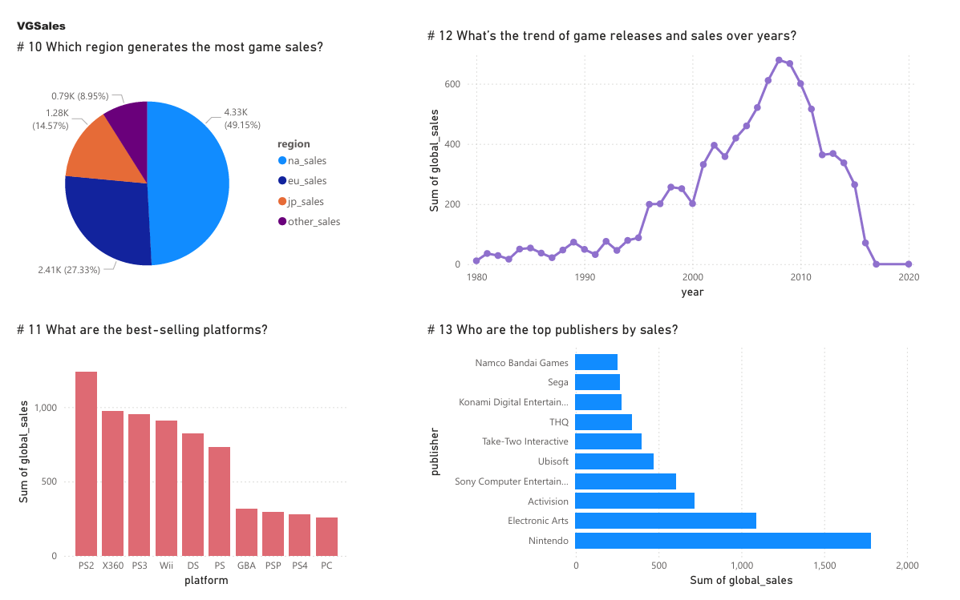

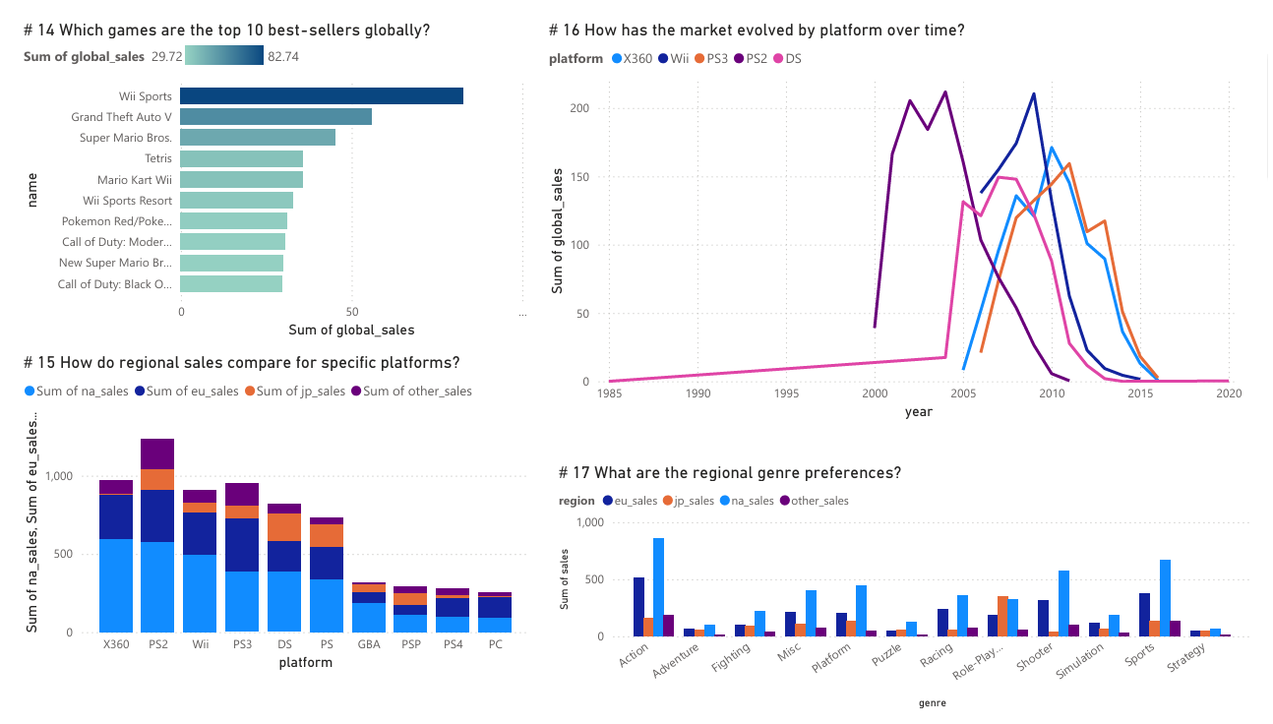

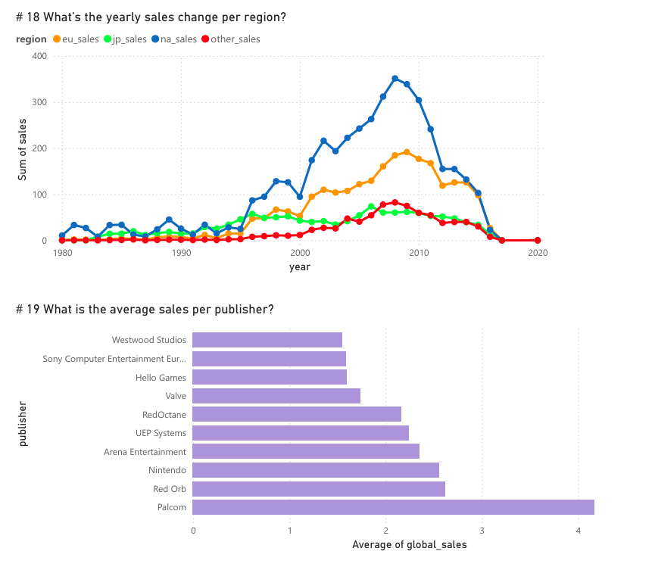

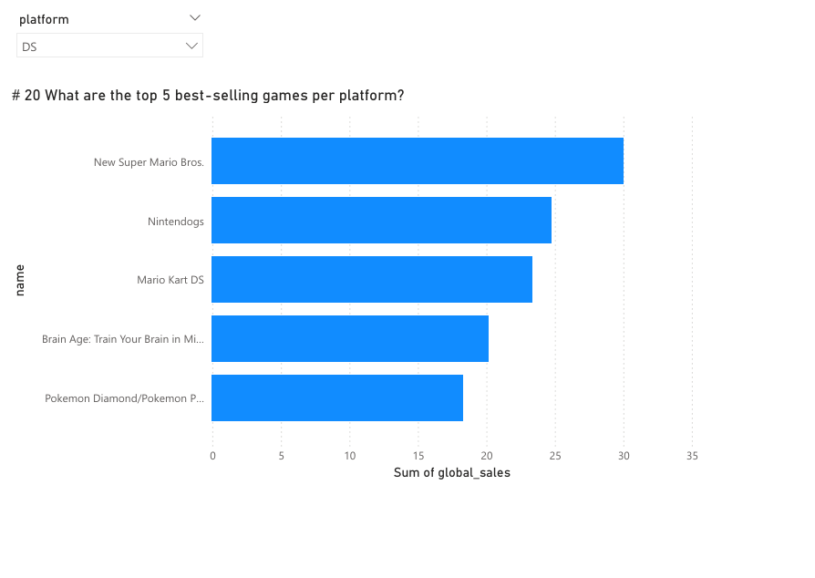

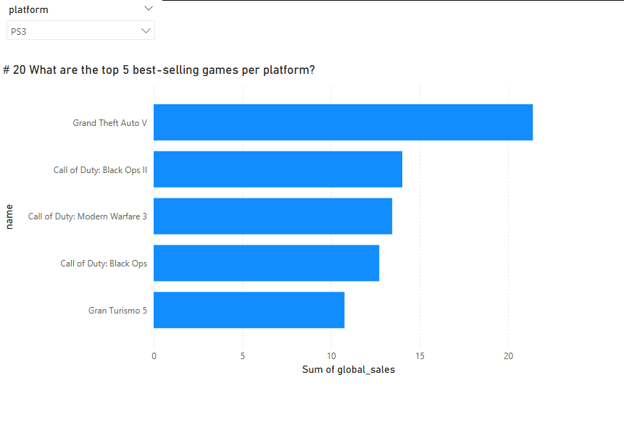

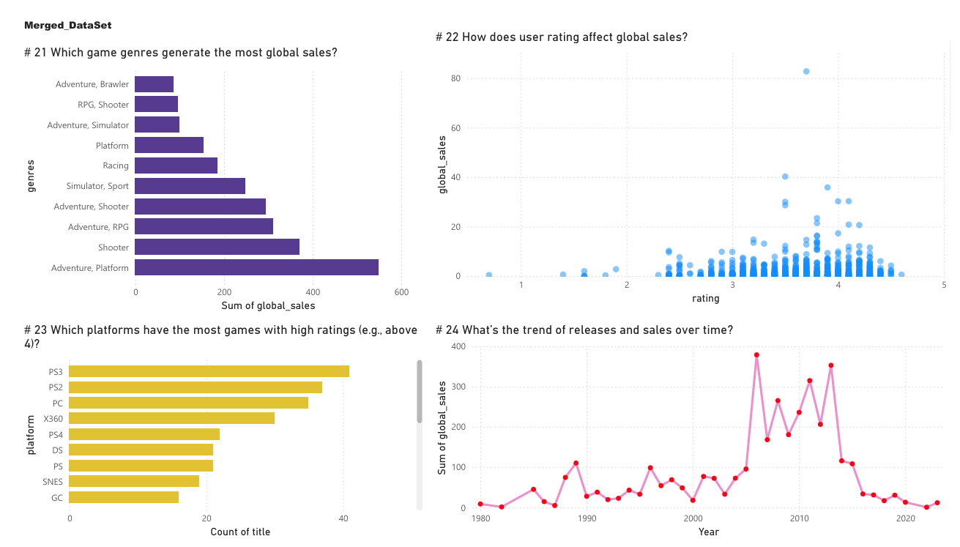

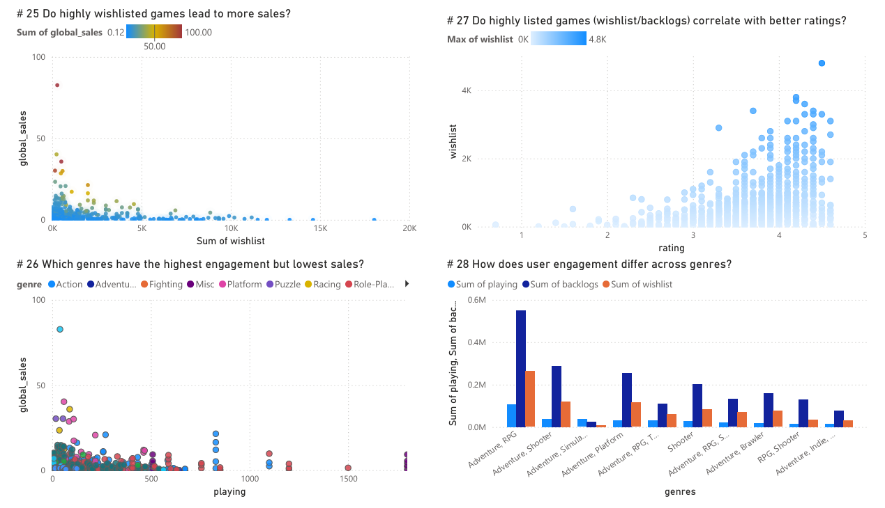

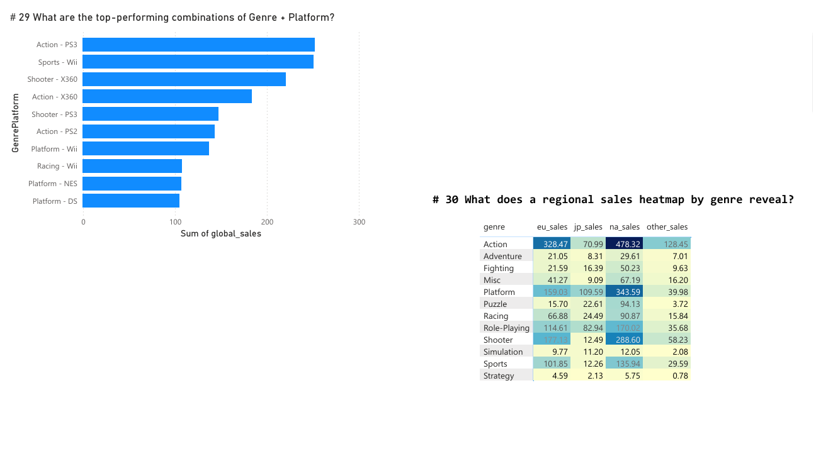



* **Directories ScreenShot:**

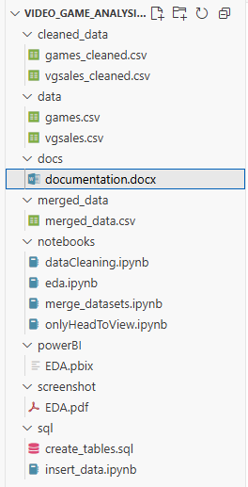

*The screenshots in full clear HD are also attached.*