AMF Shareware Productions
P.O. Box 189 • Holbrook, N.Y. 11741-0189 • USA

Try these programs in Microsoft Forums on CompuServe, The Microsoft RoundTable on GEnie, the Microsoft BBS, Ziffnet for PRODIGY, as well as FIDONet, and other Worldwide BBSs! | 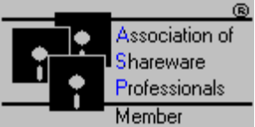

Title, Price (US $) and File Name:

Programs for Word for Windows 6.0 (GO MSWORD on CompuServe):

3.5" Disk Template: Now you can quickly print your own 3.5” disk labels as quick as you can type. Any types may be used. Labels right out of the disk box work fine. Has macros and a toolbar of its own for great ease of use. $5. Included in September 1994 CompuServeCD. 35LABW6.ZIP

CD Labeler Template: Produce double-sided CD Jewel Box (Cover) inserts for CD-ROMS, Audio CDs, and many others easily in seconds. Prints back covers and side flaps. Has macros and a toolbar of its own for easy use. $5. Included in September 1994 CompuServeCD. CDLABEL.ZIP

Play ANY Multimedia AMF: Now it’s easy to play any multimedia file right within Word! Locate a specific multimedia file and play it within Word. Easy to use button interface makes multimedia fun and easy. Has its own on-line instructions. $10 PAM.ZIP

Full Set of Colored Toolbar Icons: Jazz up the dull Word Work Place. With this set of colored toolbar icons, one can liven up presentations, and enhance productivity. Comes with 3 full color toolbars filled with icons. $10. Included in September 1994 CompuServeCD. AFCOLICO.ZIP

3 Freeware Macros: This three macro package allows the user to easily retrieve Windows' clock and calendar functions for easy access. It allows, also, the setting of the time and date. The second macro allows the user to install fonts, drivers, sounds, and any other options from Inside Word. It also allows easy shelling out to DOS from inside Word. And finally, the third macro finds the words per minute that one can type. It is based on four sample passages which are timed for typing. It will only accept 100% correct typing every time. Great for businesses and secretaries. (Non-mandatory $5) FREE.ZIP

Exit Master: Allows fast exiting/restarting of Windows, rebooting computer, exiting to DOS, and exiting of Word. Easy to use and very fast. $6 EXIT.ZIP

Foreign Language Translator: French Dictionary: This add-on allows the user to quickly look up a word in French or English and translate it into English and French, respectively. It also allows the pasting of the words with their appropriate accents right into the current document. Easy to use and great for everyone. Mentioned in August 1994’s CompuServe Magazine. $15 FRENCH.ZIP

The Ultimate Easiest Faxer: This macro allows the current document to be faxed through WinFax (any version). Easy to use and it has its own toolbar. Faxing has never been so easy! $5 AMFFAX.ZIP

Alarmer AMF: This macro alarms the user of specified times that he/she specifies. Easy to use and effective. It even allows the incorporation of Multimedia into the alarm. $5 ALARM.ZIP

Program Launchers/Runner: These add-ons allow quick launching of files as well as searching. One has a quick command line, while the other has more control over how the program is found and launched. They work much like the File Run command in Program Manager. Easy to use. $10 RUN.ZIP

Business Cards AMF: Creating custom business cards has never been so easy! Allows the creation of business cards catered to the user's tastes. Has macros to copy one card to the rest of the cards. Designed for ten card stock. $5 AFCRD.ZIP

Toolbar Doubler: Time and space saver! Allows two Word toolbars to occupy the space of one. Very effective and easy to use. Now fully customizable. Just press a button. $15 TB2X.ZIP

Quick Telephone Dialer: Store and dial phone numbers for quick access. Allows the storage of phone numbers in a rolodex-like storage device. Dial numbers directly from inside Word very quickly. A great business tool. $10 DIALAMF.ZIP

VHS Labeler: Customize your entire video library easily! Without special labels, this program creates custom-fitting VHS video tape labels. Great for private companies or home use. Add logos, pictures, etc. for great results. Allows production of more than on set of the same label. $5 VHSLAB.ZIP

Total System Information: Produces a dialog box with the current system information. Describes many aspects of the system you use, including a list of hidden windows or programs. Easy to use and a great tool. $6 TSI.ZIP

Chicago (Win 4.0)- Like Window Titler: Get rid of the 8-character DOS limit forever! Allows a temporary change of the Window Title in Word to the title of the document rather than the filename. Works like Windows 4.0 (Chicago) will work. It allows the breaking of the 8 character filename limit. $6 TITLER.ZIP

AMF Word Lock Security: Lock Word tight from prying eyes. Can only be opened with the correct password or MASTER key. Reports all tried break-ins in written formats. Great security was never so easy. $6 AFLOCK.ZIP

Hangman AMF for Word 6.0: Are you bored at work or at home? The pen and pad game returns in an electronic form. Now 300% faster, with a larger selection of words. Works like any Hangman Game. Fun and easy to use. $10 HANG.ZIP

Wordware Personal Information Manager for Word 6: Finally, a PIM comes to Word. Easy to use and very efficient. Dial the phone, print a colorful address book, add an address to a document or business letter, create an envelope, and much more! Now supports up to 21,000 entries, the fastest BACKGROUND Faxing, and looks and feels like a real rolodex. Imports databases, Searches, Creates Letters, Dials Voice Mail, Faxes, and so much more! Manages an entire business! SUPERIOR SHAREWARE in WINDOWS November 1994 Issue. Included in September 1994 CompuServeCD. $15 PIM.ZIP (Screen Shot Follows)

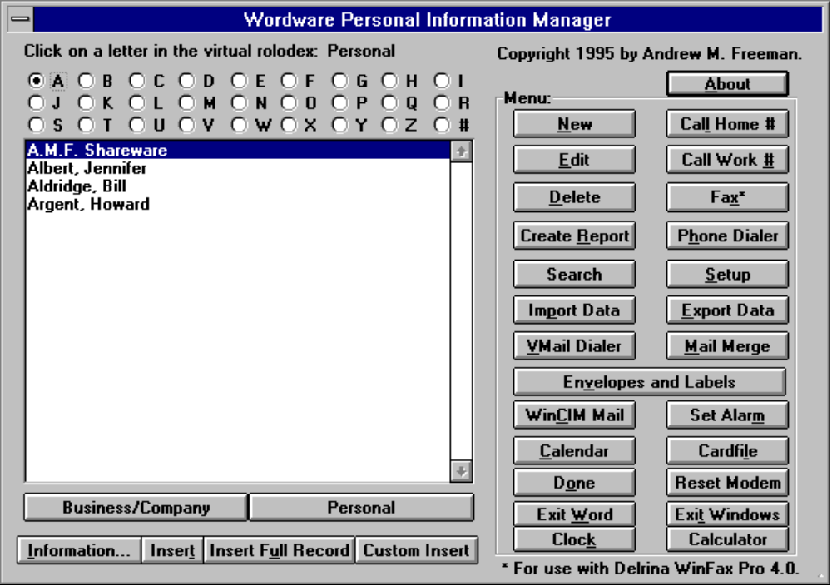

WinFax Pro 4.0 and Word 6.0 DDE Fax Macro and Template: Faxing has never been so easy or convenient. Takes full advantage of WinFax Pro 4.0’s vast programming options. Now allows storage and changing of USER information. $10 WFX40.ZIP

Wordware v3.0 for Word 6.0 for Windows: The hottest collection of over 55 macros and templates. Everything from copying a file, to managing your projects to managing your business contacts. A full-fledged Personal Information Manager is included as well as a full-function CD Player. Wordware greatly enhances Word’s native capabilities. Wordware has a Multimedia Player which will play all multimedia files, a quick command line, Windows Exit/Restart/Reboot Computer, Lock Word, Close All Files and Exit, Print Summary Information, Chicago-Like Windows Titlers, WinFax Macros, and many, many others– all in one compact package. Wordware v3.0 adds 3-D to its common dialogs. Ziff Davis Interactive calls Wordware “an intriguing set of macros for MS Word... which add workday productivity...” $39.95/ $15 upgrade. WW3.ZIP. Included in September/October 1994 CompuServeCD. WW3.ZIP

CD Player for Word 6.0: Now you can enjoy CDs while you do your work. Has a Title database which actually remembers the CDs title and author, a Random (Shuffle) Play, Fast Forward, Fast Rewind, Skip Tracks, Pause, and Eject. Even plays CDs in the background. $15 CD.ZIP.

Tic Tac Toe for Word 6.0: The original Tic Tac Toe, in a Word 6.0, for Windows version. Amazingly easy to use, works just like the old game. Allows “cheating” so that it is possible to win. Great fun, and very addicting. $10 TIC.ZIP

Programs for Windows (GO WINSHA on CompuServe):

Elbow Grease for Windows v1.0 (ELBOW.ZIP): Elbow Grease for Windows v1.0. The Ultimate, Easy to Use, Program Manager Enhancement. Features 40 launch button toolbar with large buttons, resource monitors for memory and disk space, clock, perpetual calendar to the year 9000, Appointment Book and To-Do List to schedule events until the year 9000. Drag & Drop File Manager Launching, Built in Games like Tic-Tac Toe, ToolTips help which the user specifies (works like MS office). All this in 1.5 inches which sits at the bottom of your screen. Easy to use and operate. Full help included. Needs VBRUN300.DLL. $19.95 ELBOW.ZIP

AMF Intelligent Organ/Synthesizer (ORGAN.ZIP or AORGN.ZIP): AMF Intelligent Organ/Synthesizer for Windows. Now you can click your way to stardom. The first Organ to offer features such as 127 instrument/voice selection, volume control, octave control and RECORDING CAPABILITY as well as PLAYBACK CAPABILITY. This organ actually looks and works like an organ. Has an auto playback feature which makes it look like someone is actual playing! Works like a CASIO keyboard-- but easier! Try it- a guaranteed favorite. Full help included. Needs VBRUN300.DLL. $11.95 ORGAN.ZIP

Mouse Clock ™ (MCLOCK.ZIP): Mouse Clock ™ for Windows. Mouse Clock is the only cursor enhancement you’ll ever need! Mouse Clock virtually becomes part of your mouse pointer. It stays out of the way, while providing you with the current time and free system resources. Now has a rate clock and supports 24-hour format. Can stay on top, or put behind Windows when you no longer require its use. Easy to use and fully configurable. Another very handy utility from AMF Shareware Productions. Requires VBRUN300.DLL. $10.00 MCLOCK.ZIP

AMF Multimedia Jukebox (JBOX.ZIP): Play any multimedia file effortlessly in seconds! Plays AVI, MID, WAV, VOC, MOV, FLI, FLC, etc. A beautiful 3-D interface. Allows any file to be played as many times as you want. Save pre-programmed lists of your selections, and open and play them with one click. Easy to use and operate. Full help included. Requires VBRUN300.DLL. $10.00 JBOX.ZIP

AMF Daily Planner & Personal Information Manager for Windows v4.0 (WPIM.ZIP): This PIM is the easiest one you will ever use. A full drag and drop interface is included with a perpetual calendar and planner to the year 9000. Beautiful 3-D, professional look. Store up to 21,000 entries in the Rolodex Style Phonebook. Yellow Pages and White Pages and full searching capabilities included. Dial the phone, Fax Documents using Delrina's WinFax Pro 4.0. Create business letters, schedule appointments with just a drag and drop. Edit and save text files, print them in any font you want. Create beautifully formatted reports of all your phonebook entries. Fits the FiloFax standard, as well as many others such as Day Runner, and Day Timer. Create envelopes and labels with multiple fonts and colors. Set up to 1,440 alarms per day. Stores an immense amount of data per day. Keep multiple years worth of data at your finger tips. Great for tax records and business planners. No restraints- store your appointments any way you want. Easy to use. Calculator and Clock included. A Personal Task List is included to balance daily tasks. View your appointments at a week at a glance. Anniversary, birthday, holiday reminders are a snap with the Event Master ™. Mail Merge or Merge Print a letter to all your contacts. NO TRAINING required. Import data using .MDB Access databases, or use tab or comma-delimited text files using the revolutionary Import Wizard ™. Context sensitive help is included. Please see the help file - PIM.HLP for more information. SUPERIOR SHAREWARE in WINDOWS Magazine’s January 1995 issue! WPIM.ZIP $21.95 (or as low as $4.95 in bulk) (Screen Shot Follows)

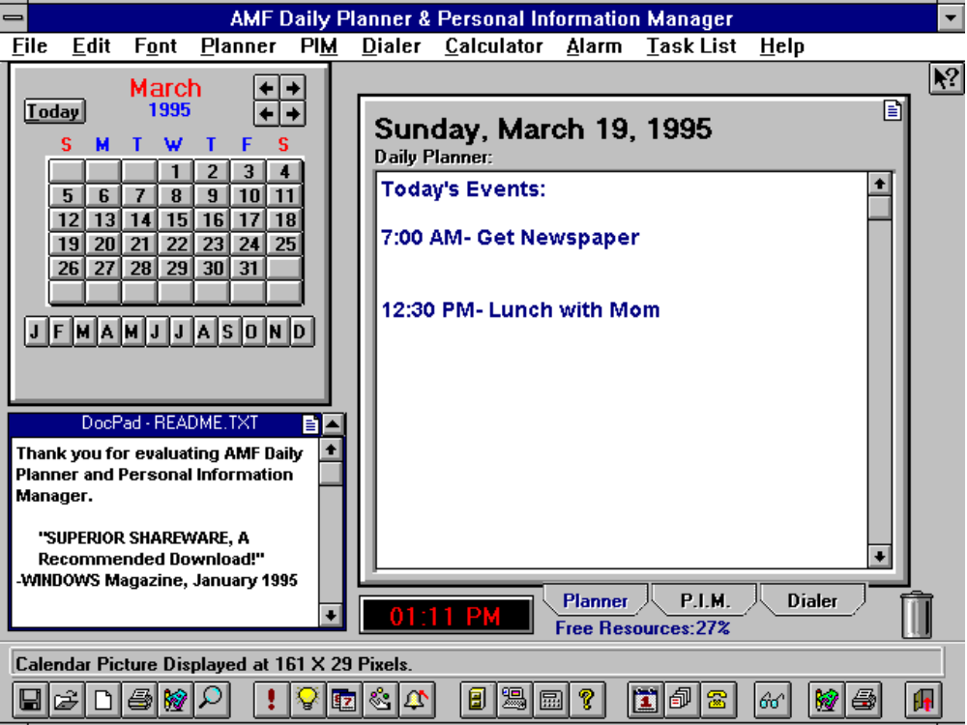

Most of the programs/macros listed can be registered electronically through CompuServe’s SWREG (Go SWREG).

Use the order form on the next page to have your order processed quickly.

>>>> OR register Toll-Free by PHONE WITH YOUR CREDIT CARD <<<<

NO UPGRADES by Credit Card.
Master Card, Visa, American Express, and Discover cards are accepted.
Only Wordware (full version) ID #11521, or AMF Daily Planner & Personal Information Manager (PIM), ID #11789 may be registered by credit card.

**** Credit Card Orders Only ****
You can order with MasterCard, Visa, American Express, or Discover Card from Public (software library) by calling 800-2424-PsL or 713-524-6394 or by FAX to 713-524-6398 or by CIS E-Mail to: 71355,470. You can also mail credit card orders to PsL at P.O. Box 35605, Houston, TX 77235-5705.
THE ABOVE NUMBERS ARE FOR ORDERS ONLY.
Any Questions about the status of the shipment of the order, refunds, registration options, product details, technical support, volume discounts, dealer pricing, site licenses, etc., must be directed to: Andrew M. Freeman, P.O. Box 189, Holbrook, N.Y. 11741-0189 or by CIS e-mail: 74250,1700. To insure you get the latest version, PsL will notify us the day of your order and we will ship the product code directly to you.
PLEASE NOTE: PsL DOES NOT Provide support for this product and will not accept returns. Address all support questions and returns, or any other questions to the author’s address and e-mail address above.

Order Form:

Quantity: | Product and Price: | Sub Total: (US$)
 | 3.5" Disk Template: each @ (US) $5
 | CD Labeler Template: each @ (US) $5
 | Play ANY Multimedia AMF: each @ (US) $10
 | Full Set of Colored Toolbar Icons: each @ (US) $10
 | Exit Master: each @ (US) $6
 | Foreign Language Translator: French Dictionary: each @ (US) $15
 | The Ultimate Easiest Faxer: each @ (US) $5
 | Alarmer AMF: each @ (US) $5
 | Program Launchers/Runner: each @ (US) $10
 | Business Cards AMF: each @ (US) $5
 | Toolbar Doubler: each @ (US) $15
 | Quick Telephone Dialer: each @ (US) $10
 | VHS Labeler: each @ (US) $5
 | Total System Information: each @ (US) $6
 | Chicago (Win 4.0)- Like Window Titler: each @ (US) $6
 | AMF Word Lock Security: each @ (US) $6
 | Hangman AMF for Word 6.0: each @ (US) $10
 | WinFax Pro 4.0 and Word 6.0 DDE Fax Macro and Template: each @ (US) $10
 | Wordware v3.0 for Word 6.0 for Windows: each @ (US) $39.95/ each @ (US) $15 upgrade
 | CD Player for Word 6.0:. each @ (US) $15
 | Tic Tac Toe for Word 6.0: each @ (US) $10
 | Wordware Personal Information Manager for Word 6: each @ (US) $15
 | Elbow Grease for Windows v1.0: each @ (US) $19.95
 | AMF Intelligent Organ/Synthesizer: each @ (US) $11.95
 | Mouse Clock ™: each @ (US) $10.00
 | AMF Multimedia Jukebox: each @ (US) $10.00
 | AMF Daily Planner & Personal Information Manager for Windows v4.0: each @ (US) $21.95

A 3.5” HD Disk will be sent with your choice of program.

+ $5.00 (US) for disk, shipping, and supplies: TOTAL (US) $_______________________

Please enclose a check or money order made payable to Andrew M. Freeman.

Return this form to:

Andrew M. Freeman
AMF Shareware Productions - Orders
P.O. Box 189
Holbrook, N.Y. 11741-0189
USA

AMF Productions also offers a FREE catalog of informational how-to reports on hundreds of subjects. For your FREE catalog, send this coupon to PO Box 189 • Holbrook, NY 11741-0189 • USA

Name: Address:

