**Lab #1 Assignment – TensorFlow Lab**

**CMPE 257 - Section 01: Machine Learning**

**Arkil Thakkar**

**013825292**

**San Jose State University**

**Objective**

Executing simple TensorFlow exercises by using TensorFlow OPs and to get used to TensorFlow API. Using street view house number dataset provided by Stanford University predict class labels from 1-10[1].

**Process**

Load train and test images and apply preprocessing like converting RGB to Gray, normalization. Build Convolutional Neural Network (CNN) architecture and train model on training dataset. Compare validation and test dataset results.

The source code files [2], [3] can be found with this report.

**Results**

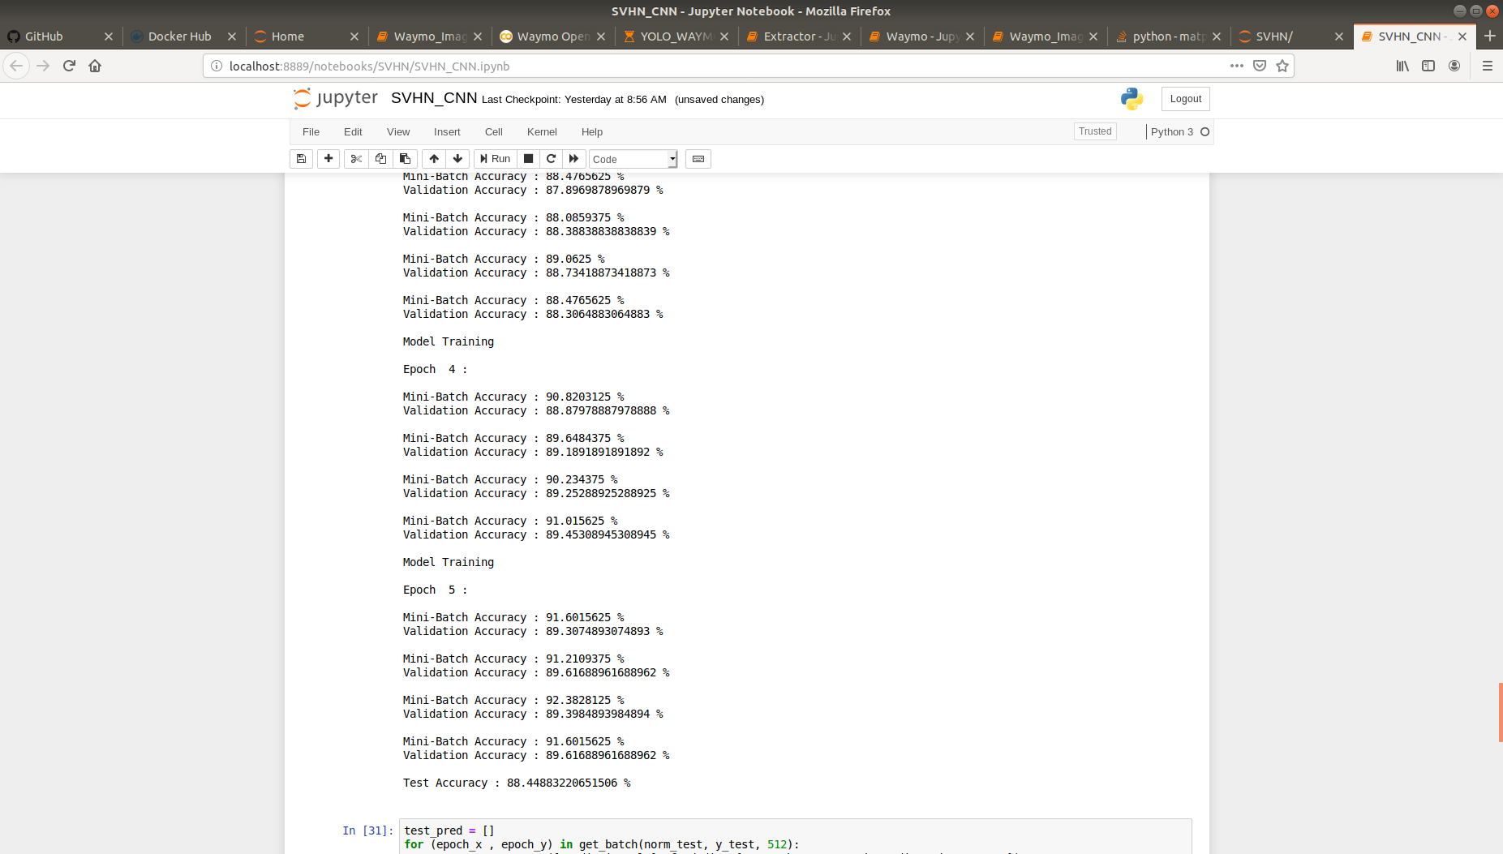**Screenshot of the Result**

**Fig. 1: Output of Model Training.**

As can be seen in the above screenshot, the validation accuracy i.e. The **classification result** obtained is **89.61%** and the Test accuracy i.e. the **comparison result** obtained is **88.44%.**

**References:**

[1] The Street View House Numbers (SVHN) Dataset. [online] Available at: http://ufldl.stanford.edu/housenumbers/ [Accessed 21 Sep. 2019].

[2] Sharma, A., aditya9211/SVHN-CNN. [online] GitHub. Available at: https://github.com/aditya9211/SVHN-CNN [Accessed 21 Sep. 2019].

[3] Huyen, C. assignment 1 · chiphuyen/stanford-tensorflow-tutorials@b7f91f3. [online] GitHub. Available at: https://github.com/chiphuyen/stanford-tensorflow-tutorials/commit/b7f91f3c55c5f9699417a74169ae2ad6bfb56a54 [Accessed 23 Sep. 2019].