**ER diagram**

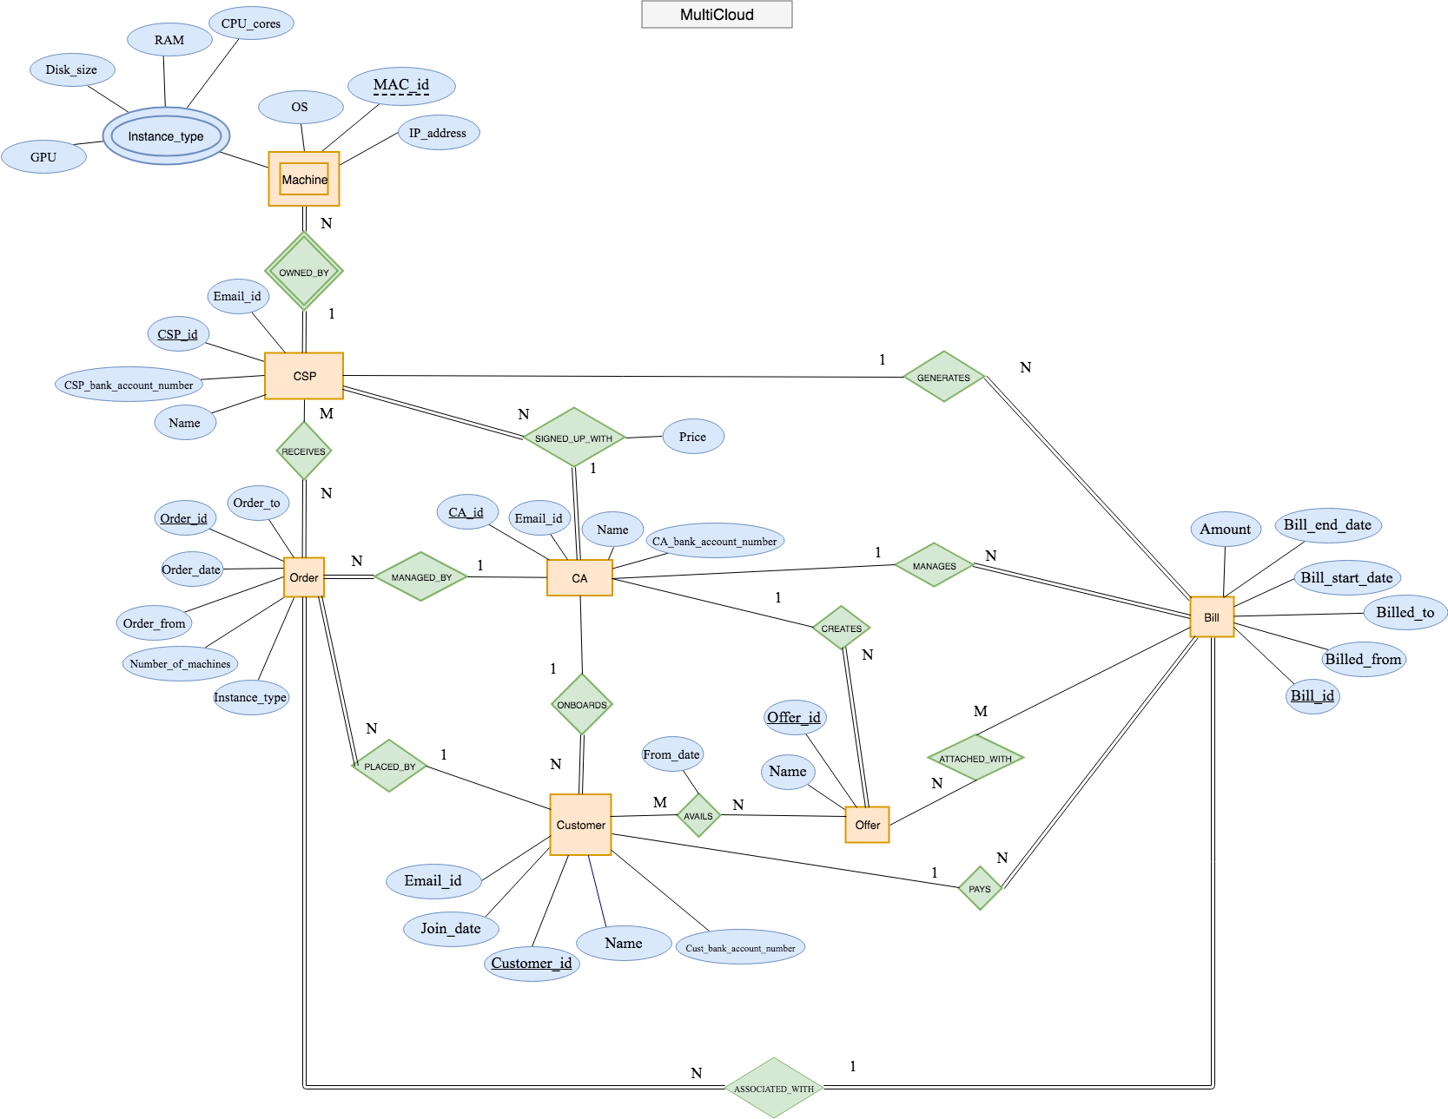

**ERD Requirements**

1. **Customer**
   1. May place N orders
   2. Must be on board to one CA
   3. May have N offers
   4. May have bills
2. **Cloud_Service_Provider CSP**
   1. Must be signed up with exactly one CA
   2. Must have N machines
   3. MAY generate some bill
   4. May receive n orders
3. **Machine**
   1. Must be owned by only one CSP
4. **Cloud_Aggregator CA**
   1. May manage N number of orders
   2. Must have 1-n CSPs
   3. May have N customers
   4. May have n billing
   5. May provide some offers
5. **Bill**
   1. Must be connected with customer
   2. Must be connected with CA
   3. Must be connected with CSP
   4. May be attached with some offers
   5. Must be connected some orders
6. **Order**
   1. Must be placed by exactly 1 customer
   2. Must be managed by exactly 1 CA
   3. Must be received by some CSPs
   4. Must be connected with 1 bill
7. **Offers**
   1. Must be created by a 1 CA
   2. May be availed by some to customers
   3. May be attached to some bills