Skip to content
Current store:
2770, Mount Druitt

Search

Lists

- Special Buys
- Groceries
- DoorDash
(opens in a new tab)

- Catalogue
(opens in a new tab)

- Recipes
- Services
HomeMy List
My List
Browse now to add more items.
Browse Categories

BAKERS LIFE
The Best White Sandwich Bread 700g
700 g ($0.54 per 100 g)$3.79
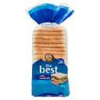
1
Mark as done

FARMDALE
Full Cream Milk 3L
3 L ($1.55 per 1 L)$4.65
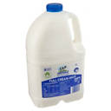
1
Mark as done

BAKERS LIFE
The Best Wholemeal Sandwich Bread 700g
700 g ($0.54 per 100 g)$3.79
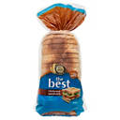
1
Mark as done
Products value
A$12.23
Value of done items
A$0.00
Footer Menu - further links
Help & Support

Help Centre
(opens in a new tab)

Store Locator
(opens in a new tab)

Product Recalls

Special Buys Delays

Stock Checker
(opens in a new tab)

Newsletter Sign Up
(opens in a new tab)

About Us

What Makes Us Good Different

Sustainability

Careers
(opens in a new tab)

Corporate & Suppliers

Media Centre
(opens in a new tab)

ALDI International
(opens in a new tab)

Download our App

Find us on our socials

Privacy and Policy Menu
Privacy Policy
Data Protection
Legal Notice
Returns Policy
Security Policy
(opens in a new tab)

Safety Data Sheets
(opens in a new tab)

Social Media Terms
Scam Notice
Liquor Licenses
Gift Cards Terms of Use
The Best White Sandwich Bread 700g added to My List.

Feedback

